Degradation of Solar Panels

Final Report, Physics of Semiconductor 2018

Pargorn Puttapirat (*ID 3117999011*)

Department of Computer Science and Technology, School of Electronic and Information Engineering  
Xi’an Jiaotong University, China  
pargorn@stu.xjtu.edu.cn

*Abstract*— This paper mainly reviews the causes of solar panel degradation which is critical to solar energy production since the uses of solar energy have exponentially increased and there are more PV modules installed all over the world. The statistics of solar energy uses are discussed to emphasize the importance of proper use of solar panel which will lead to better reliability, performance, and longer lifetime of the module. To prevent the failure or drop in energy production of these modules, we need to study the cause of failures. There are many factors in operating solar panels and they can be tuned so the system can operate at ideal output or optimum yield. Three main categories of failure including soiling, heating, and mechanical failure are discussed. This study also proposes some maintenance procedures and solutions to prevent such loss in energy production. Further studies on the degradation process could lead to a significant impact on economy and benefit the environment.

Keywords— solar, cell, panels, PV module, photovoltaic, reliability, degradation

# Introduction and Importance

As the statistics of global annual energy production from solar energy shows in Figure 1, PV is on the horizon of becoming the new main source of renewable electricity production. Therefore studies and control over its stability is crucial [1]. Over the last several years, researchers are pushing the limit of solar cell power conversion efficiency (PCE). Widely used commercial solar panels in solar farms, business, and homes have PCE at around 20-25% as can be seen in supplementary Figure 1. This PCE in households and businesses of installed solar panel will not be improving soon because the installed solar panels are meant to be used for the next 10 – 20 years. The typical life span of the solar panels are predicted to be 20 – 25 years [2].

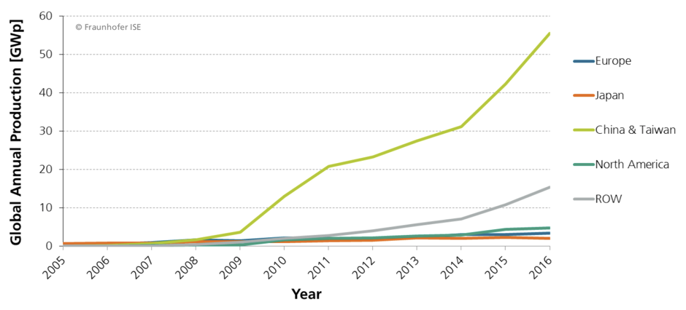

1. Global annual energy production from solar energy from 2005 to 2016

There are few studies on the behavior of solar panel in long-term usage. The loss in PCE over the years of solar panel usage would impact the overall efficiency greatly. The impact is more prominent in large-scale production such as in solar farming. PV modules do not last forever. Therefore, the studies in need are the investigations of solar panels degradation. This kind of studies should be able to provide clearer insights to PV performance, economic feasibility, and most importantly, how to prevent avoidable degradation before it happens to solar panels all around the world. As large quantity of PV modules is being installed worldwide with government initiatives and the need of renewable energy to replace the non-renewables, there might be a lot of undermaintained or unproperly treated PV modules that are going to fail or becoming not economically feasible to keep the module running in the next 10 – 20 years. Since the solar panels currently in use contain toxic component, it would post a threat to the environment when we have many unusable solar panels to be disposed [3]. In this aspect, it also gives a raise to the question about how we can recycle the solar panel as well. However, we will not discuss about the environmental effect from disposal of degraded solar panel in this literature. Ultimately, if we can extend the lift-time of solar panel, the waste caused by the manufacturing the panel and disposal can overall be minimized.

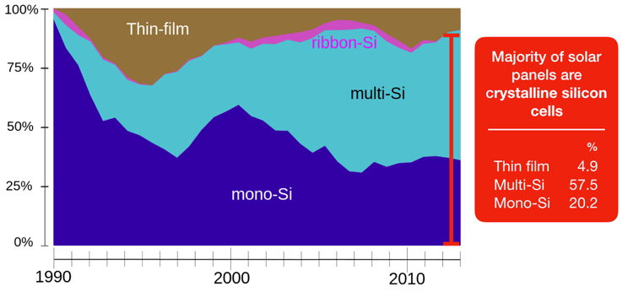

1. Global market share by PV technology from 1990 to 2013. The red bar indicates that the majority of solar energy production is based on crystalline silicon cells.

Based on PV degradation studies thus far, we can roughly conclude that the causes of module failure can be considered as avoidable and unavoidable degradation. This paper will discuss both of them. The currently unavoidable degradation is caused by heat from the environment which cause the cell to expand and contract. This phenomenon contributes to more cell stress and eventually result in micro cracks or more defects in the semiconductor material. The defective semiconductor material is then cause a drop in the panel efficiency. Another possibility about PV degradation is the currently avoidable solar panel degradation. It is also caused by the environment that the module is installed and can be varied greatly from region to region. The examples are soiling which cause the obstruction of sunlight to the solar panel, mechanical failure which could be cause by ice on the surface of the panel or accumulated snow on the panel which cause high stress, abrasive sand that abrade the panel outer surface, and failure due to manufacturing process which may involve encapsulation, framing, and cell layout design. These factors can cause both temporary drop in energy production efficiency and long-term damage to the module.

The development of techniques to prevent damages to PV or maintenance guidelines are proposed, however, comparison and implementation is a work in progress. Economic feasibility of each methods is also important as well. Some solution work for large-scale solar farm but not in the rooftop solar panel. To maximize the energy production, the installation design and maintenance plan should be considered as well.

# Cell Structure of Solar Cell

## General working principle

A simple solar cell is a p-n junction diode. The schematic of the device is shown in Figure 3. Radiation is absorbed in the depletion region and produces electrons and holes. These are separated by the built-in potential. Depending on the wavelength and the thickness different parts of the device can absorb different regions of the solar spectrum. The movement of electron with higher energy from the solar cell to an external circuit drive the current which results in energy production. The electron then dissipates its energy in the external circuit and returns to the solar cell. There are several semiconductor materials which could be used as an active region in the cell. The widespread solar panel use silicon as a main material in manufacturing the cell.

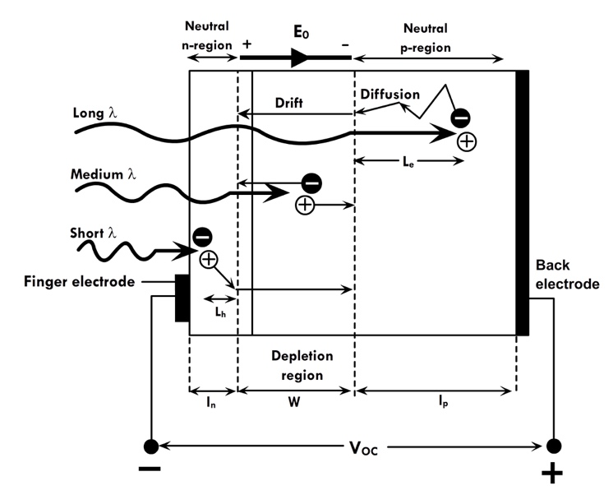

1. Basic structure of the cell structure which consist of p-doped and n-doped semiconductor and the junction. Incoming photon with the suitable wavelength will activate the cell and stimulate electron flow which drive the current and result in energy production. (Parasuraman, 2014)

In this paper, we discuss the solar panel based on this basic structure of cell because the commercialized solar panels are developed based on this same technology. It is also worth mention that there are several new cell structure and materials, both organic and inorganic, which have different working structure. Those new kinds of solar cell could also have problematic performance issue once it is being used in the real world as well.

## Scheme for solar cell power production

There are many ways solar panels are implemented in the real world. Ranging from the higher to lower energy production, solar farm could be the largest production group. In this environment setting, solar farm is often located in the rural area where the open land area is not in demand, a number of solar farm is located in the desert. The arrangement of solar panel in solar farms is well organized and the panel can be oriented in the optimum direction to generate maximum energy.

## Key matrices

For the key matrices that relate to the analysis of the PV degradation, we can look at three parameters, the first one is power conversion efficiency or PCE which is the general parameter the solar panel should have. The second parameter is the energy production efficiency which relates directly to the energy production during the module operation. The third parameter is related to electrical output from the PV module. It depends on the design of the module; however, it can be changed overtime from degradation.

### Power Conversion Efficiency

The main parameter which can be seen from the solar cell IV curve is the power conversion efficiency (PCE). This parameter describes the general efficiency of the solar cell which is the ratio of generated electricity to incoming light energy. In recent days, as shown in supplementary Figure 1, solar cell technology has developed and achieve better PCE which range from 20% to 50%. However, the PCE of commercialized solar panels we are generally using have the PCE of 20 – 25%.

### Solar Panel Energy Production Efficiency

To measure solar panel efficiency, the maximum power production (Watt per hour) of the panel is compared to its maximum power output at the time of first uses. This parameter reflects the amount of energy the module can produce at the specific time compare to the maximum energy that the module can produce. The degradation of solar panel without other damages could be dropped about 1% per year. The prediction has been made that a solar panel can last for 20 – 25 years, therefore near the end of solar panel life time, the performance could drop up to 25%.

### Output current and output voltage

The product of solar panel is electrical energy or electrical power. It is comprised of current and voltage. These parameters can be varied by the sun light that strikes the panel. If the whole panel cannot receive optimal amount of sunlight, the current could be dropped. Similarly, if some part of the panel (some cell in the series) are blocked from the light source, the solar panel could exhibit a voltage drop.

# Solar Panel Degradation Factors

In this paper, we will discuss three main factors that cause solar panel to degrade which is soiling, heating, and mechanical failure.

## Soiling

Shading due to soiling is divided in two categories, namely, soft shading such as air pollution, and hard shading which occurs when a solid such as accumulated dust blocks the sunlight. The term soiling is used to describe the accumulation of snow, dirt, dust, leaves, pollen, and bird droppings on PV panels. The performance of a PV module decreases by surface soiling, and the PV power loss increases with an increase in the quantity of soil on the PV module. Significant decrease in energy production can be caused by the accumulation of soil. The condition can be worsened in some situations such as snowfall on PV modules where snow completely covers the surface of the PV module. In this case no energy is produced at all. Therefore, both partial shading and full shading can reduce the efficiency greatly.

Full shading could cause the PV module to loss its performance up to 50%, according to several studies in different region in the world [4]. In this case, most situations are completely unavoidable such as a cloudy day or highly polluted air that block sunlight. However, some other situations such as snow cover could be fixed by implementing heating to melt the snow off or some panel surface wiping mechanism.

Other than full shading that reduce the energy production, some soil patches such as leaves, bird droppings and dirt patches that block some cells of a PV module but not the whole, have a severe effect on PV modules. As shown in Figure 4, for the cell that did not have access to sunlight, instead of producing energy, it will act as a resistance in the series. Not only that this resistance will affect energy production performance, but it will also cause the particular cell to heat up and become a hot spot – a particular area of the solar panel that heat up severely compare to the surrounding area. This hot spot will eventually cause permanent cell damages. The solution to avoid such damage is to tweak the design could of the PV module by adding bypass diodes to the system. With the bypass diodes, the generated current will be able to go around the shaded cell therefore avoid the cell to heating up and form a hot spot. The schematic of the bypass diode is shown Figure 5.

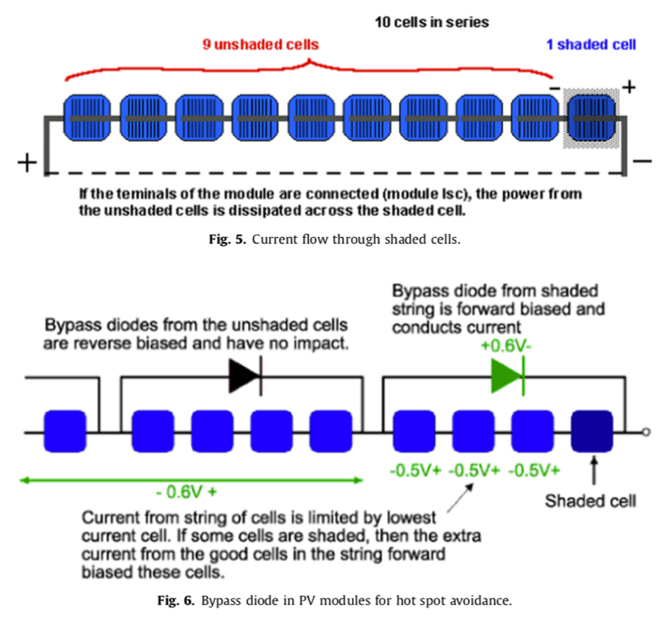

1. Current flow through partially shaded cells [4].



1. Implementation of bypass diode in PV modules to avoid hot spot effect [4].

Another scheme to prevent the formation of hot spot is to arrange the cell in such a way that partial shading would not have high influence the series of connected cell. For example, align the series of cell diagonally in the panel.

### Heat from the environment

Solar panels usually operate in the location which has relatively high ambient temperature. Heating of the solar panel is unavoidable. Thus, we need a reduce the heat from the panel as much as possible. In 2012, Ferrara and Philipp have done a one-year study on the degradation of opened and closed circuit solar panel that has been left in the sun for 360 days. The result of the study shows that the PV module of mono crystal silicon type when exposed to solar radiation, in open circuit condition, in a desert environment are visibly degraded compared with those connected to a charge (closed circuit), in identical weather conditions throughout the study. From Figure 6, we can observe the higher panel temperature throughout the day for the open circuit solar panel. The thermal cycles imposed on the PV module in this natural environment – characterized by large temperature variation – are considered as the principal factor of degradation.

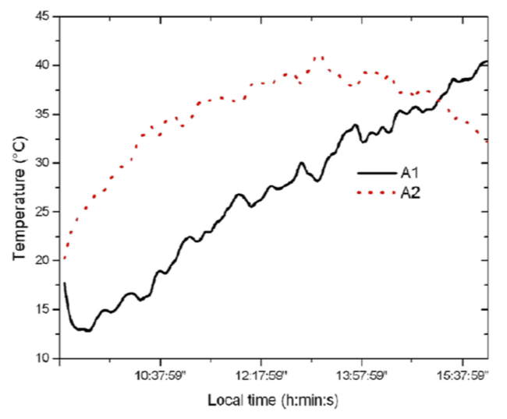

1. Changes in the temperature of modules for a day example (Nov 20th, 2015) [5], noted at A1 and A2 is close and open circuit solar panel respectively.

To explain the physical phenomenon that cause the open circuit PV module to experience more heat, we need to revisit the electron-hole generation process. The incident photons on the solar cell are processed according to their energy, according to the silicon gap (the width of the band gap Eg = 1.12 eV) which represents the absorption threshold. There are 3 possible cases, (1) If the energy of the photon incident Ephoton < 1.12 eV, this energy is insufficient to liberate an electron from the valence band; it passes through the material, releasing a portion of energy in the form of phonons, which causes the vibration of the atoms in the material in increasing its temperature. (2) If 1.12 eV ≤ Ephoton ≤ 1.77 eV, absorption of this energy by the crystal produces indirect transitions, not-radioactive, of electrons from the valence band to the conduction band, creating a free pair of charge carriers (electron – hole) because the silicon has the indirect gap. Finally, (2) If 1.77 eV ≤ Ephoton ≤ 4.13 eV, in this case the excited electron can pass vertically from the valence band (VB) to a minimum central from the conduction band (CB) and then to thermalize to the absolute minimum of (CB). This phenomenon of thermalization provides a thermal energy to the material which increases the temperature of the cell [5]. These phenomena are illustrated in Figure 3 as 𝜆long, 𝜆medium, and 𝜆short respectively.

Empirical study result is shown in Figure 7. The comparison of two solar panel which has the circuit opened and closed have been left in the sun for 360 days [5]. The result shows that performance of open circuit panel has dropped more than another panel both in term of current and voltage.

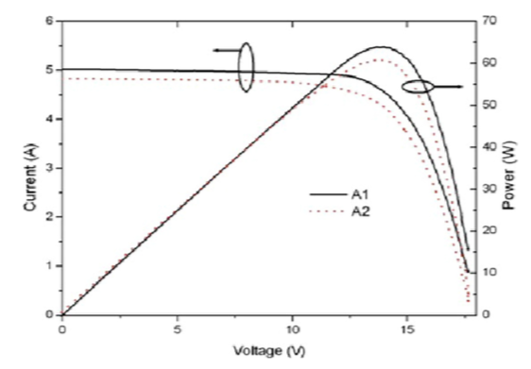

1. IV and PV curve of close circuit (A1) and open circuit (A2) solar panel that have been left in the sun for 360 days.

### Mechanical failure of PV modules

As the physical process of absorbing a photon and generate electron-hole pair need quite perfect condition for the process to take place. The exterior design of the solar panel and the installation are designed to support such process. From the mechanical aspect, PV module failure could be caused by many reasons. In this section we will discuss various factors that could affect the PV performance and the proposed solution on how to resolve the issues.

Snow and wind create different mechanical loads on PV modules. With a density from 30-50 kg/m3 (fresh snow) to 800-900 kg/m3 (frozen snow), snow is responsible for a heavy static load on the whole PV module depending on the height [2].

When hail or hailstones hit a PV module, the impact can damage the cover material or the active part of the module. This could contribute to high local impact on the performance of the PV module depending on their size and velocity. Lastly, sand and other smaller particles can abrade the glass or polymer surface of the solar panel and cause the cover to become unclear. This unclear glass or polymer could not let in as much sunlight as it should be. It can be seen that these factors can do permanent damages to the solar panel. Thus, the structure integrity and framing material used in PV modules are also crucial part to push for optimal performance of the panel throughout its lifetime.

Other two main factor that can cause mechanical failure is solar irradiation and chemical corrosions. Solar panels must be come in contact with direct sunlight. Thus, UV radiation cannot be avoided. It is important to take this factor into consideration when designing the frame or encapsulation of the panel. Polymers used in the manufacturing process should be able to stand such radiation. The failure in panel encapsulation could let humidity, water, or dust in the module and shorten the module lifetime or cause the module to become defective. PV modules installed close to roads and industries are exposed to certain types of gases, depending on the installation side. These gases, e.g. oxygen, nitrogen hydroxide, sulfur dioxide, nitrogen dioxide, chlorine, etc., alone or in combination with humidity (rain, fog, dew, etc.), can cause corrosion as for being acids (HNO3, HCl, H2SO4, etc.). The corrosion can also be accelerated by the heat on the module as well.

# Future directions and outlook

Long-term studies about solar panel degradation is highly needed. Lifetime prediction method is also needed to predict the future of solar panels. Along with those studies, the cause of PV module failures could improve the performance of solar energy production greatly. The newly manufactured PV module could learn from the failures and enhance the new modules that are coming out in the market by redesigning some part of it. The cause of failure can also lead to development of better maintenance procedure in solar panels. Finally, those studies are needed to be done in different regions of the world because different climate conditions affect the PV modules differently.

## Reducing the heat

One aspect to looking at solar panel heating is that currently we try to acquire the whole spectrum of the natural sunlight. Figure 8 illustrate how silicon material can only absorb some part of the photons [6]. The glass that cover the panel did not filter any wavelength away. The glass even has anti-glare coating to prevent light from reflecting away from the panel. This means unnecessary photons which has the unsuitable wavelengths for silicon-based PV to absorb were not reflected away. Those photons are then absorbed by other materials in the solar panel framing and generate unnecessary heat. If technique to reflect away some photons that does not have the suitable could be implemented, it could reduce the overall temperature of solar cell, and result in less thermal stress.

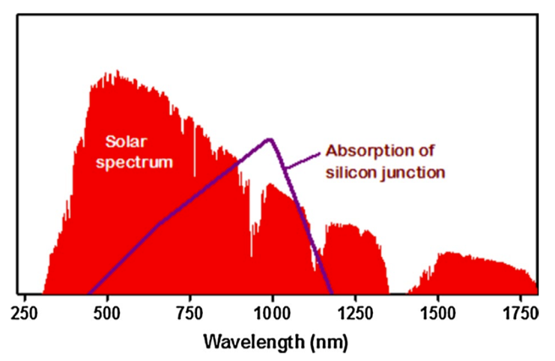

1. Natural sunlight wavelength distribution compare to absorption of silicon junction [6].

Another scheme to utilize the heat generated by sunlight is to use the heat and excess solar energy during the daytime to heat up water and store the warm water in for uses in the other time of the day. In other words, we cool could cool the panel down by some cooling system with excess energy we have. Figure 9 depict such cooling scheme which we could integrated into the solar panels. This is practical especially in household uses since the warm water is in demand and the PV module can generate excess power in the day time.

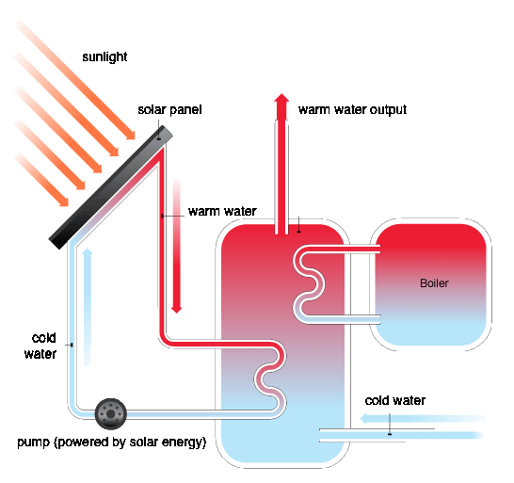

1. Schematic for utilizing heat from solar panels.

## Solar panel cleaning

Currently, one of the best and most practical way to clean the panel is use sprinkler system on the panel, however, the cleaning frequency could be varied greatly from daily to weekly depend on the local environment. In 2001 [7] there is a review of recommended cleaning cycle to mitigate impact of dust, weekly cleaning during dry seasons and daily washing recommended for intensive dust accumulation. Another way that is in use to date is manual cleaning where the disadvantages is that it needs workers and the panel surface may be scratched during the cleaning which will cause permanent damage to the panel. Lastly, rainfalls are free of charge but seasonally volatile. Thus, it is questionable to rely solely on this method to clean the PV module.

# Summary

In this paper we have discuss the importance of degradation of solar panel as a whole module. It is clear that advances in semiconductor technique and material alone may not be able to hold the PV technology up to the expectation of the PV users. Since the portion of solar energy is becoming larger than any other periods in the past, small drop in PV module’s performance would have a huge effect in overall efficiency. It is worth having a though about solar energy production in the magnitude of gigawatt-hour, with this magnitude, 20 percent drop in performance would have brought the power loss of megawatt-hour. The proposed solution to some of the failures could be further studies and it would result in energy production enhancement. Finally, it is also important to prolong the lifetime of PV module to minimize wastes from solar energy production as well.

##### Reference

[1] H. J. Snaith, “Present status and future prospects of perovskite photovoltaics,” *Nat. Mater.*, vol. 17, no. 5, pp. 372–376, 2018.

[2] C. Ferrara and D. Philipp, “Why do PV modules fail?,” *Energy Procedia*, vol. 15, no. 2011, pp. 379–387, 2012.

[3] T. Kurc *et al.*, “Scalable analysis of Big pathology image data cohorts using efficient methods and high-performance computing strategies,” *BMC Bioinformatics*, vol. 16, no. 1, pp. 1–21, 2015.

[4] M. R. Maghami, H. Hizam, C. Gomes, M. A. Radzi, M. I. Rezadad, and S. Hajighorbani, “Power loss due to soiling on solar panel: A review,” *Renewable and Sustainable Energy Reviews*, vol. 59. pp. 1307–1316, 2016.

[5] M. Boussaid, A. Belghachi, K. Agroui, M. Abdelaoui, and M. Otmani, “Solar cell degradation under open circuit condition in out-doors-in desert region,” *Results Phys.*, vol. 6, pp. 837–842, 2016.

[6] J. H. Han, S. H. Lee, B. K. Ju, B. R. Yoo, S. H. Cho, and J. S. Han, “Lanthanide complexes embedded in silicone resin as a spectral converter for solar cells,” *Res. Chem. Intermed.*, pp. 1–12, 2018.

[7] E. Asl-Soleimani, S. Farhangi, and M. S. Zabihi, “The effect of tilt angle, air pollution on performance of photovoltaic systems in Tehran,” *Renew. Energy*, vol. 24, no. 3–4, pp. 459–468, 2001.

Supplementary Figure

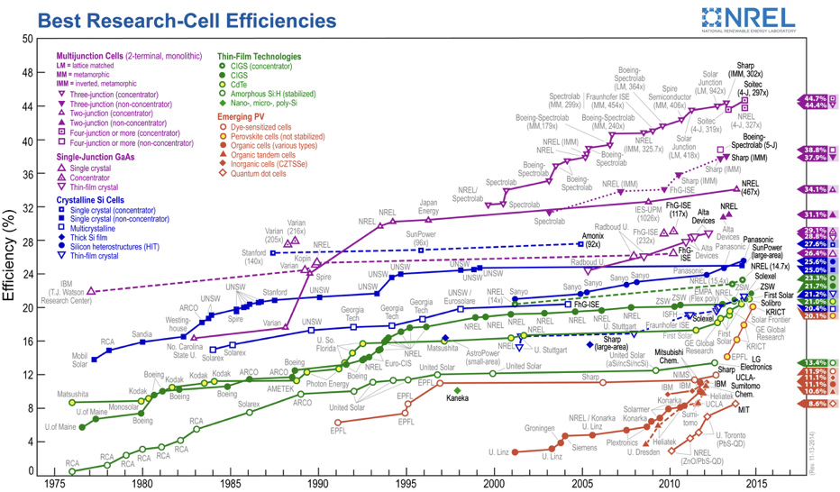

1. Development of different solar cell technology and its power conversion efficiency from 1976 to 2014.