Active-Matrix Organic   
Light-Emitting Diode Display

Final Report, Semiconductor and Lighting Technology 2018

Pargorn Puttapirat (*ID 3117999011*)

Department of Computer Science and Technology, School of Electronic and Information Engineering  
Xi’an Jiaotong University, China  
pargorn@stu.xjtu.edu.cn

*Abstract*— This paper discusses the development of display technology from the very beginning of color display technology such as CRT to modern display technology which is AMOLED display. We have introduced and discussed about each crucial revolutionary step that lead to AMOLED technology. Along the history, display has overcome issues about brightness, power consumption, color reproduction, screen flickering, and so on. Standard matrices used to determine the quality and performance of the display are also introduced such as resolution, brightness, and response time. Finally, we discuss about the advantages and disadvantages of AMOLED display among current competitors including PMOLED display and LCD. The current application of AMOLED display is in mobile devices where it has brought many new functionalities to the device such as in-screen touch sensor and always-on display. However, there are still open issues about AMOLED that has to be resolved so it could be applied in both small and big screen devices.

Abbreviations — Cathode ray tube (CRT), Light-emitting diode (LED), Organic light-emitting diode (OLED), Liquid crystal display (LCD), Thin-film Transistor (TFT), Active-matrix organic light emitting diode (AMOLED), Passive-matrix organic light emitting diode (PMOLED)

# Introduction and Background

Display is a crucial part of most modern electronic devices that need to interact with human users. These devices include stationary devices such as television or desktop computer and mobile devices such as smart-phones, tablets, and smart-watches. The main goal of display technology is to visualize information and present it to human eyes. Displays should be able to display information as if it is the real object in the real world, therefore it must be able to reproduce all colors that human eyes could see, present the image in all viewing angles, and be able to change the content on the display with robustness when needed. Other challenges to manufacture the display are common engineering problems such as resource consumption – in display this would be power consumption, its profile or form factor, and manufacturing cost.

The Active-matrix organic light emitting diode (AMOLED) is a relatively new type of display technology. It has been introduced within the last decade. The AMOLED technology relies on two main recently developed technologies which are active-matrix (AM) scheme or thin-film transistor (TFT) and organic light-emitting diode (OLED). The TFT is an application of thin-film fabrication technique which allows the controlling matrix of the display to become much thinner, this factor has enable the development of TFT as a controlling matrix for small and then mobile devices [1]. An OLED is an LED that can emit specific color of light that is suitable to be the primary colors. While it is a challenging task to create LEDs that emit preferred color spectrum, OLED can perform this very well. There is an effort to use quantum dots to create LED that emit specific color by varying the size of the dot, however, it is still a challenge to manufacture many quantum dots of the same size in large-scale production [2]. Thus, OLED is a technology of choice for the next generation display for the time being. With OLED technology, the display does not require backlighting anymore because the OLED itself can generate photons of the correct wavelength directly. Not only that it simplifies the working architecture of the display, but it also consumes less power because the light does not need to be filtered which will cause losses in brightness.

# Evolution of the displays technology

To best introduce the AMOLED display, it is better to understand the working principle of previous generation of displays as a baseline for comparison. In this paper we categorize the displays into three generations by mainly considering three important aspect of the display which is light source, color reproduction component, and controlling matrix as the summary shown in Table 1. The first generation of color display is CRT display luminescence is cause by electron particle stimulating the phosphor screen. The process happens pixel by pixel at a very high rate so human brain could see the image on the screen. This kind of display is obsolete, it is not manufactured anymore. The full diagram showing how CRT display work is depicted in Figure 1.

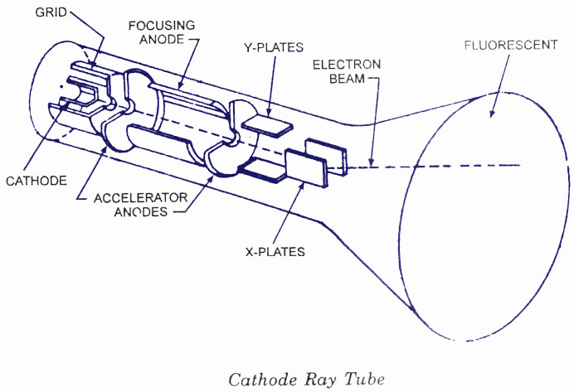

1. Diagram showing how CRI display work. (taken from *http://www.circuitstoday.com/crt-cathode-ray-tube)*

After the CRT display, LCD displays take over the market. There are many generations of LCD varying by both the light source and controlling matrix. For the light source, LCD has evolved from cold cathode fluorescence lamps (CCFL) which has high power consumption and provide ununiformed light source compare to LED backlight (create the term LED-LCD display) which is more power efficient and have better light uniformity. Both backlight provide white light and the schematic is shown in Figure 2. LCD displays rely on the backlight together with polarizer filter to get polarized light. The polarized light is then used with the liquid-crystal layer which is another adjustable polarizer to control the amount of light passing through each color filter (sub pixel). When white color is needed, the controlling matrix orient the crystal so that light can pass through the layer, and otherwise when black screen is needed. The orientation in between can adjust each subpixel individually, so the display can reproduce color. The passive- and active-matrix in LCD is developed respectively.

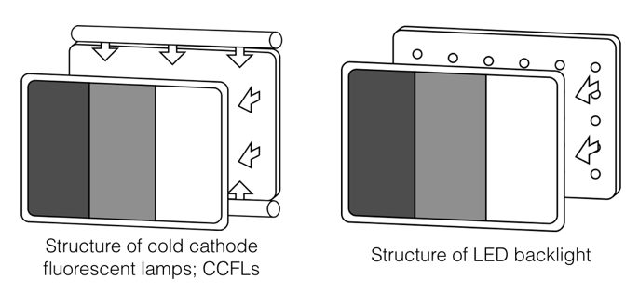

1. Layout comparison of cold cathode fluorescent lamps (CCFLs) and LED backlight. (https://en.wikipedia.org/wiki/Backlight)

The passive-matrix work by turning each pixel on and off very fast line by line to display an image. Robust response in the liquid-crystal is needed, however, it is not as robust as LED. Therefore, LCD technology is limited by this factor. Later, the development of active matrix in LCD is made to better control the orientation of the liquid-crystal provides less screen flickering. Both techniques are later used with OLED technology therefore we have both PMOLED and AMOLED displays [3].

1. Summary of major display technology and its major working component.

| Display type | Major component | | |
| --- | --- | --- | --- |
| Light source | Color representation | Controlling matrix |
| CRT | Electron gun (not a direct light source) | Phosphor screen | Vertical and horizontal electromagnetic field |
| LCD | CCFLs and LED backlight | Liquid crystal | Passive- and active-matrix |
| AMOLED | OLED | OLED | Active-matrix |

Finally, to make the concept clearer, we could compare active-matrix LCD with AMOLED to see the difference between the two technologies. Figure 4 illustrate the structure of both displays. It is clear that AMOLED has simpler structure. It works by electrical signal from TFT matrix at the bottom which supply the current to OLED layer. The light from OLED is then emitted through some polarizer, thus, this scheme emit light more directly to the user. The components of the LCD consist of backlight which generate brightness of the display that has to sine through TFT and liquid-crystal layer that filter some photons away. Therefore, in this scheme, the light has to go through several filters before it reaches user’s eyes.

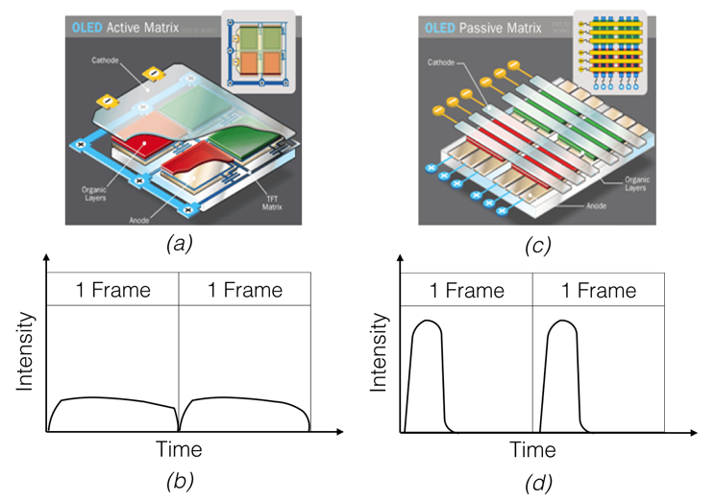

1. Comparison of structure of active matrix (a) which has dedicate transistor for each subpixels and passive matrix (b) together with its characteristic where active-matrix has more consistent output (b) and passive-matrix use fast light flickering (d).

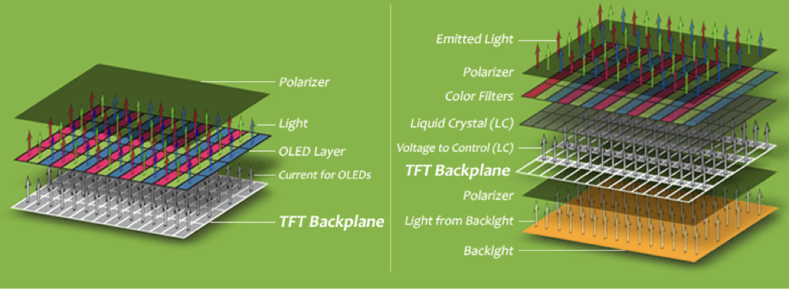

1. Structure comparison of AMOLED and AM-LCD display. (taken from *http://www.geosumtech.com/product.html?url=product_AMOLED-what.html)*

Furthermore, the subpixels arrangement in AMOLED and PMOLED display has become a concern since green OLED could produce more brightness and blue OLED tend to degrade faster than the other colors. There are several way manufacturers overcome this challenge by arrange the subpixel differently. Several examples are shown in Figure 5. The general idea is to devote smaller region to green OLED and more to other colors. Bigger blue OLED may also be used to enhance blue color when the color has fade away from long time usage.

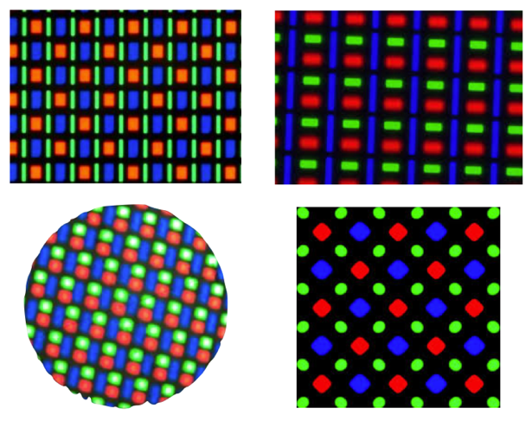

1. Example of subpixels arrangement in AMOLED displays

# Key Matrices

Different parameters are need for display quality assessment. While each different parameter has its own property and objective(s). The ultimate goal of the display is to best mimic the scene we can see in the real world with lowest resources possible. It is worth to further explain this goal to clarify some misconceptions about good display. To be able to display the images as real as the nature, the display should be able to reproduce the full color spectrum that human eyes could see with full range of brightness. Today’s best display still cannot cover the whole color spectrum as we can see in (Figure …). In term of resource consumption, the display should take smallest profile such as becoming thinner and flexible. It should also consume less power. One strange thing about display technology is that it does not have to get smaller all the time. Some aspect of display development needs the display to get bigger. The typical unit for each matrices are shown in Table 2.

1. Typical Unit of Key Matrices for AMOLED Display and Other Display Technologies

|  |  |
| --- | --- |
| Matrices | Unit |
| Brightness | cd/m2 |
| Resolution | (1) pixels (usually given in m by n where m is the vertical and n is horizontal number of pixels)  (2) dot per inch (dpi) or pixel per inch (ppi) |
| Color support | Report can be given as a CIE color map/gamut diagram or percent of coverage of the color in CIE color map. |
| Response Time | ms |
| Refresh Rate | Hz |
| Contrast Ratio | x:y |

## Brightness

Brightness is the quality or state of the display giving out light. Better displays can give out more light and can work well with all environment (for example, in-door and out-door). Typical maximum brightness of the display is around 200 cd/m2.

## Resolution

The resolution of the display reflects two main aspect of the display which is (1) how many pixels one display has and (2) how densely packed is the pixels in the display. The number of pixel in the display is limited by the controlling matrix because the display that has more pixels will require more time to refresh one frame. If there are too many pixels one display, it will be more challenging to refresh all of the pixels. The pixel density of the display reflects the size of the pixel that can be achieved. To manufacture the display with denser pixels, the size of the pixel need to be smaller. The trend of better resolution is (1) more pixels with larger display and (2) denser pixel density.

## Color Support

The color that the display can reproduce is related to color support. To consider the maximum possible color that one display, we can turn to the spectrum of wavelength that human eyes can see. If the display can reproduce every color that human eyes can see, then it can be said that the display have a very good color support. Currently, it is still a challenge to manufacture a display that can support wider range of color. A comparison of color support for each technology can be seen in Figure 6.

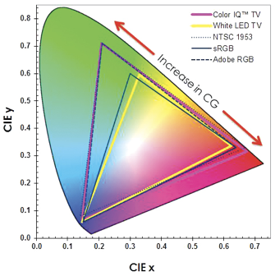

(a)

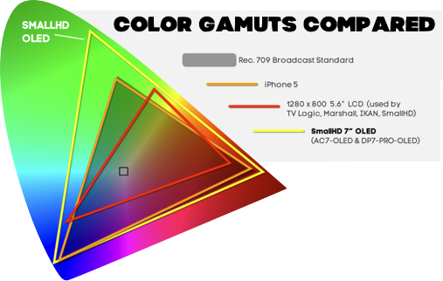

(b)

1. (a) CIE lab colormap/color model standard. This standard represents the color spectrum that human can see. (b) Comparison of color support for LCD display in LCD TV (red triangle), LCD display on smartphone (orange triangle), and OLED TV (yellow triangle).

## Response Time

The amount of time when the electric current is applied to the OLED and the time when OLED has lit up and the other way around is the response time. Better display will have shorter response time.

## Refresh Rate

Refresh rate is the rate where the display can show new set of pixels on the screen. Faster refresh rate is considered to be better.

## Contrast Ratio

Contrast ratio is the ratio between intensity of bright light produce by the display and the deepest black that the display can perform. OLED displays have much better contrast ratio compare to LCD screen because it does not require backlight.

## Others

Other matrices for the display is for it to become more power efficient, have smaller profile while can be manufactured in large-size, and have a good framing (anti-glare coating for example).

# Advantages and Disadvantages

## Advantages

### No screen flickering

Currently, human eyes (and brain) can be fully aware of light flickering at the frequency lower than 60Hz. Therefore, if the display can achieve the refresh rate higher than 60Hz then the user would not notice it. Passive-matrix OLED rely on the mentioned fact to operate. However, there are no conclusive fact about how this flickering screen affect human eyes. If it does have some bad medical effect, active-matrix technology would have been put in place. However, for the time being, development trend in display is still pushing for higher refresh rate. AMOLED display does not have to consider this factor so much because each pixel has an on-off switch. Therefore, it does not have flickering effect. This result in display that would not have flickering effect even if the refresh rate is low. This could lead to better power consumption rate in the aspect of energy wasted in processing of screen refreshes.

### Faster response time

AMOLED and PMOLED displays have faster response time than LCD displays because the OLED can be lit up faster than the orientation process of liquid-crystal. Therefore, with the same controlling matrix, the display that is based on OLED would have a better response time than the liquid-crystal based. It should be mentioned that currently some commercial LCD display may have better response time than OLED-based display. This is the case because to measure the total response time of the display, we need to take both controlling matrix (or drive circuit) and the layer of color reproduction in to consideration. In some cases, OLED display on mobile device use optimized screen refresh rate to reserve the battery power, therefore, it has lower response time.

## Disadvantages

### Short lifetime

Due to the nature of OLED which is based on organic materials, the OLED devices have shorter lifetime compare to its LED predecessor which use inorganic materials [4]. During the operation of the device, heat is generated and degrade the organic material faster than inorganic material because inorganic material is prone to heat. Heating from other component in the device such as battery on the smartphones could shortened the lifetime of OLED display as well.

### Screen burn-in

Another disadvantage of all OLED displays including AMOLED and PMOLED is screen burn-in. This phenomenon occurs when a pixel or a group of pixels is instructed to turn on for extended period of time and they did not turn off completely – turn back to black color. This results in ghost images on the display. This phenomenon also occurs in other kind of display as well, mainly CRT display. There are no physics solution to this problem yet because it is due to the nature of organic material. However, there is a work around where the manufacturer would program a software for the display to move the content on the display in a small step, so the user would not notice the change but the pixel on the display does not have to turn on for a long period of time.

### Color over-saturation

Because of high contrast ratio and more vibrant light emitted from the OLED, images displayed on PMOLED and AMOLED displays look unrealistic and over-saturate compare to LCD displays. This issue could be resolved by fine-tuning the display during the calibrations and adjusting image processing part of the display.

### Foldable, flexible, and transparent screen

Since the OLED is manufactured by thin-film growing or depositing the material on the substrate, it is possible to manufacture a very thin layer of OLED. Furthermore, the nature of organic material of OLED result in lower temperature in the growth process. This factor allows polymers to be used as a material for substrate [5]. As a result, flexible active- and passive-matrix OLED display can be manufactured. Example of such screen is shown in Figure 7. Also, without limitation that the substrate must be silicon-based, transparent display could be achieved as well, the example is shown in Figure 8, while its useful application is still a debate [6].

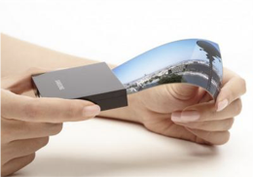

1. Example of flexible AMOLED display.

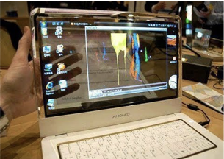

1. Example of transparent display.

# Applications

The obvious application of AMOLED displays is to be used in mobile devices. AMOLED displays have the properties best fit for mobile devices such as smart phone in many aspects including its high resolution, densely packed pixels, low power consumption, thin profile, high brightness with vibrant color, and its flexibility – for specific purpose such as curved screen for smartwatches to curve over the wrist. Also, its limitations do fall in the category that was not required by mobile devices such as large screen manufacturing. Currently, it is challenging to manufacture large AMOLED display due to cost. AMOLED’s short lifetime also plays good role with smartphones because the smartphone’s display is not designed to be turned on all the time. Thus, it could last long enough to work properly on such devices.

Always on display is possible with OLED based displays because since there are no backlight, it is efficient to turn on just some part of the display. Thus, always on display is possible with reasonable energy consumption. The application of such functionality is to display time on smartphones as shown in Figure 9.

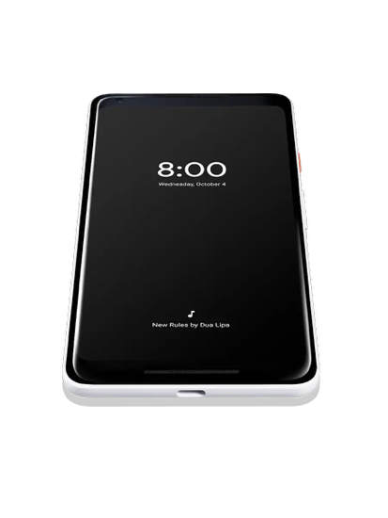

1. Example of always-on functionality on Google Pixel 2.

Currently, LCD displays dominate large screen market because of high OLED cost. However, if the cost has come down to economically feasible point, AMOLED displays should be a great alternative.

# Outlook

The demand of better display in electronic devices is very high because display is a crucial part that connects the human user to any electronic devices. Displays will be used to show information to the user. Any better display technologies will be commercialized very rapidly. Therefore, much research is done in the commercial research and development unit and result in less publications in the academic research community.

The main goal of visualization technology does not limit to displays. We are still trying to transfer visual information to be able to interact with human brain in other ways as well. The example would range from virtual reality goggles which enables 3D experiences and it still based on matrix of pixels, virtual retinal display where the device shine light directly into human eyes, to neural-based technology where we directly interact with human electrical brain signal directly.

# Conclusion

Display technology has come a long way from CRT displays to AMOLED. We are able to get closer to more realistic image representation on displays and we are currently on the edge of 2D display technology. There are still room for improvements in this display technology with the goal that the device could fully connect with the human user as we have discussed in the outlook section. From the evolution of display technology that we have discussed thus far, we can see that AMOLED display technology has come in the right direction with improvement in all aspects in the key matrices. It has become more power efficient, thinner, and be able to reproduce better color therefore represent more realistic images.

##### References

[1] A. Nathan, G. R. Chaji, and S. J. Ashtiani, “Driving schemes for a-Si and LTPS AMOLED displays,” *IEEE/OSA J. Disp. Technol.*, vol. 1, no. 2, pp. 267–277, 2005.

[2] H. J. Kim and B. D. Chin, *Technologies for AMOLED Displays*, vol. 27, no. 2. 2013.

[3] R. Deshpande, O. Pawar, and A. Kute, “Advancement in the technology of organic light emitting diodes,” in *2017 International Conference on Innovations in Information, Embedded and Communication Systems (ICIIECS)*, 2017, pp. 1–5.

[4] K. Oh, S.-K. Hong, and O.-K. Kwon, “Lifetime Extension Method for Active Matrix Organic Light-Emitting Diode Displays Using a Modified Stretched Exponential Decay Model,” *IEEE Electron Device Lett.*, vol. 36, no. 3, pp. 277–279, Mar. 2015.

[5] X. Huang, K. Hu, L. Lin, Q. Shan, X. Yang, and X. Gao, “33-1: Invited Paper : Development of AMOLED Display: From Rigid to Flexible,” *SID Symp. Dig. Tech. Pap.*, vol. 47, no. 1, pp. 412–414, 2016.

[6] J. hyuk Lee, H. D. Kim, C. H. Lee, H.-J. Chung, S. C. Kim, and S. S. Kim, “The technological trends of future AMOLED,” no. August, p. 74150O, 2009.