Simple text. **Bold text**. *Italic text*. ~~Strike text~~. Red text. **Glowing text**. Text with

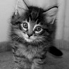carriage return. This text will be inserted into a numerating list with an image

The sun shines as it has never shone. This sentence is wrong, can you tell me why?