
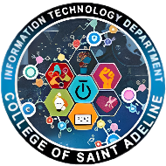
DATAMEX COLLEGE OF SAINT ADELINE - PARAÑAQUE
8167 Dr. A. Santos Avenue, San Dionisio, Parañaque City
Bachelor of Science in Information Technology

In Partial Fulfillment in E-Business

“TarotKnight: E-Commerce Website with Online Payment Integration”

Submitted By:

Marcial Lawrence Jr V. Caronan
Jhay L. Castro
Tyron John L. Dela Cruz
Kerr Cassel Pangan
Kaye Emmannuele Nercua

Instructor Name:
Mr. Randy Villanueva

ABSTRACT

The TarotKnight Crystal Art project represents an extensive and sophisticated digital transformation, effectively migrating a traditional, niche artisanal craft into a highly advanced, dual-purpose ecosystem that harmonizes e-commerce retail with a professional service-scheduling infrastructure. This ambitious initiative was born from an essential necessity to provide both spiritual practitioners and crystal enthusiasts with a centralized, "all-in-one" digital sanctuary. By doing so, the platform successfully bridges the historical gap between the tactile world of physical retail and the ethereal realm of spiritual consultations. The system’s architecture is meticulously engineered to handle the intricate and delicate nuances associated with the sale of handcrafted jewelry—specifically focusing on artisan wire-wrapped pendants, bracelets, rings, and earrings—while simultaneously maintaining a high-precision, real-time booking calendar dedicated to sensitive spiritual services such as Tarot divinations, energy cleansing sessions, and holistic crystal healing.

In its current sophisticated operational state, the platform moves far beyond the limitations of simple, static web listings by implementing a high-performance, fully responsive storefront. This interface is designed to adapt fluidly and elegantly to a vast array of user devices, from high-resolution desktop monitors to mobile smartphones, ensuring a premium user experience regardless of the hardware used. A foundational pillar of the system is its robust and seamless financial integration; by leveraging the advanced capabilities of the PayMongo API, the platform has successfully transitioned away from outdated, manual, and error-prone payment verification methods toward a fully automated, high-security transaction model. This technological leap ensures that every single purchase and service booking is validated instantaneously through secure webhooks, providing immediate peace of mind for the modern consumer while establishing streamlined, hands-free operational workflows for the system administrator. Furthermore, the inclusion of a dedicated, feature-rich user portal allows customers to engage deeply with the brand’s identity through personalized profiles, completely transparent order histories, and a direct, secure line of communication with the practitioner.

Moreover, the entire system is anchored by a high-level, comprehensive Administrative Control Center that empowers the business owner with profound, data-driven insights. This backend infrastructure provides the administrator with granular, surgical control over inventory levels, allowing for real-time stock adjustments and dynamic category management to effectively prevent the logistical nightmare of overselling unique, one-of-a-kind items. Beyond simple inventory tracking, the admin panel serves as a centralized hub for exhaustive financial reporting, appointment calendar management, and customer relationship moderation. By strategically integrating modern, industry-standard web technologies—such as PHP for complex server-side logic, MySQL for robust data persistence, and a cutting-edge AI-powered Knowledge Base for automated, intelligent customer assistance—TarotKnight Crystal Art stands as a definitive testament to the practical and powerful application of modern e-business principles within a digital-first, 21st-century marketplace.

INTRODUCTION

Background of the Study

In the contemporary global landscape, electronic business—commonly referred to as E-business—has undergone a profound and rapid transformation, migrating from a high-cost luxury reserved exclusively for massive multinational corporations into an absolute and non-negotiable survival requirement for small-scale, niche enterprises. Within the specific socio-economic context of the Philippines, the recent and dramatic surge in digital literacy, coupled with the near-universal adoption of mobile banking and digital wallets, has fostered a sophisticated consumer base. These modern consumers now demand instant gratification, seamless navigation, and highly professional digital interfaces as a baseline for trust. For a specialized and artisanal venture such as TarotKnight Crystal Art, reliance on a fixed physical location severely restricts growth by limiting potential reach to local foot traffic alone; conversely, the implementation of a comprehensive, web-based platform effectively dissolves all geographical barriers. This digital expansion empowers a spiritual practitioner to provide high-quality service to clients across the diverse islands of the Philippine archipelago at any hour of the day or night, irrespective of physical distance. Consequently, this strategic shift toward a dedicated digital storefront provides an unparalleled level of convenience for users, allowing them to browse energetically charged artifacts or schedule a transformative healing session without being tethered to the rigid constraints of traditional "brick-and-mortar" business hours.

The architecture of the current system is specifically engineered to address a glaring and significant gap in the contemporary market, where the vast majority of small-scale spiritual practitioners and sellers still rely on fragmented, decentralized social media platforms to conduct their daily business operations. These traditional, "manual" methods of commerce—often characterized by "direct messaging" for orders—frequently result in disorganized record-keeping, the high probability of missed orders, and significant security vulnerabilities during the payment phase. By centralizing the entirety of the business logic into a single, custom-built web application, this study explores the innovative ways in which a unified, relational database can efficiently manage two distinct and seemingly disparate revenue streams: the retail sale of physical crystal products and the scheduling of time-based spiritual appointments. This structural integration is vital to the business model because it facilitates the creation of a "sticky" and holistic ecosystem. In this environment, a customer may navigate the site to purchase a handcrafted crystal pendant and, recognizing the synergy of the platform, immediately book a professional cleansing session to energetically charge that specific item—all occurring within the confines of a single, fluid user session and a unified payment flow.

Furthermore, the technical foundation of this extensive study places a rigorous focus on the enhanced reliability and scalability of fully automated systems when compared to traditional manual intervention. The seamless integration of the PayMongo API serves as a critical and highly relevant case study in modernizing financial workflows; specifically, it replaces the cumbersome and high-risk process of manual GCash reference number verification with instantaneous, webhook-based transaction confirmations. This technological transition does far more than simply enhance the user experience by providing immediate psychological feedback and confirmation; it fundamentally secures the business against the rising tide of fraudulent payment claims and "screenshot-based" scams. Through the methodical development and deployment of TarotKnight, this study provides a definitive demonstration that by applying structured web development frameworks and rigorous database management protocols, even a small-scale, specialized craft business can achieve the sophisticated operational efficiency and transactional security typically associated with large-scale, enterprise-level e-commerce platforms.

Objectives

Project Objectives

The architectural development and strategic implementation of the TarotKnight Crystal Art platform are strictly guided by a comprehensive set of specific, measurable, achievable, relevant, and time-bound (SMART) goals. These objectives are meticulously designed to ensure that the final system not only meets the aesthetic and functional expectations of a high-end spiritual brand but also adheres to the rigorous technical requirements of modern, secure e-commerce and service-based software engineering.

- Thematic Brand Development and Aesthetic Identity: One of the primary objectives is to architect a highly immersive, "spiritual-themed" digital storefront that transcends the typical retail experience. By utilizing a premium and sophisticated color palette—dominated by deep Indigo and Harvest Gold—the interface is designed to visually articulate the high-end, artisanal nature of handcrafted crystal art. This thematic consistency ensures that the user feels a sense of sacred space and professional credibility from the moment they enter the landing page.

- Dynamic Product Diversity and Catalog Management: The project aims to create a versatile and high-performance digital catalog capable of managing a wide array of distinct jewelry categories, including wire-wrapped pendants, bracelets, rings, and earrings. This system is engineered to support high-resolution imagery and rich, detailed descriptions for every individual piece. By providing such granular detail, the platform compensates for the lack of physical touch, allowing customers to appreciate the intricate craftsmanship of each energetically charged artifact before making a purchase.

- Seamless and Automated Financial API Integration: A critical technical objective is the implementation of the PayMongo API as the universal and exclusive gateway for all financial traffic. This move is designed to eliminate the inefficiencies of manual intervention by providing a singular, highly secure portal that supports a broad spectrum of modern Philippine payment methods, including GCash, Maya, and major Credit/Debit cards. The goal is to facilitate an automated "Pay-and-Confirm" workflow that updates order statuses instantaneously upon successful transaction verification.

- High-Precision, Real-Time Appointment Scheduling Engine: Beyond retail, the project seeks to build a sophisticated service booking engine specifically tailored for spiritual consultations. This system is designed with rigorous backend logic to prevent the possibility of double-bookings or scheduling conflicts. It allows users to browse available time slots in real-time, enabling them to select specific dates and hours for Tarot readings or healing sessions that align with their personal schedules, thereby optimizing the practitioner's time management.

- Robust User Data Protection and Enhanced Security: To foster a relationship of trust with the consumer base, the system is committed to providing top-tier encrypted authentication protocols. This objective ensures that sensitive customer data, personal contact information, and confidential purchase histories are shielded from unauthorized access. By implementing secure session handling and password hashing, the platform guarantees that every user’s digital footprint within the TarotKnight ecosystem remains entirely private and secure.

- Comprehensive Administrative Oversight and Analytics Hub: A vital goal is the development of an all-encompassing Administrative Dashboard that serves as the central "nerve center" for the business owner. This interface is designed to provide real-time monitoring of critical business metrics, including total revenue streams, inventory stock-out alerts, and live appointment calendars. By consolidating this data into a single, intuitive view, the admin panel empowers the practitioner to make informed, data-driven decisions regarding stock replenishment and daily operational scheduling.

- Interactive Multi-Channel Communication and AI Support: Finally, the project aims to bridge the communication gap through a direct, real-time chat system between users and the administrator. This is further enhanced by the integration of an AI-powered Guide, which is programmed to provide instantaneous spiritual insights and basic information based on a pre-defined, specialized knowledge base. This objective ensures that customers receive immediate engagement and support, even when the human administrator is unavailable, maintaining a constant presence in the digital marketplace.

Scope and Limitations

The operational boundaries of the TarotKnight Crystal Art system are defined by a comprehensive suite of features designed to facilitate a seamless transition from product discovery to post-purchase engagement. This section outlines the specific breadth of the system’s capabilities as well as the deliberate technical constraints that define its current development phase.

Scope of the System

The current iteration of the system is architected as a fully functional, end-to-end digital ecosystem that meticulously manages the entirety of the customer journey within a unified environment. From the initial moment a user arrives on the thematic homepage, the system provides a sophisticated interface where they can filter handcrafted products by specific categories, view individual items in a high-detail layout, and manage selections via a persistent shopping cart that retains data throughout the session. For those seeking spiritual guidance rather than physical artifacts, the system offers a dedicated, service-oriented booking interface where spiritual consultations are presented with transparent, fixed pricing and a real-time selection of available time slots.

The specific high-level features included within this scope are:

- Comprehensive Client-Facing Interface: The platform features a sophisticated multi-page navigation system that includes the primary Storefront (Shop), the Service Booking Hub, a User-Generated Review Portal, and a Real-Time Consultation Chat. Each page is designed with a consistent "Spiritual" aesthetic to maintain brand immersion.

- Automated Payment Ecosystem: A central pillar of the system is its full integration with the PayMongo API. This allows for a frictionless, instant checkout experience that supports modern Philippine e-wallets and credit cards. The system handles automated status transitions, moving orders from "Pending" to "Paid" or "Confirmed" immediately upon successful API callback, thereby eliminating manual verification delays.

- Live Consultation and AI-Enhanced Portal: Through the contact_admin.php interface, the system provides a real-time messaging environment. This portal allows users to transmit text and media files to the practitioner, while simultaneously benefiting from an integrated AI Knowledge Logic that provides instantaneous, automated responses based on spiritual keywords and pre-defined data.

- Centralized Account and History Management: To ensure user transparency, the system includes a "My History" section where customers can track the lifecycle of their specific crystal orders or the schedule of their upcoming spiritual sessions in a unified, chronological view.

- Full-Scale Administrative Management Suite: The backend provides the business owner with a complete set of CRUDS (Create, Read, Update, Delete) tools. This empowers the admin to dynamically manage the product catalog, adjust service descriptions, monitor real-time revenue, and oversee the entire scheduling calendar from a secure dashboard.

Limitations of the System

Despite its robust feature set and professional-grade infrastructure, the TarotKnight system currently operates within a specific set of technical and logistical constraints that are inherent to its present version:

- Logistics and Shipping Automation Constraints: While the system is programmed to display J&T Express as the primary shipping partner and calculate baseline fees, it does not currently feature a direct API hook for real-time GPS parcel tracking. Consequently, the administrator must manually procure and input the tracking numbers into the system after the physical shipment has been dispatched.

- Financial Sandbox Environment: During this terminal phase of development and demonstration, the payment ecosystem may remain configured in "Sandbox" or "Test Mode." This requires the use of simulated test cards and accounts to demonstrate the checkout flow, as live bank settlements are restricted to the production environment.

- Simplified Inventory and Variant Logic: The current database architecture does not support "multi-variant" product grouping (for example, offering a single ring listing with a dropdown menu for multiple sizes). In the present system, each unique physical item must be listed as an individual product entry with its own dedicated stock count and description.

- Third-Party Dependency: The system’s real-time confirmation functionality is entirely dependent on the uptime and response latency of the PayMongo external servers; any downtime on the provider's side may temporarily delay the automated transition of order statuses.

SYSTEM OVERVIEW

System Architecture

The structural framework of the TarotKnight Crystal Art platform is engineered upon a classic and highly disciplined 3-Tier Web Model. This architectural paradigm is strategically employed to ensure a strict "Separation of Concerns," wherein the presentation layer, the computational logic, and the data persistence layers are decoupled into distinct, independent tiers. This sophisticated organization not only facilitates significantly easier long-term maintenance and modular updates but also fortifies the system's security by ensuring that each layer operates within its own specific functional boundaries.

- Presentation Tier (Frontend Interface): Acting as the primary point of entry for the consumer, this tier is meticulously crafted using a combination of HTML5, CSS3, and JavaScript to render a high-fidelity, spiritual-themed user interface. This layer is responsible for translating complex data into a visually immersive and aesthetically pleasing experience that reflects the brand’s identity. Beyond mere visual rendering, the Presentation Tier manages all client-side interactions—such as form validations, dynamic price updates, and responsive layout adjustments—while serving as the gateway that captures user inputs and transmits them as structured requests to the server for processing.

- Application Tier (Server-Side Logic & Processing): Serving as the "Engine Room" or the core intelligence of the system, this tier is powered by PHP 8.x. This layer is where the critical business logic and decision-making processes reside. It is responsible for the heavy lifting of the system, including the management of persistent shopping carts, the precise calculation of totals (inclusive of shipping and service fees), and the orchestration of secure API handshakes with the PayMongo gateway. Furthermore, this tier houses the logic for the AI Knowledge Base, analyzing incoming customer inquiries in the consultation portal to determine and generate appropriate automated responses in real-time.

- Data Tier (Database & Storage Management): Functioning as the definitive "Brain" or long-term memory of the entire platform, the Data Tier is managed by a MySQL Relational Database. This tier is responsible for the secure storage, retrieval, and structural integrity of all organizational records. It houses a complex schema of interconnected tables that store sensitive user credentials, the dynamic product catalog, real-time appointment calendars, and the historical archive of customer reviews. By centralizing all data in this secure repository, the system ensures that every user action—from a crystal purchase to a scheduled Tarot reading—is accurately logged, persistent, and readily accessible for administrative oversight.

Data Flow Process

The operational lifecycle of a single interaction within the TarotKnight Crystal Art ecosystem is governed by a rigorous and sequential data flow. This movement of information ensures that every user action is captured, processed, and recorded with absolute precision, maintaining the integrity of both the retail and service-based business models.

- Discovery and User Interaction Phase: The process begins at the Presentation Tier, where the user actively engages with the frontend interface. During this stage, the system handles dynamic requests as the user navigates through the curated collection of artisanal crystals or evaluates the various spiritual consultations available. Whether filtering by jewelry category (pendants, bracelets, etc.) or checking time-slot availability for a Tarot reading, the frontend serves as the primary data collector, gathering user preferences and preparing them for server-side submission.

- Transaction Initialization and Backend Logic: Upon the user’s decision to proceed to the checkout, the Application Tier (PHP 8.x) takes control of the data flow. The backend logic immediately generates a unique, non-repeating identifier—either an order_id for physical goods or a booking_id for spiritual services. Simultaneously, the system calculates the final financial obligations and initiates a secure API handshake with the PayMongo gateway, transmitting a structured payment request that includes the total amount and the unique transaction metadata.

- External Validation and Secure Payment Processing: At this critical junction, the data flow exits the local environment and enters the secure infrastructure of the PayMongo payment portal. The user is redirected to a high-security environment to complete their transaction via E-wallet or Credit Card. Once the payment is successfully processed, PayMongo’s servers generate an encrypted "Success" signal (callback), which is transmitted back to the TarotKnight website’s listener script. This external validation acts as the definitive proof of purchase, ensuring that no manual receipt verification is required.

- Automated Database Synchronization and Status Update: Upon receiving the successful validation signal, the system triggers an immediate and automated update within the Data Tier (MySQL). The relational database locates the specific record associated with the transaction and performs a status transition. For physical retail items, the order status is elevated from "Pending" to "Paid," whereas spiritual services are transitioned to "Confirmed." This automated synchronization ensures that the user's "My History" portal reflects the most current information without any administrative delay.

- Administrative Notification and Fulfillment Execution: The final stage of the data flow concludes in the Admin Panel. The administrator is presented with a real-time update on their dashboard, highlighting the newly paid order or confirmed booking. For physical products, this triggers the logistical workflow for artisan packaging and J&T Express dispatch; for service bookings, it unlocks the communication portal, allowing the practitioner to begin the scheduled spiritual consultation or energy work with the client.

FRONT-END DEVELOPMENT

The user-facing layer of the TarotKnight Crystal Art platform was meticulously constructed to balance high-performance functionality with a deeply immersive, brand-aligned aesthetic. The frontend architecture serves as the digital gateway where the mystical nature of the products meets modern, high-speed interface standards.

Technologies Used

The selection of frontend technologies was strategically chosen to provide a seamless, intuitive experience that resonates with the spiritual nature of the products while maintaining the technical rigor required for secure e-commerce.

- HTML5 (HyperText Markup Language - Version 5): Serving as the fundamental skeletal framework of the entire digital ecosystem, HTML5 was utilized to structure all site content with a rigorous focus on semantic clarity. By employing modern semantic tags, the system ensures that every element—from the intricate descriptions of artisan wire-wrapped pendants to the scheduling forms for spiritual consultations—is logically organized for both human accessibility and search engine indexing. This structural precision is critical for Search Engine Optimization (SEO), ensuring that the TarotKnight brand remains discoverable to a wider audience of spiritual practitioners across the Philippines.

- CSS3 (Custom Cascading Style Sheets - Version 3): To transcend the generic appearance of standard templates, the platform implements highly customized CSS3 styling. This layer is responsible for the execution of a specialized "Spiritual" visual theme, intentionally designed to evoke a sense of professional mysticism and sacred space. The typography utilizes elegant Serif fonts (primarily Georgia) to convey a classic, high-end artisanal feel. This is complemented by a sophisticated and symbolic color palette, dominated by Deep Indigo (#4B0082)—representing intuition and higher consciousness—and Harvest Gold (#B8860B), which symbolizes solar energy and the premium quality of the handcrafted crystal jewelry. These styles are applied across a responsive grid system, ensuring that the brand identity remains consistent and visually striking on any screen size.

- JavaScript & FontAwesome (Client-Side Interactivity and Iconography): To provide the "instant gratification" those modern digital consumers demand, JavaScript was integrated to handle all real-time, client-side interactions. Within the booking hub, JavaScript logic is responsible for the Dynamic Price Computation; as a user toggles between different spiritual services, the "Computed Fee" updates instantaneously without requiring a page refresh. This interactive layer is supported by FontAwesome, a professional iconography library used to provide intuitive visual cues—such as crystal icons, calendar symbols, and secure payment badges—which enhance the overall user interface (UI) and streamline the navigation experience (UX).

Pages Implemented

The platform is divided into several specialized modules, each meticulously designed to fulfill a specific stage of the customer’s spiritual and commercial journey.

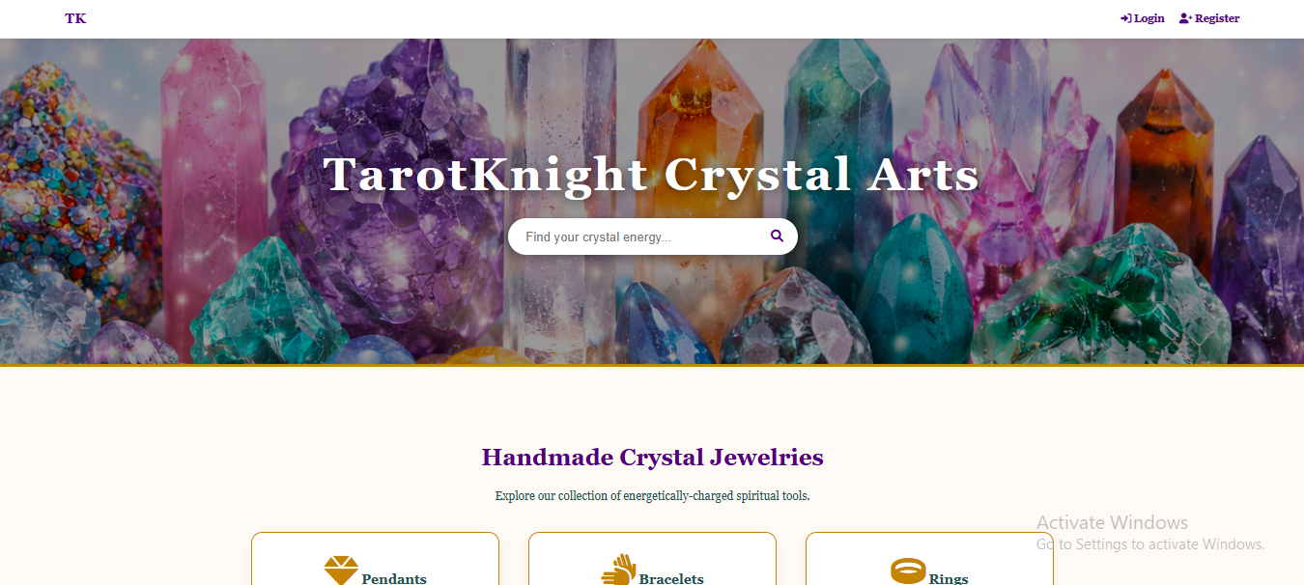
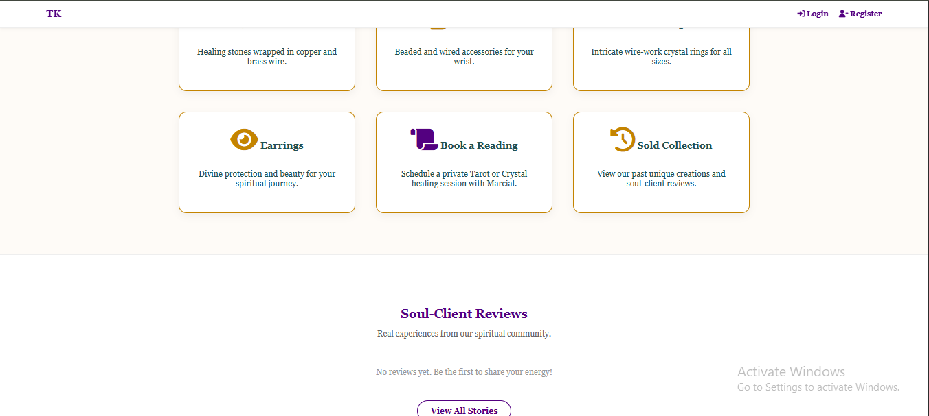
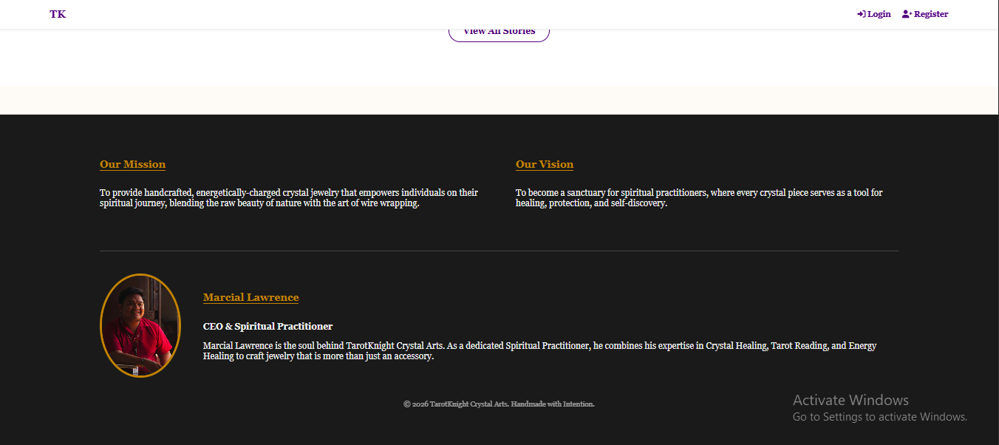

- Home Page (index.php): Functioning as the primary landing hub and the "digital storefront window," the Home Page introduces users to the TarotKnight mission statement. It features a curated selection of "Featured Products" and organizes the inventory into clear, highlighted categories (Pendants, Bracelets, Rings, and Earrings). This page sets the thematic tone for the entire site, utilizing high-resolution banners and smooth transitions to welcome visitors into the spiritual marketplace.

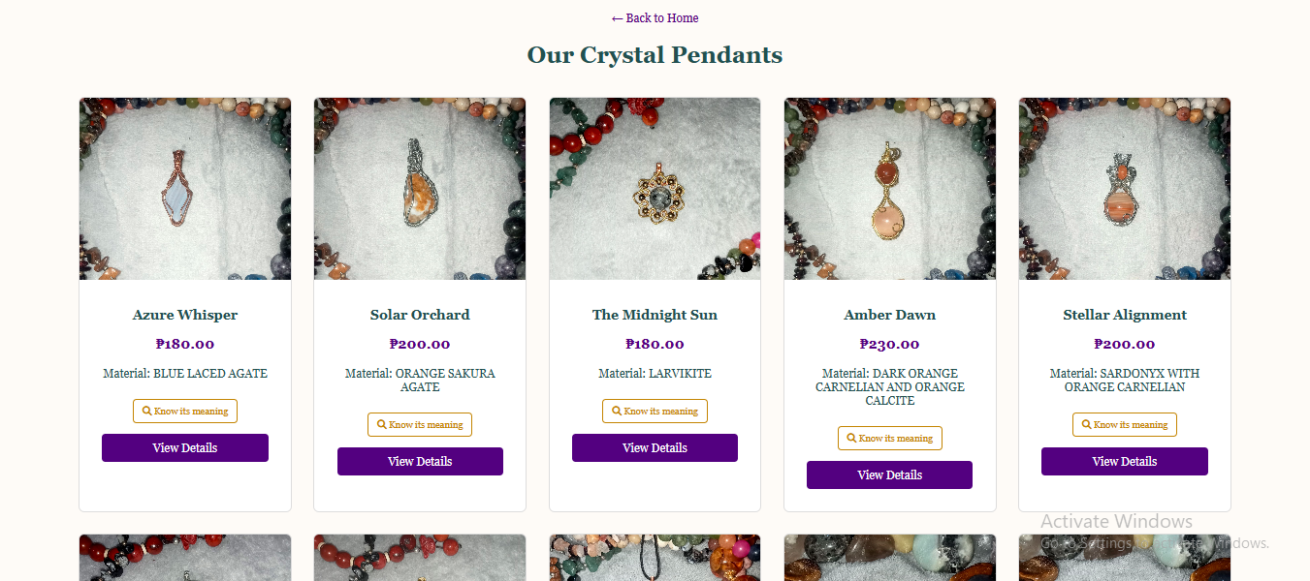

- Product Detail Page: To compensate for the lack of physical interaction, each individual crystal piece is granted a dedicated view. This page provides a comprehensive breakdown of the specific wire-wrapping technique employed by the artisan and a detailed explanation of the crystal's metaphysical and spiritual properties. Users can zoom in on high-quality images to inspect the intricate wirework before utilizing the "Add to Cart" functionality to move toward checkout.

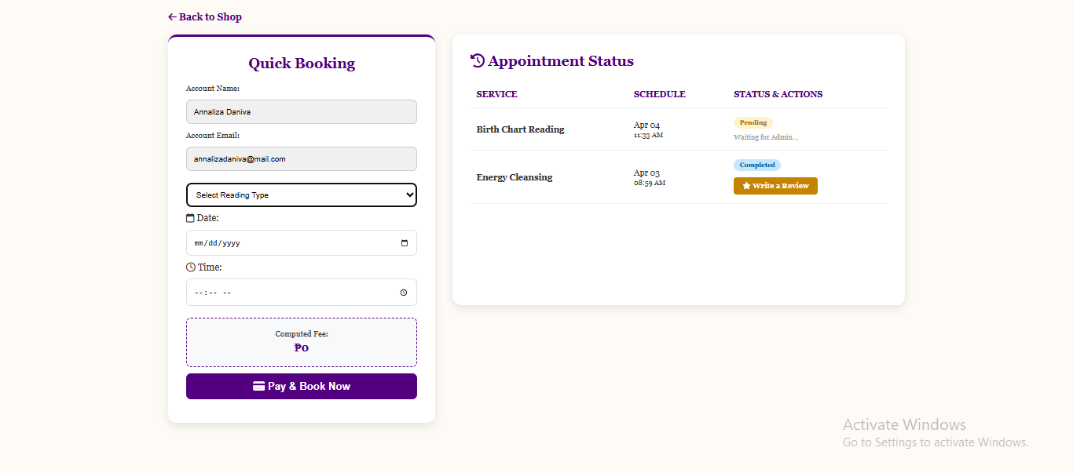

- Booking Hub (book_reading.php): This page represents a unique interface specifically designed for service-oriented interactions. Users are presented with a streamlined form where they can choose between three core spiritual services: Tarot Reading, Crystal Healing, or Energy Cleansing. A custom JavaScript function acts as a real-time calculator, displaying the "Computed Fee" based on the selection. This ensures total price transparency, allowing the user to confirm the cost and select a preferred time slot before the system initiates the PayMongo payment bridge.

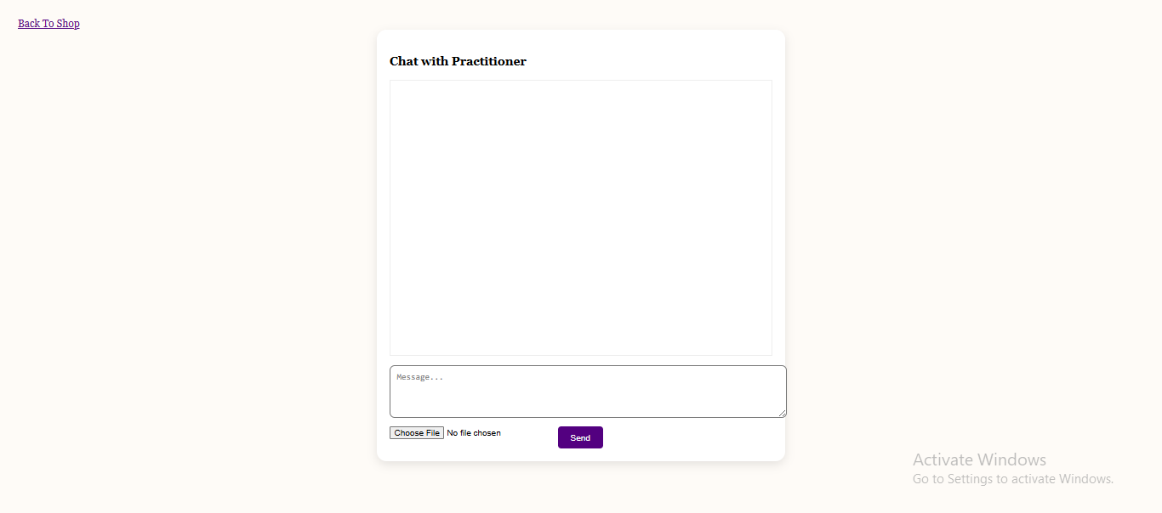

- Live Consultation Portal (contact_admin.php): Designed for deep engagement, this modern messaging interface facilitates direct communication between the client and the practitioner. The portal is technically advanced, supporting asynchronous file uploads for sharing aura photos or reading results. Furthermore, it is integrated with the system's AI logic, which scans messages for spiritual keywords and displays automated guidance to the user, ensuring they receive immediate support even when the administrator is offline.

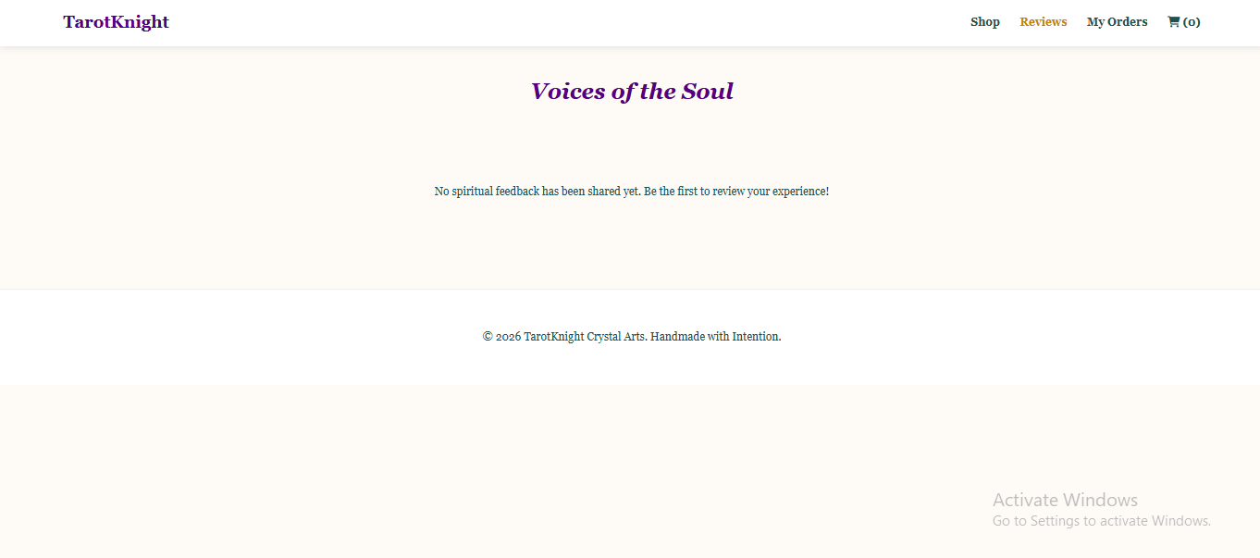

- Unified and "Smart" Review Page: This module is engineered with conditional logic to provide a highly relevant feedback experience. The page is "context-aware"; it detects whether the user is providing feedback for a physical ring purchase or a spiritual Tarot session. Based on this detection, the system dynamically adjusts the form questions and rating criteria, ensuring that the qualitative data gathered is specific to the nature of the transaction (e.g., "Quality of Craftsmanship" for products vs. "Insightfulness of Reading" for services).

BACK-END DEVELOPMENT

The backend infrastructure of the TarotKnight Crystal Art platform serves as the sophisticated computational engine that powers every automated process, from the initial user authentication to the final execution of a secure payment. This layer is designed with a focus on high-performance logic, ensuring that the transition between retail shopping and service scheduling remains seamless and mathematically accurate.

Technologies and Server-Side Environment

The robust backend is architected upon the industry-standard LAMP/WAMP stack (an acronym representing the Linux or Windows operating system, Apache web server, MySQL database, and PHP scripting language). This particular stack was selected for its proven reliability in high-traffic e-commerce environments and its native compatibility with modern API integrations.

PHP 8.x (Hypertext Preprocessor): At the core of the Application Tier, PHP was specifically chosen for its superior, enterprise-grade Session-Handling Capabilities. These capabilities are absolutely fundamental for maintaining a persistent and secure user experience. By utilizing server-side sessions, the system can preserve a user’s "Logged-In" status and retain every item within their shopping cart as they navigate across disparate pages. This prevents data loss during the transition from browsing handcrafted rings to selecting a spiritual Tarot session, providing a cohesive and non-disruptive customer journey.

Core Functional Features

The backend logic is divided into specialized modules that handle security, financial transactions, and intelligent user interaction through the following core features:

- Secure Session Handling and Authentication Guards: To protect the privacy of the spiritual community, the system implements a rigorous security layer using the $_SESSION superglobal. This logic acts as an "authentication guard," verifying the user's identity before granting access to sensitive areas of the site. For instance, the system ensures that only authorized, logged-in users can proceed to the checkout portal or utilize the private consultation chat. If an unauthenticated user attempts to access these restricted scripts, the PHP logic triggers an immediate redirect to the login page, thereby shielding the platform from unauthorized intrusion.

- Specialized PayMongo API Integration Logic: The financial heartbeat of the system resides in a specialized script known as paymongo_booking_handler.php. This complex piece of backend engineering is responsible for managing the high-level API Handshake between the TarotKnight server and the PayMongo payment gateway. It initiates the checkout session, transmits the encrypted transaction metadata, and listens for the asynchronous callback that confirms the payment success. This logic eliminates the need for manual oversight, as the script automatically updates the database records once the financial verification is complete.

- Intelligent "AI Guide" Brain Logic: Within the live consultation portal, the backend utilizes an innovative AI Logic Engine. This is implemented through a custom PHP function that systematically scans incoming user messages for specific "Keywords" related to spiritual queries. By querying the ai_knowledge_base table in real-time, the system can deliver an Instant Spiritual Response if a match is identified. In scenarios where the inquiry is too complex for the automated guide, the logic is programmed to notify the user gracefully that the practitioner has been alerted and will provide a personalized response shortly, ensuring the customer never feels ignored.

- Architectural Polymorphic Feedback Logic: To maintain a clean and highly organized database schema, the system employs a sophisticated Polymorphic Review System. Rather than creating multiple redundant tables for feedback, the backend utilizes a singular, shared reviews table. This table is cleverly architected with nullable Foreign Keys for both product_id and booking_id. The backend logic is "smart" enough to detect the context of the review—whether it originates from a physical crystal purchase or a spiritual energy session—and populates the corresponding column accordingly. This ensures that all qualitative feedback, regardless of its source, is archived in one centralized repository for easy administrative moderation and display.

DATABASE DESIGN

The foundational "brain" of the TarotKnight Crystal Art system is a sophisticated and highly relational database architecture managed through MySQL. This structural design is engineered to maintain absolute data integrity and prevent information redundancy by utilizing a web of Foreign Key (FK) constraints. These constraints ensure that every transaction—whether it be a physical jewelry purchase or a scheduled spiritual session—is logically and permanently tethered to a specific user identity and a validated payment record.
The database schema is divided into several specialized tables, each serving a critical role in the platform’s daily operations:

- Comprehensive Users Table (Central Identity Hub): This table acts as the primary repository for all participant data within the ecosystem. It does not merely store basic login credentials such as encrypted passwords and email addresses; it also manages User Roles (distinguishing between standard Customers and System Administrators). Furthermore, it tracks last_active timestamps, a technical feature that allows the system to monitor user engagement and manage real-time presence during live consultation sessions.

- Dynamic Products and Inventory Table: Architected specifically for the retail side of the business, this table houses the entire digital catalog for handcrafted pendants, bracelets, rings, and earrings. Beyond storing aesthetic data like product names and image paths, it features a critical Stock Counter Logic. This counter is programmed to automatically decrease in real-time following every successful PayMongo transaction. This prevents the logistical conflict of "overselling," ensuring that once a unique, wire-wrapped piece is sold, its status is updated across the entire frontend storefront.

- High-Precision Bookings and Appointments Table: Diverging from the retail logic, this table is specifically engineered to handle the temporal nature of spiritual services. It stores the reading_type (e.g., Tarot, Healing, or Cleansing) and is strictly indexed by booking_date and booking_time. By utilizing relational indexing, the system can perform rapid "availability checks," ensuring that no two clients can reserve the same spiritual practitioner for the same time slot, thereby maintaining a professional and conflict-free schedule.

- Unified Polymorphic Reviews and Ratings Table: To streamline the feedback process, the database utilizes a single, "smart" table for all customer testimonials. This table captures 1–5 star numerical ratings and qualitative text comments. Its unique strength lies in its Polymorphic Linkage; through the use of nullable columns, a single review entry can be uniquely associated with either a physical product_id or a service-based booking_id. This centralized approach allows the administrator to moderate all site feedback from a single interface while displaying the relevant reviews on the appropriate product or booking pages.

- AI Knowledge Base and Response Table: This specialized table serves as the "memory" for the system's automated consultant. It consists of two primary columns: "Keywords" and "Spiritual Content." When a user types an inquiry into the consultation portal, the backend performs a query against this table to find a linguistic match. This allows the administrator to dynamically update the AI's "intelligence" by simply adding new rows of spiritual wisdom or service information, ensuring the automated guide evolves alongside the business.

PAYMENT API INTEGRATION

The financial architecture of the TarotKnight Crystal Art platform is anchored by a sophisticated, fully automated integration that bridges the gap between spiritual retail and modern financial technology. By moving away from traditional, fragmented payment methods, the system provides a seamless and secure transactional environment that adheres to the highest standards of digital commerce in the Philippines.

Gateway Selection and Strategic Implementation

The platform exclusively utilizes PayMongo, a premier and highly regulated Philippine-based payment gateway, as its primary financial intermediary. This strategic selection was made to transcend the limitations of manual banking and provide customers with a truly Professional and Frictionless Checkout Experience. By integrating the PayMongo API, the system is capable of supporting a diverse array of modern payment vehicles—including popular e-wallets like GCash and Maya, as well as major international Credit and Debit Cards (Visa/Mastercard)—within a single, unified interface. The implementation of this professional gateway serves a dual purpose: it significantly enhances the brand's credibility in the eyes of the consumer, and it completely eliminates the administrative "bottleneck" of manual verification. The practitioner no longer needs to undergo the "manual hassle" of cross-referencing SMS notifications, checking bank statements, or validating digital "payment proofs" and screenshots, as the system handles all verification protocols autonomously.

Technical Payment Process Flow

The lifecycle of a financial transaction within the TarotKnight ecosystem is governed by a precise, automated sequence of API calls and server-side responses, ensuring that no order is processed without verified funding.

- Initiation and Session Creation: The process begins the moment a user interacts with the final call-to-action—either "Place Order" for physical crystal jewelry or "Pay & Book" for a spiritual consultation. At this millisecond, the PHP backend triggers a request to the PayMongo servers to generate a unique Checkout Session. This session encapsulates all pertinent transaction data, including the total calculated amount, the unique order or booking identifier, and the specific success and failure redirect URLs.

- Secure External Redirection: Once the session is successfully initialized, the user is safely redirected away from the local site to a High-Security PayMongo Hosted Page. This external environment is PCI-DSS compliant, ensuring that sensitive financial details, such as credit card numbers or e-wallet credentials, are never stored or even touched by the TarotKnight database, thereby drastically reducing the platform's security liability.

- Asynchronous Validation and Redirect: Upon the successful completion of the payment on the PayMongo portal, the user is automatically redirected back to a dedicated "Success Page" on the TarotKnight website. Simultaneously, PayMongo’s server sends a background notification (callback) to the site’s listener script.

- Database Synchronization: This return trigger executes a specialized PHP script that performs the final Database Reconciliation. The script identifies the specific transaction record and executes a status transition—permanently marking the order as "Paid" for physical goods or "Confirmed" for spiritual services. This instant synchronization ensures that the user's purchase history is updated in real-time, providing immediate psychological confirmation of a successful transaction.

ADMINISTRATIVE CONTROL CENTER (ADMIN PANEL)

The Administrative Control Center serves as the definitive "nerve center" and operational headquarters for the entire TarotKnight Crystal Art ecosystem. It is a secure, high-privilege interface designed specifically to empower the practitioner with complete oversight and granular control over every facet of the digital business. By consolidating fragmented data into a single, intuitive dashboard, the Admin Panel transforms complex backend information into actionable business intelligence, allowing for the seamless management of both physical retail and spiritual service fulfillment.

The panel is meticulously organized into several mission-critical modules, each designed to handle a specific pillar of the platform’s operations:

- Centralized Business Dashboard (Command Overview): Upon successful authentication, the administrator is presented with a high-level Executive Dashboard. This module acts as a visual summary of the platform's health, displaying real-time metrics such as the number of pending orders, today’s scheduled spiritual sessions, and recent customer inquiries. It provides a "bird's-eye view" that allows the practitioner to prioritize daily tasks—such as packaging jewelry for shipment or preparing for an upcoming Tarot reading—at a single glance.
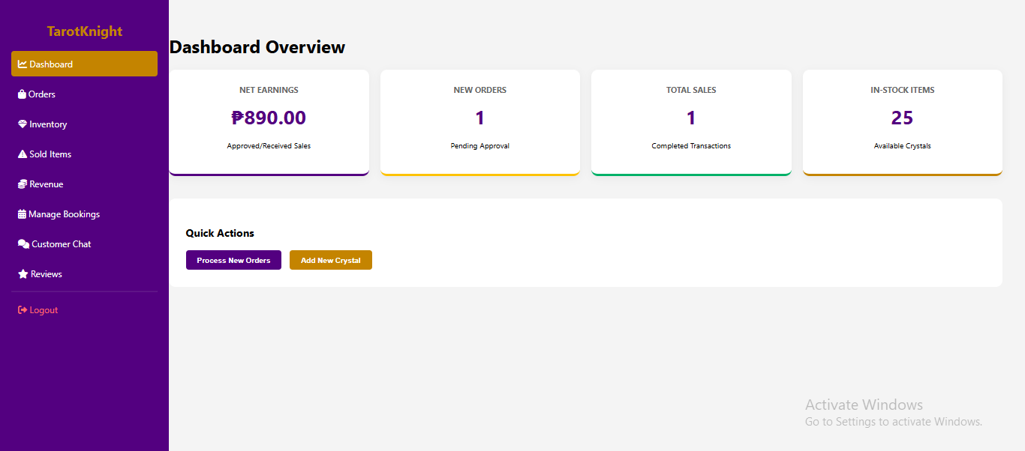

- Dynamic Inventory and Product Manager: This module is the primary tool for managing the physical storefront. It allows the administrator to perform Full CRUD (Create, Read, Update, Delete) Operations on the crystal catalog. The admin can effortlessly upload new handcrafted crystal art pieces, complete with high-resolution imagery and metaphysical descriptions. Furthermore, this interface provides the flexibility to adjust the pricing of spiritual services or update the "In Stock" status of wire-wrapped items, ensuring that the frontend catalog always reflects the current physical inventory.
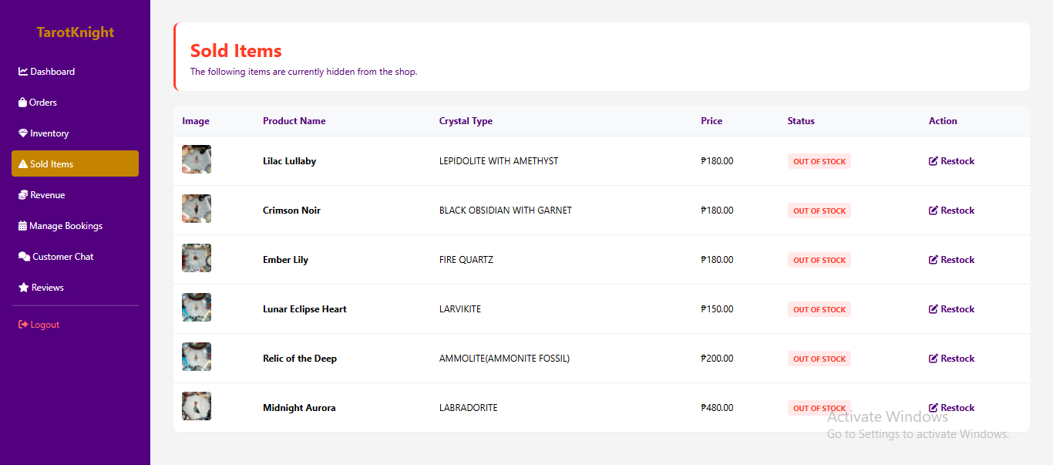
- Dedicated Sold Items and Archive Ledger: This specialized module serves as a permanent historical record for every physical product that has exited the inventory. It functions as a read-only architectural archive designed for long-term inventory reconciliation. By isolating "Sold" data from "Available" stock, this interface provides a chronological gallery of past creations, capturing final sale prices and unique SKUs to prevent accidental overselling and identify trending designs.
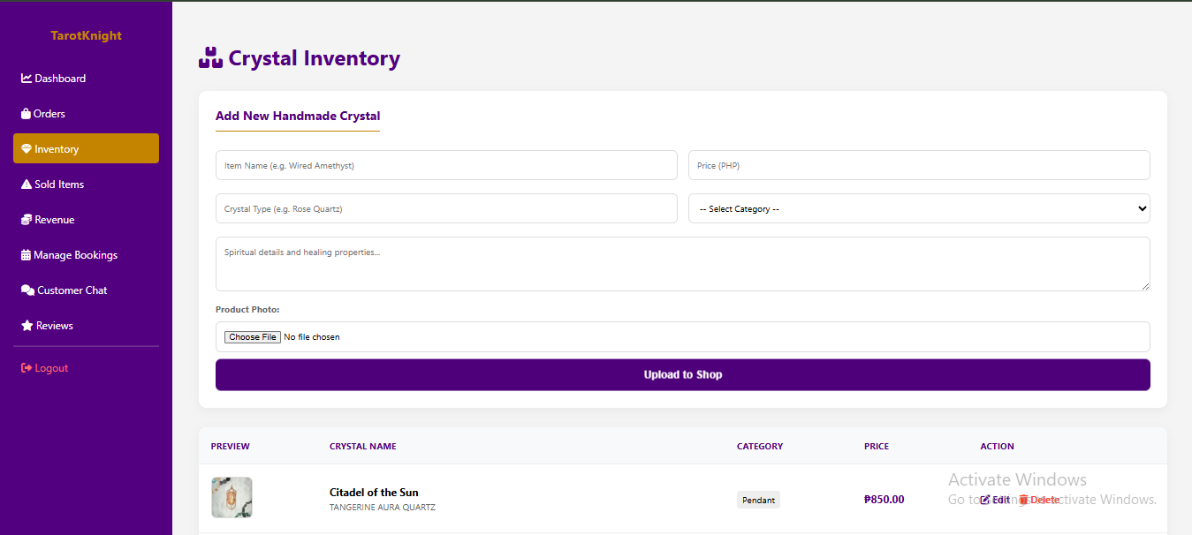

- Integrated Order and Booking Monitor: This sophisticated module serves as a live ledger for all successful transactions. It provides a Real-Time Synchronized List of every customer who has successfully completed a PayMongo transaction. For physical goods, it displays the specific jewelry items purchased and the shipping details required for fulfillment. For the service-oriented side of the business, it acts as a Digital Appointment Calendar, showing a chronological schedule of confirmed Tarot, Healing, or Cleansing sessions, thereby preventing any logistical overlaps or missed consultations.

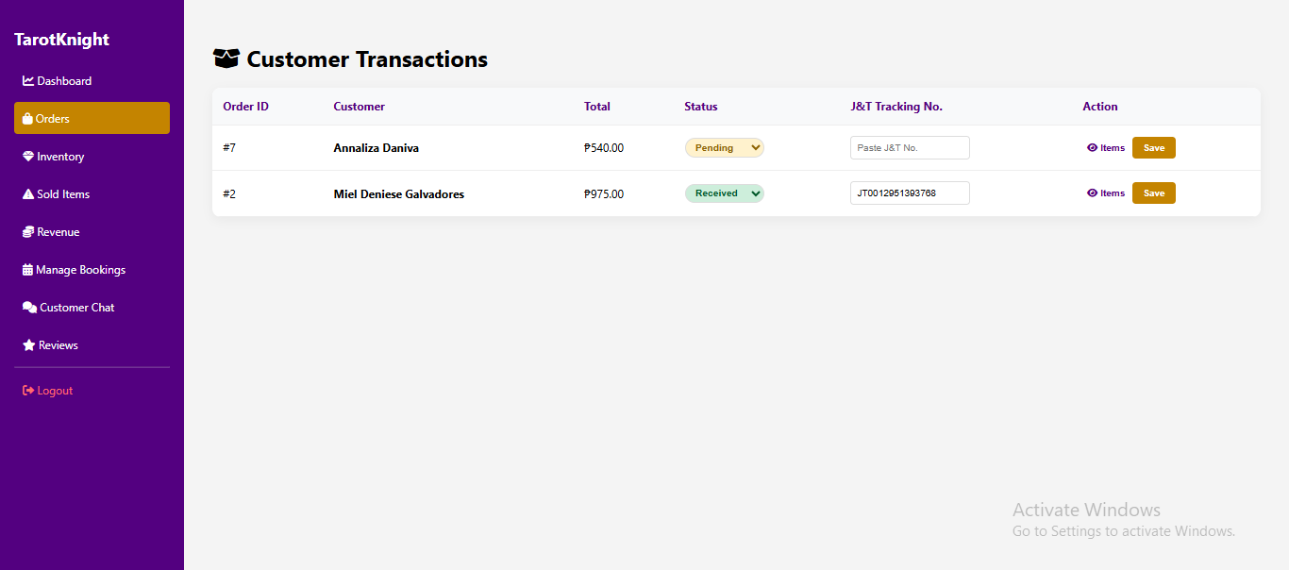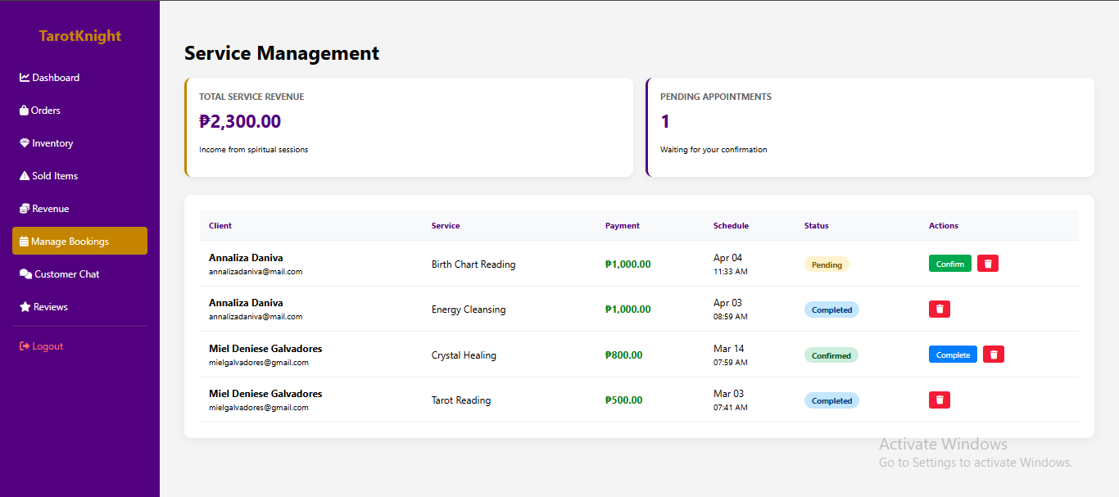
- Automated Revenue and Financial Analytics Hub: To eliminate the need for manual bookkeeping, the system includes an Automated Financial Engine. This module systematically aggregates data from the orders and bookings tables to calculate total gross earnings. It distinguishes between revenue generated from "Crystal Sales" and "Spiritual Services," providing the administrator with a clear understanding of which business segment is performing best. This data-driven approach is essential for long-term financial planning and evaluating the growth of the TarotKnight brand.

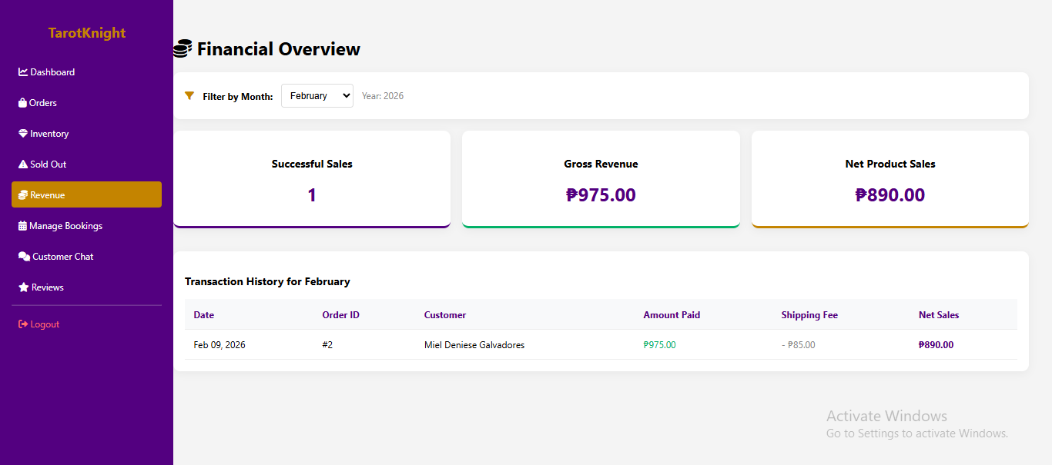
- Customer Relationship and Moderation Hub: Recognizing that the spiritual community thrives on trust and engagement, this module serves as the primary interface for customer interaction. It is divided into two sub-sections:

  - Customer Chat Portal: A real-time messaging interface where the admin can respond to inquiries, provide personalized spiritual advice, and view any media files sent by the client via the contact_admin.php portal.
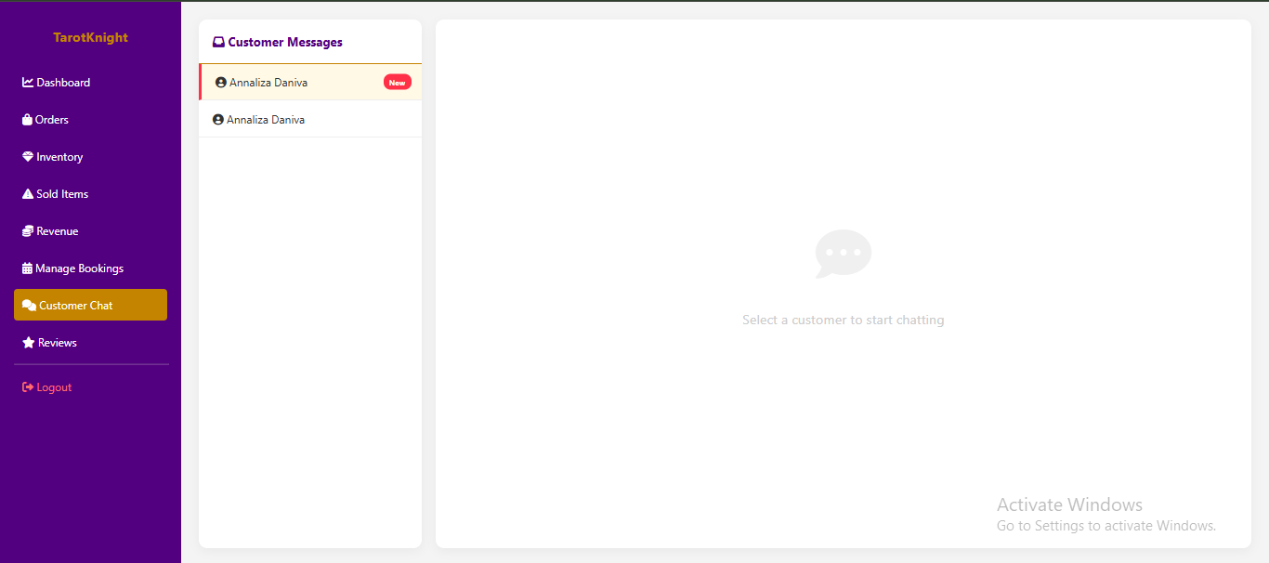

  - Review Moderation System: A dedicated space where the administrator can monitor, verify, and respond to customer-submitted testimonials. This ensures that the public-facing feedback remains professional, helpful, and aligned with the brand's spiritual values.
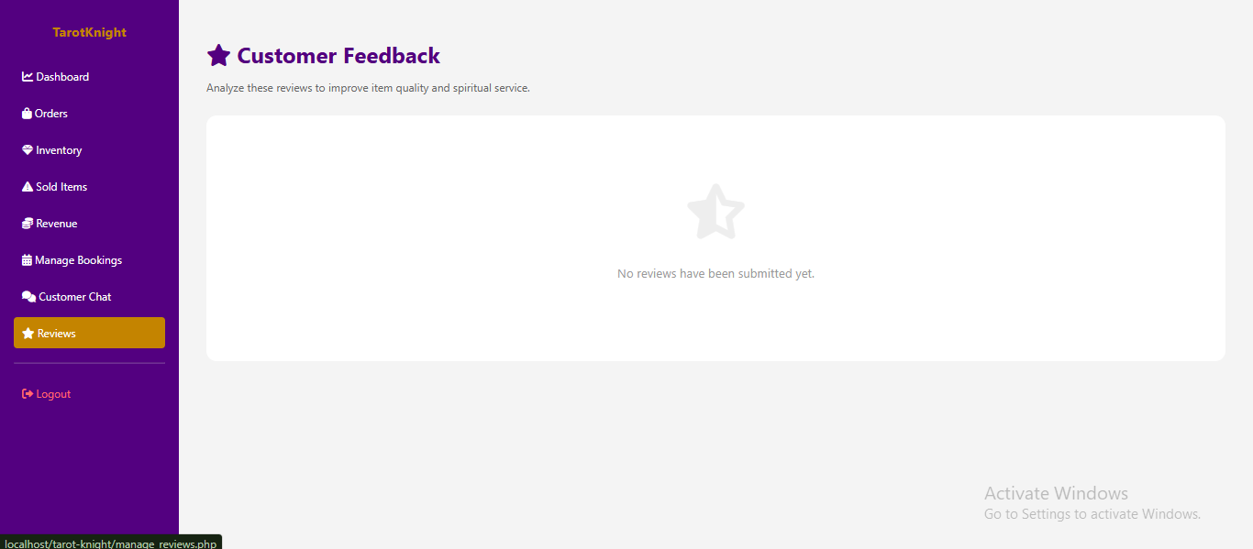

CONCLUSION

The successful architecture and deployment of the TarotKnight Crystal Art platform serve as a definitive and compelling demonstration of how traditional, artisanal spiritual crafts can be fundamentally empowered and elevated through the strategic application of modern web technologies. By meticulously bridging the gap between ancient metaphysical practices and 21st-century digital commerce, the project has transformed a high-touch, niche hobby into a sophisticated and scalable business model. The seamless integration of the PayMongo API for fully automated financial transactions, alongside the deployment of an AI-powered Knowledge Guide for instantaneous customer support, has effectively cultivated a professional, high-integrity, and deeply trustworthy digital sanctuary for the spiritual community. This synergy of "Old World" craftsmanship and "New World" automation ensures that the brand maintains its mystical essence while providing the operational efficiency expected of a modern enterprise.

Furthermore, the development of this platform highlights the critical importance of a unified, holistic system capable of harmoniously managing both physical retail and time-sensitive, service-based business models within a single, integrated environment. The project’s success in balancing the logistical complexities of wire-wrapped jewelry inventory with the temporal requirements of a real-time spiritual booking calendar proves that Digital Transformation is no longer a luxury but a vital necessity for the survival of niche businesses in the modern era. By centralizing these disparate revenue streams into a cohesive, relational database architecture, the TarotKnight system eliminates the fragmentation often found in social media-based commerce, providing the practitioner with unprecedented administrative oversight and a clear, data-driven path toward sustainable financial growth.

Ultimately, TarotKnight Crystal Art stands as a robust technical blueprint for small-scale artisans and spiritual practitioners seeking to expand their reach beyond local geographical limitations. The project underscores the reality that structured web development frameworks—when paired with secure payment gateways and intelligent automation—can provide a "level playing field," allowing specialized micro-businesses to achieve the same level of transactional security and user engagement as global e-commerce giants. As the platform moves forward, it remains a testament to the fact that when technology is applied with intention and technical rigor, it does not diminish the "spirit" of the craft but rather provides the necessary infrastructure to share that craft with a global audience, proving that the digital-first approach is indeed the key to unlocking the full potential of artisanal commerce.

FUTURE ENHANCEMENTS

While the current iteration of the TarotKnight Crystal Art system provides a robust and fully functional foundation for spiritual e-commerce and automated service bookings, the ever-evolving nature of digital landscapes offers numerous opportunities for expansion. To ensure the platform remains at the forefront of the niche spiritual market, several high-impact enhancements are proposed for future development cycles. These improvements aim to deepen user engagement, streamline logistical operations, and provide the administrator with more sophisticated tools for business growth.

Real-Time Logistics and Shipping Integration

Currently, the system relies on manual entry of J&T Express tracking numbers by the administrator. A primary future enhancement involves the integration of a Courier API (Application Programming Interface) that connects the TarotKnight backend directly with local shipping providers. This would allow the system to automatically generate shipping labels upon payment confirmation and provide customers with a live, real-time tracking map within their "My Orders" portal. By removing the need for manual tracking updates, the system would significantly reduce the margin for human error and provide customers with the instant transparency they expect from modern e-commerce platforms.

Automated Multi-Channel Notifications

To improve the communication flow between the business and its clients, the implementation of an Automated Notification Engine is planned. This feature would go beyond simple on-site status updates by sending real-time Email and SMS alerts to customers. For example, a customer would receive an instant "Payment Successful" email immediately after a PayMongo transaction, followed by an SMS reminder one hour before their scheduled spiritual consultation. These proactive touchpoints ensure that customers stay informed throughout the fulfillment process, reducing "no-shows" for readings and increasing overall user satisfaction.

Advanced Sales and Predictive Analytics

As the database grows with transaction history, the system can be upgraded to include Advanced Business Intelligence (BI) Analytics. Instead of simple revenue tracking, the future dashboard will feature visual heatmaps and predictive charts that identify trending crystals or peak booking times for Tarot readings. By applying basic data science principles, the system could suggest which products the administrator should restock based on seasonal demand or customer browsing patterns. This transition from "descriptive" to "predictive" analytics will empower the business owner to make smarter, data-driven decisions regarding inventory and marketing spend.

Mobile Application and Progressive Web App (PWA)

While the current storefront is fully responsive for mobile browsers, a dedicated Mobile Application version would offer a more immersive experience for loyal practitioners. By developing a mobile app or a Progressive Web App (PWA), TarotKnight could utilize native phone features such as Push Notifications, which are far more effective than emails for urgent updates. A mobile app would also allow for a smoother "one-touch" checkout process and provide a more intimate environment for the Live Consultation chat, making spiritual guidance accessible to users literally at their fingertips, anywhere and at any time.

Fortified Security and AI Expansion

As the platform scales and handles more sensitive user data and financial transactions, the implementation of Improved Security Features remains a top priority. Future iterations will include Two-Factor Authentication (2FA) for admin access and enhanced encryption for the storage of consultation transcripts. Furthermore, the AI Guide will be expanded using Natural Language Processing (NLP) to understand more complex spiritual inquiries. Rather than relying solely on keyword matches, the upgraded AI would be able to hold more fluid conversations, helping users choose the right crystal or service based on their current emotional or spiritual state, thereby acting as a digital concierge for the TarotKnight brand.

