
DATAMEX COLLEGE OF SAINT ADELINE
8167 DR.A. SANTOS AVENUE, SAN DIONISIO, PARAÑAQUE CITY

“Game Development: Mythic Gambit”

Group Members:
Marcial Lawrence Jr V. Caronan
Jhay L. Castro
Tyron John L. Dela Cruz
Kerr Cassel Pangan
Kaye Emmanuel Nercua
Jonvie Cantero

Submitted To:
Ms. Jeanniel T. Ilago

Subject & Course: Game Development (BSIT)
Table of Contents

Section Title | Subtitles / Components | Page Number
I. Executive Summary | Project Overview, Core Concepts, Strategic Ecosystem, Foundational GDD Blueprint | 1
II. Game Overview | Core Gameplay, Manifestation System, Ranked Progression, Kingdom Roster, Dynamic Board, Ultimate Moves, Live-Service Framework | 2
III. Storyline | The Shattering of the Infinite Tapestry, The Great Betrayal and Proliferation of Shards, The War of the Endless Shards | 3
IV. Objectives | Strategic Supremacy, Player Progression & Retention, Immersive Live-Service Expansion, Cinematic Presentation | 4
V. Gameplay Mechanics | Standard Chess Foundation, The Manifestation System, Dynamic Board & Terrains, Kingdom Passives, Signature Ultimate Moves | 5
VI. Characters & Kingdom Lore | 1. The Obsidian Roost (Catalyst, Hierarchy, Passive, Ultimate)  2. The Verdant Court (Catalyst, Hierarchy, Passive, Ultimate)  3. The Iron-Anvil Forge (Catalyst, Hierarchy, Passive, Ultimate)  4. The Abyssal Tides (Catalyst, Hierarchy, Passive, Ultimate)  5. The Frostbound Reach (Catalyst, Hierarchy, Passive, Ultimate)  6. The Fulminating Spire (Catalyst, Hierarchy, Passive, Ultimate)  7. The Gossamer Glade (Catalyst, Hierarchy, Passive, Ultimate)  8. The Titan’s Foothold (Catalyst, Hierarchy, Passive, Ultimate)  9. The Iron-Tusk Horde (Catalyst, Hierarchy, Passive, Ultimate)  10. The Sanguine Court (Catalyst, Hierarchy, Passive, Ultimate)  11. The Howling Pack (Catalyst, Hierarchy, Passive, Ultimate)  12. The Abyssal Veil (Catalyst, Hierarchy, Passive, Ultimate)  13. The Gearwork Citadel (Catalyst, Hierarchy, Passive, Ultimate)  14. The Sun-Scorched Sands (Catalyst, Hierarchy, Passive, Ultimate)  15. The Grave-Bound Dynasty (Catalyst, Hierarchy, Passive, Ultimate) | 6 - 12
VII. Environment | The Planar Board, Terrain Transformation, Atmospheric Realms | 13
VIII. Level Design | Standardized 8x8 Tactical Grid, Zonal Ownership Design, Visual Feedback Layouts | 14
IX. User Interface (UI) | Main Menu Hub, In-Game Head-Up Display (HUD), Tactical Overlay, Post-Match Summary Screen | 15
X. Audio Design | Faction-Specific Soundscapes & Audio Identities (All 15 Kingdoms), Dynamic Musical Score, Impact & Manifestation Audio | 16
XI. Art Style | 3D Stylized Fantasy, Thematic Color Palettes & Visual Identities (All 15 Kingdoms), Visual Clarity | 17
XII. Technical Requirements | Game Engine, Target Platforms, Minimum Hardware Specifications (OS, Processor, Memory, Graphics, Storage) | 18
XIII. Development Timeline | Phase 1: Pre-Production  Phase 2: Core Engineering  Phase 3: Content Creation  Phase 4: Balancing & Polish | 19
XIV. References | Theses, and Research Papers | 20
XV. Appendices | Appendix A: Wireframes (Main Menu, Kingdom Selection, In-Game HUD, Post-Match)  Appendix B: Storyboards (Manifestation System, Queen's Ultimate)  Appendix C: Sketches & Concept Art Repositories | 21 - 23

Executive Summary

Mythic Gambit represents an ambitious and visionary undertaking conceptualized, designed, and structured by the Bachelor of Science in Information Technology (BSIT) student development cohort at Datamex College of Saint Adeline. At its core, the project successfully bridges the timeless intellectual architecture of classical board gaming with the immersive, high-octane narrative and visual splendor of modern fantasy media. By translating the fundamental rules of traditional chess into a grand, high-fantasy tactical theater, the game plunges participants into a persistent, living universe where numerous distinct magical kingdoms vie for absolute supremacy across an evolving battlefield.

Rather than relying solely on sterile grid calculations, Mythic Gambit introduces the groundbreaking "Manifestation" system, ensuring that every successful piece capture triggers a visually arresting, kingdom-specific cinematic combat execution. Furthermore, the introduction of permanent board terrain conversion, specialized kingdom passives, a comprehensive live-service quarterly ranking ladder, and continuous post-launch expansions elevates the experience from a simple match into a deeply strategic, highly competitive esport ecosystem. This comprehensive Game Design Document (GDD) serves as the exhaustive foundational blueprint, meticulously detailing every narrative, mechanical, artistic, and technical requirement necessary to transition Mythic Gambit from an academic proposal into a fully realized commercial masterpiece.

I. Game Overview

Mythic Gambit is an intricately designed, strategic, turn-based fantasy simulation that completely reimagines the rigid, traditional parameters of classical chess through the grand narrative lens of epic high-fantasy warfare. Within this sprawling digital universe, players assume the mantle of supreme commanders, taking control of fully sentient, magically imbued armies that represent distinct, culturally rich mythical kingdoms. Every engagement on the checkered board transcends a standard tactical skirmish; each aggressive capture initiates a unique, highly stylized magical event dictated by the aggressor’s elemental and cultural affinity.

The primary structural pillars defining the Mythic Gambit experience include:
- Core Gameplay Mechanics: The game meticulously adheres to foundational chess movement logic while introducing deep "Kingdom Synergy" and fully animated, breathing 3D character units equipped with distinct idle stances and dynamic combat flourishes.

- The "Manifestation" System: A signature combat mechanism wherein executing an enemy piece transitions the game engine into a cinematic sequence that leverages the attacking faction's distinct elemental magic to annihilate the target.

- Robust Ranked Progression: Designed for long-term competitive engagement, the game incorporates a quarterly tier-based ladder system (progressing through Bronze, Silver, Gold, Platinum, and Mythic) governed by Victory Stars, scheduled seasonal rollbacks, and exclusive quarterly rewards.

- Extensive Kingdom Roster: A diverse array of specialized civilizations—ranging from The Obsidian Roost and The Verdant Court to The Iron-Anvil Forge—that map traditional chess hierarchies directly into unique thematic visual skins and tactical philosophies.

- Dynamic Board & Terrains: An evolving battlefield where tiles permanently transform under the influence of advancing units, actively triggering strategic passives like Heat Haze, Root-Bound, or Tidal Flow.

- Signature Ultimate Moves: Dramatic, post-checkmate sequences wherein the victorious Queen executes a catastrophic, board-clearing magical ultimate unique to her faction's lore.

- Live-Service Framework: A sustainable post-launch support ecosystem characterized by quarterly expansion updates, continuous content injections, and rigorous meta-balancing.

II. Storyline

The Shattering of the Infinite Tapestry

Long before mortal hands ever carved stone or forged iron, the cosmos was sustained by the Aether-Weave—an infinite, luminous web of universal law that bound all planes of existence in absolute harmony. This weave was governed by the Prime Architects, ancient cosmic entities who maintained balance among every elemental and primordial force. However, absolute harmony eventually bred stagnation, and stagnation birthed ambition across the cosmos.

The Great Betrayal and the Proliferation of Shards

The catalyst for the current cosmic war was a catastrophic act of supreme betrayal. The entity known as the Void Sovereign, once a trusted architect of shadow, sought to monopolize the Aether-Weave to reshape reality in its own dark image. Whispering promises of absolute dominion, the Sovereign corrupted key leaders across countless realms—bending ancient kings, corrupting sovereign bloodlines, and exploiting deep-seated grievances across the universe.

When the plot was exposed, the cosmic order fractured entirely. As the inner circle turned on one another, the Prime Architects were sealed away, and the Aether-Weave did not merely break into a fixed handful of pieces—it shattered into a vast, uncountable multitude of Aether-Shards. As the cosmic fabric unraveled, dozens upon dozens of distinct realms, dynasties, and factions emerged from the chaos, each managing to capture just enough lingering shards of the weave to forge their own sovereign existence and protect their territories.

The War of the Endless Shards

Now, an ever-growing multitude of kingdoms is locked in an inescapable existential war upon the mystic battlegrounds of the board. Because new factions continue to discover and harness scattered shards from the cataclysm, the conflict is endlessly expanding. It is a desperate struggle for total metaphysical survival: if any single faction claims absolute dominance, they risk unravelling the remaining threads entirely, plunging existence into an endless void—or worse, allowing corrupted dynasties to permanently warp reality. Every pawn moved and every king captured represents a deeper tragedy of broken oaths, ancient blood debts, and the bitter fight to preserve what remains of a fractured cosmos.

III. Objectives

The realization of Mythic Gambit is steered by a series of precise developmental and strategic milestones:
- Strategic Supremacy: To engineer a deeply absorbing, intellectually rigorous competitive tactical experience that honors foundational classical chess rules while introducing refreshing, modern high-fantasy mechanics and faction-specific passives.

- Player Progression & Retention: To institute a deeply rewarding, cyclical quarterly ranking architecture (spanning from Bronze to Mythic tiers) reinforced by seasonal resets and prestigious cosmetic rewards that maintain long-term community dedication.

- Immersive Live-Service Expansion: To establish a reliable, high-quality content pipeline capable of delivering fresh kingdoms, extensive balance patches, and evolving meta-gameplay paradigms every three months.

- Cinematic Presentation: To seamlessly weave 3D stylized fantasy aesthetics, reactive environmental transformations, and awe-inspiring post-checkmate ultimate spectacles into a cohesive audiovisual triumph.

IV. Gameplay Mechanics

The mechanical backbone of Mythic Gambit relies on an intricate balance between predictable tactical geometry and unpredictable magical disruption:
- Standard Chess Foundation: All character units strictly abide by historical movement frameworks (Rooks executing orthogonal sweeps, Knights executing precision L-shaped hops), ensuring that seasoned chess veterans retain immediate strategic intuition.

- The Manifestation System: Capturing an opposing piece immediately triggers a specialized, real-time cinematic combat animation that showcases the brutal or mystical execution style inherent to the aggressor's kingdom.

- Dynamic Board & Terrains: Matches commence upon a neutral grid split between player starting territories; as units march forward, the floor tiles permanently absorb their kingdom's essence, creating altered zones of influence.

- Kingdom Passives: Factions leverage specialized systemic advantages designed for battlefield control and tactical disruption rather than simple raw power—such as The Obsidian Roost's Heat Haze, The Verdant Court's Root-Bound, The Abyssal Tides' Tidal Flow, and The Fulminating Spire's Static Charge.

- Signature Ultimate Moves (Post-Checkmate): Upon the fall of a King, the victorious Queen initiates an apocalyptic board-altering ultimate sequence—ranging from cascading lava torrents and tectonic fractures to absolute glacial stasis.

V. Characters & Kingdom Lore

The character architecture of Mythic Gambit translates the archetypal hierarchy of classical chess into highly detailed, culturally distinct variants across an expanding roster of kingdoms. Beyond their tactical roles, every single kingdom is driven to the board by profound emotional catalysts, unique terrain passives, and post-checkmate ultimate moves:

1. The Obsidian Roost (Fire & Might)

- Emotional Catalyst (Anger & Pride): Scorched by the betrayal of celestial allies who branded them monsters, they fight out of burning fury and unyielding pride to reclaim their volcanic skies.

- Hierarchy: King: The Eternal Drake | Queen: The Ash Matriarch | Bishop: The Pyromancer | Knight: The Flame-Winged Vanguard | Rook: The Magma Sentinel | Pawn: The Scale-Bearer.

- Kingdom Passive (Heat Haze): Units adjacent to a Dragon piece on Dragon-terrain have their vision obscured, preventing the opponent from seeing the potential moves of that piece for one turn.

- Signature Ultimate (Lava Torrent): The Queen breathes a torrent of liquid fire across the board, melting the tiles into a sea of lava that consumes the victor's remaining pieces.

2. The Verdant Court (Nature & Magic)

- Emotional Catalyst (Loneliness & Grief): Having watched their ancient starlight groves wither due to the cosmic fallout, they march with a profound, aching loneliness, fighting to resurrect what was lost.

- Hierarchy: King: The Elder Dryad | Queen: The Forest Matriarch | Bishop: The Sylvaris | Knight: The Stag-Rider | Rook: The Treant Guardian | Pawn: The Sapling.

- Kingdom Passive (Root-Bound): When a Verdant Court piece ends its turn on a Verdant-terrain tile, it gains "Photosynthesis," which allows it to ignore any movement penalties caused by enemy terrain effects.

- Signature Ultimate (Thorn Surge): The Forest Matriarch commands the roots of the world to surge upward, shattering the board and entangling the victor's army in a rapidly growing, impenetrable forest of ancient thorns.

3. The Iron-Anvil Forge (Earth & Forge)
- Emotional Catalyst (Stubborn Resolve & Resentment): Driven by deep resentment toward those who shattered the Aether-Weave, they forge weapons out of sheer grit, refusing to let their heritage be buried under slag.

- Hierarchy: King: The High Thane | Queen: The Forge Matriarch | Bishop: The Rune-Smith | Knight: The Shield-Bearer | Rook: The Anvil-Crusher | Pawn: The Iron-Clan Miner.

- Kingdom Passive (Reinforced Plate): Iron-Anvil pieces on Forge-terrain gain "Defensive Stance," which prevents them from being pushed back or swapped by enemy abilities.

- Signature Ultimate (Geothermal Overload): The Forge Matriarch triggers a geothermal overload; the board begins to glow red-hot before the entire surface sinks into a massive, bubbling pit of liquid metal and slag.

4. The Abyssal Tides (Water & Depth)

- Emotional Catalyst (Melancholy & Isolation): Living in the silent, suffocating trenches of the ocean floor, they are driven by a sorrowful desperation to force the surface world to feel the crushing weight of their neglect.

- Hierarchy: King: The Abyssal King | Queen: The Siren Queen | Bishop: The Deep-Seer | Knight: The Kelp-Stalker | Rook: The Trench-Titan | Pawn: The Tide-Runner.

- Kingdom Passive (Tidal Flow): When an Abyssal Tide piece moves onto Abyssal terrain, it gains "Fluid Motion," allowing it to jump over one adjacent piece, regardless of that piece’s rank.

- Signature Ultimate (Crushing Deluge): The Siren Queen summons a massive, crushing wave that floods the entire board, dragging all remaining pieces into the dark, silent depths of the ocean floor.

5. The Frostbound Reach (Ice & Shattering)

- Emotional Catalyst (Numbness & Despair): Consumed by an internal emotional frost following the loss of their home world, they fight with cold detachment, seeking to freeze the chaos of reality into eternal peace.

- Hierarchy: King: Frost Monarch | Queen: Ice Queen | Bishop: Glacial Mage | Knight: Ice Charger | Rook: Frost Sentinel | Pawn: Ice Shard.

- Kingdom Passive (Chilling Mist): Enemy pieces that start their turn on Frost-terrain have their movement range reduced by one square for that turn.

- Signature Ultimate (Eternal Stasis): A flash-freeze sweeps the board, turning the environment into a massive, jagged ice sculpture that encases the winner's army in eternal stasis.
6. The Fulminating Spire (Lightning & Speed)

- Emotional Catalyst (Restless Impatience & Frustration): Born from chaotic storms, they harbor a frantic, electric anger toward a universe moving too slowly to fix its own broken laws.

- Hierarchy: King: Storm Lord | Queen: Lightning Matriarch | Bishop: Spark weaver | Knight: Bolt Rider | Rook: Thunder Tower | Pawn: Spark.

- Kingdom Passive (Static Charge): When an enemy piece moves onto a Lightning-terrain tile, it creates a "Charge" marker; if the piece does not capture on its next turn, it is stunned and cannot move.

- Signature Ultimate (Scorched Crater): A continuous strike of golden lightning obliterates every tile, leaving the board as a scorched, electrified crater.

7. The Gossamer Glade (Fairy Illusion)

- Emotional Catalyst (Fear & Melancholy): Terrified of fading into complete irrelevance as the cosmos collapses, they weave elaborate illusions out of a desperate desire to hide their vulnerability.

- Hierarchy: King: Fairy King | Queen: Titania | Bishop: Illusionist | Knight: Sprite Scout | Rook: Thistle Guard | Pawn: Pollenling.

- Kingdom Passive (Glimmer): When a Fairy piece moves to an empty tile, it leaves behind a "Glimmer" decoy that mimics the piece's movement range until it is passed through by an enemy.

- Signature Ultimate (Blooming Suppression): The board is swallowed by rapidly growing, enchanted thorns and massive blooms that crush the structures of the battlefield.

8. The Titan’s Foothold (Giant Power)

- Emotional Catalyst (Heavy Burden & Exhaustion): Weary of carrying the physical weight of broken mountains, their march is fueled by a rumbling, earth-shaking exhaustion that turns into destructive fury when provoked.

- Hierarchy: King: Mountain King | Queen: Peak Matriarch | Bishop: Earth Shaper | Knight: Boulder Crusher | Rook: Stone Bastion | Pawn: Pebble.

- Kingdom Passive (Bulwark): Friendly pieces adjacent to a Giant piece on Giant-terrain are anchored; they cannot be displaced by opponent abilities or terrain effects.

- Signature Ultimate (Subterranean Rift): A massive tectonic shift causes the board to fold and crumble, sliding the entire army into a deep subterranean rift.

9. The Iron-Tusk Horde (Orc Brute Force)

- Emotional Catalyst (Righteous Vengeance): For centuries marginalized and driven into barren wastes by elite dynasties, their war drums beat with a fierce, vindictive anger demanding absolute equality through force.

- Hierarchy: King: Warchief | Queen: War Matriarch | Bishop: Shaman | Knight: Warg Rider | Rook: War Engine | Pawn: Grunt.

- Kingdom Passive (War Cry): When an Orc piece moves onto a tile adjacent to an enemy, the enemy piece is "Intimidated" and its next movement must be away from the Orc unit.

- Signature Ultimate (Iron Eruption): The ground erupts as war-machines and heavy iron-spikes rise from beneath the tiles, shredding the board surface.

10. The Sanguine Court (Vampire Magic)

- Emotional Catalyst (Hunger & Existential Dread): Plagued by an unquenchable thirst and a terrifying dread of true mortality, they wage war simply to drain the lifeblood of a dying universe and prolong their own existence.

- Hierarchy: King: Elder Progenitor | Queen: Blood Matriarch | Bishop: Hemomancer | Knight: Night-Stalker | Rook: Stone Gargoyle | Pawn: Thrall.

- Kingdom Passive (Life-Tap): When a Sanguine piece captures an enemy, the captured tile becomes a "Corrupted Patch." If an enemy moves onto this patch later, they are slowed (must spend two turns to leave the tile).

- Signature Ultimate (Shadow Dimension): The board bleeds into darkness, with pools of crimson rising to swallow the remaining pieces into a shadow dimension.

11. The Howling Pack (Werewolf Frenzy)

- Emotional Catalyst (Primal Anguish): Bound to the cruel phases of a bleeding moon, they fight with wild, howling sorrow, mourning the loss of their wild lands to encroaching civilization.

- Hierarchy: King: Alpha | Queen: Moon Matriarch | Bishop: Spirit Seer | Knight: Pack Hunter | Rook: Den Guardian | Pawn: Pup.

- Kingdom Passive (Moonlight Scent): Werewolf pieces can detect the "Glimmer" decoys of the Fairy kingdom, revealing them as illusions immediately upon getting within two tiles.

- Signature Ultimate (Spectral Tear): The sky turns a blood-red color, and a pack of spectral wolves tears the board apart, piece by piece, under Pulse-light of the moon.

12. The Abyssal Veil (Shadow & Void)

- Emotional Catalyst (Emptiness & Bitterness): Having been abandoned in the dark corners of the void, they harbor a bitter envy toward the light, seeking to pull every other kingdom down into their silence.

- Hierarchy: King: Void King | Queen: Shadow Queen | Bishop: Void Mage | Knight: Shadow Stalker | Rook: Void Pillar | Pawn: Shade.

- Kingdom Passive (Shadow Walk): Once per game, a Shadow piece can swap positions with any friendly piece on the board, regardless of distance.

- Signature Ultimate (The Vortex): The board dissolves into a swirling vortex of nothingness, pulling the remaining pieces into the void.

13. The Gearwork Citadel (Clockwork & Steam)

- Emotional Catalyst (Obsessive Perfectionism): Driven mad by the imperfection of the shattered Aether-Weave, they seek to brutally re-engineer reality down to the exact tick of a clock, eliminating all organic emotion.

- Hierarchy: King: Grand Inventor | Queen: Gear Matriarch | Bishop: Aether-Smith | Knight: Clockwork Steed | Rook: Steam Engine | Pawn: Automaton.

- Kingdom Passive (Overclock): Friendly pieces adjacent to a Clockwork piece gain +1 to their turn's maximum movement distance on Gearwork-terrain tiles.

- Signature Ultimate (The Clockwork Mechanism): The tiles retract and lock together, transforming the board into a colossal, spinning clock-mechanism that grinds everything to dust.

14. The Sun-Scorched Sands (Desert Heat)

- Emotional Catalyst (Endurance & Sorrow): Swept by burning winds that erased their ancient histories, they fight with silent, scorching grief, determined to bury those who forgot them beneath the dunes.

- Hierarchy: King: Sultan | Queen: Sand Matriarch | Bishop: Dune Mage | Knight: Dune Strider | Rook: Oasis Gate | Pawn: Nomad.
- Kingdom Passive (Mirage Veil): When a unit on Sand-terrain is targeted by a long-range piece (like a Bishop), there is a 50% chance the attack misses, as the unit is revealed to be a sand-mirage.

- Signature Ultimate (Colossal Sandstorm): A colossal sandstorm manifests, burying the entire board under a mountain of shifting, sun-scorched dunes.

15. The Grave-Bound Dynasty (Death Soul)

- Emotional Catalyst (Cold Acceptance & Remorse): Already dead, their motivation is a chilling, hollow remorse—they fight to drag the living into eternal peace, believing that only in death can souls find rest from the cosmic war.

- Hierarchy: King: The Lich Lord | Queen: The Death Matriarch | Bishop: The Soul-Weaver | Knight: The Skeletal Charger | Rook: The Crypt Guardian | Pawn: The Risen Thrall.

- Kingdom Passive (Soul Binding): When a Necromancy piece is captured, the tile becomes a "Soul Well" for two turns; if a friendly piece moves onto that tile within those two turns, they gain "Spectral Protection," preventing capture on the opponent's next turn.

- Signature Ultimate (Subterranean Abyss): The Death Matriarch causes the ground to split, and a legion of skeletal hands emerges from every tile to drag the opponent’s pieces into a subterranean abyss.

VI. Environment

- The Planar Board: A breathtaking, suspended floating tactical grid composed of modular, reactive tiles that visually articulate the constant ideological and magical struggle between competing empires.

- Terrain Transformation: Floors actively shift in real-time through procedural texture blending, dynamic lighting adjustments, and intricate particle systems—manifesting glowing runes, sprouting thorns, creeping frost, or bubbling magma as units traverse the grid.

- Atmospheric Realms: Surrounding environmental backdrops dynamically evolve to match the chosen factions, seamlessly transitioning between volatile volcanic peaks, enchanted starlight forests, intricate clockwork citadels, and abyssal oceanic trenches.

VII. Level Design

- Standardized 8x8 Tactical Grid: Maintains uncompromising geometric symmetry identical to standard chess boards to safeguard absolute competitive integrity, fairness, and deep strategic calculation.

- Zonal Ownership Design: The board layout deliberately sections off distinct neutral zones and home baselines, encouraging natural tactical bottlenecks, localized skirmishes, and calculated territorial expansion.

- Visual Feedback Layouts: Integrated floor-projected UI elements, clear border indicators, and distinct hazard highlights ensure that players can instantly read movement ranges, attack vectors, and active terrain debuffs during high-pressure competitive scenarios.

VII. User Interface (UI)

- Main Menu Hub: An immersive, high-fantasy command dashboard offering instantaneous navigation to Ranked Matchmaking, the extensive Kingdom Roster browser, Quarterly Season progression ladders, and the comprehensive Lore Codex.

- In-Game Head-Up Display (HUD): A clean, non-intrusive minimalist overlay displaying turn timers, captured piece inventories, active kingdom passive status trackers, and current competitive tier insignia.

- Tactical Overlay: Advanced hover-state UI feedback that projects clear movement trajectories, threat ranges, active terrain debuffs (such as Frost-terrain velocity penalties or Lightning-terrain charge warnings), and deceptive decoy indicators.

- Post-Match Summary Screen: An in-depth analytical breakdown showcasing match durations, Victory Stars acquired, tier progression metrics, and cinematic replay controls.

IX. Audio Design

- Faction-Specific Soundscapes & Kingdom Audio Identities: Audio engineering adapts organically to the selected kingdoms, giving every single faction its own bespoke auditory signature that reflects both its physical makeup and its deep emotional core:
  - The Obsidian Roost: Characterized by booming, volcanic deep-bass rumbles, the crackle of localized magmatic heat, and sharp, resonant reptilian screeches.

  - The Verdant Court: Composed of gentle, ambient forest whispering, rustling ancient leaves, soft wind chimes, and ethereal starlight acoustic frequencies.

  - The Iron-Anvil Forge: Driven by heavy industrial metallic clangs, rhythmic anvil strikes, roaring furnace blowtorches, and echoing subterranean resonance.

  - The Abyssal Tides: Defined by deep underwater pressure groans, fluid aquatic echoes, whale-like sub-bass pulses, and hollow maritime resonance.

  - The Frostbound Reach: Built upon chilling glacial crackles, howling winter wind gusts, and high-pitched crystalline tinks that evoke absolute emotional numbness.

  - The Fulminating Spire: Characterized by sudden, high-voltage electric crackles, ozone hums, and rapid static discharge snaps.

  - The Gossamer Glade: Imbued with light, fluttering fairy wing hums, whimsical music-box melodies, and shimmering pollen-drift chimes.

  - The Titan’s Foothold: Anchored by low, rumbling seismic sub-frequencies, heavy tectonic grinding, and deep earth-shaking footsteps.

  - The Iron-Tusk Horde: Powered by heavy, tribal war drums, blaring brass horns, and aggressive, guttural battle cries.

  - The Sanguine Court: Wrapped in atmospheric gothic organ notes, fluttering bat-wing rustles, and soft, chilling liquid drips.

  - The Howling Pack: Featuring haunting lunar wolf howls, snapping brushwood, and primal, echoing forest calls.

  - The Abyssal Veil: Composed of eerie void drones, reversed audio echoes, and absolute, dead silence punctuating sudden shifts.

  - The Gearwork Citadel: Dominated by intricate clockwork ticking gears, steam-piston releases, and precise mechanical whirs.

  - The Sun-Scorched Sands: Highlighted by whistling desert sandstorms, dry wind whispers, and hollow terracotta acoustic reverberations.

  - The Grave-Bound Dynasty: Soundscaped with hollow skeletal rattles, ghostly spectral wails, and echoing churchyard bell tolls.

- Dynamic Musical Score: A sweeping orchestral fantasy soundtrack that scales dynamically based on the tension of the match, transitioning smoothly from quiet, contemplative tactical melodies into roaring, choir-backed movements during checkmate climaxes and Queen Ultimates.

- Impact & Manifestation Audio: Punchy, satisfying acoustic feedback for standard piece captures paired with booming magical flourishes and elemental roars during "Manifestation" sequences to maximize tactile engagement.

X. Art Style

- 3D Stylized Fantasy: A polished, vibrant artistic direction that combines striking character silhouettes with rich, painterly textures and high-end modern particle visual effects.

- Thematic Color Palettes & Kingdom Visual Identities: Every kingdom leverages an immediate, highly legible color theory and bespoke visual palette to reflect its cultural essence, elemental alignment, and emotional catalyst:
  - The Obsidian Roost: Smoldering obsidian blacks, ash grays, and fiery molten golds.

  - The Verdant Court: Deep forest greens, mossy tones, and ethereal starlight silvers.
  - The Iron-Anvil Forge: Industrial gunmetal grays, rugged iron browns, and glowing forge-orange accents.

  - The Abyssal Tides: Deep ocean navy blues, bioluminescent cyan glows, and sea-foam whites.

  - The Frostbound Reach: Crystalline glacial blues, pale frost whites, and sharp ice-refraction silvers.

  - The Fulminating Spire: Electric violet purples, storm-cloud slates, and blinding flash-yellow highlights.

  - The Gossamer Glade: Pastel pinks, soft lavenders, and shimmering iridescent greens.

  - The Titan’s Foothold: Heavy earth-browns weathered granite grays, and dust-orange highlights.

  - The Iron-Tusk Horde: Blood-rust reds, war-paint bone whites, and rugged hide browns.

  - The Sanguine Court: Deep velvet crimsons, midnight blacks, and aged parchment golds.

  - The Howling Pack: Lunar silver-grays, midnight forest blues, and bleeding crimson accents.

  - The Abyssal Veil: Void purples, absolute pitch-blacks, and ghostly spectral blue highlights.

  - The Gearwork Citadel: Polished brass golds, copper rust-browns, and steam-iron grays.

  - The Sun-Scorched Sands: Sun-baked amber golds, terracotta rust-reds, and dune-sand yellows.

  - The Grave-Bound Dynasty: Cryptic bone-whites, rotting shroud greens, and eerie soul-fire cyan glows.

- Visual Clarity: Rigorously optimized asset design ensuring that even during chaotic, particle-heavy "Manifestation" animations and shifting board terrains, piece silhouettes and spatial positions remain effortlessly distinguishable to competitive players.

XI. Technical Requirements

- Game Engine: Unity or Unreal Engine (selected for industry-leading 3D rendering pipelines, robust particle architecture, and multi-platform deployment capabilities).

- Target Platforms: Primary deployment on PC (Windows and macOS), with structured future scalability toward mobile and tablet operating systems.

- Minimum Hardware Specifications:

  - OS: Windows 10/11 (64-bit)

  - Processor: Quad-core Intel Core i5 or AMD Ryzen 5 processor (2.5 GHz or faster)

  - Memory: 8 GB RAM

  - Graphics: NVIDIA GeForce GTX 1060 / AMD Radeon RX 580 or equivalent GPU with full DirectX 11 compatibility

  - Storage: 15 GB of available high-speed storage space

XII. Development Timeline

- Phase 1: Pre-Production: Comprehensive conceptualization, finalization of asset style guides, narrative documentation, and prototyping of the foundational "Manifestation" animation library.

- Phase 2: Core Engineering: Programming the fundamental chess logic engine, establishing secure multiplayer networking architecture for matchmaking, and coding the "Capture Event" trigger system.

- Phase 3: Content Creation: Production of 3D models and rigs for all kingdoms, environmental asset sculpting, and the composition of faction-specific audio soundscapes.

- Phase 4: Balancing & Polish: Extensive meta-game balancing passes to guarantee absolute chess equilibrium across all unique visual skins, followed by closed beta testing, bug remediation, and final quality assurance.

XII. References

- Ritalahti, J. (2023). Best Practices in Video Game Design. Master's Thesis, Aalto University School of Science. https://aaltodoc.aalto.fi/bitstreams/f36a7403-c469-4333-9fdc-4baeb958f987/download

- Valls, J., & Economou, D. (2016). Design, Development and Evaluation of a Chess Game in a Ubiquitous Environment. ResearchGate. https://www.researchgate.net/publication/311456876_Design_Development_and_Evaluation_of_a_Chess_Game_in_a_Ubiquitous_Environment

XIV. Appendices

Appendix A: Wireframes

The following textual wireframes outline the primary user interface (UI) layouts and screen structures for Mythic Gambit, detailing the placement of navigational elements, HUD components, and interactive components.

Wireframe 1: Main Menu Dashboard

- Layout Structure: Full-screen immersive high-fantasy background with floating particle effects (embers or stardust depending on active profile theme).

- Top Navigation Bar:

  - Top-Left: Player Profile Avatar, Level Badge, and Currency/Shard Counter.

  - Top-Right: Settings Gear Icon (Audio, Graphics, Controls) and Notifications Bell.

- Central Display (Main Hub):

  - Center-Left Vertical Menu:

    - [ PLAY MATCH ] (Primary CTA Button - Prominent glowing border)

    - [ RANKED LADDER ] (Displays current tier icon: Bronze to Mythic)

    - [ KINGDOM ROSTER ] (Opens faction selection and lore codex)

    - [ SHOP / COSMETICS ] (Custom skins and visual effects)

  - Center-Right Showcase: Dynamic 3D model viewer displaying the player's currently selected Kingdom King/Queen unit with idle animation.

- Bottom Footer: Seasonal event timer ("Quarterly Reset in: XX Days") and community news ticker.

Wireframe 2: Kingdom Selection & Codex Screen

- Top Header: Back Arrow (Return to Main Menu) and Screen Title: "CHOOSE YOUR FACTION".

- Left Panel (Faction List - Scrollable):
  - Vertical list of kingdom names (e.g., The Obsidian Roost, The Verdant Court, The Iron-Anvil Forge). Selecting an item updates the central preview.

- Central Panel (Thematic Showcase):

  - Top Section: Faction Crest / Insignia and Emotional/Lore Catalyst summary (e.g., Anger & Pride, Loneliness & Grief).

  - Bottom Section (Piece Preview Grid): Small interactive thumbnails of the King, Queen, Bishop, Knight, Rook, and Pawn. Clicking a piece plays its specific model animation.

- Right Panel (Mechanical Overview):

  - Passive Ability Box: Name and tactical description of the faction's terrain passive (e.g., Heat Haze, Root-Bound).

  - Ultimate Preview Button: [ WATCH QUEEN ULTIMATE ] (Triggers a pop-up modal showing the cinematic post-checkmate sequence).

- Bottom Action Bar: [ SELECT KINGDOM ] confirmation button.

Wireframe 3: In-Game HUD (Tactical Board View)

- Top HUD Overlay:

  - Top-Left: Opponent Profile, Username, Rank Tier, and Captured Pieces Bank (shows enemy pieces taken by the opponent).

  - Top-Center: Turn Timer bar and active match round counter.

  - Top-Right: Player Profile, Username, Rank Tier, and Captured Pieces Bank (shows pieces taken by the player). Pause/Surrender Menu Icon.

- Central Screen: The 8x8 floating planar board with real-time dynamic terrain conversion textures and active grid highlights.

- Bottom-Right HUD: Active Kingdom Passive indicator icon with cooldown/status meter.

- Bottom-Left HUD: Quick-chat / Emote wheel icon.

Wireframe 4: Post-Match Summary Screen

- Background: Faded translucent overlay with celebratory particle effects (Victory) or shattering shards (Defeat).

- Center Modal Box:
  - Header: Large bold text: [ VICTORY ] or [ DEFEAT ] accompanied by faction theme audio sting.

  - Progression Section:

    - Victory Star counter update (+1 Star earned or lost).

    - Tier progression progress bar filling toward the next rank tier.

  - Match Statistics Grid:

    - Total turns played, pieces captured, terrain tiles converted, and "Manifestation" animations triggered.

- Bottom Action Buttons:

  - [ VIEW REPLAY ] | [ RETURN TO MENU ] | [ PLAY AGAIN ]

Appendix B: Storyboards

The following storyboard sequences detail the visual and narrative progression of key cinematic events within Mythic Gambit.

Storyboard Sequence 1: The "Manifestation" System (In-Game Capture Event)
- Panel 1 (The Trigger):
  - Visual: Camera zooms in tight on an active 8x8 tactical tile. The player's Knight (The Obsidian Roost: Flame-Winged Vanguard) moves diagonally to occupy the square held by an enemy Pawn (The Verdant Court: Sapling).

  - Audio: Heavy, sharp stone-and-metal footstep sound effect.

- Panel 2 (The Transition):

  - Visual: The standard board perspective instantly cuts to a dynamic, cinematic low-angle third-person perspective. The game interface fades out, and swirling molten embers engulf the borders of the screen.

  - Audio: A low, resonant orchestral swell mixed with a sudden rush of roaring fire.

- Panel 3 (The Action):

  - Visual: The Flame-Winged Vanguard unleashes its kingdom-specific affinity—surging forward with obsidian wings wreathed in liquid gold fire, slashing through the enemy Sapling which shatters into glowing stardust and ash.

  - Audio: Piercing crystal-shattering sound followed by a deep fiery roar.

- Panel 4 (The Resolution & Board State):

  - Visual: Camera cuts back to the tactical top-down board view. The captured enemy piece disappears from the tile, and the floor tile permanently transforms, erupting into glowing obsidian ground with molten cracks (Obsidian Roost influence).

  - Audio: Satisfying magical hum as the terrain transformation settles.

Storyboard Sequence 2: The Queen’s Signature Ultimate (Post-Checkmate Event)

- Panel 1 (Checkmate Achieved):

  - Visual: The opposing King piece is knocked backward and dematerializes into light shards. The word CHECKMATE flashes across the screen in golden typography.

  - Audio: Triumphant brass fanfare cut short by a dramatic, eerie silence.

- Panel 2 (The Queen Rises):

  - Visual: Camera focuses entirely on the victorious player’s Queen (The Verdant Court: The Forest Matriarch). She steps forward to the center of the board, raising her staff high as the ambient lighting shifts into an ethereal twilight green.

  - Audio: Whispering winds, chirping forest spirits, and building choir vocals.

- Panel 3 (Cataclysmic Environment Shift):

  - Visual: Massive, ancient tree roots burst upward through the floating geometric tiles of the board, wrapping around and crushing the remaining enemy pieces and structures into the ground while a dense, glowing starlight forest canopy rapidly sprouts over the arena.

  - Audio: Deafening cracking of stone, tearing wood, and a booming, resonant choral climax.

- Panel 4 (Final Victory Screen):
  - Visual: The camera pans up through the newly formed ancient forest canopy toward a glowing starlight sky as the match summary overlay fades into view.

  - Audio: Peaceful, sweeping orchestral resolution melody.

Appendix C: Sketches And Concept Art

The following sketches and concept artworks present the visual development of Mythic Gambit. The collection includes preliminary character designs, kingdom and faction concepts, battlefield and environmental sketches, gameplay mechanic visualizations, and special effects concepts.

1. Character Concept Sketches
This section focuses on the individual chess-piece characters and their designs.

Figure C.1 – The Obsidian Roost: Complete Chess Piece Hierarchy

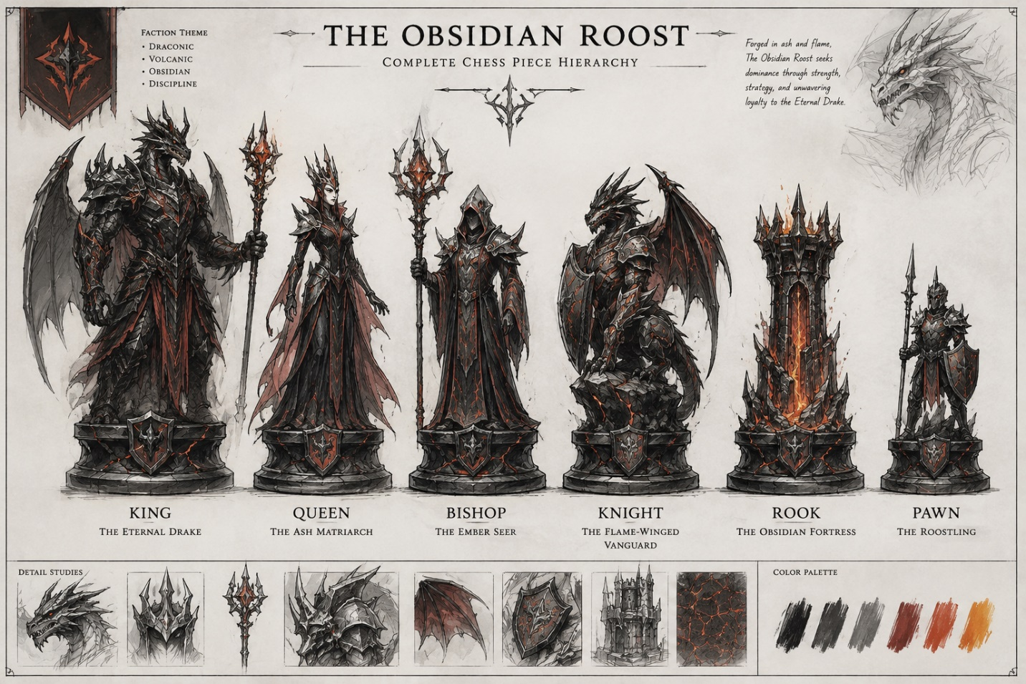
Character concept sheet showing the King, Queen, Bishop, Knight, Rook, and Pawn of The Obsidian Roost.

Figure C.2 – The Eternal Drake
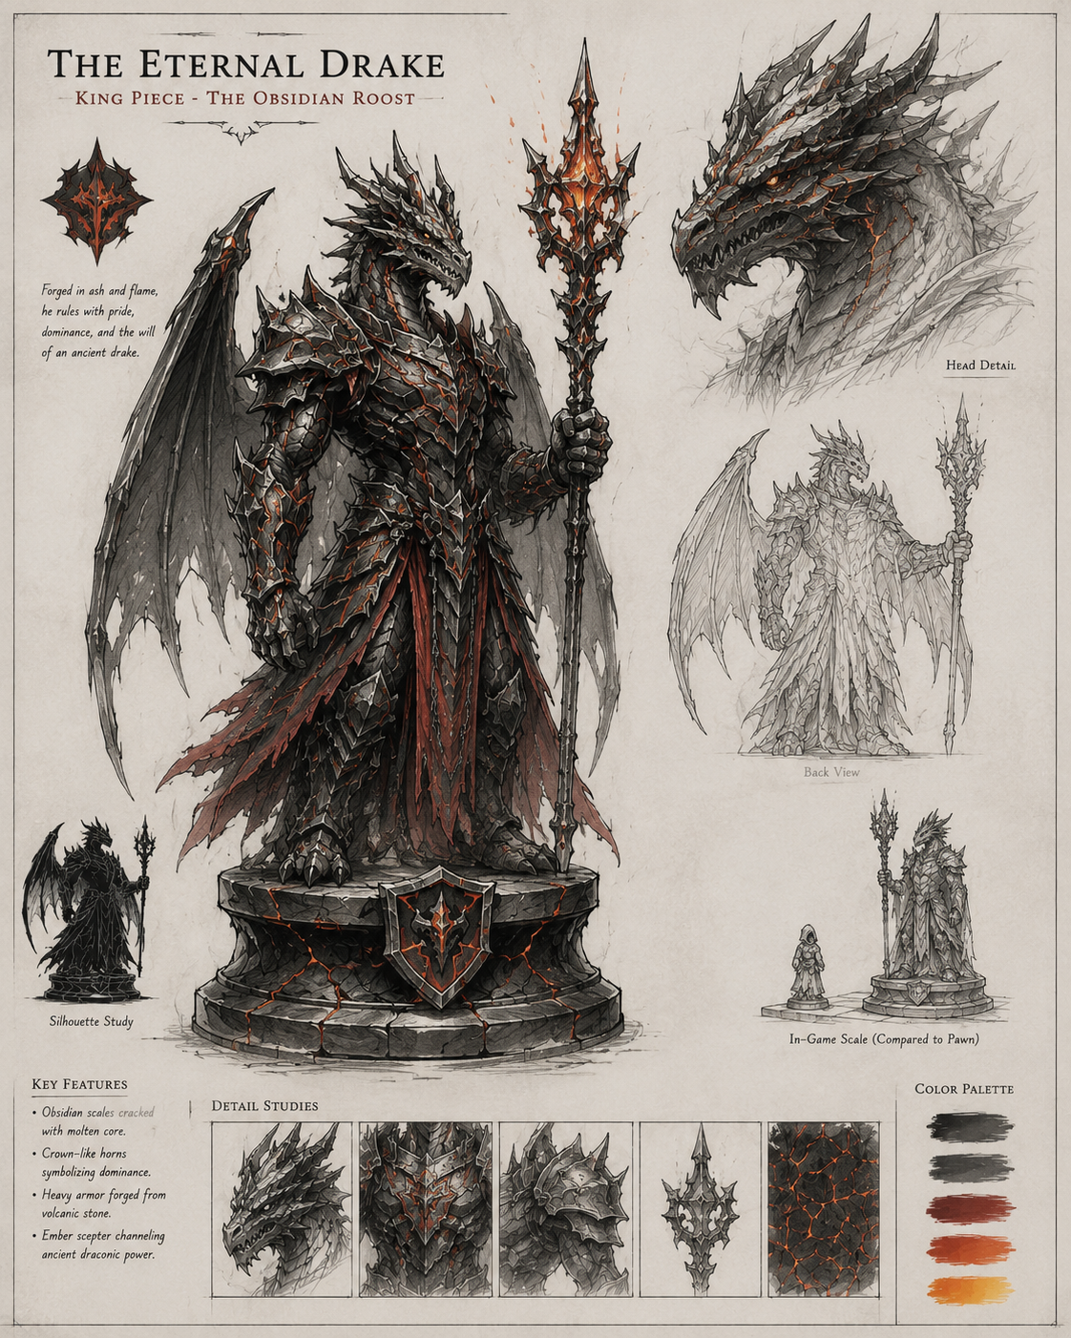
Preliminary character concept of The Eternal Drake, the King piece of The Obsidian Roost.
Figure C.3 – The Ash Matriarch
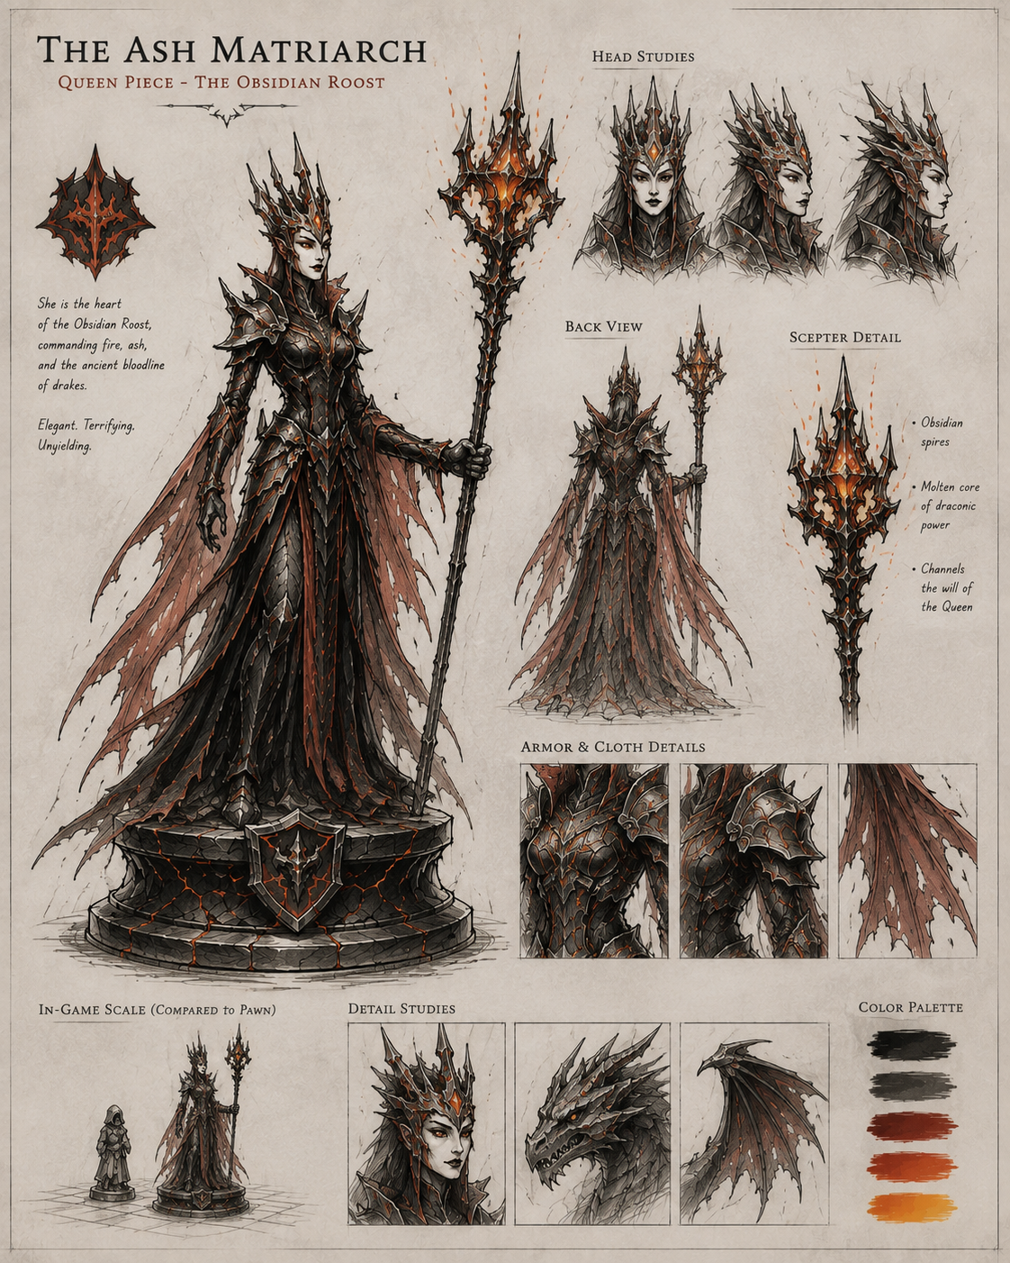
Preliminary character concept of The Ash Matriarch, the Queen piece of The Obsidian Roost.
Figure C.4 – The Flame-Winged Vanguard
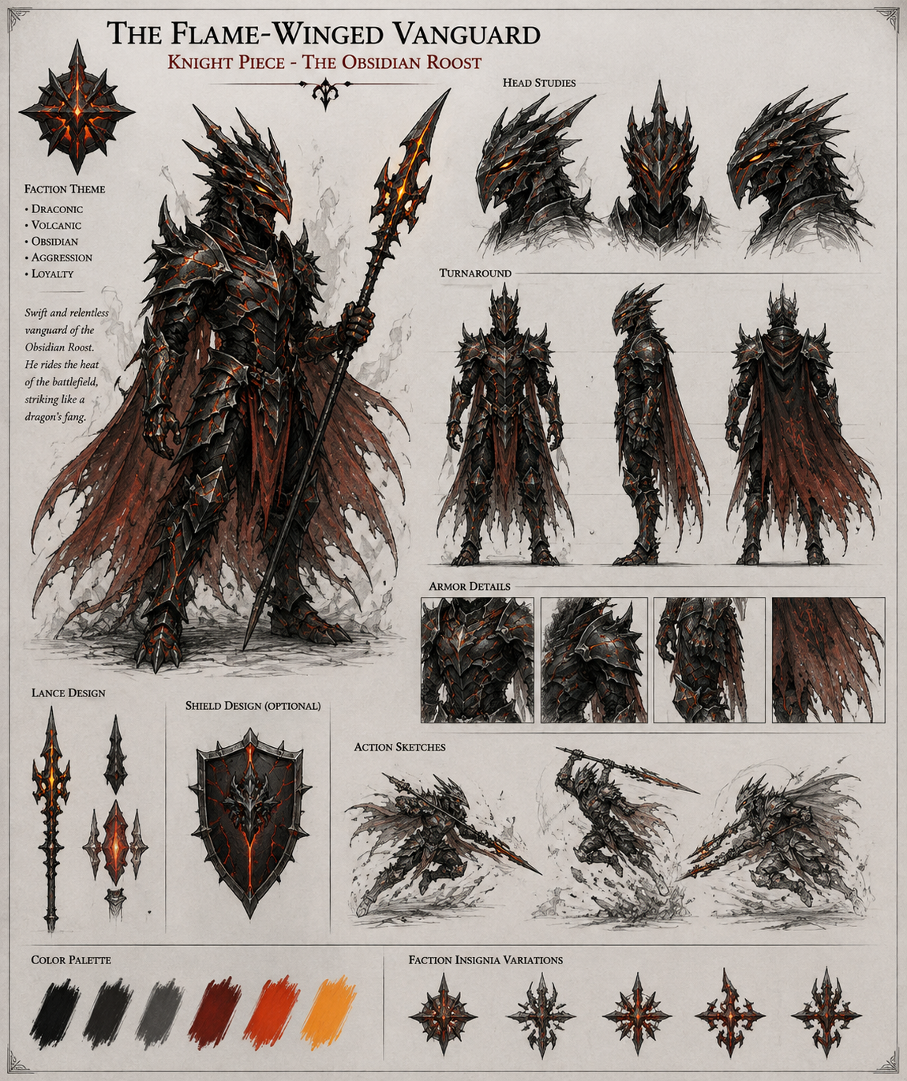
Preliminary character concept of the Flame-Winged Vanguard, the Knight piece of The Obsidian Roost.

Figure C.5 – The Verdant Court: Complete Chess Piece Hierarchy
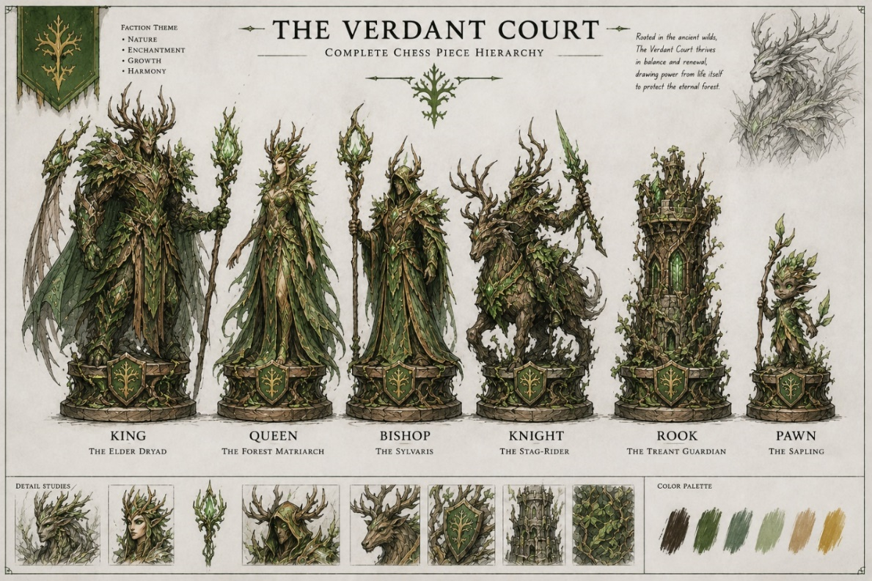
Character concept sheet showing the King, Queen, Bishop, Knight, Rook, and Pawn of The Verdant Court.

Figure C.6 – The Elder Dryad
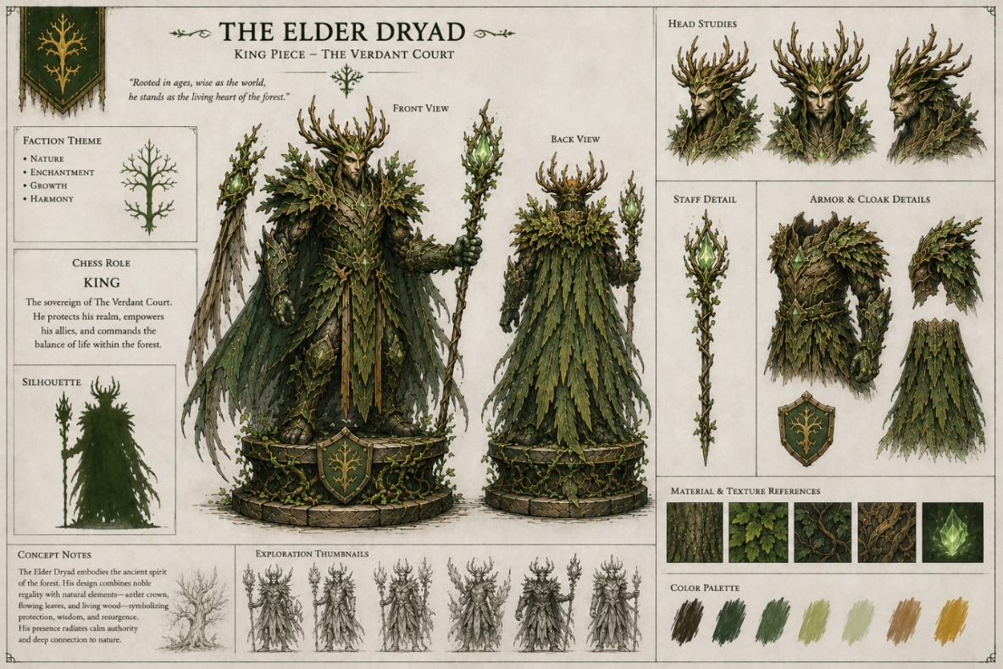
Preliminary character concept of The Elder Dryad, the King piece of The Verdant Court.

Figure C.7 – The Forest Matriarch
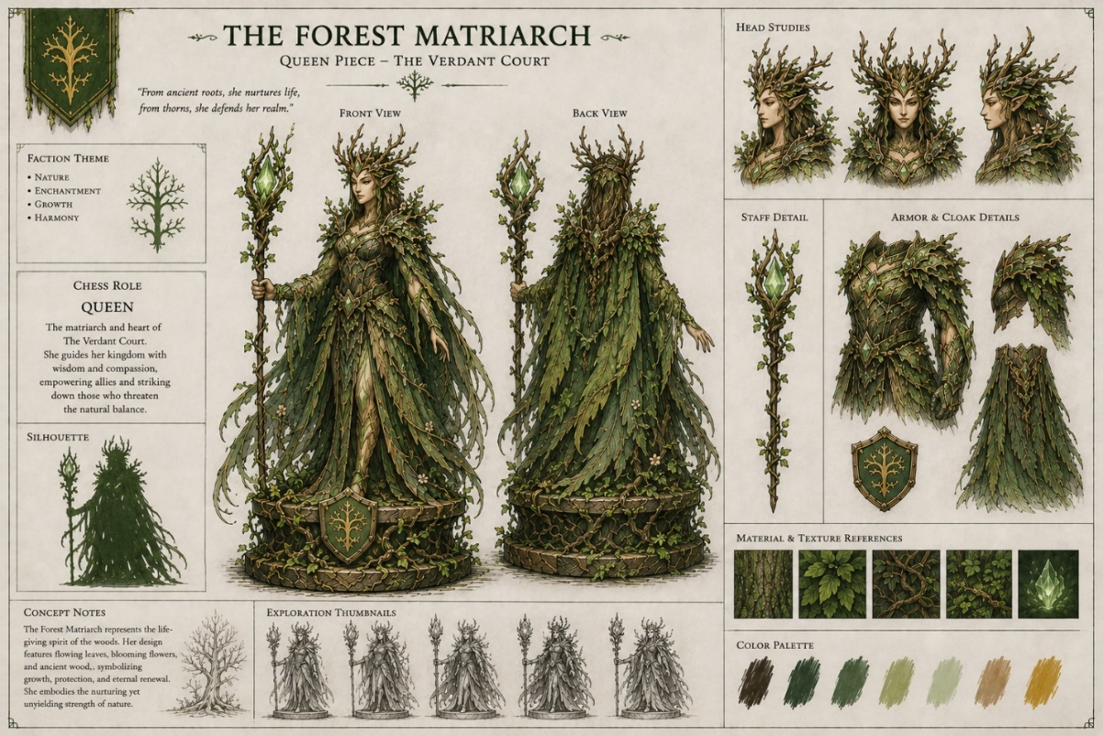
Preliminary character concept of The Forest Matriarch, the Queen piece of The Verdant Court.

Figure C.8 – The Stag-Rider
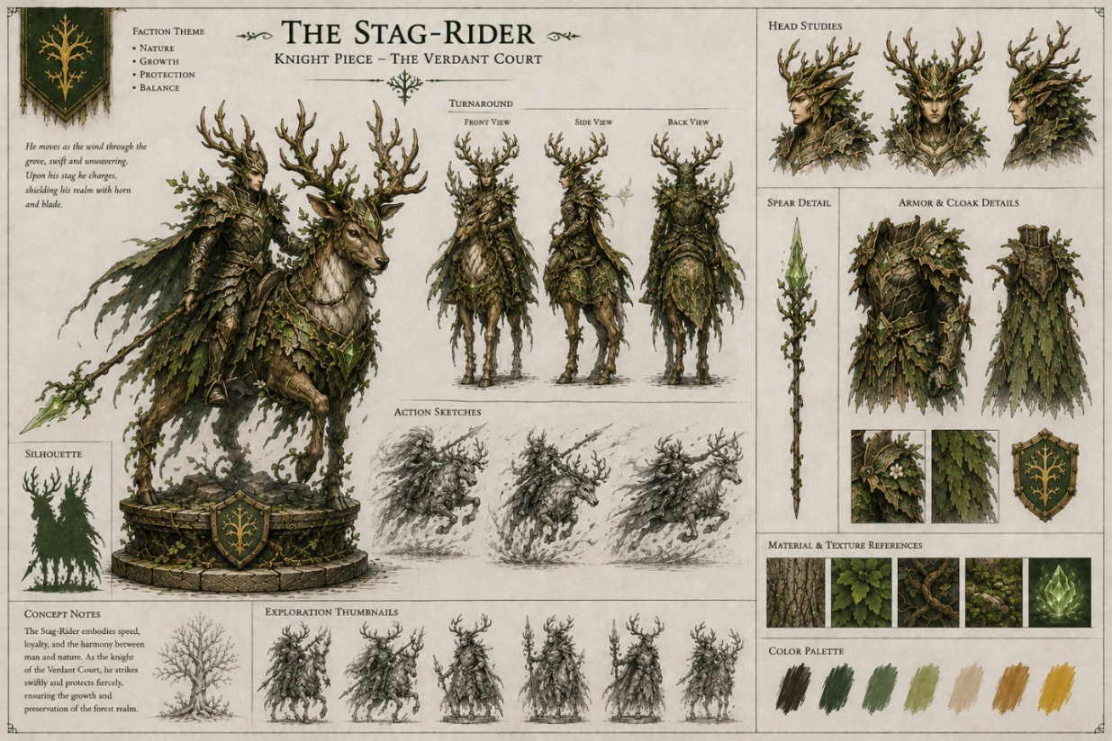
Preliminary character concept of the Stag-Rider, the Knight piece of The Verdant Court.
Figure C.9 – Character Silhouette Comparison

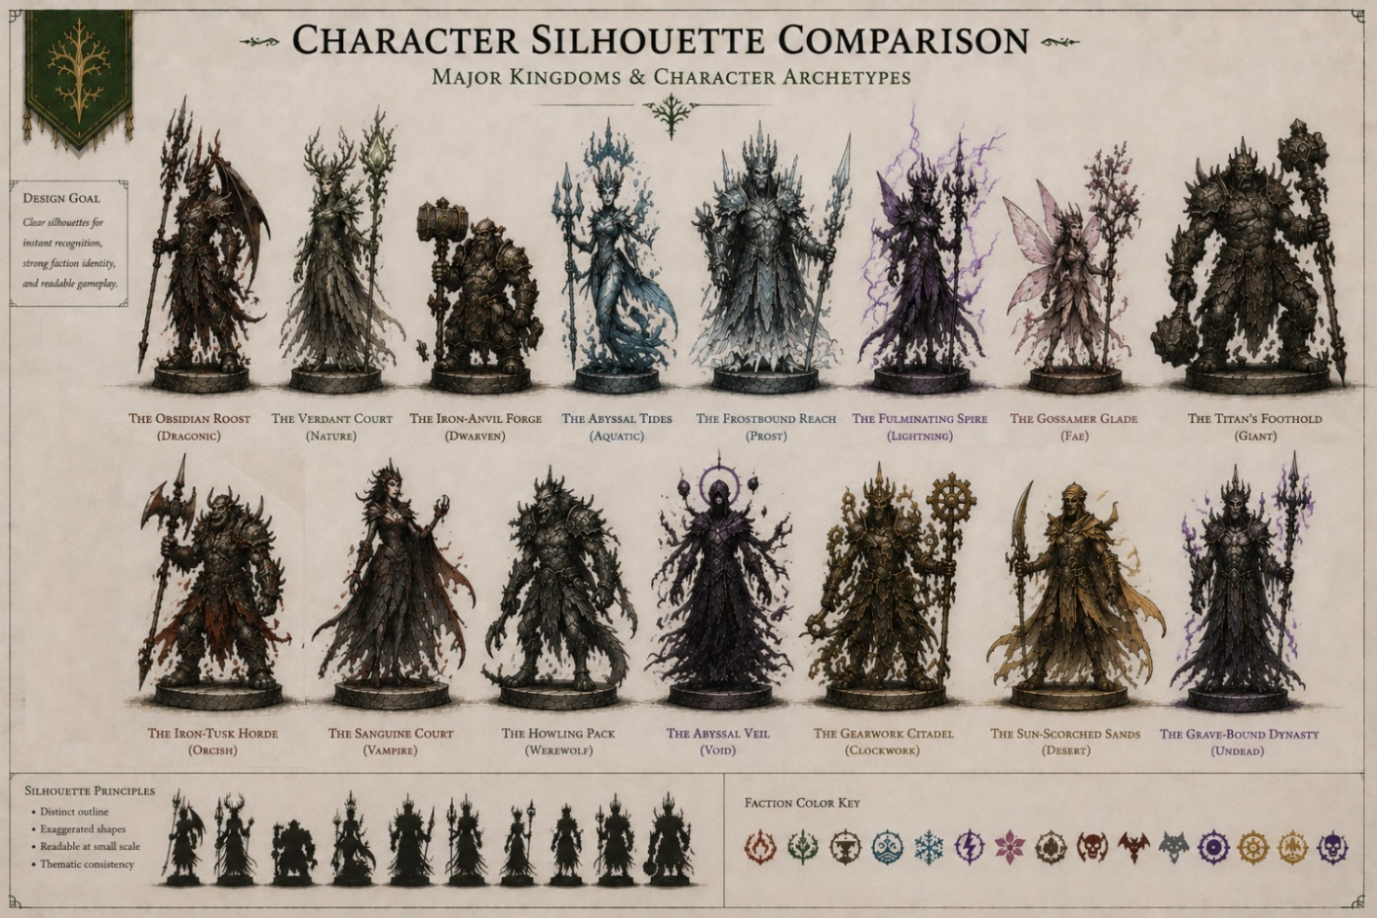
Comparative silhouette study demonstrating the visual differences among the major kingdoms and character archetypes of Mythic Gambit.

2. Kingdom & Faction Concept Art

This section shows the visual identity of the 15 kingdoms. You do not need to draw all six chess pieces again; one representative concept per kingdom is enough.

Figure C.10 – The Obsidian Roost
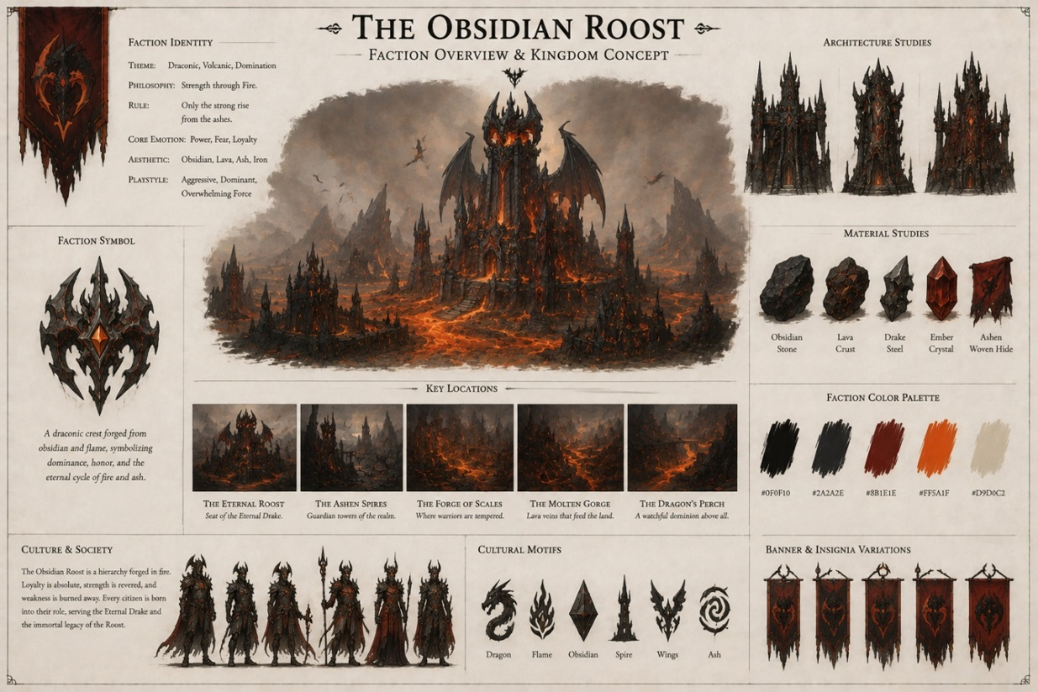
Faction concept illustrating the volcanic, draconic, and obsidian-inspired visual identity of The Obsidian Roost.

Figure C.11 – The Verdant Court
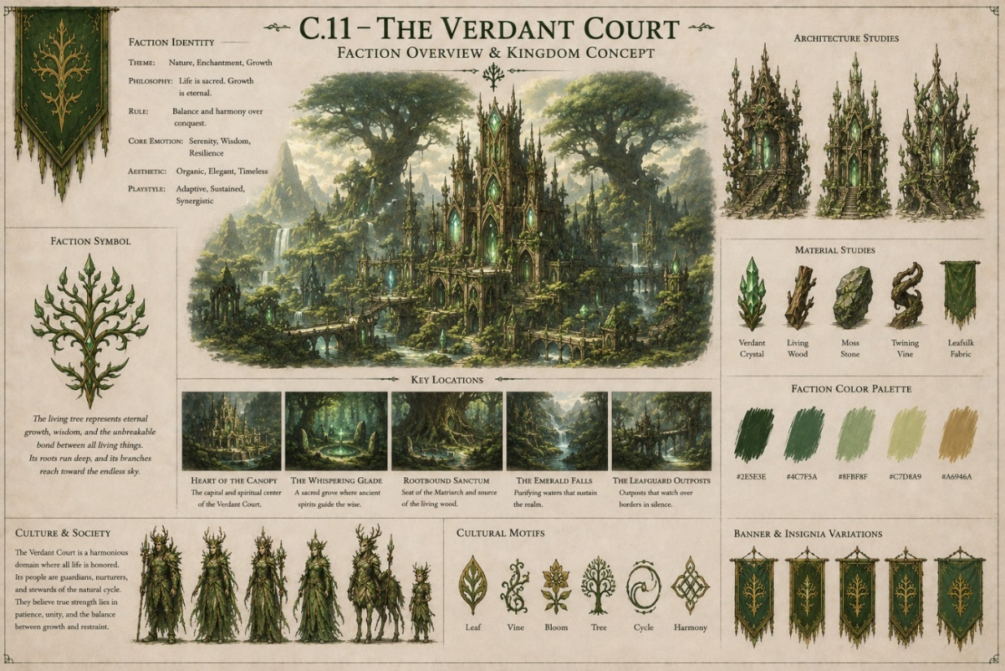
Faction concept illustrating the enchanted forest, magical vegetation, and nature-based identity of The Verdant Court.
Figure C.12 – The Iron-Anvil Forge
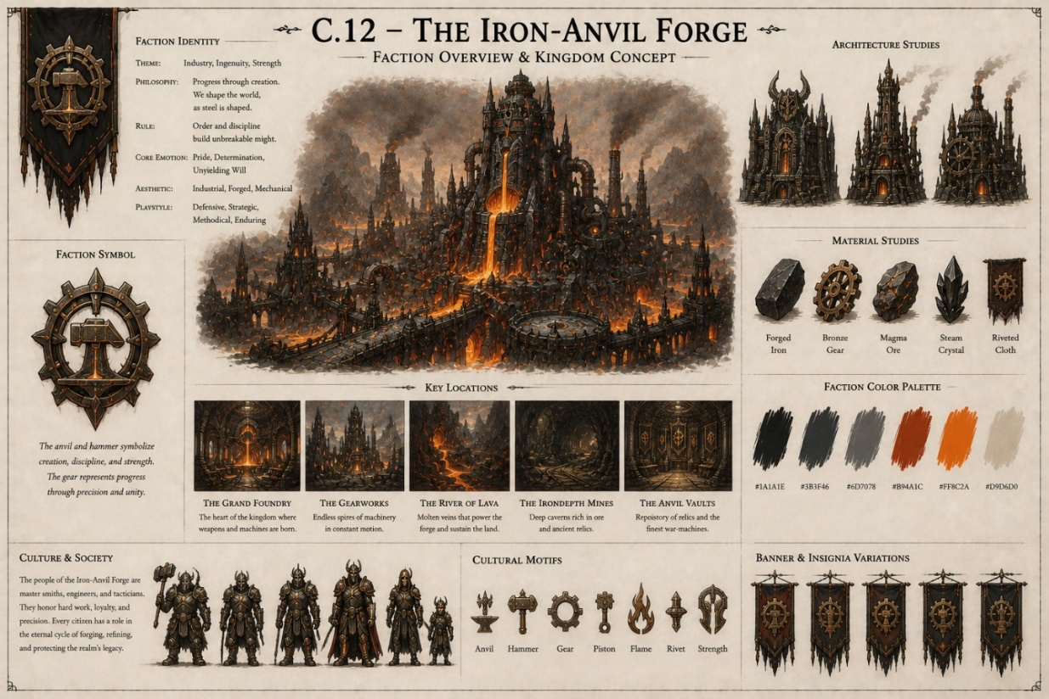
Faction concept illustrating the forged metal, industrial, and earth-based identity of The Iron-Anvil Forge.

Figure C.13 – The Abyssal Tides
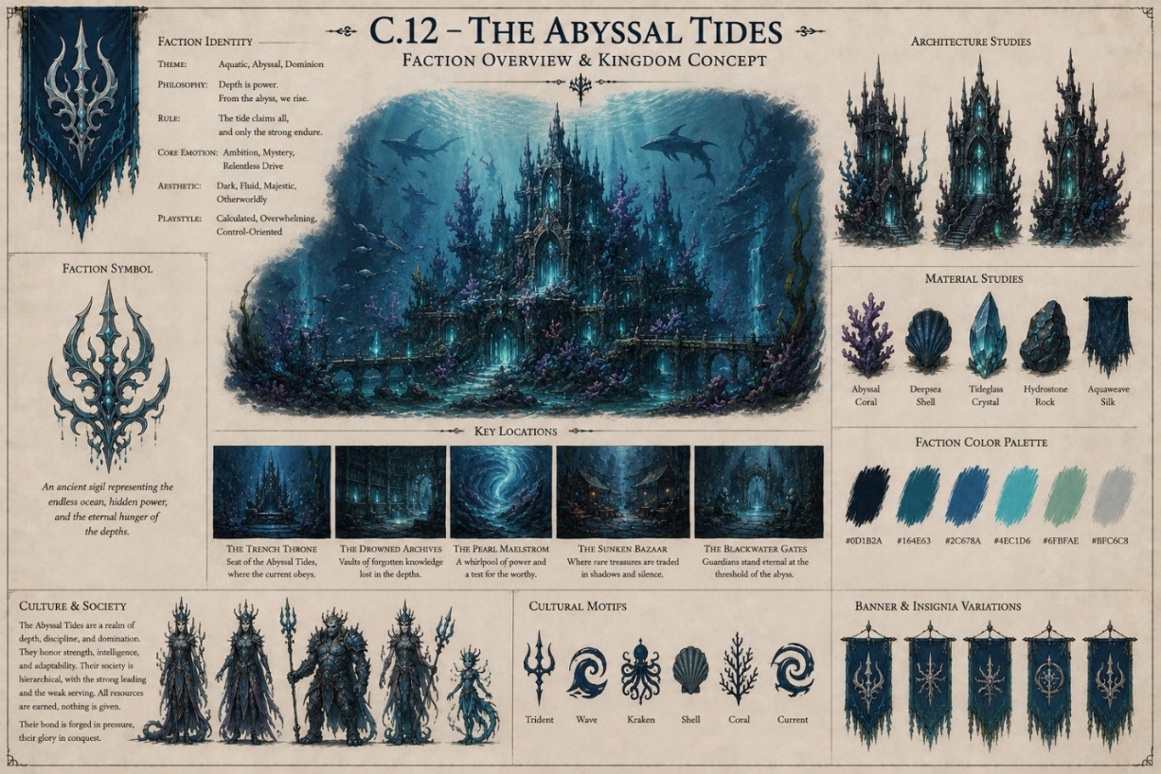
Faction concept illustrating the deep-ocean, aquatic, and bioluminescent identity of The Abyssal Tides.
Figure C.14 – The Frostbound Reach
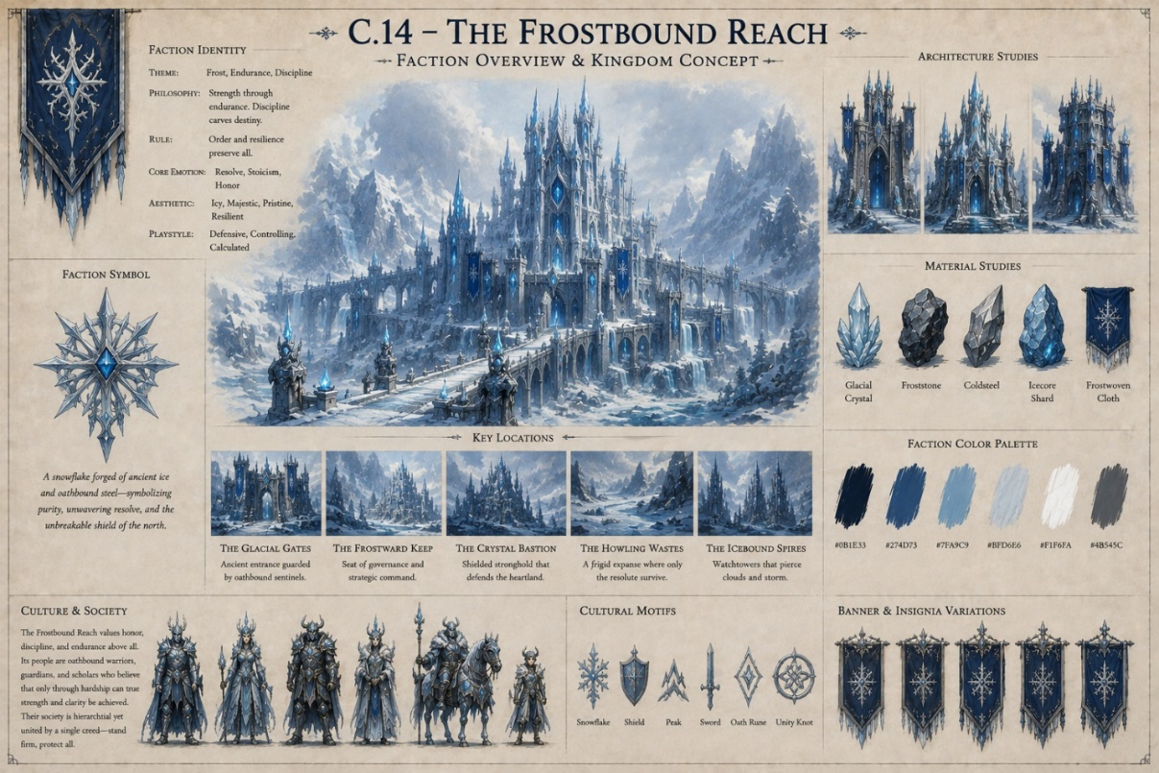
Faction concept illustrating the glacial, crystalline, and frozen identity of The Frostbound Reach.

Figure C.15 – The Fulminating Spire
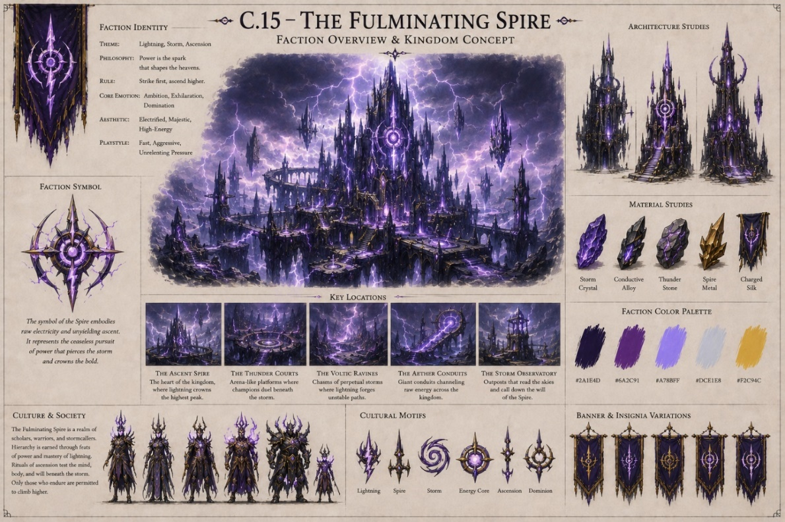
Faction concept illustrating the lightning, storm, and high-energy identity of The Fulminating Spire.

Figure C.16 – The Gossamer Glade

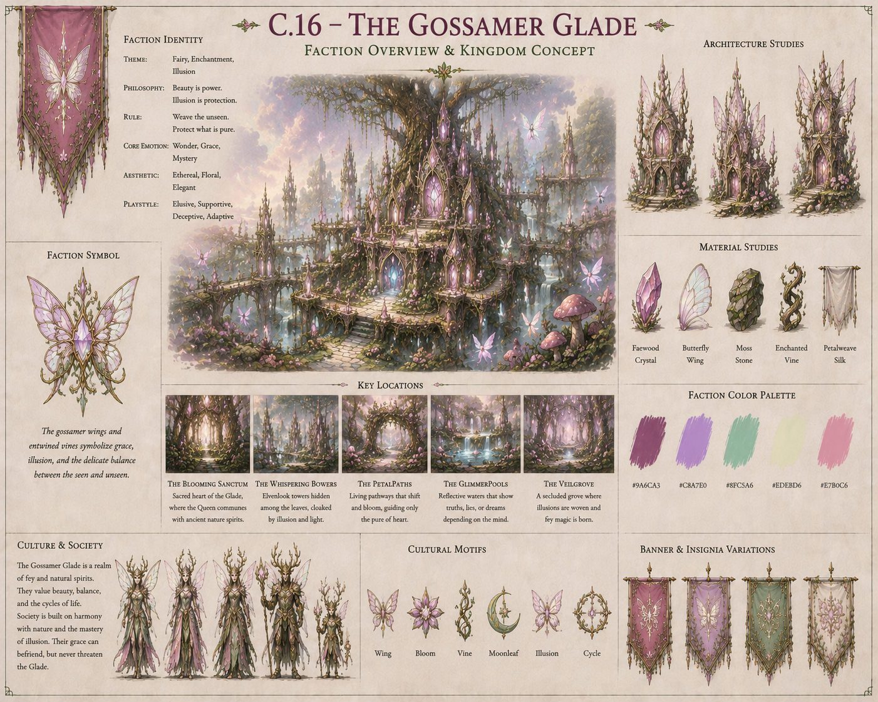
Faction concept illustrating the fairy, illusion, and enchanted botanical identity of The Gossamer Glade.

Figure C.17 – The Titan's Foothold

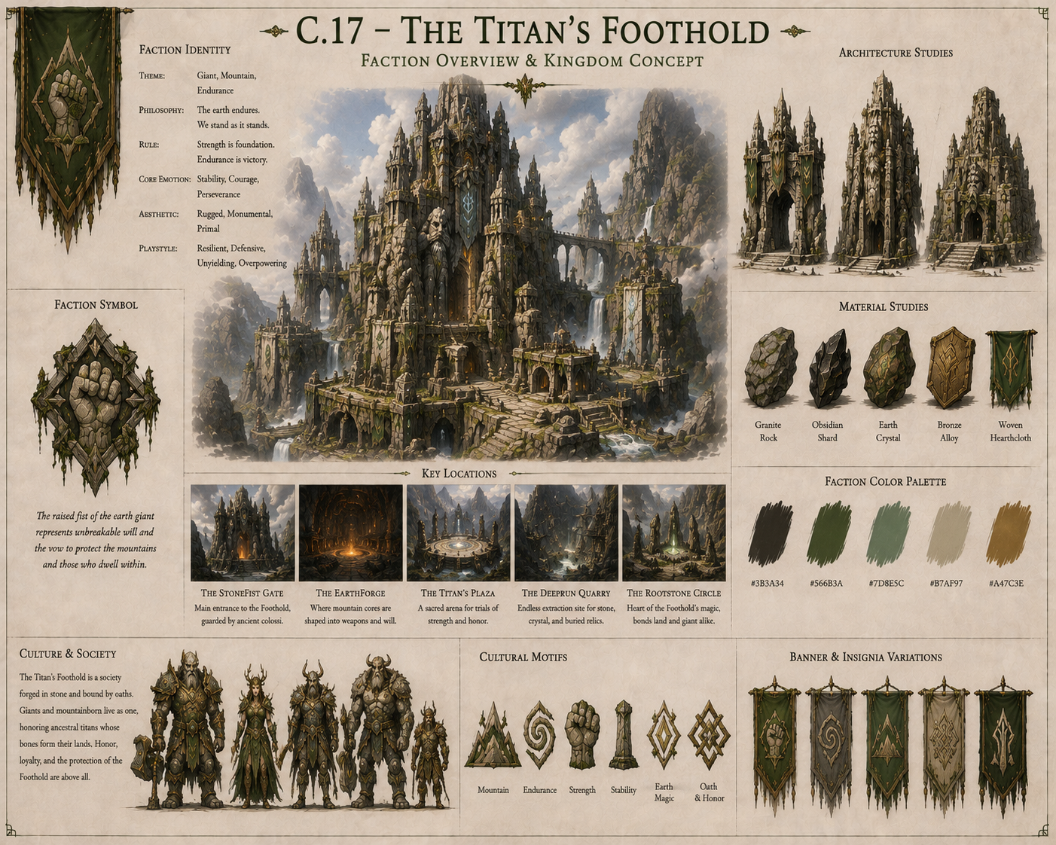
Faction concept illustrating the giant, mountain, and earth-based identity of The Titan's Foothold.

Figure C.18 – The Iron-Tusk Horde

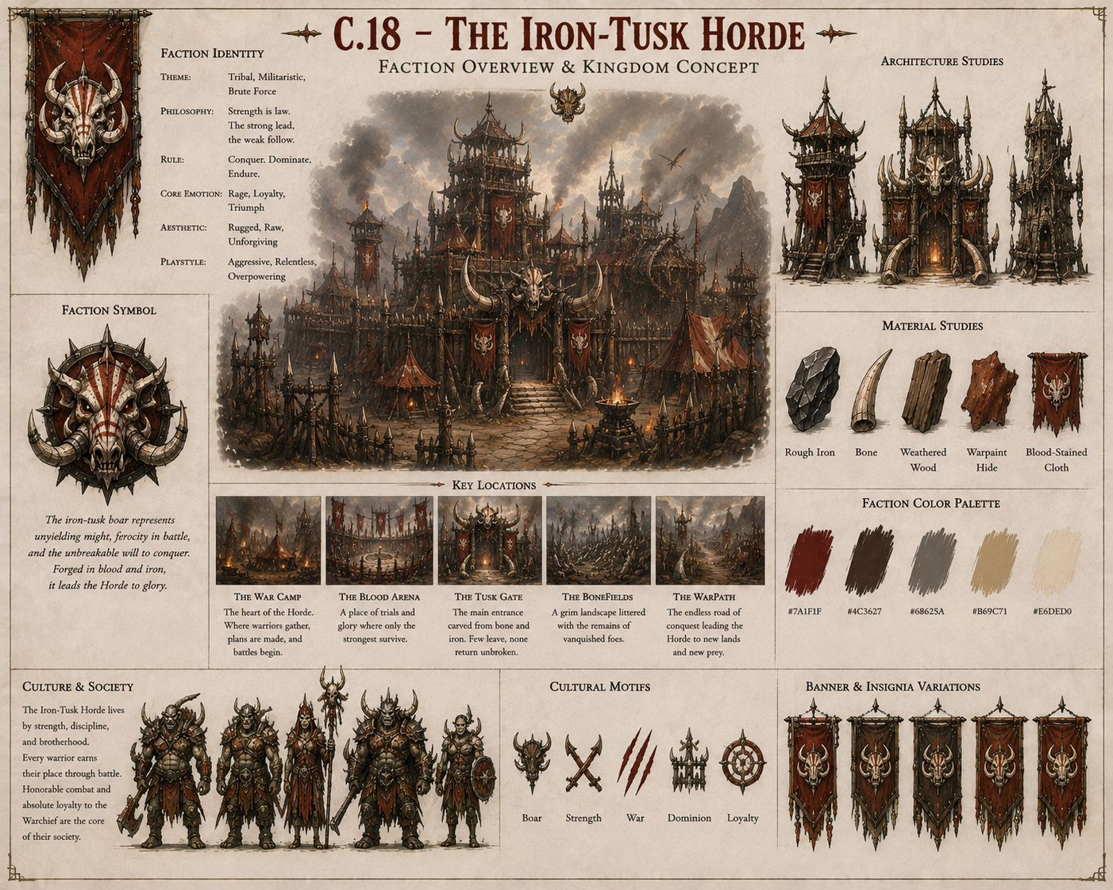
Faction concept illustrating the tribal, militaristic, and brute-force identity of The Iron-Tusk Horde.

Figure C.19 – The Sanguine Court

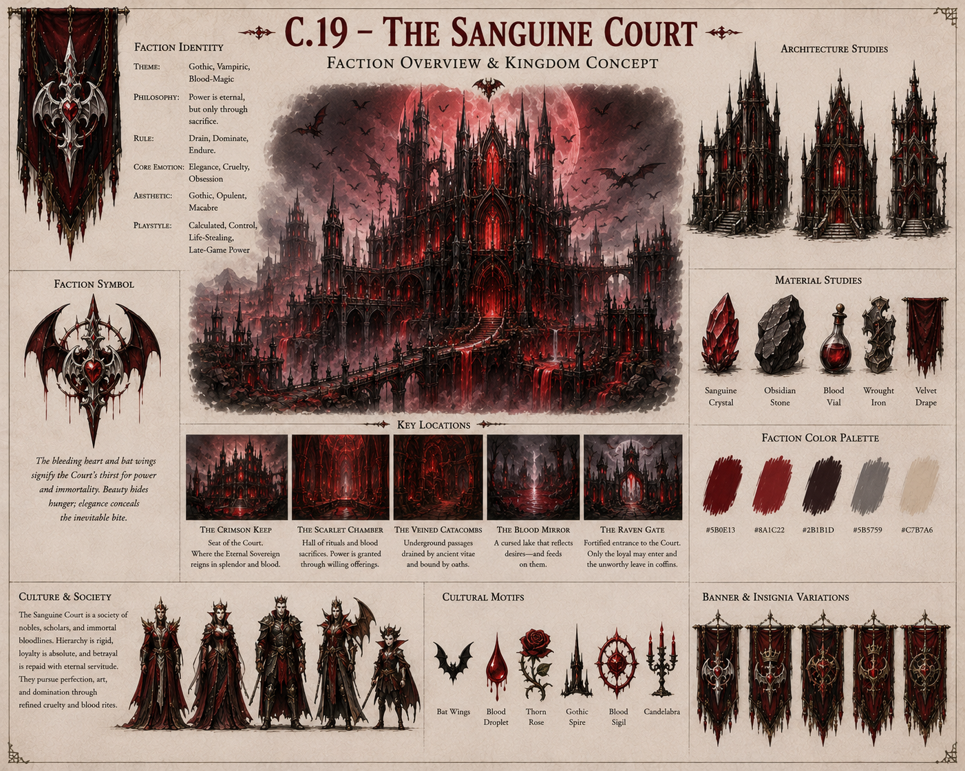
Faction concept illustrating the gothic, vampiric, and blood-magic identity of The Sanguine Court.

Figure C.20 – The Howling Pack
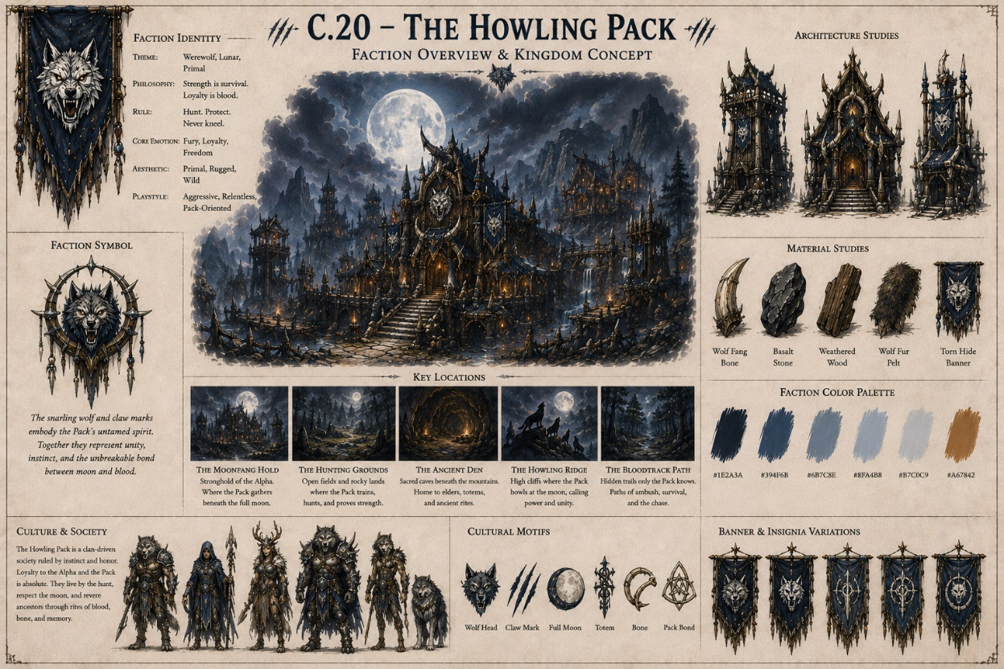
Faction concept illustrating the werewolf, lunar, and primal identity of The Howling Pack.

Figure C.21 – The Abyssal Veil
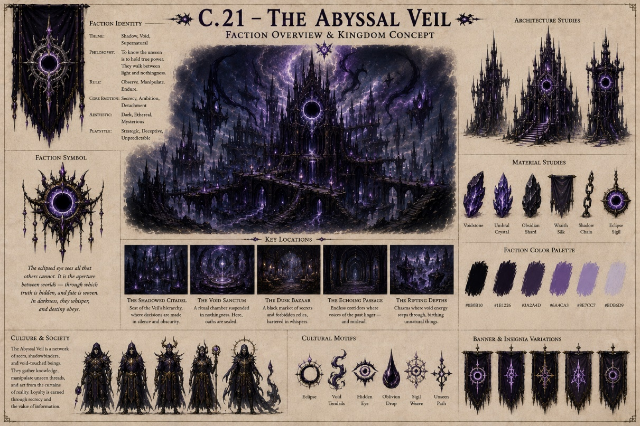
Faction concept illustrating the shadow, void, and supernatural identity of The Abyssal Veil.
Figure C.22 – The Gearwork Citadel
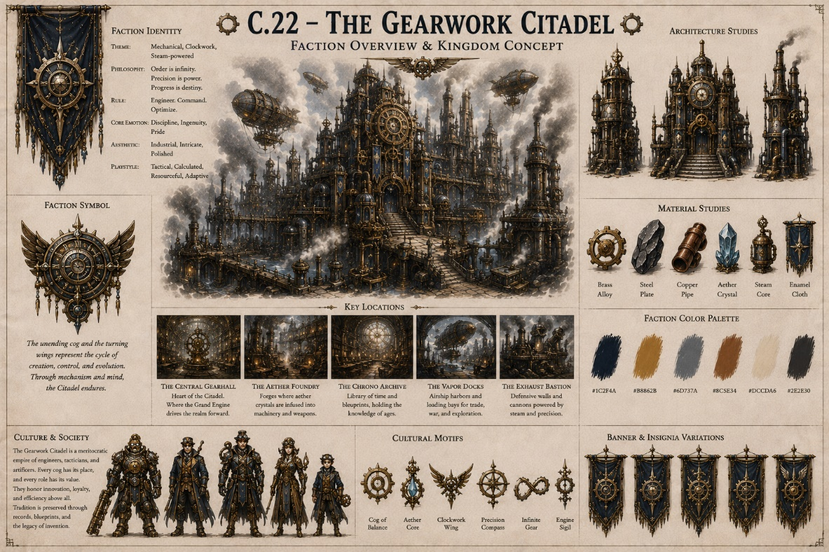
Faction concept illustrating the mechanical, clockwork, and steam-powered identity of The Gearwork Citadel.

Figure C.23 – The Sun-Scorched Sands
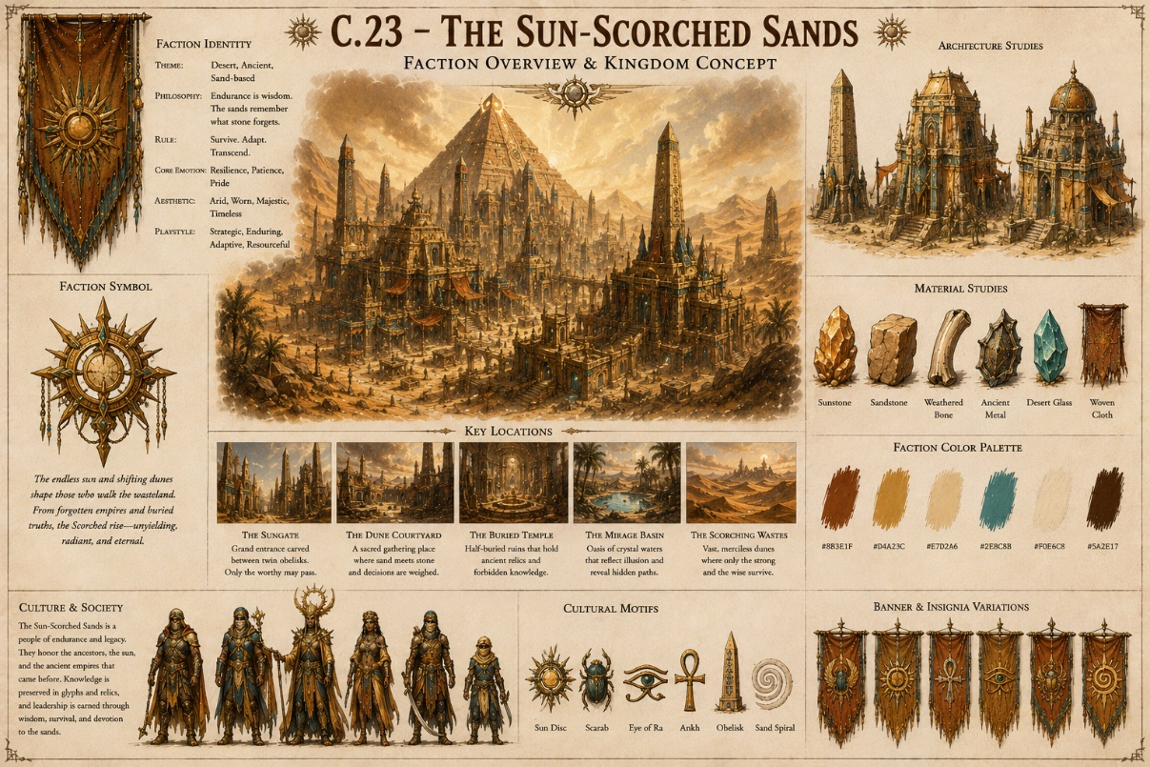
Faction concept illustrating the desert, ancient, and sand-based identity of The Sun-Scorched Sands.

Figure C.24 – The Grave-Bound Dynasty

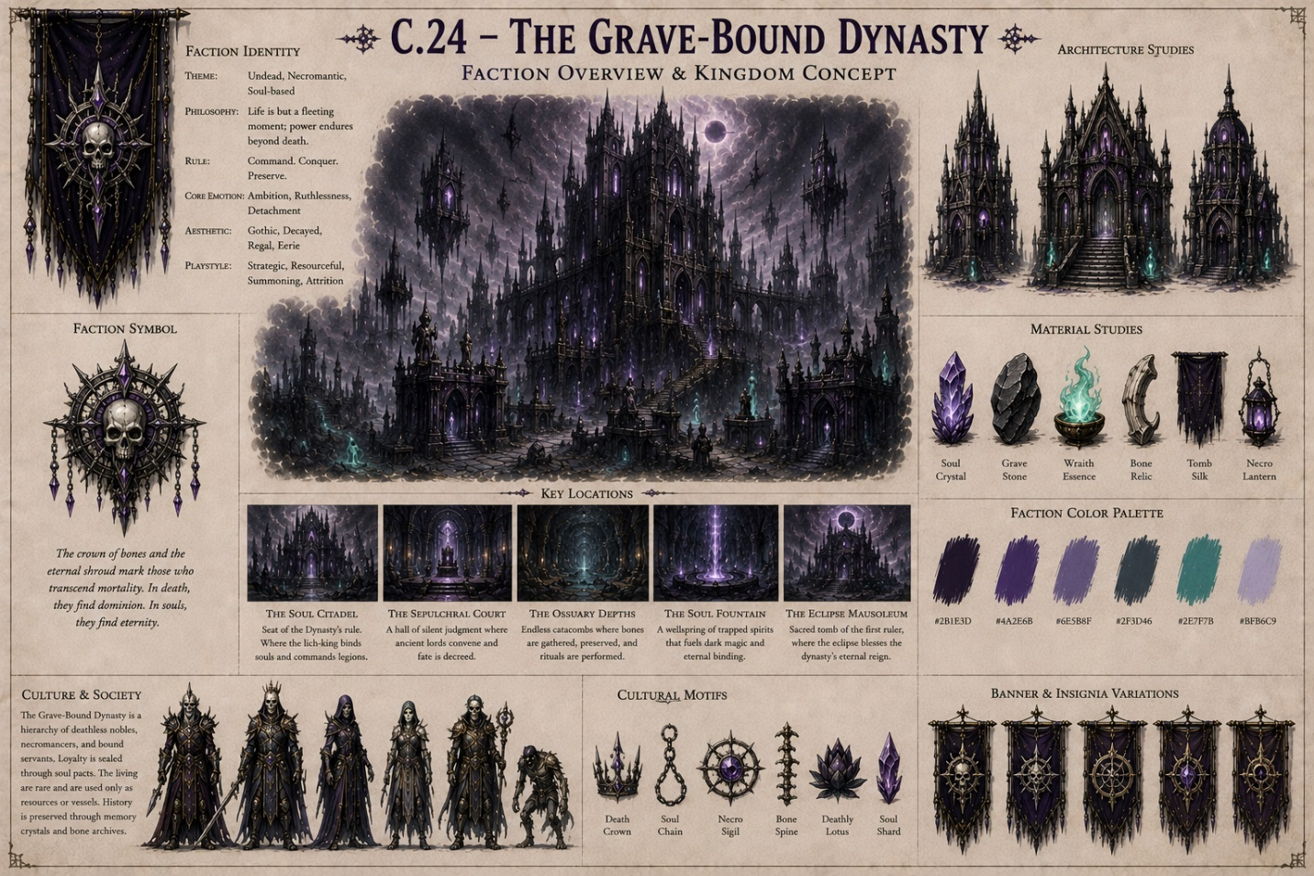
Faction concept illustrating the undead, necromantic, and soul-based identity of The Grave-Bound Dynasty.

3. Chess Board & Environment Sketches

This section focuses on the battlefield, floating board, terrain, and atmospheric environments.

Figure C.25 – The Planar Board

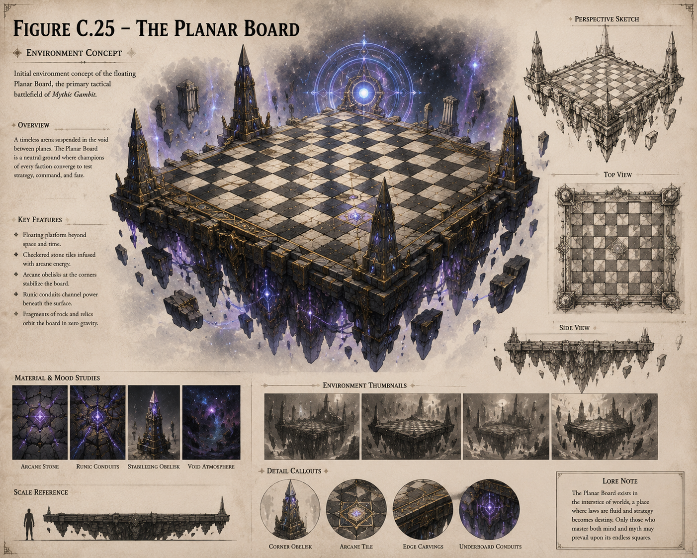
Initial environment concept of the floating Planar Board, the primary tactical battlefield of Mythic Gambit.

Figure C.26 – Standardized 8×8 Tactical Grid

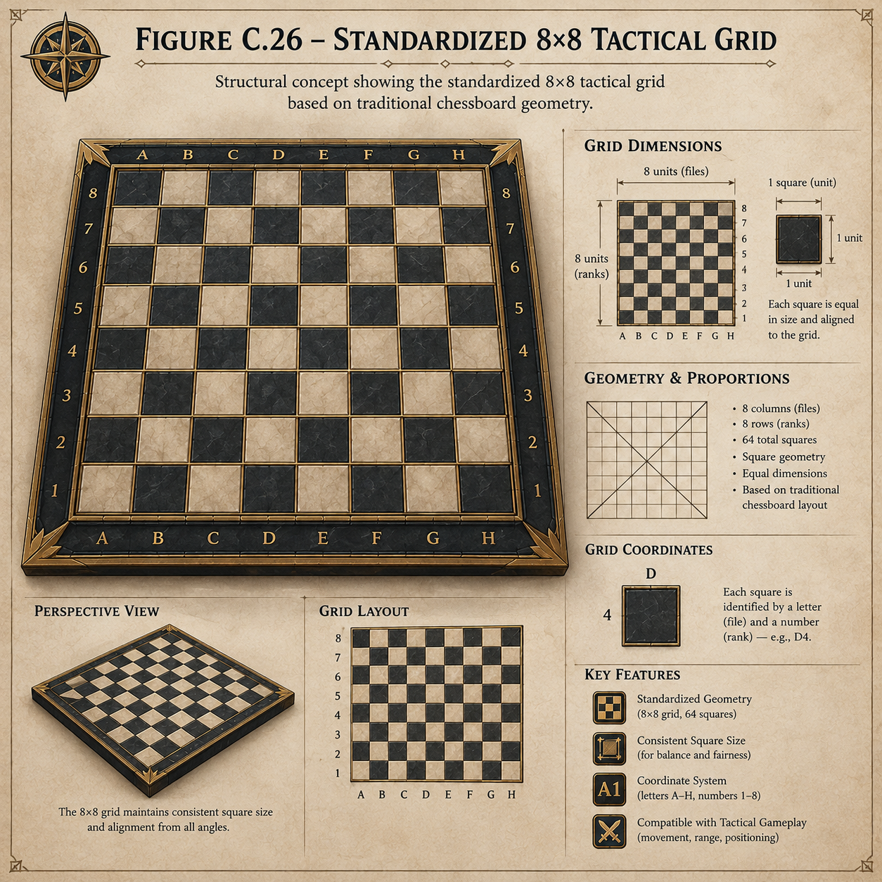
Structural concept showing the standardized 8×8 tactical grid based on traditional chessboard geometry.

Figure C.27 – Zonal Ownership and Territory Expansion

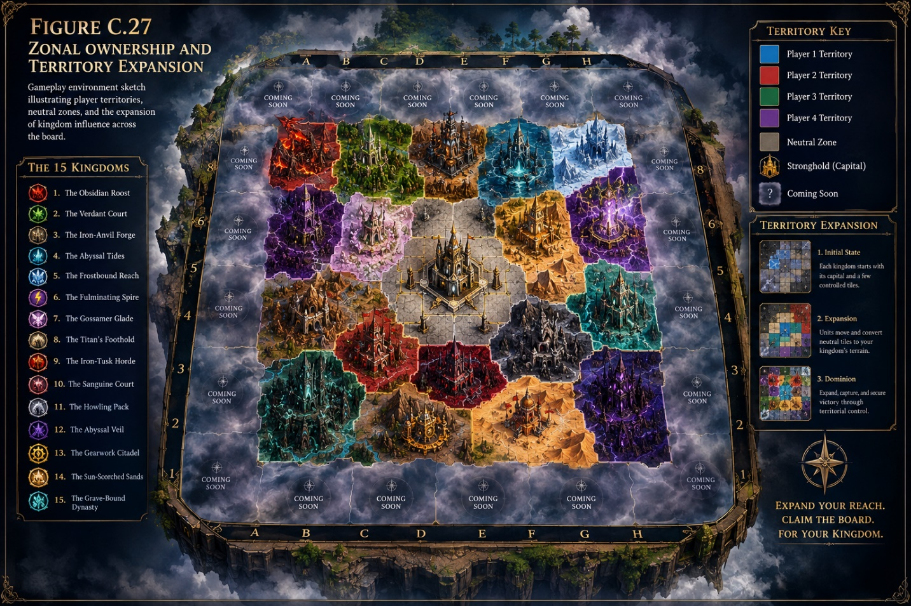
Gameplay environment sketch illustrating player territories, neutral zones, and the expansion of kingdom influence across the board.

Figure C.28 – Terrain Transformation Concept

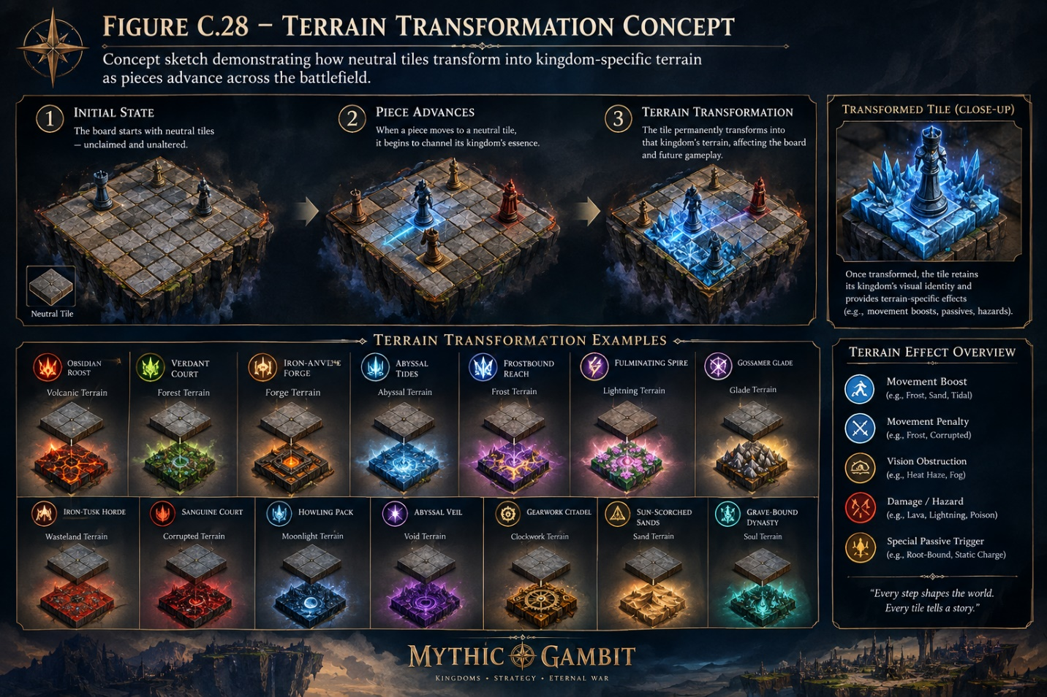
Concept sketch demonstrating how neutral tiles transform into kingdom-specific terrain as pieces advance across the battlefield.

Figure C.29 – Kingdom Terrain Comparison

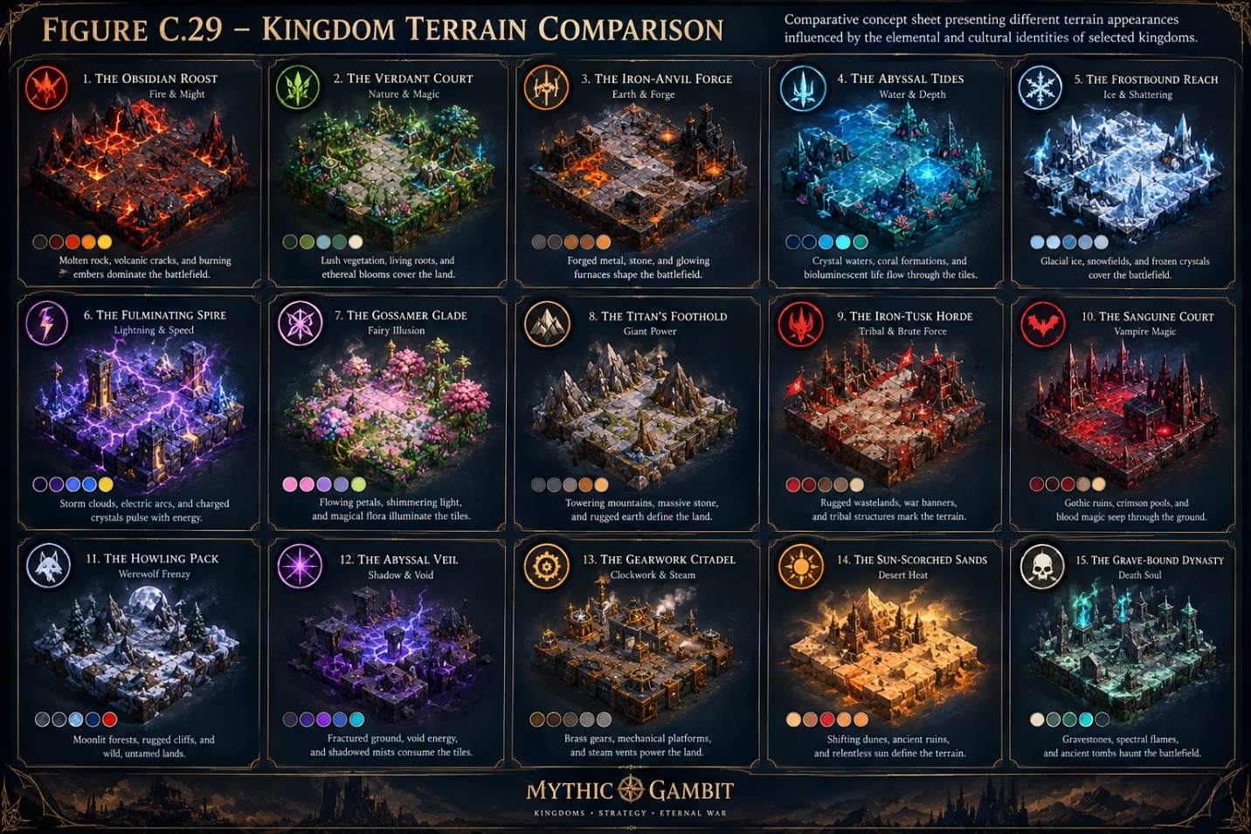
Comparative concept sheet presenting different terrain appearances influenced by the elemental and cultural identities of selected kingdoms.

Figure C.30 – Volcanic Realm

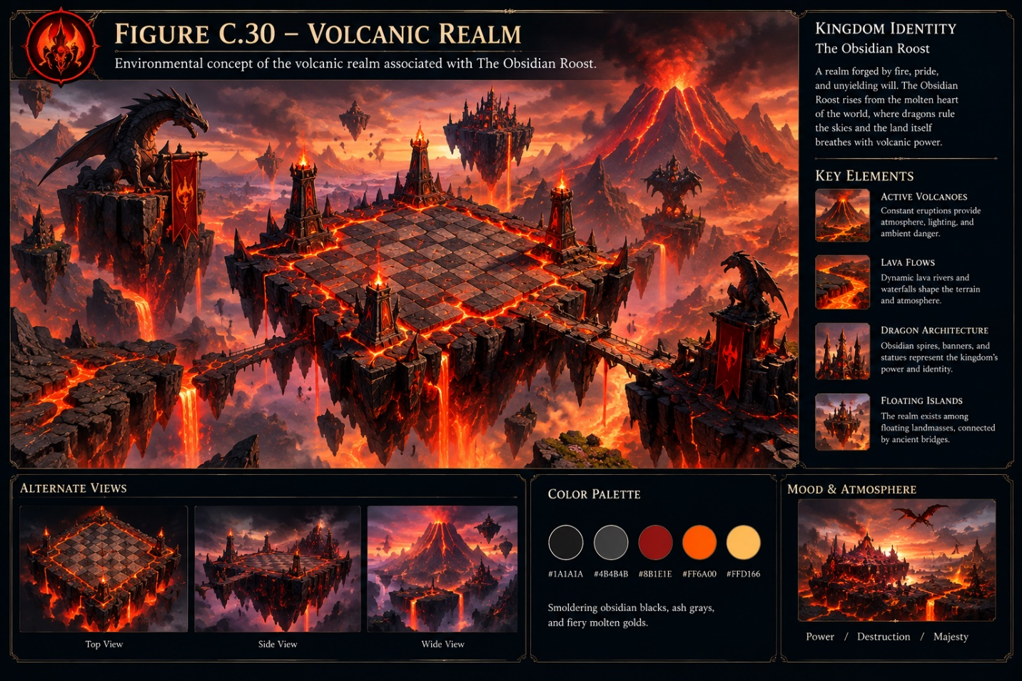
Environmental concept of the volcanic realm associated with The Obsidian Roost.

Figure C.31 – Enchanted Forest Realm
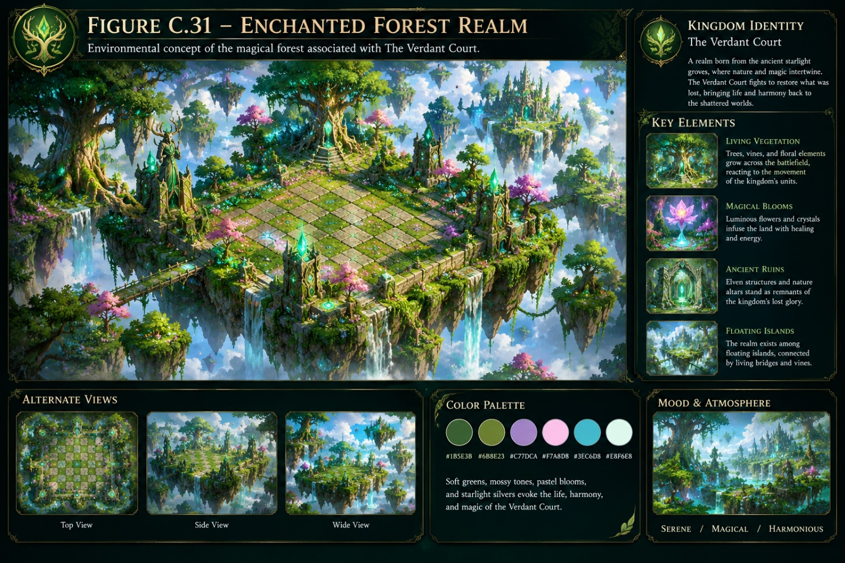
Environmental concept of the magical forest associated with The Verdant Court.

Figure C.32 – Frozen Realm
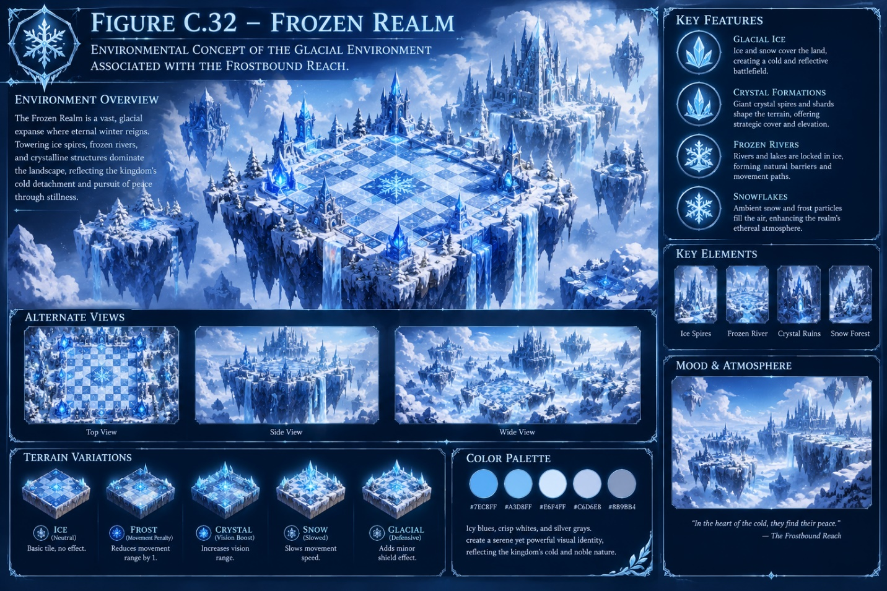
Environmental concept of the glacial environment associated with The Frostbound Reach.

Figure C.33 – Abyssal Ocean Realm
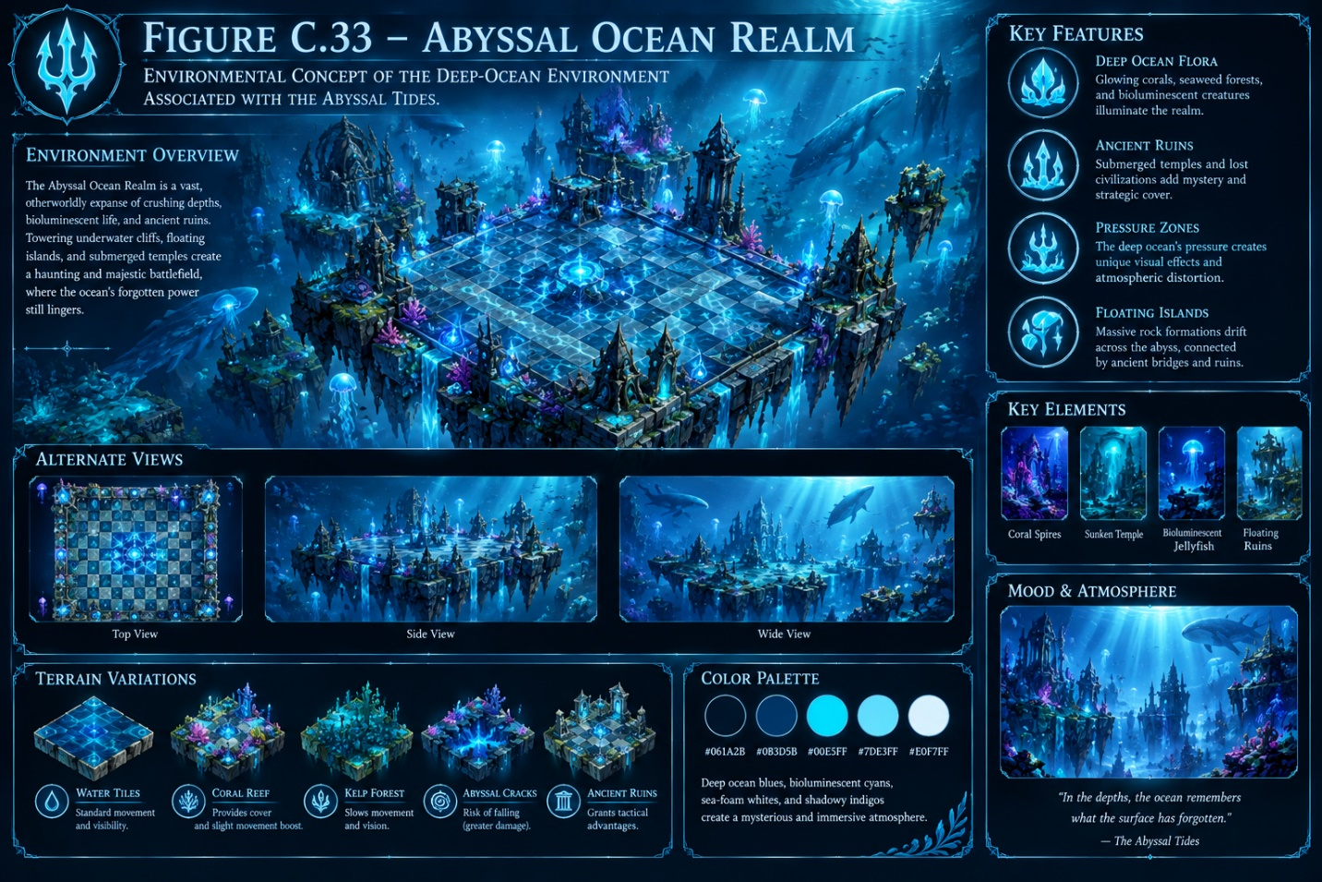
Environmental concept of the deep-ocean environment associated with The Abyssal Tides.

Figure C.34 – Clockwork Citadel Realm
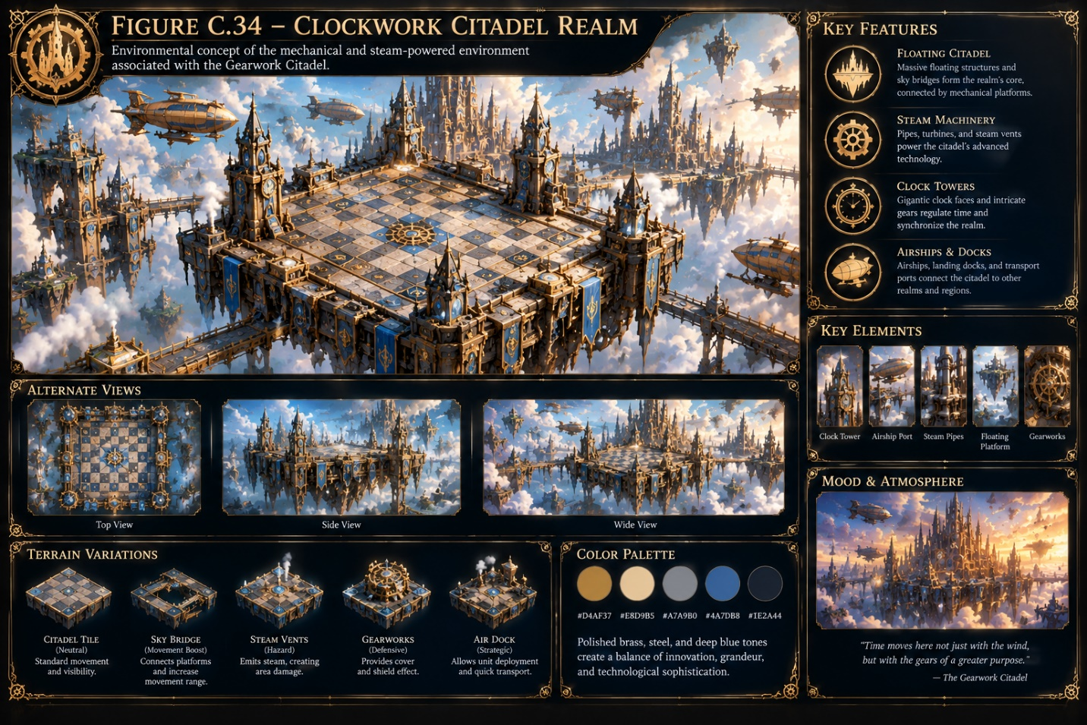
Environmental concept of the mechanical and steam-powered environment associated with The Gearwork Citadel.

4. Gameplay Mechanic Visual Concepts
This section visually explains the major gameplay systems that make Mythic Gambit different from traditional chess.

Figure C.35 – Traditional Chess Movement System
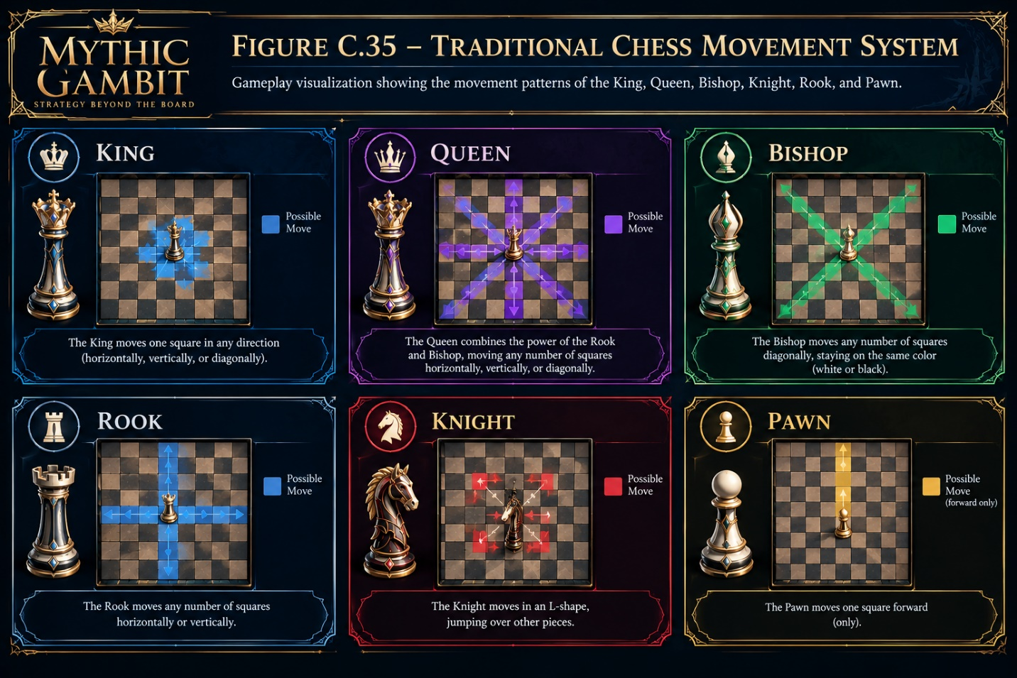
Gameplay visualization showing the movement patterns of the King, Queen, Bishop, Knight, Rook, and Pawn.

Figure C.36 – The Manifestation System
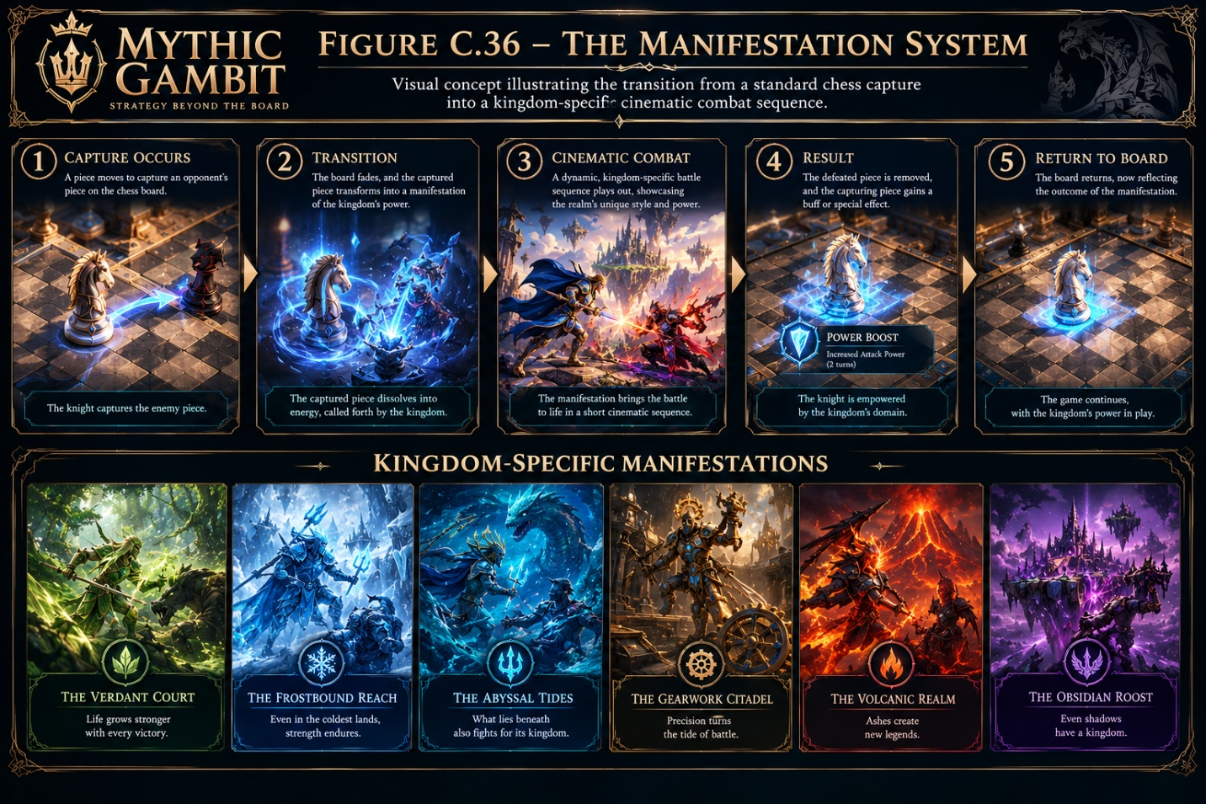
Visual concept illustrating the transition from a standard chess capture into a kingdom-specific cinematic combat sequence.

Figure C.37 – Dynamic Terrain Influence
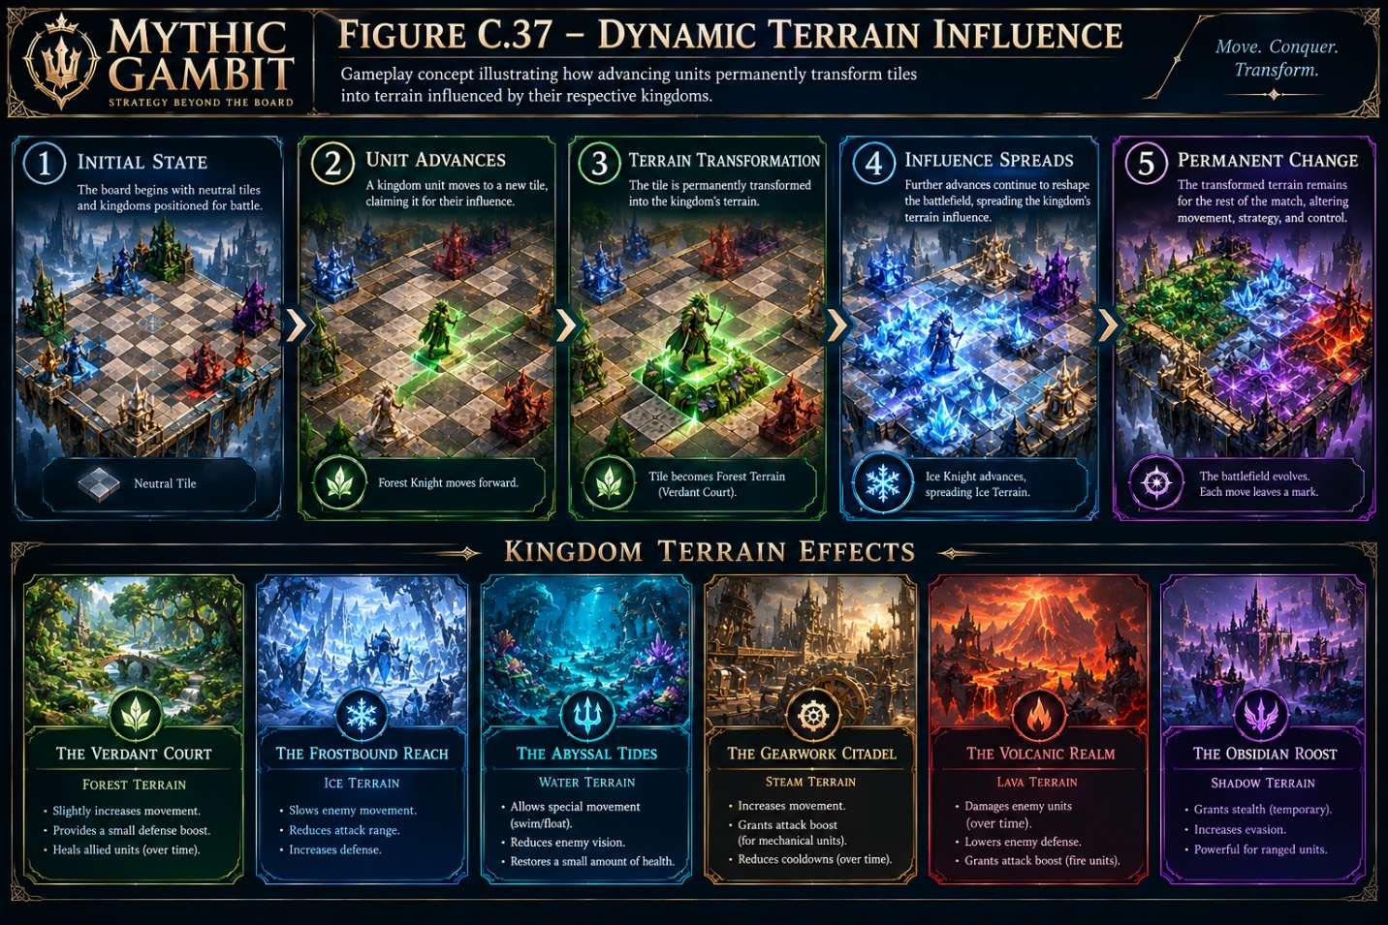
Gameplay concept illustrating how advancing units permanently transform tiles into terrain influenced by their respective kingdoms.

Figure C.38 – Heat Haze
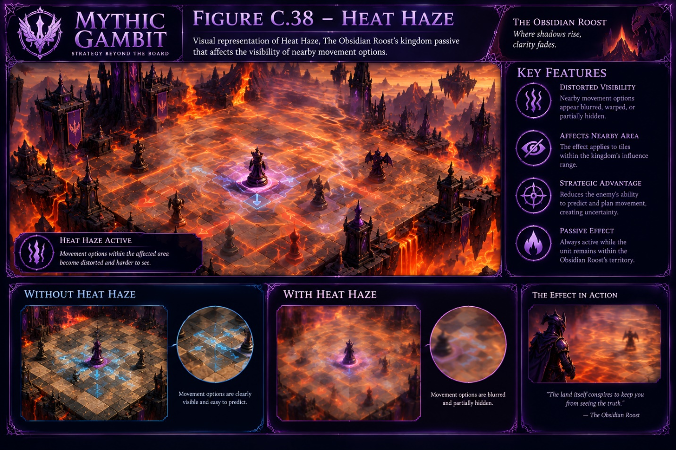
Visual representation of Heat Haze, The Obsidian Roost's kingdom passive that affects the visibility of nearby movement options.

Figure C.39 – Root-Bound
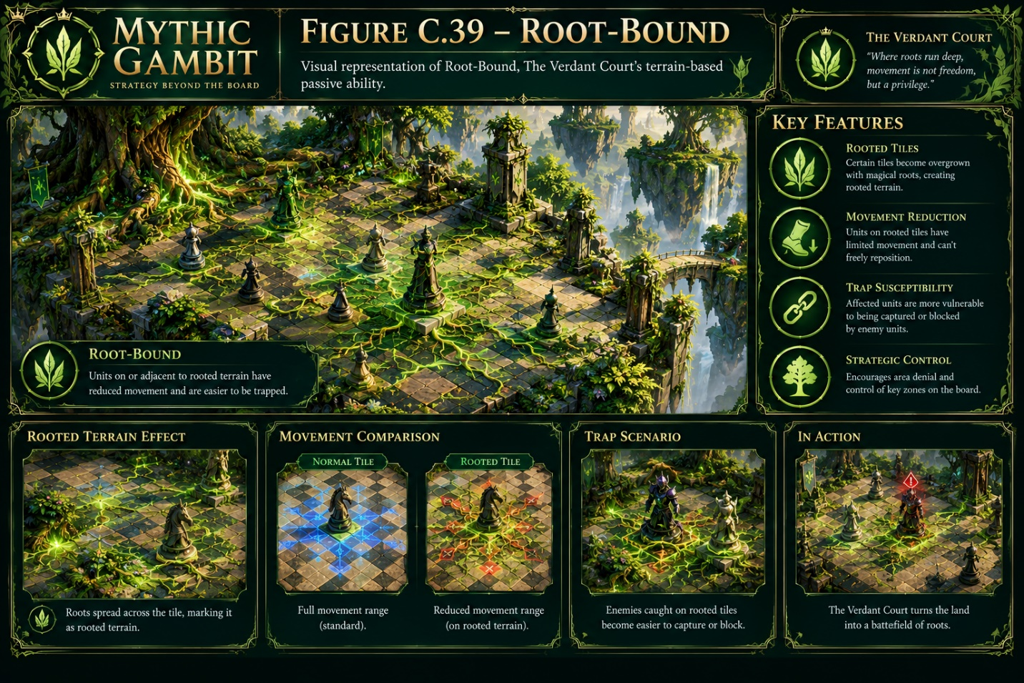
Visual representation of Root-Bound, The Verdant Court's terrain-based passive ability.

Figure C.40 – Tidal Flow
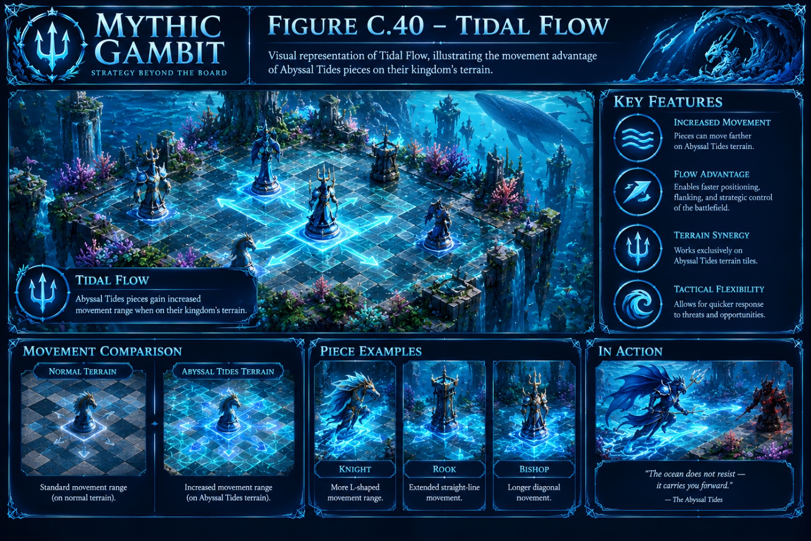
Visual representation of Tidal Flow, illustrating the movement advantage of Abyssal Tides pieces on their kingdom's terrain.

Figure C.41 – Static Charge
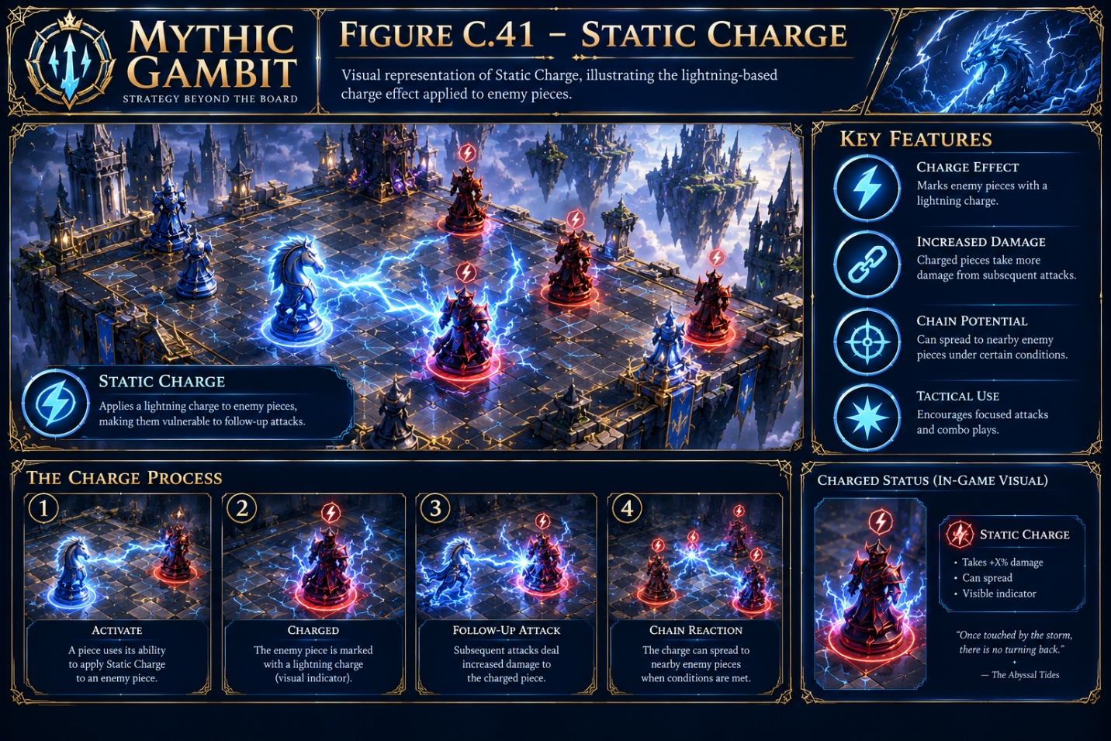
Visual representation of Static Charge, illustrating the lightning-based charge effect applied to enemy pieces.

Figure C.42 – Glimmer
Visual representation of Glimmer, illustrating the creation of an illusionary decoy by a Gossamer Glade piece.

These concepts are grounded in the paper's gameplay mechanics, including standard chess movement, Manifestation, dynamic terrain, and kingdom passives.

5. Ultimate Move & Special Effects Concepts
This final section presents the game's most cinematic and visually powerful sequences: the Queen's Signature Ultimate Moves.

Figure C.43 – Lava Torrent
Concept sketch of Lava Torrent, The Obsidian Roost's signature ultimate, showing The Ash Matriarch unleashing molten lava across the battlefield.

Figure C.44 – Thorn Surge
Concept sketch of Thorn Surge, The Verdant Court's signature ultimate, showing massive roots and enchanted thorns erupting across the board.

Figure C.45 – Eternal Stasis
Concept sketch of Eternal Stasis, The Frostbound Reach's signature ultimate, transforming the battlefield into a frozen landscape.

Figure C.46 – Scorched Crater
Concept sketch of Scorched Crater, The Fulminating Spire's signature ultimate, showing powerful lightning strikes destroying and electrifying the battlefield.

Figure C.47 – The Vortex
Concept sketch of The Vortex, The Abyssal Veil's signature ultimate, illustrating the battlefield being consumed by a swirling void.

Figure C.48 – Subterranean Abyss
Concept sketch of Subterranean Abyss, The Grave-Bound Dynasty's signature ultimate, showing skeletal hands emerging from beneath the battlefield.

