# Solution

## Solution Overview

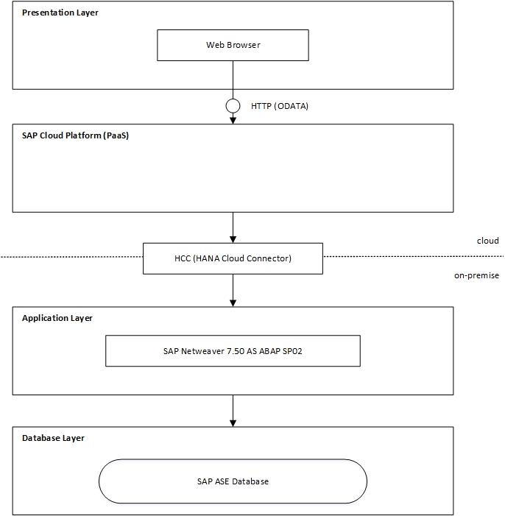

## User Interfaces

To meet the customers’, stakeholders requirements for the user interface of the Support-Ticketing-System the SAP Fiori design guidelines were applied. <https://experience.sap.com/fiori-design-web/downloads/#design-stencils-microsoft-powerpointr>

<https://open.sap.com/courses/fiux2>

Additionally, SAP Design Stencils for Microsoft PowerPoint were used to create low-fidelity Wireframes and in the second step Visual Designs. Furthermore a high-fidelity prototype was created with build.me <https://www.build.me>. This demo application only shows the look and feel of Fiori design and does not cover all use case scenarios.

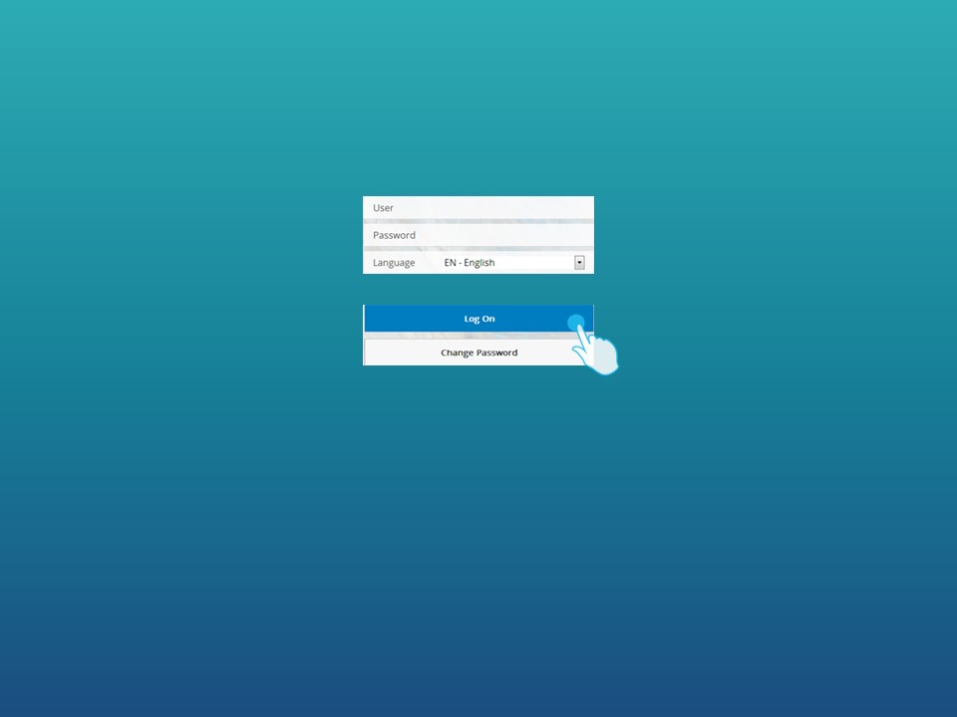 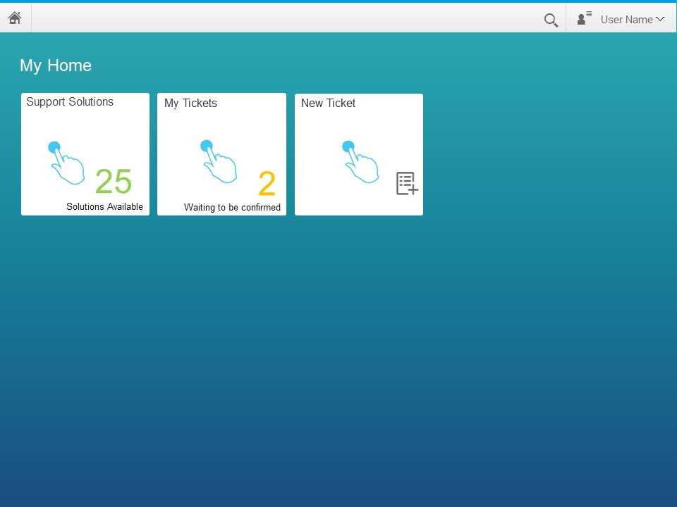 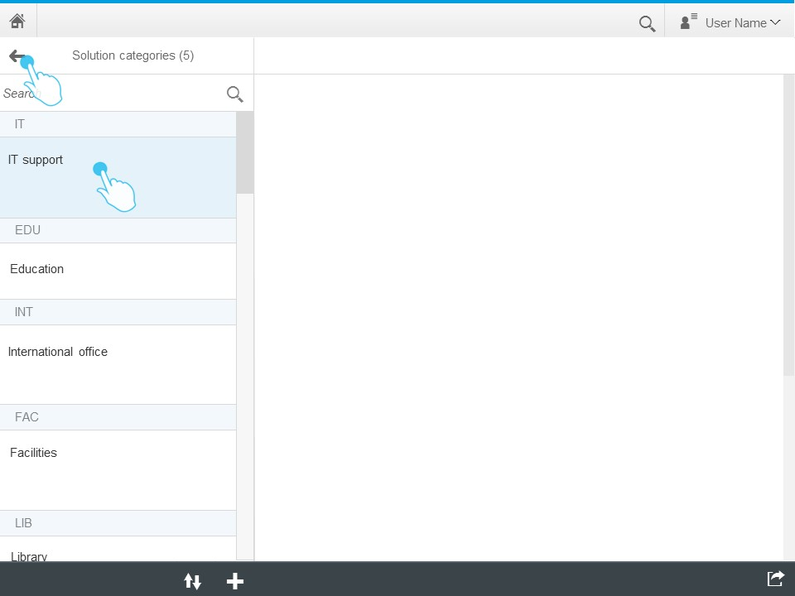 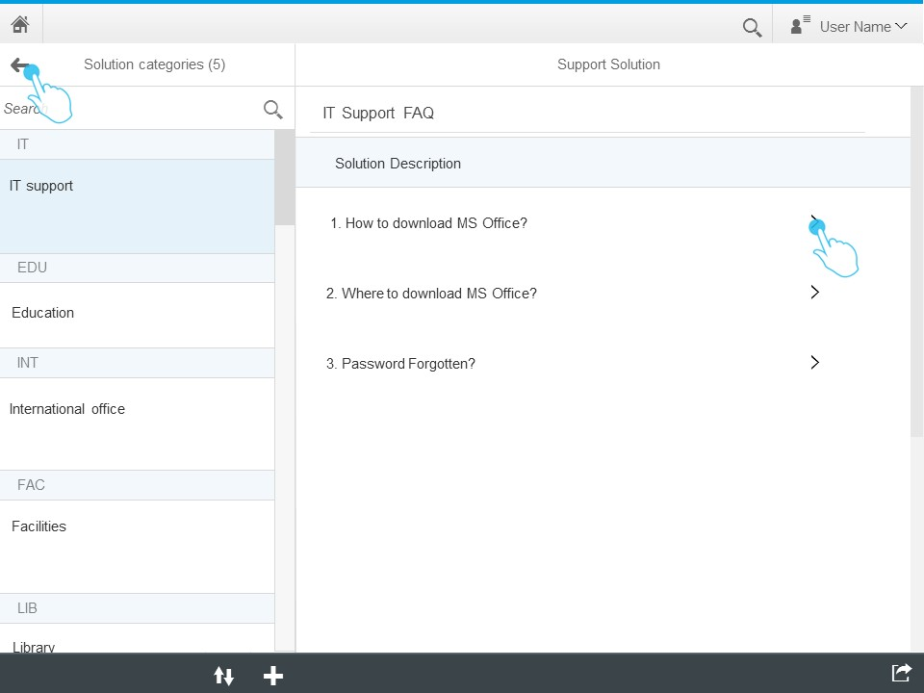

## User Roles and Authorizations / Authentication

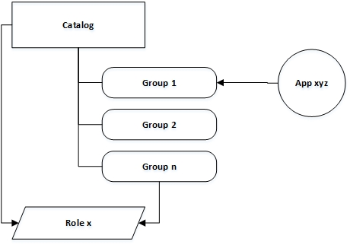

## Integration

Text

## Solution Assumptions

**Copied from IPM Draft**

With the beginning of project developing phase following prerequisites must be fulfilled:

* Development & Quality systems provided by Customer
* Development phase proceed with a fix versions of used platforms and tools
* Users with proper authorization should be provided by Customer to development team 2 weeks before development phase starts
* Any issues/bugs with used development platforms resolved by Customer and third-parties with informing development team
* Complete test cases provided by Customer 1 week before each development phase starts
* A person responsible for product acceptance from Customer side participate in each build review meetings of development team