1. **Overview**

Regarding the support requests of students in the previous years, necessity of a support ticketing system application has been established. This application is designed as a platform where students will find a variety of predefined solutions and additionally, they will have the possibility to create new tickets regarding their needs. There are 3 user types in this application: student, support team member and support team manager.

Students can search and view predefined solutions which will be organized by categories. In case they cannot find solutions regarding their requests or questions, they can create new tickets. After a ticket has been resolved, the student will be asked to fill a satisfaction questionnaire. This will provide the rating of the support and will be used for analytics to improve the system.

Support team members can create and edit solution categories which are necessary to facilitate solution search for students. They can create and edit predefined solutions and resolve tickets which are created by students. Number of open tickets with a link to the list will be displayed on the initial screen of support team member, this will provide an easy insight to reach the waiting requests.

Support team manager will be able to view all tickets. On the initial screen, a link to overdue tickets which are not responded within 48 hours will be displayed. Support team manager can assign these tickets to support team members. Additionally, analytics will be provided for support team manager which can be filtered for a specific period and/or responsible support team member. Different analytics will be displayed based on the ticket status or ratings of the provided solution.

1. **Personas**
   1. **Student**

Jane is a master student with a Bachelor degree in business administration. She has average computer skills, so she needs some technical support when she has to deliver assignments for her lectures for which she needs to use some applications. She also needs help to get an access for student portal where all her lecture’s content are published.

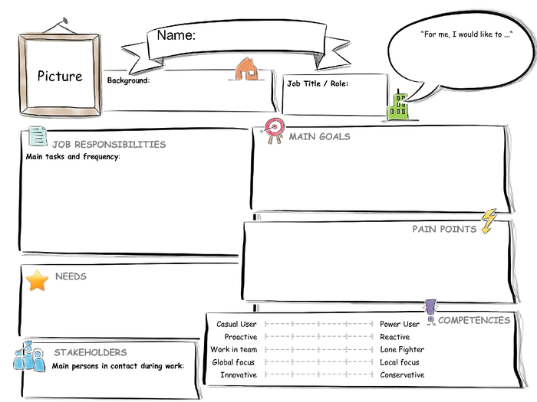

Bachelor degree in business administration, first semester in master program, average computer skills

I would like to get technical support during my master program

Support team member

I need support to prepare projects with software tools, to access online student portal

Get lecture content,

Deliver assignments/lecture projects on time,

Pass exams

Master Student

Jane

Lack of technical skills to deliver assignments/projects

Attend lectures on time,

Prepare and deliver assignments/projects, Sign in for exams,

Check exam results

* 1. **Support Team Member**

Marc is a member of support team. He studied information systems and has 3 years of work experience in IT departments of several companies. He would like to achieve high performance on delivering support on time. To reduce his response time to the requests, a dashboard with a list of open tickets would be very helpful for him. The strongest pain point for him is the communication with the requester. He needs a platform where he can see all communication history to follow up the case easier.



Lack of sufficient information about the support needed, lack of notification on time.

Students,

Support team manager

Support Team Member

Studied information systems, worked 3 years in it department, very good computer skills

I would like to achieve high performance on delivering support on time to students

I need a dashboard to see new and open tickets, a platform that I can contact the requester.

Resolve issues of students within 24 hours

Marc

Provide support/information to students

* 1. **Support Team Manager**

Albert is the support team manager. He studied information systems and worked for 8 years in IT and support departments of several companies. His goal is to improve efficiency and effectiveness of support team. He needs a real time insight for overdue requests so that he can assign them manually to avoid late support. He spends much time to create performance reports so analytics will facilitate his job to review performance of his team.



Studied information systems, worked 8 years in it and support departments, very good computer and management skills

I need to reduce response time for support requests,

I need realtime insight of support team activities

Support team members,

Students

Support Team Manager

I would like to improve efficiency and effectiveness of support team

Reduce response time for support requests,

Reduce overdue support requests,

Improve support for students

Albert

Excessive time spent to create reports of support team activities,

Late insight into overdue support requests

Oversee daily support activities,

Handle overdue support requests,

Supervise support team members,

Manage support team performance

1. **User Experience Journeys**
   1. **Student Experience Journey**

A student needs the content of his lecture. To reach the content he needs access to student portal. He thinks of getting the content from a classmate but decides to ask for access to support team, because he will need it for the rest of his studies. He is concerned of being already late and considers talking to the teacher. After sending an email to support team he waits for a response. Next day he receives a response which describes how to get access to the portal.

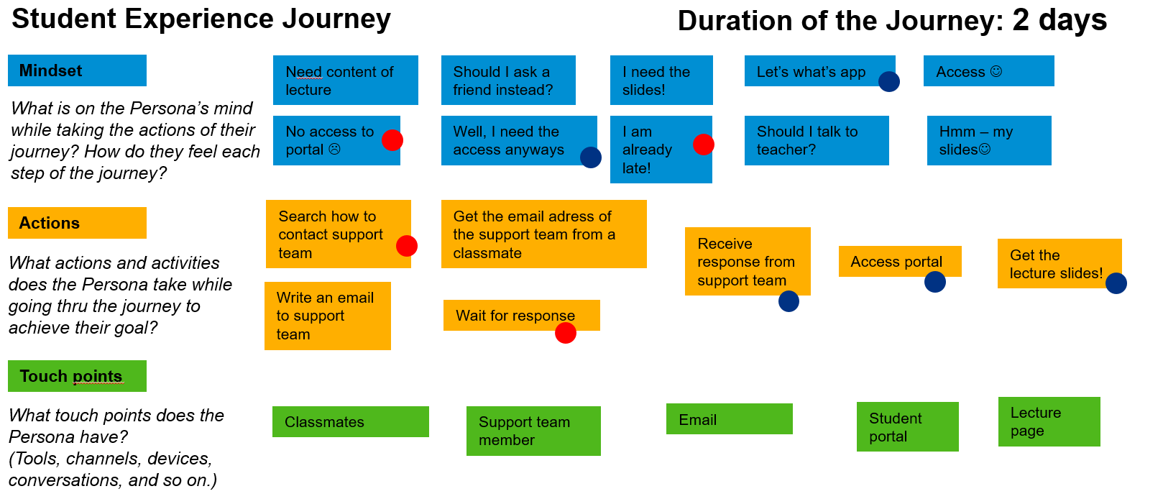

* 1. **Support Team Member Experience Journey**

Support team member opens his mailbox to read the support mails. He has to read them to find out which one is more urgent. In some cases he needs extra information from the requester and waits for his response to solve the issue. When he has all necessary information, he sends the solution to the requester and waits for his confirmation.

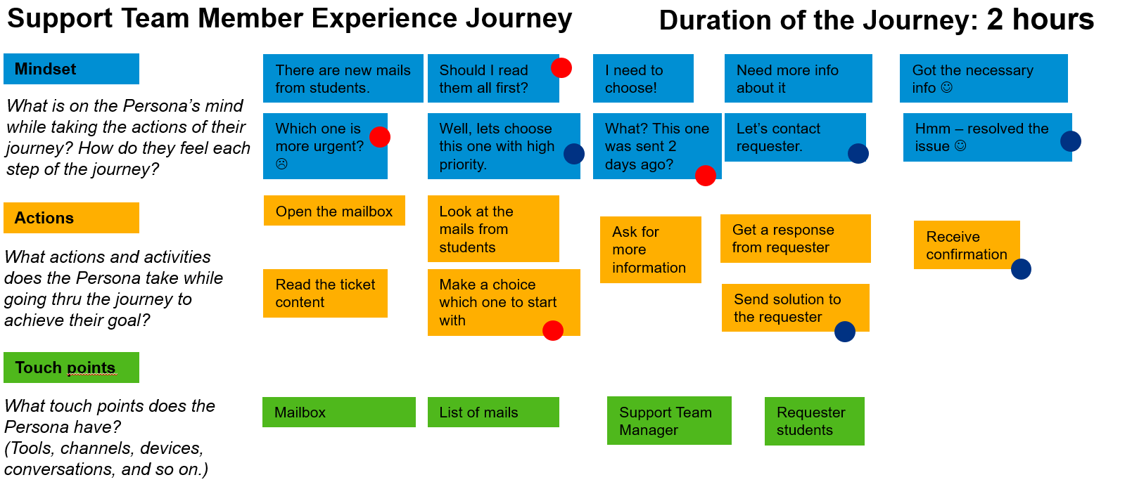

* 1. **Support Team Manager Experience Journey**

Support team manager opens his mailbox to follow up on overdue tickets. He needs to check every mail to find out if it is in process or still waiting. For the requests which are overdue, he assigns them to the available support team member. To view performance results of the team he needs to create reports manually and read feedback mails from students.

