**Overview**

Support Ticketing System application is designed to support students with their requests and questions. It is a platform where students will find a variety of predefined solutions such as “how to install MS Office”, “how to access shared folder” etc. Additionally, they will have the possibility to create new tickets. There are 3 user types in this application: student, support team member and support team manager.

**Student**

Students can search and view predefined solutions which will be organized by categories. In case they cannot find solutions regarding their requests or questions, they can create new tickets. After a ticket has been resolved, the student will be asked to fill a satisfaction questionnaire. This will be saved as the rating of the provided support.

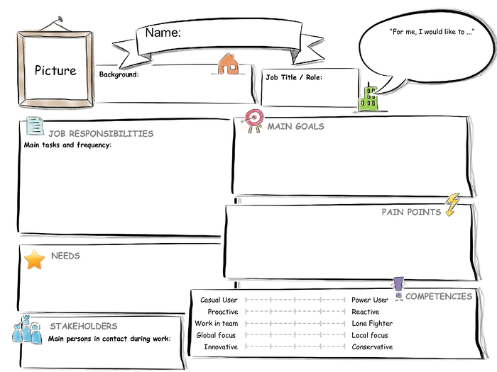

Bachelor degree in business administration, first semester in master program, average computer skills

I would like to get technical support during my master program

Support team member

I need support to prepare projects with software tools, to access online student portal

Get lecture content,

Deliver assignments/lecture projects on time,

Pass exams

Master Student

Jane

Lack of technical skills to deliver assignments/projects

Attend lectures on time,

Prepare and deliver assignments/projects, Sign in for exams,

Check exam results

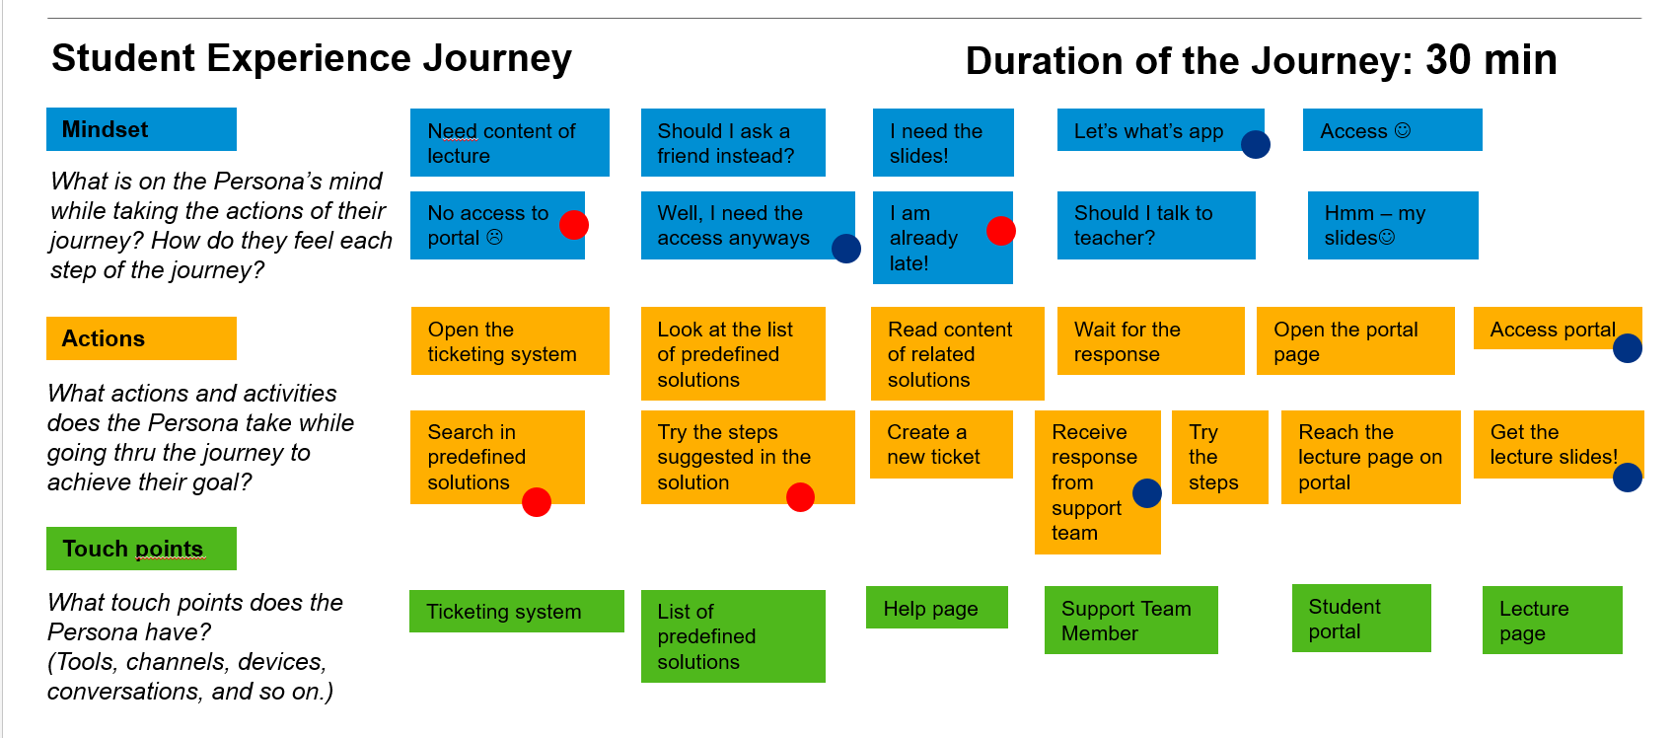

**Support Team Member**

Support team members can create and edit solution categories which are necessary to facilitate solution search for students. They can create and edit predefined solutions and resolve tickets which are created by students. Number of open tickets will be displayed on the initial screen of support team member. When a ticket is being processed, it will be assigned to the support team member automatically.



Students,

Support team manager

Support Team Member

Studied information systems, worked 3 years in it department, very good computer skills

I would like to achieve high performance on delivering support on time to students

I need a dashboard to see new and open tickets, a platform that I can contact the requester.

Resolve issues of students within 24 hours

Marc

Lack of sufficient information about the support needed, lack of notification on time.

Provide support/information to students

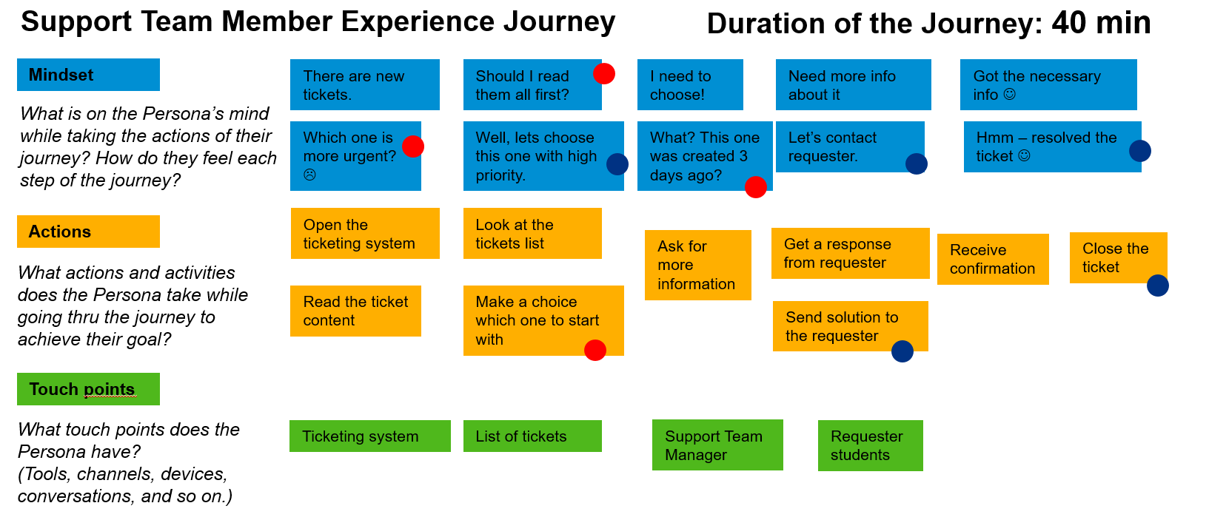

**Support Team Manager**

Support team manager can view all tickets. On the initial screen, a link to tickets which are not responded within 48 hours will be displayed additionally. Support team manager can assign these tickets to support team members. Additionally, analytics will be provided for support team manager which can be filtered for a specific period and/or responsible support team member. Different analytics will be displayed based on the ticket status or ratings of the provided solution.



I need to reduce response time for support requests,

I need realtime insight of support team activities

Support team members,

Students

Support Team Manager

Studied information systems, worked 8 years in it department, very good computer and management skills

I would like to improve efficiency and effectiveness of support team

Reduce response time for support requests,

Reduce overdue support requests,

Improve support for students

Albert

Excessive time spent to create reports of support team activities,

Late insight into overdue support requests

Oversee daily support activities,

Handle overdue support requests,

Supervise support team members,

Manage support team performance

