**Why Use Moodle?**

1. **Critical Mass:**

[](http://www.linkedin.com/in/jimkeiken)Moodle is the world’s #1 LMS (Learning Management System) used by over 60+ million students world-wide at over 65,000+ institutions—as a **FREE**and open-source platform, teachers from around the world can now build, collaborate, and share content to leverage a proven learning management system used by K-12 schools, universities, Fortune 500 companies, hospitals, firefighters, and municipal government institutions.  With its active user base, market share, and community, Moodle isupdated weekly and ***actively developed*** by educators and programmers from around the world with customized plugins, modules, and blocks to make it a better tool for learning in the 21st century.

My Moodle Hero:  
Jim Keiken, Deputy Director at Illinois Fire Institute, U of I at the Midwest Moodle Moot 2013

2.  **Open Source**

Moodle's founder, [Martin Dougiamas](http://en.wikipedia.org/wiki/Martin_Dougiamas), has committed to keeping Moodle free and open source.  What that means is that you will not be locked into a single vendor who can change pricing structures or yearly subscription fees, and also encourages active development by the Moodle community to make the product a better tool for teaching and learning.  Because Moodle is open source, data can be imported and exported in many formats, and your hard work in building your course is highly portable and can be moved between servers (basically, as long as you have your Moodle Course Backup (MBZ file) you can Restore it to another server!).

Since the *motivation* for Moodle is **education** and not just profit, the robust community around Moodle makes it better quickly—for example*, within just 3 weeks* of Moodle 2.0 being released a plugin was written to import ExamView banks! (This is HUGE for many of us who use ExamView for our quizzes, tests, clicker questions, and other assessments!).

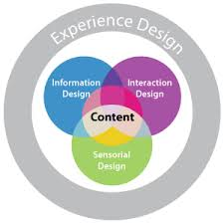What is not free is a web server to run the program and the valuable development and training time necessary to build a robust learning platform.  
  
3.  **Learning Centric Design**

Moodle was built by Martin's frustration with his college job working for a corporate LMS that was designed by computer programmers and engineers--so he decided to build Moodle (Modular Object-Oriented Dynamic Learning Environment) for his Ph. D. from the ground up to be based on learning activities and social constructivist ideas that we build meaning and learning together in communities and that learners as well as teachers can contribute to the educational experience in a flexible environment.

With its open source nature, Moodle is constantly being updated, improved, and extended by armies of programmers from around the world writing new blocks, activities, plugins, and modules to make Moodle a better tool for teaching and learning.

4.  **Robust Assessment Engine**Moodle has a strong assessment engine critical for formative and summative assessments, including a wide variety of options and customizations including sophisticated drag-and-drop interactions for creative, visual and process questioning.  In particular, the ability to give students multiple attempts, immediate feedback, and dynamic questions with randomized variables (i.e. every student has the same problem but with different numbers) makes the assessment engine a key component of not only Moodle, but any LMS of the future.

Teachers can also configure assignments and resources to be unlocked based on students meeting conditional learning requirements, creating individualized learning paths and differentiated instructional paths to guide students in their studies.

There are also “Learning Dashboards” of where students are at within your course so you can quickly gauge where each individual is at and pinpoint any areas to troubleshoot or intervene in real-time, along with meaningful logs of student activity for accountability and tracking progress.

5.  **Student Friendly Features**Moodle provides a platform for students to have a centralized one-stop shop for managing their learning, including a place to not only find course documents, assignments, calendars, announcements, and discussion forums, but also a unique checklist of activities and assignments to help students track their progress towards meeting learning objectives.  With a mobile friendly theme and *responsive web design*, students can also learn anytime, anywhere they have Internet access whether it be at home, in school, or while riding the bus to an athletic competition!

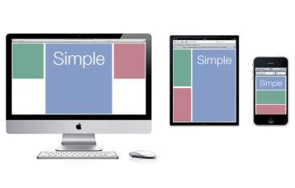6. **Easy to Use, with the Power to Grow**

Moodle is easy to use for any instructor wishing to get started with a basic online presence, but is flexible enough and powerful enough to grow with you into the future with its robust community of users and developers world-wide.

It has the right technologies built in that matter such as *responsive web design* which fluidly adapts content to any screen size for elegant course design and consistent, convenience of access for the end-user and AJAX editing (allows you to drag-and-drop for editing course content and updating gradebooks on the fly without cumbersome clicks or web forms).

With its open source nature, Moodle “talks” to the right tools and formats to make day-to-day teaching a reality—whether it be importing and exporting grades from Excel in CSV format, pulling in quiz banks from ExamView exported as a ZIP file, publishing a student’s customized achievement certificates to a PDF file to celebrate their accomplishments, to running on a Windows, Mac, or Linux server with a MySQL or IIS Windows database, Moodle is put to work around the world in creative ways to equip instructors and students of all walks of life to make the world of teaching and learning a better place!