

* **Who we are?**
  + Tier5 is an American Software Development firm specializing in the design and development of websites, web applications, and mobile applications. We also offer digital marketing services (SEO/SEM), and online reputation management services.
* **Where did we come from?** 
  + Tier5 is the brain child of Jon Vaughn a software developer from Indiana University and Duane Dennis an Operations Research graduate from MIT Cambridge.
* **What we are looking for?**
  + We are looking for direct sales partners who will market and sell our development, design, and digital marketing services.
* **The idea candidate?** 
  + The idea candidate for this position understands technology, software development, and programming, but does not need to be a programmer or do any programming. They have great communication and logic skills. They are confident and strong sellers.
* **What is a Tier?**
  + A Tier is actually a level of service, Tier5 has 6 Tiers. Tier[0] – Tier[5]. This is where the name Tier5 comes from. As far as you’re concerned a Tier represents how you came to be a part of Tier5. When you become a part of Tier5, you are Tier[5]. Suppose your friend Bob told you about Tier5 and had you sign up, You are Bob’s Tier[4]. Suppose Bob’s friend Jon got Bob involved in Tier5, Bob is Jon’s Tier[4] and you are Bob’s Tier[4] but you are also Jon’s Tier[3]. Jon can have all the way down to Tier[0] and so can Bob, and so can you. Anyone can have multiple Tier[4]’s and Tier[3]’s…etc.
* **What’s the payout?**
  + The payout is large. My first year working in this model I made over $53,000 and last year I made over $93,000, in the last 3 months I’ve made over $30,000 which I am happy to provide proof of. We charge a minimum fee per development hour, anything above that minimum fee is the payout.

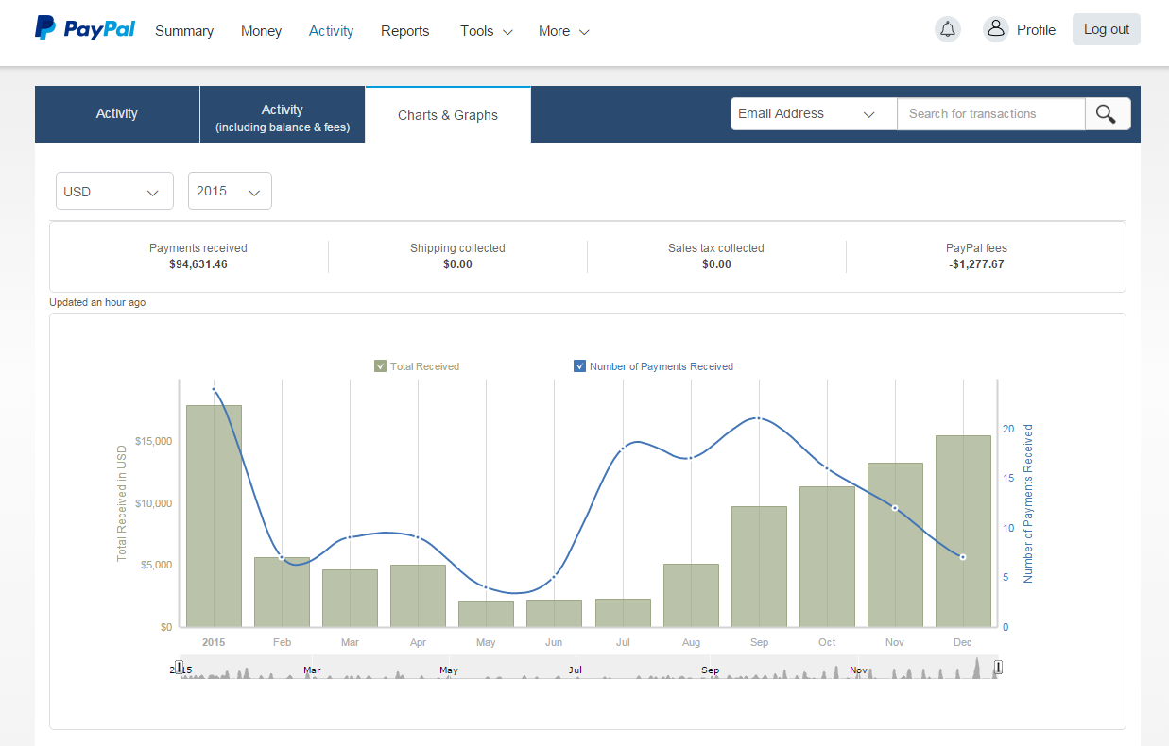

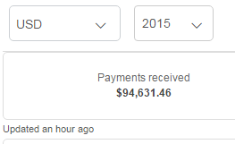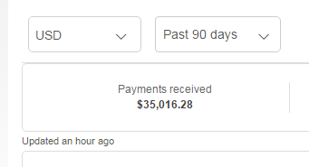

* **How much of the payout is mine?** 
  + In the worst case scenario 50% of the payout is yours, in the best case 100% is yours. Your % of the payout depends on how many Tiers are above you. As you can guess Tier5 has 5 Tiers (although that is not the reason behind our name).
* **How much do I actually make?**
  + Yes, the best question. We already talked about payouts. How much you actually make depends on how many development hours you and the Tier[s] below you actually contract out. The payout scale looks like this:
    - Tier[5] (YOU): 50% of payout
    - Tier[4]: 15% of payout
    - Tier[3]: 10% of payout
    - Tier[2]: 10% of payout
    - Tier[1]: 10% of payout
    - Tier[0]: 5% of payout

Let’s look at 2 simple examples:

**Ex 1:** You are a Tier[x] of no one, you are at the Top Tier, this means you started with Tier5 from the beginning. Let’s say our minimum cost is $15/hr and you contract 1 hour for $25/hr. You would get 100% of (25-15), or you would get $10 paid out to you.

**Ex 2:** You are Tier[0] of some Tier[5]. You have 5 Tiers above you. This means you didn’t start at the top but someone that was already working for Tier5 brought you onboard at some point. Considering the same as above, our minimum cost is $15/hr and you sell 1 development hour for $25/hr, you would get 50% of (25-15) or you would get $5. The person right above you who recruited you (you are their Tier[4]) would get 15% of of (25-15) or they would get $1.50. The person right above them (you are their Tier[3]) would get 10% of (25-15), or they would get $1.00. The person at the top (you are their Tier[0]) would get 5% of (25-15), or they would get $0.50.

Let’s look at this a little more in detail to make sure everyone is on the same page and understands how much you would actually get properly.

Let’s assume that Jon started at the start of the Tier5 affiliate program, Jon is at the root level and is no one’s Tier[4]. Let’s consider that Jon recruited David, David recruited Amy, Amy recruited Mark, Mark recruited Julie, and Julie recruited Mike. To keep it simple let’s assume that’s it. This is how each network would look.

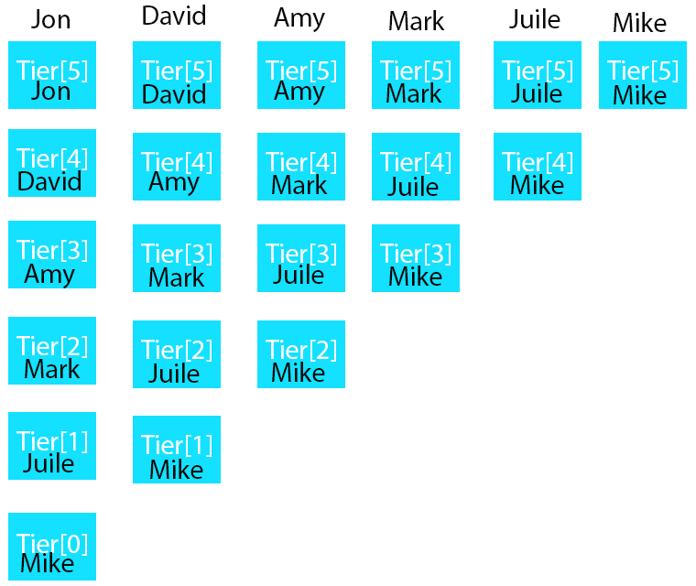

Now let’s make a few more assumptions, the assumptions are as follows:

* Everyone sells only one development hour.
* Their selling price is all at $25 (selling price = SP)
* Tier5 cost is at $15 (cost = C)
* This would make the payout at $10 (P = SP – C, P = $25 - $15, P = $10)

Let’s look at the payouts again and then show you how much you would actually make considering this example.

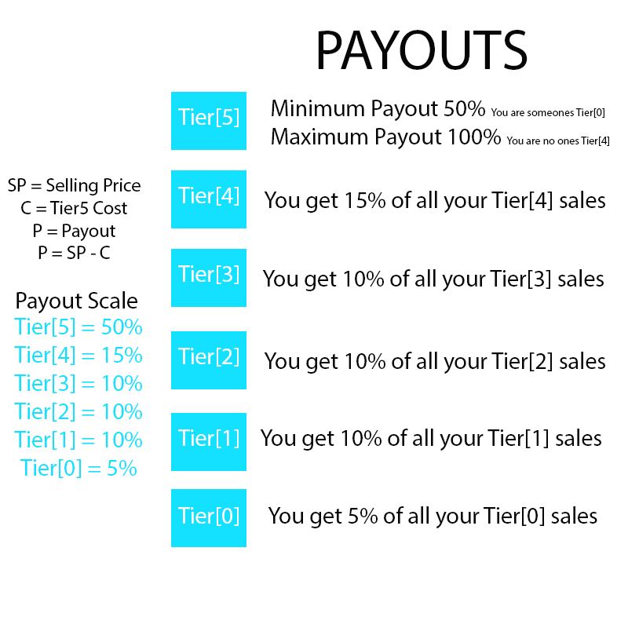

Now let’s see how much everyone makes considering the assumptions we made, here are the assumptions again.

* Everyone sells only one development hour.
* Their selling price is all at $25 (selling price = SP)
* Tier5 cost is at $15 (cost = C)
* This would make the payout at $10 (P = SP – C, P = $25 - $15, P = $10)

**Jon**. Since Jon is no one’s Tier[4] his pay out on his sales is 100%. So for his 1 development hour he sells that has a $10 payout he gets 100%. So he gets paid $10 for his one development hour sale. Here is a complete breakdown of how much he gets following the assumptions.

* **Tier[5] = P * 1 = $10**
* **Tier[4] = P * .15 = $1.50**
* **Tier[3] = P * .1 = $1.00**
* **Tier[2] = P * .1 = $1.00**
* **Tier[1] = P * .1 = $1.00**
* **Tier[0] = P * .05 = $0.50**

Jon makes a total of $15 when he and everyone in his network all sell just one development hour.

**David.** David is Jon’s Tier[4], but David is no one’s Tier[3]. So David’s payout per each development hour he sells is 100% - Tier[4] payout (15%). So David’s payout is 85% per development hour sold. So for his 1 development hour he sells that has a $10 payout he gets 85%. So he gets paid $8.50for his one development hour sale. Here is a complete breakdown of how much he gets following the assumptions.

* **Tier[5] = P * .85 = $8.50**
* **Tier[4] = P * .15 = $1.50**
* **Tier[3] = P * .1 = $1.00**
* **Tier[2] = P * .1 = $1.00**
* **Tier[1] = P * .1 = $1.00**
* **Tier[0] = David has no Tier[0] right now. He needs to get his Tier[1] recruiting people.**

David makes a total of $13 when he and everyone in his network sell just 1 development hour. David should focus on getting his Tier[1] to recruit so he can have a Tier[0].

**Amy.** Amy is David’s Tier[4] and she is also Jon’s Tier[3], but she is no one’s Tier[0]. So Amy’s payout per each development hour she sells is 100% - Tier[4] payout (15%) – Tier[3] payout (10%). So Amy’s payout is 75%. So for her 1 development hour she sells that has a $10 payout she gets 75%. So she gets paid $7.50 for her one development hour sale. Here is a complete breakdown of how much she gets following the assumptions.

* **Tier[5] = P * .75 = $7.50**
* **Tier[4] = P * .15 = $1.50**
* **Tier[3] = P * .1 = $1.00**
* **Tier[2] = P * .1 = $1.00**
* **Tier[1] = Amy has no Tier[1] right now. She needs to get her Tier[2] recruiting people.**
* **Tier[0] = Amy needs a Tier[1] before she can get a Tier[0]**

**Mike.** Yes let’s skip all the way to Mike. Mike is Juile’s Tier[4] and Mike is also Jon’s Tier[0]. So Mike’s payout is 100% - Tier[4] payout (15%) – Tier[3] payout (10%) – Tier[2] payout (10%) – Tier[1] payout (10%) – Tier[0] payout (5%). So Mikes payout is 50%. So for his 1 development hour he sells that has a $10 payout he gets 50%. So he gets paid $5.00 for his one development hour sale. Here is a complete breakdown of how much he gets following the assumptions.

* **Tier[5] = P * .5 = $5.00**
* **Tier[4] = Mike has no Tier[4] right now. Mike needs to recruit people..**
* **Tier[3] = Mike needs a Tier[4] before he can get a Tier[3]**
* **Tier[2] = Mike needs a Tier[3] before he can get a Tier[2]**
* **Tier[1] = Mike needs a Tier[2] before he can get a Tier[1]**
* **Tier[0] = Mike needs a Tier[1] before he can get a Tier[0]**