Marci B Copeland BAN502 Module 2 Assignment 2

install.packages(“gridExtra”)

library(tidyverse)

## -- Attaching packages ---------------------------------------------------------- tidyverse 1.2.1 --

## v ggplot2 3.2.1 v purrr 0.3.3  
## v tibble 2.1.3 v dplyr 0.8.3  
## v tidyr 1.0.0 v stringr 1.4.0  
## v readr 1.3.1 v forcats 0.4.0

## -- Conflicts ------------------------------------------------------------- tidyverse_conflicts() --  
## x dplyr::filter() masks stats::filter()  
## x dplyr::lag() masks stats::lag()

library(GGally)

## Warning: package 'GGally' was built under R version 3.6.2

## Registered S3 method overwritten by 'GGally':  
## method from   
## +.gg ggplot2

##   
## Attaching package: 'GGally'

## The following object is masked from 'package:dplyr':  
##   
## nasa

library(MASS)

##   
## Attaching package: 'MASS'

## The following object is masked from 'package:dplyr':  
##   
## select

library(car)

## Warning: package 'car' was built under R version 3.6.2

## Loading required package: carData

##   
## Attaching package: 'car'

## The following object is masked from 'package:dplyr':  
##   
## recode

## The following object is masked from 'package:purrr':  
##   
## some

library(gridExtra)

## Warning: package 'gridExtra' was built under R version 3.6.2

##   
## Attaching package: 'gridExtra'

## The following object is masked from 'package:dplyr':  
##   
## combine

bike<-read_csv("hour.csv")

## Parsed with column specification:  
## cols(  
## instant = col_double(),  
## dteday = col_date(format = ""),  
## season = col_double(),  
## yr = col_double(),  
## mnth = col_double(),  
## hr = col_double(),  
## holiday = col_double(),  
## weekday = col_double(),  
## workingday = col_double(),  
## weathersit = col_double(),  
## temp = col_double(),  
## atemp = col_double(),  
## hum = col_double(),  
## windspeed = col_double(),  
## casual = col_double(),  
## registered = col_double(),  
## count = col_double()  
## )

bike = bike %>% mutate(season = as_factor(as.character(season))) %>%  
mutate(season = fct_recode(season,  
"Spring" = "1",  
"Summer" = "2",  
"Fall" = "3",  
"Winter" = "4"))

bike = bike %>% mutate(yr = as_factor(yr))  
bike = bike %>% mutate(mnth = as_factor(mnth))  
bike = bike %>% mutate(hr = as_factor(hr))

bike = bike %>% mutate(holiday = as_factor(holiday)) %>%  
mutate(holiday = fct_recode(holiday,  
"NotHoliday" = "0",  
"Holiday" = "1"))

bike = bike %>% mutate(workingday = as_factor(workingday)) %>%  
mutate(workingday = fct_recode(workingday,  
"Notworkingday" = "0",  
"workingday" = "1"))

bike = bike %>% mutate(weathersit = as_factor(weathersit)) %>%  
mutate(weathersit = fct_relevel(weathersit,  
"NoPrecip" ="1",  
"Misty" = "2",  
"LightPrecip" = "3",  
"HeavyPrecip" = "4"))

bike = bike %>% mutate(weekday = as_factor(weekday)) %>%  
mutate(weekday = fct_recode(weekday,  
"Sunday" = "0",  
"Monday" = "1",  
"Tuesday" = "2",  
"Wednesday" = "3",  
"Thursday" = "4",  
"Friday" = "5",  
"Saturday" = "6"))

Task 1: They contain levels and to utilize levels in R must utilize factors and therefore why these should be converted to factor.

Task 2: Count is not correlated with any of the quantitative variables.

ggplot(bike, aes(x=count,y=instant)) + geom_boxplot() + theme_bw()

## Warning: Continuous x aesthetic -- did you forget aes(group=...)?

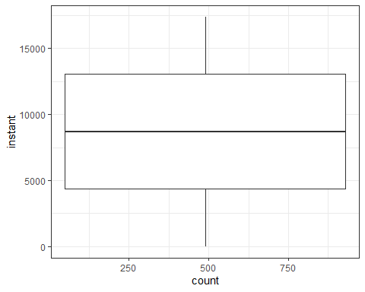

ggplot(bike, aes(x=count,y=dteday)) + geom_boxplot() + theme_bw()

## Warning: Continuous x aesthetic -- did you forget aes(group=...)?

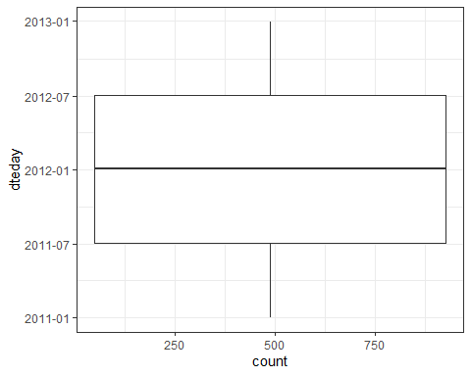

ggplot(bike, aes(x=count,y=season)) + geom_boxplot() + theme_bw()

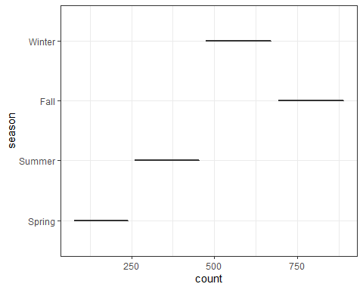

ggplot(bike, aes(x=count,y=yr)) + geom_boxplot() + theme_bw()

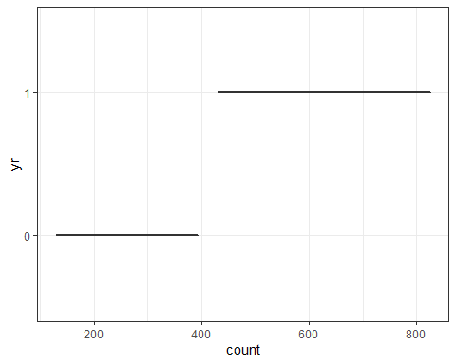

ggplot(bike, aes(x=count,y=mnth)) + geom_boxplot() + theme_bw()

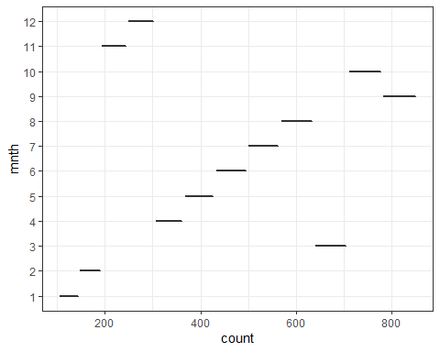

ggplot(bike, aes(x=count,y=hr)) + geom_boxplot() + theme_bw()

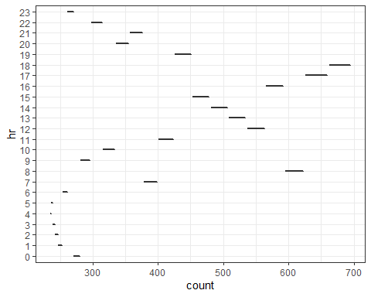

ggplot(bike, aes(x=count,y=holiday)) + geom_boxplot() + theme_bw()

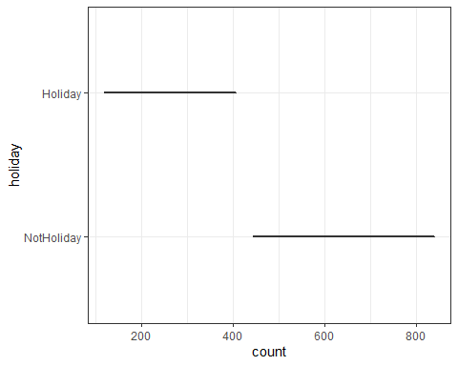

ggplot(bike, aes(x=count,y=weekday)) + geom_boxplot() + theme_bw()

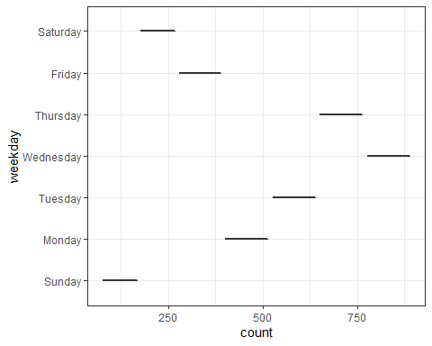

ggplot(bike, aes(x=count,y=workingday)) + geom_boxplot() + theme_bw()

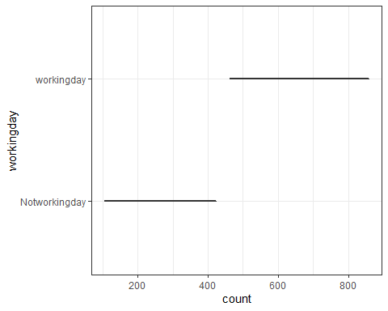

ggplot(bike, aes(x=count,y=weathersit)) + geom_boxplot() + theme_bw()

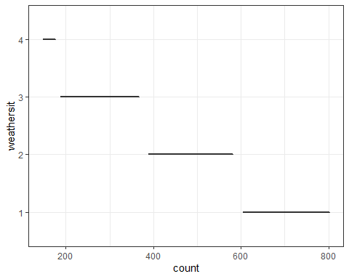

ggplot(bike, aes(x=count,y=temp)) + geom_boxplot() + theme_bw()

## Warning: Continuous x aesthetic -- did you forget aes(group=...)?

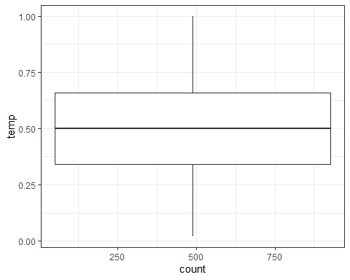

ggplot(bike, aes(x=count,y=atemp)) + geom_boxplot() + theme_bw()

## Warning: Continuous x aesthetic -- did you forget aes(group=...)?

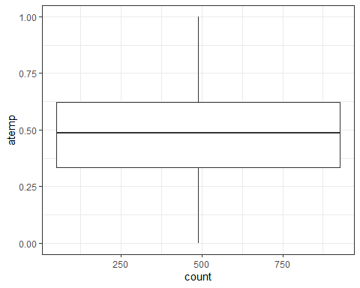

ggplot(bike, aes(x=count,y=hum)) + geom_boxplot() + theme_bw()

## Warning: Continuous x aesthetic -- did you forget aes(group=...)?

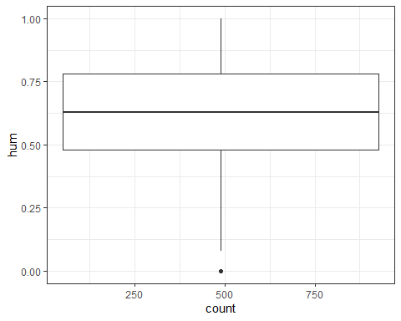

ggplot(bike, aes(x=count,y=windspeed)) + geom_boxplot() + theme_bw()

## Warning: Continuous x aesthetic -- did you forget aes(group=...)?

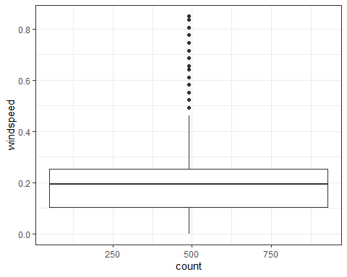 I was unable to get grid.arrange to not generate an error. Month, weathersit, season, hour, holiday, workingday do affect count based on the boxplots whereas the other variables do not.

bike2 = bike %>% dplyr::select(-c(instant, dteday, registered, casual))

allmodel = lm(count ~., bike2) #use the ~. to include all predictors rather than typing them all in  
summary(allmodel)

##   
## Call:  
## lm(formula = count ~ ., data = bike2)  
##   
## Residuals:  
## Min 1Q Median 3Q Max   
## -393.87 -60.66 -7.96 51.31 439.18   
##   
## Coefficients: (1 not defined because of singularities)  
## Estimate Std. Error t value Pr(>|t|)   
## (Intercept) -83.630 6.633 -12.608 < 2e-16 ***  
## seasonSummer 38.178 4.856 7.862 4.00e-15 ***  
## seasonFall 32.055 5.749 5.575 2.51e-08 ***  
## seasonWinter 67.994 4.882 13.928 < 2e-16 ***  
## yr1 85.431 1.563 54.658 < 2e-16 ***  
## mnth2 3.426 3.920 0.874 0.382185   
## mnth3 14.299 4.407 3.244 0.001179 **   
## mnth4 6.230 6.548 0.951 0.341438   
## mnth5 20.657 7.007 2.948 0.003201 **   
## mnth6 6.238 7.205 0.866 0.386617   
## mnth7 -13.269 8.082 -1.642 0.100645   
## mnth8 7.897 7.879 1.002 0.316222   
## mnth9 32.269 7.001 4.609 4.07e-06 ***  
## mnth10 15.843 6.483 2.444 0.014549 *   
## mnth11 -9.840 6.238 -1.577 0.114744   
## mnth12 -6.256 4.954 -1.263 0.206718   
## hr1 -17.294 5.345 -3.236 0.001216 **   
## hr2 -26.369 5.364 -4.916 8.91e-07 ***  
## hr3 -37.112 5.403 -6.869 6.67e-12 ***  
## hr4 -40.263 5.408 -7.445 1.01e-13 ***  
## hr5 -23.501 5.373 -4.374 1.23e-05 ***  
## hr6 35.393 5.359 6.605 4.10e-11 ***  
## hr7 170.418 5.348 31.864 < 2e-16 ***  
## hr8 310.801 5.342 58.183 < 2e-16 ***  
## hr9 163.101 5.347 30.501 < 2e-16 ***  
## hr10 108.444 5.370 20.196 < 2e-16 ***  
## hr11 133.843 5.409 24.742 < 2e-16 ***  
## hr12 173.142 5.456 31.735 < 2e-16 ***  
## hr13 168.102 5.494 30.600 < 2e-16 ***  
## hr14 152.249 5.525 27.558 < 2e-16 ***  
## hr15 161.707 5.535 29.213 < 2e-16 ***  
## hr16 223.834 5.524 40.522 < 2e-16 ***  
## hr17 377.535 5.491 68.750 < 2e-16 ***  
## hr18 345.587 5.455 63.350 < 2e-16 ***  
## hr19 236.919 5.404 43.841 < 2e-16 ***  
## hr20 157.293 5.375 29.266 < 2e-16 ***  
## hr21 107.840 5.353 20.147 < 2e-16 ***  
## hr22 70.907 5.343 13.272 < 2e-16 ***  
## hr23 32.112 5.338 6.015 1.83e-09 ***  
## holidayHoliday -26.228 4.881 -5.374 7.81e-08 ***  
## weekdayMonday 9.275 2.973 3.120 0.001812 **   
## weekdayTuesday 10.849 2.904 3.736 0.000187 ***  
## weekdayWednesday 13.625 2.900 4.698 2.64e-06 ***  
## weekdayThursday 13.149 2.901 4.532 5.87e-06 ***  
## weekdayFriday 17.445 2.892 6.032 1.65e-09 ***  
## weekdaySaturday 16.089 2.878 5.591 2.30e-08 ***  
## workingdayworkingday NA NA NA NA   
## weathersit2 -10.409 1.920 -5.421 6.00e-08 ***  
## weathersit3 -65.189 3.236 -20.145 < 2e-16 ***  
## weathersit4 -62.580 58.893 -1.063 0.287970   
## temp 116.384 29.513 3.943 8.06e-05 ***  
## atemp 127.975 30.624 4.179 2.94e-05 ***  
## hum -82.802 5.554 -14.909 < 2e-16 ***  
## windspeed -29.167 7.052 -4.136 3.55e-05 ***  
## ---  
## Signif. codes: 0 '***' 0.001 '**' 0.01 '*' 0.05 '.' 0.1 ' ' 1  
##   
## Residual standard error: 101.7 on 17326 degrees of freedom  
## Multiple R-squared: 0.6864, Adjusted R-squared: 0.6854   
## F-statistic: 729.1 on 52 and 17326 DF, p-value: < 2.2e-16

emptymodel = lm(count ~1, bike2) #use ~1 to build an empty model  
summary(emptymodel)

##   
## Call:  
## lm(formula = count ~ 1, data = bike2)  
##   
## Residuals:  
## Min 1Q Median 3Q Max   
## -188.46 -149.46 -47.46 91.54 787.54   
##   
## Coefficients:  
## Estimate Std. Error t value Pr(>|t|)   
## (Intercept) 189.463 1.376 137.7 <2e-16 ***  
## ---  
## Signif. codes: 0 '***' 0.001 '**' 0.01 '*' 0.05 '.' 0.1 ' ' 1  
##   
## Residual standard error: 181.4 on 17378 degrees of freedom

forwardmodel = stepAIC(emptymodel, direction = "forward", scope=list(upper=allmodel,lower=emptymodel),  
 trace = TRUE)

## Start: AIC=180764.7  
## count ~ 1  
##   
## Df Sum of Sq RSS AIC  
## + hr 23 286734681 285026910 168713  
## + temp 1 93677759 478083832 177657  
## + atemp 1 91907421 479854170 177721  
## + hum 1 59618351 512143240 178853  
## + mnth 11 42909976 528851615 179431  
## + season 3 37729358 534032233 179584  
## + yr 1 35876722 535884870 179641  
## + weathersit 3 12285030 559476561 180393  
## + windspeed 1 4970060 566791531 180615  
## + holiday 1 546889 571214702 180750  
## + workingday 1 524387 571237204 180751  
## + weekday 6 687929 571073662 180756  
## <none> 571761591 180765  
##   
## Step: AIC=168712.5  
## count ~ hr  
##   
## Df Sum of Sq RSS AIC  
## + atemp 1 50518941 234507969 165324  
## + temp 1 50101685 234925225 165355  
## + mnth 11 44822160 240204750 165761  
## + season 3 39619754 245407156 166117  
## + yr 1 36875130 248151780 166307  
## + weathersit 3 13766672 271260238 167858  
## + hum 1 4924310 280102600 168412  
## + windspeed 1 1476211 283550699 168624  
## + holiday 1 561784 284465126 168680  
## + weekday 6 719530 284307380 168681  
## + workingday 1 485366 284541544 168685  
## <none> 285026910 168713  
##   
## Step: AIC=165324  
## count ~ hr + atemp  
##   
## Df Sum of Sq RSS AIC  
## + yr 1 33463769 201044200 162650  
## + weathersit 3 9227265 225280704 164632  
## + hum 1 7008684 227499285 164799  
## + season 3 6580442 227927527 164835  
## + mnth 11 5854560 228653409 164907  
## + weekday 6 607638 233900331 165291  
## + holiday 1 274006 234233963 165306  
## + temp 1 152153 234355816 165315  
## + windspeed 1 120557 234387412 165317  
## + workingday 1 90170 234417799 165319  
## <none> 234507969 165324  
##   
## Step: AIC=162650.2  
## count ~ hr + atemp + yr  
##   
## Df Sum of Sq RSS AIC  
## + weathersit 3 8408358 192635842 161914  
## + season 3 7190305 193853896 162023  
## + mnth 11 6486062 194558138 162102  
## + hum 1 4341837 196702363 162273  
## + weekday 6 641648 200402552 162607  
## + holiday 1 324763 200719438 162624  
## + windspeed 1 109311 200934889 162643  
## + workingday 1 106404 200937797 162643  
## + temp 1 91735 200952465 162644  
## <none> 201044200 162650  
##   
## Step: AIC=161913.7  
## count ~ hr + atemp + yr + weathersit  
##   
## Df Sum of Sq RSS AIC  
## + season 3 7771024 184864818 161204  
## + mnth 11 7464989 185170852 161249  
## + hum 1 805099 191830743 161843  
## + weekday 6 686172 191949670 161864  
## + holiday 1 413536 192222305 161878  
## + workingday 1 212428 192423414 161897  
## + temp 1 134482 192501360 161904  
## + windspeed 1 44407 192591435 161912  
## <none> 192635842 161914  
##   
## Step: AIC=161204.1  
## count ~ hr + atemp + yr + weathersit + season  
##   
## Df Sum of Sq RSS AIC  
## + mnth 11 2051323 182813495 161032  
## + hum 1 1810161 183054657 161035  
## + weekday 6 704303 184160515 161150  
## + holiday 1 392702 184472116 161169  
## + temp 1 352584 184512234 161173  
## + workingday 1 214973 184649845 161186  
## <none> 184864818 161204  
## + windspeed 1 158 184864660 161206  
##   
## Step: AIC=161032.2  
## count ~ hr + atemp + yr + weathersit + season + mnth  
##   
## Df Sum of Sq RSS AIC  
## + hum 1 2356411 180457084 160809  
## + weekday 6 692672 182120823 160978  
## + holiday 1 312321 182501174 161004  
## + temp 1 233052 182580443 161012  
## + workingday 1 203953 182609542 161015  
## <none> 182813495 161032  
## + windspeed 1 68 182813428 161034  
##   
## Step: AIC=160808.7  
## count ~ hr + atemp + yr + weathersit + season + mnth + hum  
##   
## Df Sum of Sq RSS AIC  
## + weekday 6 581105 179875980 160765  
## + holiday 1 322997 180134087 160780  
## + workingday 1 194139 180262945 160792  
## + windspeed 1 114287 180342797 160800  
## + temp 1 100025 180357059 160801  
## <none> 180457084 160809  
##   
## Step: AIC=160764.7  
## count ~ hr + atemp + yr + weathersit + season + mnth + hum +   
## weekday  
##   
## Df Sum of Sq RSS AIC  
## + workingday 1 274717 179601263 160740  
## + holiday 1 274717 179601263 160740  
## + windspeed 1 112085 179763895 160756  
## + temp 1 77171 179798809 160759  
## <none> 179875980 160765  
##   
## Step: AIC=160740.1  
## count ~ hr + atemp + yr + weathersit + season + mnth + hum +   
## weekday + workingday  
##   
## Df Sum of Sq RSS AIC  
## + windspeed 1 111562 179489701 160731  
## + temp 1 95460 179505803 160733  
## <none> 179601263 160740  
##   
## Step: AIC=160731.3  
## count ~ hr + atemp + yr + weathersit + season + mnth + hum +   
## weekday + workingday + windspeed  
##   
## Df Sum of Sq RSS AIC  
## + temp 1 160954 179328746 160718  
## <none> 179489701 160731  
##   
## Step: AIC=160717.7  
## count ~ hr + atemp + yr + weathersit + season + mnth + hum +   
## weekday + workingday + windspeed + temp  
##   
## Df Sum of Sq RSS AIC  
## <none> 179328746 160718

summary(forwardmodel)

##   
## Call:  
## lm(formula = count ~ hr + atemp + yr + weathersit + season +   
## mnth + hum + weekday + workingday + windspeed + temp, data = bike2)  
##   
## Residuals:  
## Min 1Q Median 3Q Max   
## -393.87 -60.66 -7.96 51.31 439.18   
##   
## Coefficients:  
## Estimate Std. Error t value Pr(>|t|)   
## (Intercept) -83.630 6.633 -12.608 < 2e-16 ***  
## hr1 -17.294 5.345 -3.236 0.00122 **   
## hr2 -26.369 5.364 -4.916 8.91e-07 ***  
## hr3 -37.112 5.403 -6.869 6.67e-12 ***  
## hr4 -40.263 5.408 -7.445 1.01e-13 ***  
## hr5 -23.501 5.373 -4.374 1.23e-05 ***  
## hr6 35.393 5.359 6.605 4.10e-11 ***  
## hr7 170.418 5.348 31.864 < 2e-16 ***  
## hr8 310.801 5.342 58.183 < 2e-16 ***  
## hr9 163.101 5.347 30.501 < 2e-16 ***  
## hr10 108.444 5.370 20.196 < 2e-16 ***  
## hr11 133.843 5.409 24.742 < 2e-16 ***  
## hr12 173.142 5.456 31.735 < 2e-16 ***  
## hr13 168.102 5.494 30.600 < 2e-16 ***  
## hr14 152.249 5.525 27.558 < 2e-16 ***  
## hr15 161.707 5.535 29.213 < 2e-16 ***  
## hr16 223.834 5.524 40.522 < 2e-16 ***  
## hr17 377.535 5.491 68.750 < 2e-16 ***  
## hr18 345.587 5.455 63.350 < 2e-16 ***  
## hr19 236.919 5.404 43.841 < 2e-16 ***  
## hr20 157.293 5.375 29.266 < 2e-16 ***  
## hr21 107.840 5.353 20.147 < 2e-16 ***  
## hr22 70.907 5.343 13.272 < 2e-16 ***  
## hr23 32.112 5.338 6.015 1.83e-09 ***  
## atemp 127.975 30.624 4.179 2.94e-05 ***  
## yr1 85.431 1.563 54.658 < 2e-16 ***  
## weathersit2 -10.409 1.920 -5.421 6.00e-08 ***  
## weathersit3 -65.189 3.236 -20.145 < 2e-16 ***  
## weathersit4 -62.580 58.893 -1.063 0.28797   
## seasonSummer 38.178 4.856 7.862 4.00e-15 ***  
## seasonFall 32.055 5.749 5.575 2.51e-08 ***  
## seasonWinter 67.994 4.882 13.928 < 2e-16 ***  
## mnth2 3.426 3.920 0.874 0.38219   
## mnth3 14.299 4.407 3.244 0.00118 **   
## mnth4 6.230 6.548 0.951 0.34144   
## mnth5 20.657 7.007 2.948 0.00320 **   
## mnth6 6.238 7.205 0.866 0.38662   
## mnth7 -13.269 8.082 -1.642 0.10065   
## mnth8 7.897 7.879 1.002 0.31622   
## mnth9 32.269 7.001 4.609 4.07e-06 ***  
## mnth10 15.843 6.483 2.444 0.01455 *   
## mnth11 -9.840 6.238 -1.577 0.11474   
## mnth12 -6.256 4.954 -1.263 0.20672   
## hum -82.802 5.554 -14.909 < 2e-16 ***  
## weekdayMonday -16.953 5.081 -3.337 0.00085 ***  
## weekdayTuesday -15.379 5.641 -2.726 0.00641 **   
## weekdayWednesday -12.603 5.639 -2.235 0.02544 *   
## weekdayThursday -13.079 5.600 -2.336 0.01952 *   
## weekdayFriday -8.783 5.599 -1.569 0.11676   
## weekdaySaturday 16.089 2.878 5.591 2.30e-08 ***  
## workingdayworkingday 26.228 4.881 5.374 7.81e-08 ***  
## windspeed -29.167 7.052 -4.136 3.55e-05 ***  
## temp 116.384 29.513 3.943 8.06e-05 ***  
## ---  
## Signif. codes: 0 '***' 0.001 '**' 0.01 '*' 0.05 '.' 0.1 ' ' 1  
##   
## Residual standard error: 101.7 on 17326 degrees of freedom  
## Multiple R-squared: 0.6864, Adjusted R-squared: 0.6854   
## F-statistic: 729.1 on 52 and 17326 DF, p-value: < 2.2e-16

All variables are included in the forward model except instant, dteday, registered, casual.

#backward  
backmodel = stepAIC(allmodel, direction = "backward", trace = TRUE)

## Start: AIC=160717.7  
## count ~ season + yr + mnth + hr + holiday + weekday + workingday +   
## weathersit + temp + atemp + hum + windspeed  
##   
##   
## Step: AIC=160717.7  
## count ~ season + yr + mnth + hr + holiday + weekday + weathersit +   
## temp + atemp + hum + windspeed  
##   
## Df Sum of Sq RSS AIC  
## <none> 179328746 160718  
## - temp 1 160954 179489701 160731  
## - windspeed 1 177057 179505803 160733  
## - atemp 1 180751 179509498 160733  
## - holiday 1 298893 179627639 160745  
## - weekday 6 498795 179827541 160754  
## - mnth 11 2426171 181754917 160929  
## - hum 1 2300667 181629413 160937  
## - season 3 2398467 181727213 160943  
## - weathersit 3 4208731 183537478 161115  
## - yr 1 30920851 210249597 163480  
## - hr 23 196741474 376070220 173542

summary(backmodel)

##   
## Call:  
## lm(formula = count ~ season + yr + mnth + hr + holiday + weekday +   
## weathersit + temp + atemp + hum + windspeed, data = bike2)  
##   
## Residuals:  
## Min 1Q Median 3Q Max   
## -393.87 -60.66 -7.96 51.31 439.18   
##   
## Coefficients:  
## Estimate Std. Error t value Pr(>|t|)   
## (Intercept) -83.630 6.633 -12.608 < 2e-16 ***  
## seasonSummer 38.178 4.856 7.862 4.00e-15 ***  
## seasonFall 32.055 5.749 5.575 2.51e-08 ***  
## seasonWinter 67.994 4.882 13.928 < 2e-16 ***  
## yr1 85.431 1.563 54.658 < 2e-16 ***  
## mnth2 3.426 3.920 0.874 0.382185   
## mnth3 14.299 4.407 3.244 0.001179 **   
## mnth4 6.230 6.548 0.951 0.341438   
## mnth5 20.657 7.007 2.948 0.003201 **   
## mnth6 6.238 7.205 0.866 0.386617   
## mnth7 -13.269 8.082 -1.642 0.100645   
## mnth8 7.897 7.879 1.002 0.316222   
## mnth9 32.269 7.001 4.609 4.07e-06 ***  
## mnth10 15.843 6.483 2.444 0.014549 *   
## mnth11 -9.840 6.238 -1.577 0.114744   
## mnth12 -6.256 4.954 -1.263 0.206718   
## hr1 -17.294 5.345 -3.236 0.001216 **   
## hr2 -26.369 5.364 -4.916 8.91e-07 ***  
## hr3 -37.112 5.403 -6.869 6.67e-12 ***  
## hr4 -40.263 5.408 -7.445 1.01e-13 ***  
## hr5 -23.501 5.373 -4.374 1.23e-05 ***  
## hr6 35.393 5.359 6.605 4.10e-11 ***  
## hr7 170.418 5.348 31.864 < 2e-16 ***  
## hr8 310.801 5.342 58.183 < 2e-16 ***  
## hr9 163.101 5.347 30.501 < 2e-16 ***  
## hr10 108.444 5.370 20.196 < 2e-16 ***  
## hr11 133.843 5.409 24.742 < 2e-16 ***  
## hr12 173.142 5.456 31.735 < 2e-16 ***  
## hr13 168.102 5.494 30.600 < 2e-16 ***  
## hr14 152.249 5.525 27.558 < 2e-16 ***  
## hr15 161.707 5.535 29.213 < 2e-16 ***  
## hr16 223.834 5.524 40.522 < 2e-16 ***  
## hr17 377.535 5.491 68.750 < 2e-16 ***  
## hr18 345.587 5.455 63.350 < 2e-16 ***  
## hr19 236.919 5.404 43.841 < 2e-16 ***  
## hr20 157.293 5.375 29.266 < 2e-16 ***  
## hr21 107.840 5.353 20.147 < 2e-16 ***  
## hr22 70.907 5.343 13.272 < 2e-16 ***  
## hr23 32.112 5.338 6.015 1.83e-09 ***  
## holidayHoliday -26.228 4.881 -5.374 7.81e-08 ***  
## weekdayMonday 9.275 2.973 3.120 0.001812 **   
## weekdayTuesday 10.849 2.904 3.736 0.000187 ***  
## weekdayWednesday 13.625 2.900 4.698 2.64e-06 ***  
## weekdayThursday 13.149 2.901 4.532 5.87e-06 ***  
## weekdayFriday 17.445 2.892 6.032 1.65e-09 ***  
## weekdaySaturday 16.089 2.878 5.591 2.30e-08 ***  
## weathersit2 -10.409 1.920 -5.421 6.00e-08 ***  
## weathersit3 -65.189 3.236 -20.145 < 2e-16 ***  
## weathersit4 -62.580 58.893 -1.063 0.287970   
## temp 116.384 29.513 3.943 8.06e-05 ***  
## atemp 127.975 30.624 4.179 2.94e-05 ***  
## hum -82.802 5.554 -14.909 < 2e-16 ***  
## windspeed -29.167 7.052 -4.136 3.55e-05 ***  
## ---  
## Signif. codes: 0 '***' 0.001 '**' 0.01 '*' 0.05 '.' 0.1 ' ' 1  
##   
## Residual standard error: 101.7 on 17326 degrees of freedom  
## Multiple R-squared: 0.6864, Adjusted R-squared: 0.6854   
## F-statistic: 729.1 on 52 and 17326 DF, p-value: < 2.2e-16

Similar results between forward and back models. The R-square is the same for both models, but is still not strong as it is between 0 and 1 but not extremely close to 1. This models are helpful but not strong.