Marci Copeland BAN502 Module6 Assignment 1

install.packages(“factoextra”) install.packages(“dendextend”)

library(tidyverse)

## -- Attaching packages ------------------------------------- tidyverse 1.2.1 --

## v ggplot2 3.2.1 v purrr 0.3.3  
## v tibble 2.1.3 v dplyr 0.8.3  
## v tidyr 1.0.0 v stringr 1.4.0  
## v readr 1.3.1 v forcats 0.4.0

## -- Conflicts ---------------------------------------- tidyverse_conflicts() --  
## x dplyr::filter() masks stats::filter()  
## x dplyr::lag() masks stats::lag()

library (cluster)  
library (factoextra)

## Warning: package 'factoextra' was built under R version 3.6.2

## Welcome! Want to learn more? See two factoextra-related books at https://goo.gl/ve3WBa

library (dendextend)

##   
## ---------------------  
## Welcome to dendextend version 1.13.4  
## Type citation('dendextend') for how to cite the package.  
##   
## Type browseVignettes(package = 'dendextend') for the package vignette.  
## The github page is: https://github.com/talgalili/dendextend/  
##   
## Suggestions and bug-reports can be submitted at: https://github.com/talgalili/dendextend/issues  
## Or contact: <tal.galili@gmail.com>  
##   
## To suppress this message use: suppressPackageStartupMessages(library(dendextend))  
## ---------------------

##   
## Attaching package: 'dendextend'

## The following object is masked from 'package:stats':  
##   
## cutree

trucks <-read_csv("trucks.csv")

## Parsed with column specification:  
## cols(  
## Driver_ID = col_double(),  
## Distance = col_double(),  
## Speeding = col_double()  
## )

str(trucks)

## Classes 'spec_tbl_df', 'tbl_df', 'tbl' and 'data.frame': 4000 obs. of 3 variables:  
## $ Driver_ID: num 3.42e+09 3.42e+09 3.42e+09 3.42e+09 3.42e+09 ...  
## $ Distance : num 71.2 52.5 64.5 55.7 54.6 ...  
## $ Speeding : num 28 25 27 22 25 10 20 8 34 19 ...  
## - attr(*, "spec")=  
## .. cols(  
## .. Driver_ID = col_double(),  
## .. Distance = col_double(),  
## .. Speeding = col_double()  
## .. )

summary(trucks)

## Driver_ID Distance Speeding   
## Min. :3.423e+09 Min. : 15.52 Min. : 0.00   
## 1st Qu.:3.423e+09 1st Qu.: 45.25 1st Qu.: 4.00   
## Median :3.423e+09 Median : 53.33 Median : 6.00   
## Mean :3.423e+09 Mean : 76.04 Mean : 10.72   
## 3rd Qu.:3.423e+09 3rd Qu.: 65.63 3rd Qu.: 9.00   
## Max. :3.423e+09 Max. :244.79 Max. :100.00

trucks_scaled <-scale(trucks)  
summary(trucks_scaled)

## Driver_ID Distance Speeding   
## Min. :-1.7314 Min. :-1.1319 Min. :-0.7821   
## 1st Qu.:-0.8657 1st Qu.:-0.5759 1st Qu.:-0.4903   
## Median : 0.0000 Median :-0.4248 Median :-0.3444   
## Mean : 0.0000 Mean : 0.0000 Mean : 0.0000   
## 3rd Qu.: 0.8657 3rd Qu.:-0.1947 3rd Qu.:-0.1255   
## Max. : 1.7314 Max. : 3.1560 Max. : 6.5127

ggplot(trucks,aes(x=Speeding,y=Distance))+   
 geom_point()

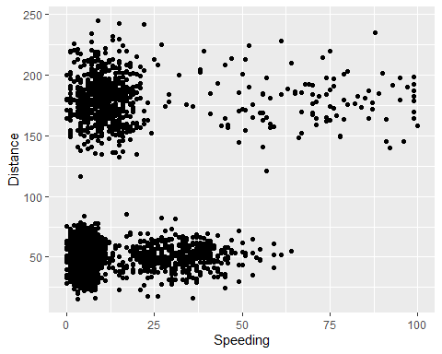 Based on the above plot there is clustering of speeding between 0 and 12.5 with a distnace between 25 and 75 and 150 and 200.

trucks2 = subset(trucks, select = -c(Driver_ID))  
trucks2_scaled <-scale(trucks2)  
summary(trucks2_scaled)

## Distance Speeding   
## Min. :-1.1319 Min. :-0.7821   
## 1st Qu.:-0.5759 1st Qu.:-0.4903   
## Median :-0.4248 Median :-0.3444   
## Mean : 0.0000 Mean : 0.0000   
## 3rd Qu.:-0.1947 3rd Qu.:-0.1255   
## Max. : 3.1560 Max. : 6.5127

set.seed(1234)  
cluster1 <- kmeans(trucks2_scaled, 2)  
fviz_cluster(cluster1, trucks2_scaled)

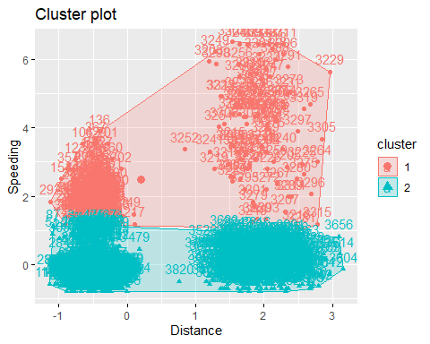

Based on the cluster, common characteristics are shared in both cluster 1 and 2 by speeding and distance.

set.seed(123)  
fviz_nbclust(trucks2_scaled,kmeans,method="wss")

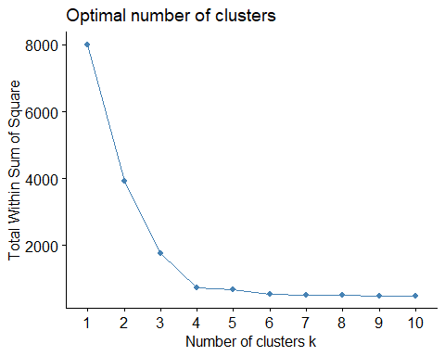

set.seed(123)  
fviz_nbclust(trucks2_scaled,kmeans,method="silhouette")

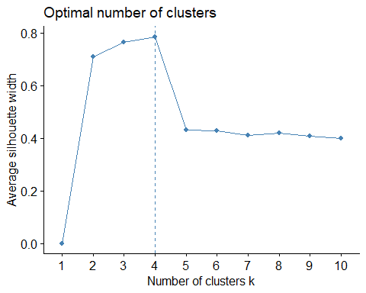

There is consensus between the two models that the optimal number of clusters is 4.

set.seed(1234)  
cluster1 <- kmeans(trucks2_scaled, 4)  
fviz_cluster(cluster1, trucks2_scaled)

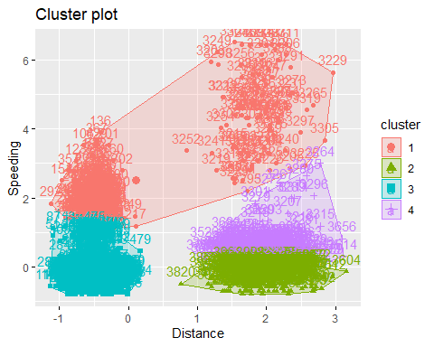 Based on the cluster, common characteristics are shared in clusters 1,2,3 and 4 by speeding and distance as well as highest number of clusters starting in 1 then decreasing going into the subsequent clusters 2,3,4.

wineprice <-read_csv("wineprice.csv")

## Parsed with column specification:  
## cols(  
## Year = col_double(),  
## Price = col_double(),  
## WinterRain = col_double(),  
## AGST = col_double(),  
## HarvestRain = col_double(),  
## Age = col_double(),  
## FrancePop = col_double()  
## )

str(wineprice)

## Classes 'spec_tbl_df', 'tbl_df', 'tbl' and 'data.frame': 25 obs. of 7 variables:  
## $ Year : num 1952 1953 1955 1957 1958 ...  
## $ Price : num 7.5 8.04 7.69 6.98 6.78 ...  
## $ WinterRain : num 600 690 502 420 582 485 763 830 697 608 ...  
## $ AGST : num 17.1 16.7 17.1 16.1 16.4 ...  
## $ HarvestRain: num 160 80 130 110 187 187 290 38 52 155 ...  
## $ Age : num 31 30 28 26 25 24 23 22 21 20 ...  
## $ FrancePop : num 43184 43495 44218 45152 45654 ...  
## - attr(*, "spec")=  
## .. cols(  
## .. Year = col_double(),  
## .. Price = col_double(),  
## .. WinterRain = col_double(),  
## .. AGST = col_double(),  
## .. HarvestRain = col_double(),  
## .. Age = col_double(),  
## .. FrancePop = col_double()  
## .. )

summary(wineprice)

## Year Price WinterRain AGST   
## Min. :1952 Min. :6.205 Min. :376.0 Min. :14.98   
## 1st Qu.:1960 1st Qu.:6.519 1st Qu.:536.0 1st Qu.:16.20   
## Median :1966 Median :7.121 Median :600.0 Median :16.53   
## Mean :1966 Mean :7.067 Mean :605.3 Mean :16.51   
## 3rd Qu.:1972 3rd Qu.:7.495 3rd Qu.:697.0 3rd Qu.:17.07   
## Max. :1978 Max. :8.494 Max. :830.0 Max. :17.65   
## HarvestRain Age FrancePop   
## Min. : 38.0 Min. : 5.0 Min. :43184   
## 1st Qu.: 89.0 1st Qu.:11.0 1st Qu.:46584   
## Median :130.0 Median :17.0 Median :50255   
## Mean :148.6 Mean :17.2 Mean :49694   
## 3rd Qu.:187.0 3rd Qu.:23.0 3rd Qu.:52894   
## Max. :292.0 Max. :31.0 Max. :54602

wine2 = subset(wineprice, select = -c(Year,FrancePop))  
wine2_scaled <-scale(wine2)  
summary(wine2_scaled)

## Price WinterRain AGST   
## Min. :-1.32596 Min. :-1.73332 Min. :-2.25947   
## 1st Qu.:-0.84329 1st Qu.:-0.52375 1st Qu.:-0.45801   
## Median : 0.08284 Median :-0.03992 Median : 0.03548   
## Mean : 0.00000 Mean : 0.00000 Mean : 0.00000   
## 3rd Qu.: 0.65777 3rd Qu.: 0.69339 3rd Qu.: 0.82524   
## Max. : 2.19343 Max. : 1.69885 Max. : 1.68888   
## HarvestRain Age   
## Min. :-1.4856 Min. :-1.586   
## 1st Qu.:-0.8003 1st Qu.:-0.806   
## Median :-0.2494 Median :-0.026   
## Mean : 0.0000 Mean : 0.000   
## 3rd Qu.: 0.5165 3rd Qu.: 0.754   
## Max. : 1.9275 Max. : 1.794

set.seed(123)  
fviz_nbclust(wine2_scaled,kmeans,method="wss")

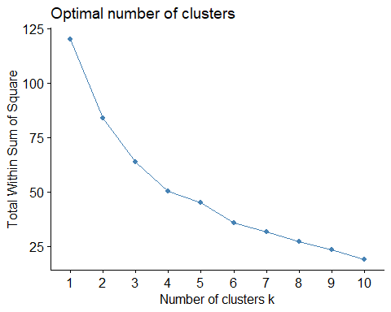

set.seed(123)  
fviz_nbclust(wine2_scaled,kmeans,method="silhouette")

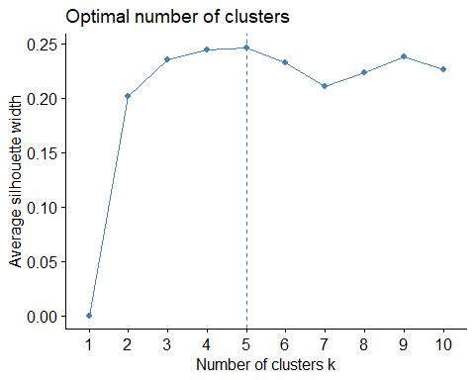

There is pretty close consensus between the two models that the optimal number of clusters is 5.

set.seed(1234)  
cluster2 <- kmeans(wine2_scaled, 5)  
fviz_cluster(cluster2, wine2_scaled)

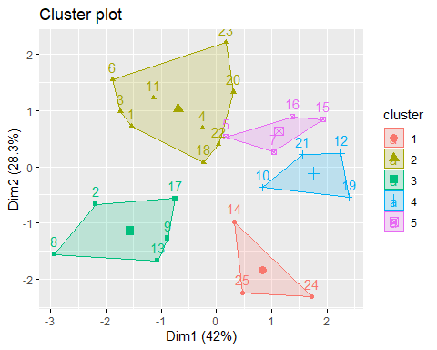

m = c( "average", "single", "complete", "ward")  
names(m) = c( "average", "single", "complete", "ward")  
  
ac = function(x) {  
 agnes(wine2_scaled, method = x)$ac  
}  
map_dbl(m, ac)

## average single complete ward   
## 0.5666719 0.2920143 0.7196616 0.8112139

hc = agnes(wine2_scaled, method = "ward")   
pltree(hc, cex = 0.6, hang = -1, main = "Agglomerative Dendrogram")

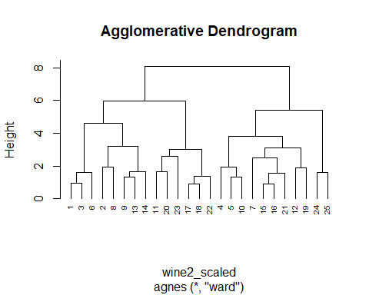 Divisive clustering

hc2 = agnes(wine2_scaled)  
pltree(hc2, cex = 0.6, hang = -1, main = "Divisive Dendogram")

 