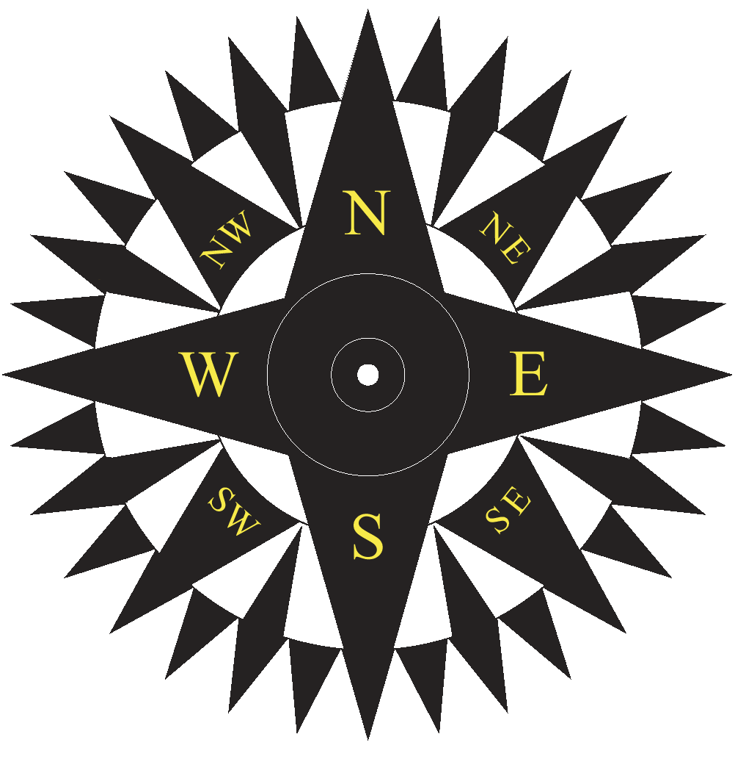

Digital Compass Prototype Presentation
CS470 Applied Software Development
by Raymond E. Marcil

A presentation on the development of a solid state compass, including hardware/software design, and algorithm implementation. All students, staff, and faculty are invited to attend.

 | CAS 118, Friday May 5  10:00AM to 12:00 noon | 

See http://saturn.math.uaa.alaska.edu/~marcilr/compass/

