Project PiJ – aka mobile SwitchBuilder

Objective

This script will automate the upgrade of a Juniper , DMC-12 and Accton 4610 device to a final software version and fully configure them without need for access to corporate network.

Benefits

Juniper devices are configured automatically with minimum human intervention, DMC-12 and Acctons will be configured with configuration scripts running from dedicated micro server.

# Requirements:

* server with httpd/tftpd/dhcpd installed and configured
* serial numbers of all devices required for upgrade and configuration
* configuration files, firmware and scripts
* access switch for device interconnection

# Server preparation:

1.Download Raspberry Pi Imager <https://www.raspberrypi.com/software/>

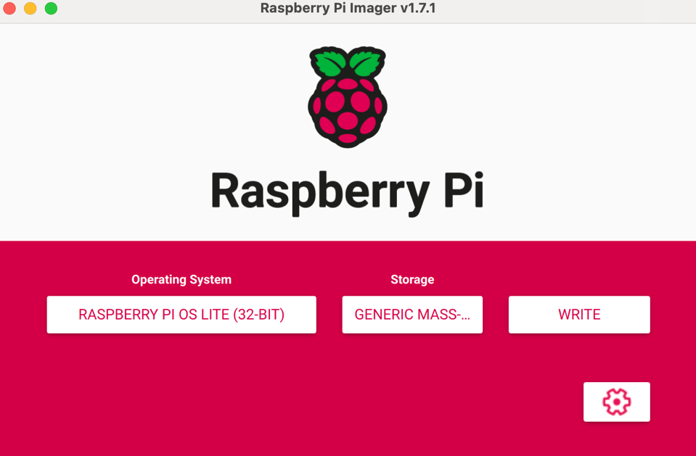

2.Download Raspberry Pi OS Lite <https://www.raspberrypi.com/software/operating-systems/#raspberry-pi-os-32-bit>

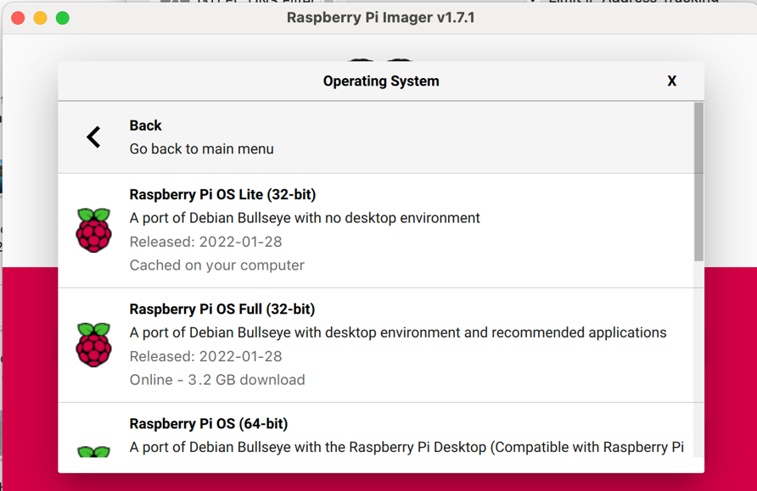

3. Create Raspberry pi image, use advanced option to create user/password , enable ssh and connect to local wifi - best is to create hotspot on your phone

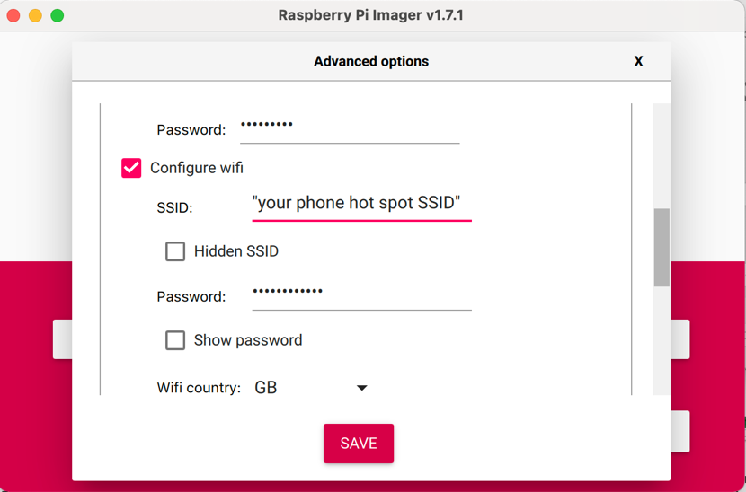

4. Connect your laptop to the same wi-fi as you set for Pi

5.Once image is created insert SD card to Pi and power it up

6. Verify your IP (ipconfig/ifconfig) and find IP of the PI connected to your phone hot-spot, usually it will be +1 or +2 then your laptop

7. ssh to the Pi and configure the server

sudo apt-get update

sudo apt-get upgrade

sudo apt-get install isc-dhcp-server lighttpd xinetd tftpd tftp vim ntp -y

sudo vi /etc/xinetd.d/tftp

service tftp

{

protocol = udp

port = 69

socket_type = dgram

wait = yes

user = nobody

server = /usr/sbin/in.tftpd

server_args = /var/www/html/

disable = no

}

sudo chown -R www-data:www-data /var/www

sudo service xinetd restart

sudo vim /etc/ntp.conf

# If you want to provide time to your local subnet, change the next line.

# (Again, the address is an example only.)

broadcast 10.3.14.255 < change this from default

sudo service ntp restart

sudo vi /etc/default/isc-dhcp-server

change from INTERFACESv4="" to INTERFACESv4="eth0"

sudo vi /etc/network/interfaces

auto eth0

iface eth0 inet static

address 10.3.14.1/24

sudo ifup eth0

sudo cp /etc/dhcp/dhcpd.conf /etc/dhcp/dhcpd.conf.bk

sudo vi /etc/dhcp/dhcpd.conf

delete content of the file and copy dhcp config from

<https://code.amazon.com/packages/Project_PiJ/blobs/mainline/--/dhcpd.conf>

sudo service isc-dhcp-server restart

At this stage you should be able to connect to server using network cable from your laptop using 10.3.14.1

8 . [Juniper prep] Copy the fallowing to /var/www/html/

* <https://code.amazon.com/packages/Project_PiJ/blobs/mainline/--/firmwares>
* <https://code.amazon.com/packages/Project_PiJ/blobs/mainline/--/junos-configurator.slax>
* <https://code.amazon.com/packages/Project_PiJ/blobs/mainline/--/delete>
* from your local laptop - configuration and software downloaded after podluncher prep step

~/podlauncher_workplace/configs/ebr/fra52-95/* to /var/www/html/cfg/

* Generate console network configuration files on network-config-builder and copy them to your local laptop and then to server (*/var/www/html/cfg/*)

*/apollo/env/ConsoleCfgGen/bin/l3v3_config_gen.py generate -C ~/ConsoleSiteDef --model QFX-5100-48S fra52-95-esoob-con-agg-r1 > fra52-95-esoob-con-agg-r1.config*

sftp network-config-builder

cd ConsoleSiteDef

get *.config

* ~/podlauncher_workplace/configs/ebr/jinstall-ex-4300-14.1X53-D35.3-domestic-signed.tgz to /var/www/html/images/
* ~/podlauncher_workplace/configs/ebr/jinstall-qfx-5-flex-14.1X53-D28.17-domestic-signed.tgz /var/www/html/images/
* ~/podlauncher_workplace/configs/ebr/junos-srxentedge-15.1X49-D140.3-domestic.tgz /var/www/html/images/

9. [Juniper prep] Create inventory file where you assign all devices serial numbers to device names

inventory

PD3721350304,fra52-95-co-acc-sw001

PD3721350280,fra52-95-co-acc-sw002

VB3121280020,fra52-95-co-agg-r1

VB3121330098,fra52-95-co-agg-r2

VB3121280288,fra52-95-co-cor-r1

VB3121280098,fra52-95-co-cor-r2

VB3121370050,fra52-95-np-cor-r101

VB3120010009,fra52-95-np-cor-r102

PD3721350304,fra52-95-co-acc-sw001

PD3721350280,fra52-95-co-acc-sw002

VB3121280020,fra52-95-co-agg-r1

VB3121330098,fra52-95-co-agg-r2

VB3121280288,fra52-95-co-cor-r1

VB3121280098,fra52-95-co-cor-r2

PD3721350281,fra52-95-esoob-con-agg-r1

PD3721350282,fra52-95-esoob-con-agg-r2

PD3721350283,fra52-95-wsoob-con-agg-r1

PD3721350284,fra52-95-wsoob-con-agg-r2

PD3721350285,fra52-95-con-cor-r1

PD3721350286,fra52-95-con-cor-r2

And copy to /var/www/html/inventory

10. change file permission on /var/www/

sudo chown -R www-data:www-data /var/www/

At the end your server should have the fallowing

/var/www/html/

├── cfg

│   ├── disable_sfp_diag.slax

│   ├── fra52-95-co-acc-sw001.config

│   ├── fra52-95-co-acc-sw002.config

│   ├── fra52-95-co-agg-r1.config

│   ├── fra52-95-co-agg-r2.config

│   ├── fra52-95-co-cor-r1.config

│   ├── fra52-95-co-cor-r2.config

│   ├── fra52-95-co-dsn-fw1.config

│   ├── fra52-95-co-dsn-fw2.config

│   ├── fra52-95-np-cor-r101.config

│   ├── fra52-95-np-cor-r102.config

│   ├── fra52-95-esoob-con-agg-r1.config

│   ├── fra52-95-esoob-con-agg-r1.config

│   ├── fra52-95-wsoob-con-agg-r1.config

│   ├── fra52-95-wsoob-con-agg-r2.config

│   ├── fra52-95-con-cor-r1.config

│   ├── fra52-95-con-cor-r2.config

│   ├── interface-desc-update-lldp.slax

│   ├── set_trunk_offset.slax

│   └── tcam-pct-used.slax

├── dhcpd.conf

├── delete

├── firmwares

├── icos_3.4.3.7_4610.stk

├── images

│   ├── icos_3.4.3.7_4610.stk

│   ├── jinstall-ex-4300-14.1X53-D35.3-domestic-signed.tgz

│   ├── jinstall-qfx-5-flex-14.1X53-D28.17-domestic-signed.tgz

│   ├── junos-srxentedge-15.1X49-D140.3-domestic.tgz

│   ├── junos-srxentedge-15.1X49-D230-domestic.tgz

│   ├── junos-srxentedge-15.1X49-D80.4-domestic.tgz

│   └── onie-installer-arm

├── index.lighttpd.html

├── inventory

├── junos-configurator.slax

└── onie-installer-arm

# Deployment:

## [Juniper deplymant]

1.Connect access switch to all Juniper devices mgmt. port

2.Connect server to access switch

3.power on devices

4. connect with console to one of the Juniper devices to monitor the process.

* each device will start requesting IP and configuration file from the server approximately 1 minute after the mgmt. interface turn UP.
* each device will pull software according to the hardware and current standards
* after the install reboot device will pull the configuration file based on its serial number and inventory file set in preparation stage

at this stage device is fully configured and can be access via console with neteng/datatech user

The whole process should not take more then 30 minutes since devices are connected to the mobile SwitchBuilder server