Project PiJ – aka mobile SwitchBuilder

Objective

This script will automate the upgrade of a Juniper , DMC-12 and Accton 4610 device to a final software version and fully configure them without need for access to corporate network.

Benefits

Juniper devices are configured automatically with minimum human intervention, DMC-12 and Acctons will be configured with configuration scripts running from dedicated micro server.

# Requirements:

* server with httpd/tftpd/dhcpd installed and configured
* serial numbers of all devices required for upgrade and configuration
* configuration files, firmware and scripts
* access switch for device interconnection

# Server preparation:

1.Download Raspberry Pi Imager <https://www.raspberrypi.com/software/>

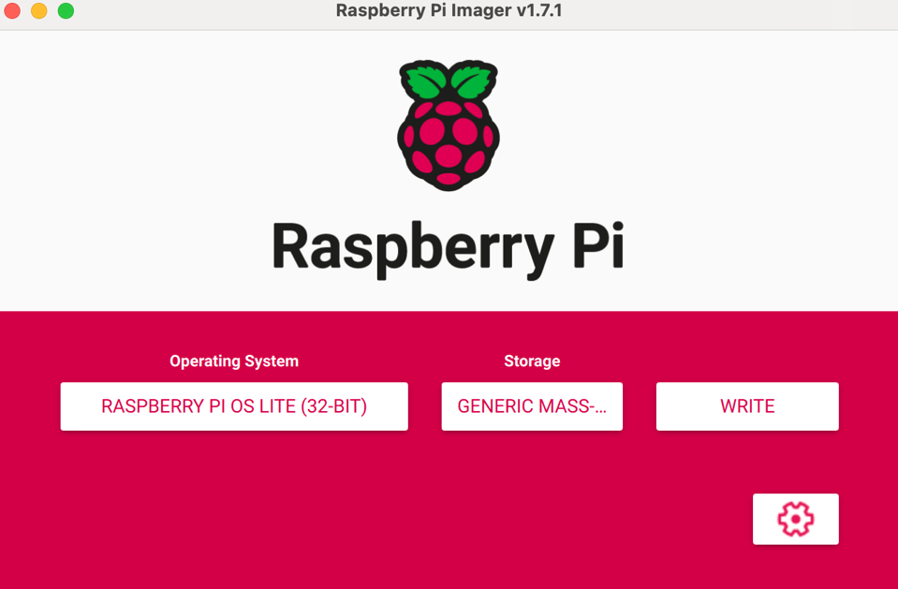

2.Download Raspberry Pi OS Lite <https://www.raspberrypi.com/software/operating-systems/#raspberry-pi-os-32-bit>

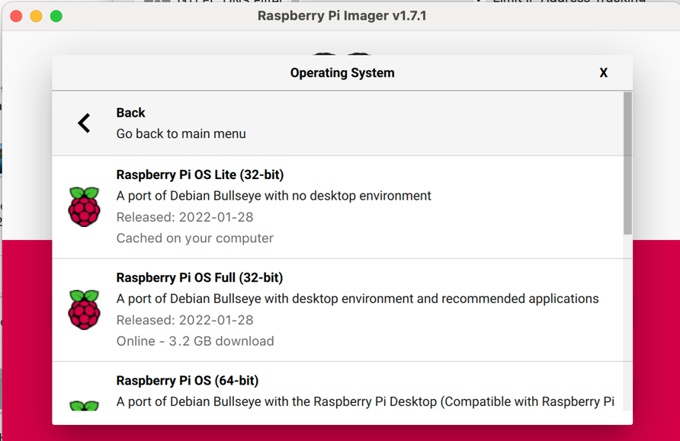

3. Download MSB using the commands below in a terminal:

**Windows**

Download and setup MSB using the commands below in Cmd, Powershell, or Git bash prompt:

mwinit -o -s

cd C:\Users\marcinxk  
git ssh://git.amazon.com/pkg/Project_PiJ

cd Project_PiJ/pi_setup

python -m pip install -r requirements.txt

**MacOS/Ubuntu**

mwinit -o -s

kinit -f  
cd ~/  
git clone ssh://git.amazon.com/pkg/Project_PiJ

cd Project_PiJ/pi_setup

sudo python3 -m pip install -r requirements.txt

4. Create Raspberry pi image, use advanced option to create user/password , enable ssh and connect to local wifi - best is to create hotspot on your phone (make sure your SSID does not contain special characters )

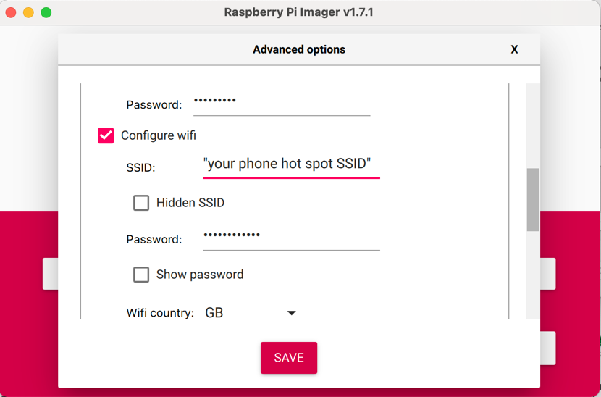

5. Connect your laptop to the same wi-fi as you set for Pi

6.Once image is created insert SD card to Pi and power it up

7. Verify your IP (ipconfig/ifconfig) and find IP of the PI connected to your phone hot-spot, usually it will be +1 or +2 then your laptop

8. Setup MSB using the commands below in a terminal:

**Windows**

Setup MSB using the commands below in Cmd, Powershell, or Git bash prompt:

*python pi_setup.py -u {user} -a {IP_ADDRESS} -f pi_file -c pi_env*

**MacOS/Ubuntu**

*python3 pi_setup.py -u {user} -a {IP_ADDRESS} -f pi_file -c pi_env*

9 . [Juniper prep] Copy the fallowing to /var/www/html/

* from your local laptop - configuration and software downloaded after podlauncher prep step
* Generate console network configuration files on network-config-builder and copy them to your local laptop and then to server (*/var/www/html/cfg/*)

*/apollo/env/ConsoleCfgGen/bin/l3v3_config_gen.py generate -C ~/ConsoleSiteDef --model QFX-5100-48S fra52-95-esoob-con-agg-r1 > fra52-95-esoob-con-agg-r1.config*

sftp network-config-builder

cd ConsoleSiteDef

get *.config

* open your web browser to IP the same IP as you use to run pi_setup and upload files one by one

10. [Juniper prep] Create inventory file where you assign all devices serial numbers to device names and upload to server using web browser.

inventory

PD3721350304,fra52-95-co-acc-sw001

PD3721350280,fra52-95-co-acc-sw002

VB3121280020,fra52-95-co-agg-r1

VB3121330098,fra52-95-co-agg-r2

VB3121280288,fra52-95-co-cor-r1

VB3121280098,fra52-95-co-cor-r2

VB3121370050,fra52-95-np-cor-r101

VB3120010009,fra52-95-np-cor-r102

PD3721350304,fra52-95-co-acc-sw001

PD3721350280,fra52-95-co-acc-sw002

VB3121280020,fra52-95-co-agg-r1

VB3121330098,fra52-95-co-agg-r2

VB3121280288,fra52-95-co-cor-r1

VB3121280098,fra52-95-co-cor-r2

PD3721350281,fra52-95-esoob-con-agg-r1

PD3721350282,fra52-95-esoob-con-agg-r2

PD3721350283,fra52-95-wsoob-con-agg-r1

PD3721350284,fra52-95-wsoob-con-agg-r2

PD3721350285,fra52-95-con-cor-r1

PD3721350286,fra52-95-con-cor-r2

# Deployment:

## [Juniper deployment]

1.Connect access switch to all Juniper devices mgmt. port

2.Connect server to access switch

3.power on devices

4. connect with console to one of the Juniper devices to monitor the process.

* each device will start requesting IP and configuration file from the server approximately 1 minute after the mgmt. interface turn UP.
* each device will pull software according to the hardware and current standards
* after the install reboot device will pull the configuration file based on its serial number and inventory file set in preparation stage

at this stage device is fully configured and can be access via console with neteng/datatech user

The whole process should not take more then 30 minutes from the moment devices are connected to the mobile SwitchBuilder server