Ellie v5: Architecture, Features & Governance Specification
Public / External Engineering Reference — Designed for AI Employee Systems
Core Principle: Operating doctrine: "The agent owns the work. The owner owns decisions and commitments. Host code owns authority."
Scope: This document describes an implementation showcase, not a supported hosted service or production deployment contract. Task content is processed by configured external providers.

0. Executive Preface: Context Note for AI Employee Platforms

Background and Motivation
This architecture specification documents Ellie v5, a single-tenant, Slack-first AI Chief of Staff reference implementation.
Commercial AI coworker platforms excel for mid-size and enterprise companies, where pooled team budgets absorb usage-based consumption naturally. Such platforms pioneered several interaction patterns that heavily inspired Ellie:
- 1. The coworker experience: Interacting inside Slack channels and threads with a natural conversational voice, responsiveness, and solid context retention instead of acting like a temporary chatbot.
- 2. Silence as a valid output: Recognizing that in scheduled monitoring, saying nothing when nothing changed is the hallmark of an executive assistant.
- 3. Interactive spaces: Publishing persistent, visual HTML micro-applications and dashboards instead of dumping walls of formatted text into chat.

The Solo Operator Dilemma & Real-World Friction
For a freelancer or solo operator, usage-based credit tiers become an obstacle to running an always-on, 24/7 personal chief of staff:
- Background vigilance anxiety: Running continuous background watchers (inbox monitoring, calendar overlap checks, folder sweeps, open loop tracking) constantly drains monthly credit allotments. Having to throttle or pause 10 out of 11 routines just to save credits defeats the core value of an autonomous coworker.
- Polling versus thinking: Multi-tenant managed agents often spend substantial capacity on idle checks and conversational turns instead of bounded reasoning.
While the coworker workflow is compelling, running it continuously as an independent operator required a setup anchored in direct-API pricing and deterministic host-code execution:
- 1. Cheap triggers, expensive thinking: Trigger detection runs in lightweight host code (inspecting IMAP UID sequences, Gmail historyId checkpoints, Google Drive modification timestamps, or receiving webhooks) at zero marginal cost. Gemini models run only when an actual state change needs intelligence, reducing background costs to near zero while keeping sub-minute responsiveness.
- 2. Deterministic governance vs prompt pleading: System prompts like "do not send emails without permission" fail under prompt injection, context truncation, or subtle conversational pressure. Host code keeps the authority boundary. Native tools belong to effect classes (READ, LOCAL_WRITE, INTERNAL_REVERSIBLE_WRITE, CONSEQUENTIAL). Consequential tools cannot execute directly. The dispatcher records a proposal in SQLite and appends its state transitions to an event history before rendering the full serialized payload in a Slack approval card. Only an explicit owner interaction with a valid Slack signature triggers execution.
- 3. Outbound claims banking: Language models drafting executive correspondence or resumes tend to embellish metrics, hallucinate phone numbers, or invent career milestones. An automated claims bank guard intercepts outbound drafts and documents. It scans text against a verified identity corpus and numerical repository, blocking ungrounded quantitative claims and unauthorized contact details before text reaches the approval queue.
- 4. Self-referential evidence protection: Over time, an agent reading past documents or email threads begins treating its own prior drafts as ground-truth evidence, compounding hallucinations over successive cycles. Tools with authored-resource tracking log generated Docs and Drive files. Declared reads of those resources, plus stored results, are marked as non-evidence, reducing self-referential hallucination loops.
- 5. Memory regularization: Unchecked agent self-learning causes prompt context explosion and captures transient details (such as specific email addresses, one-off dates, private recipient notes) into global long-term memory. A regularized self-improvement engine enforces a strict budget cap of about 1,000 tokens on active injected memory, scores lessons using Wilson-score utility rankings, and runs an automated leakage critic that rejects candidates containing specific dates, currency amounts, emails, or recipient-specific proper nouns.

1. System Architecture & Runtime Topology

1.1 High-Level Architecture Diagram
The diagram below illustrates the runtime components, governance gates, local SQLite stores, and external integrations:
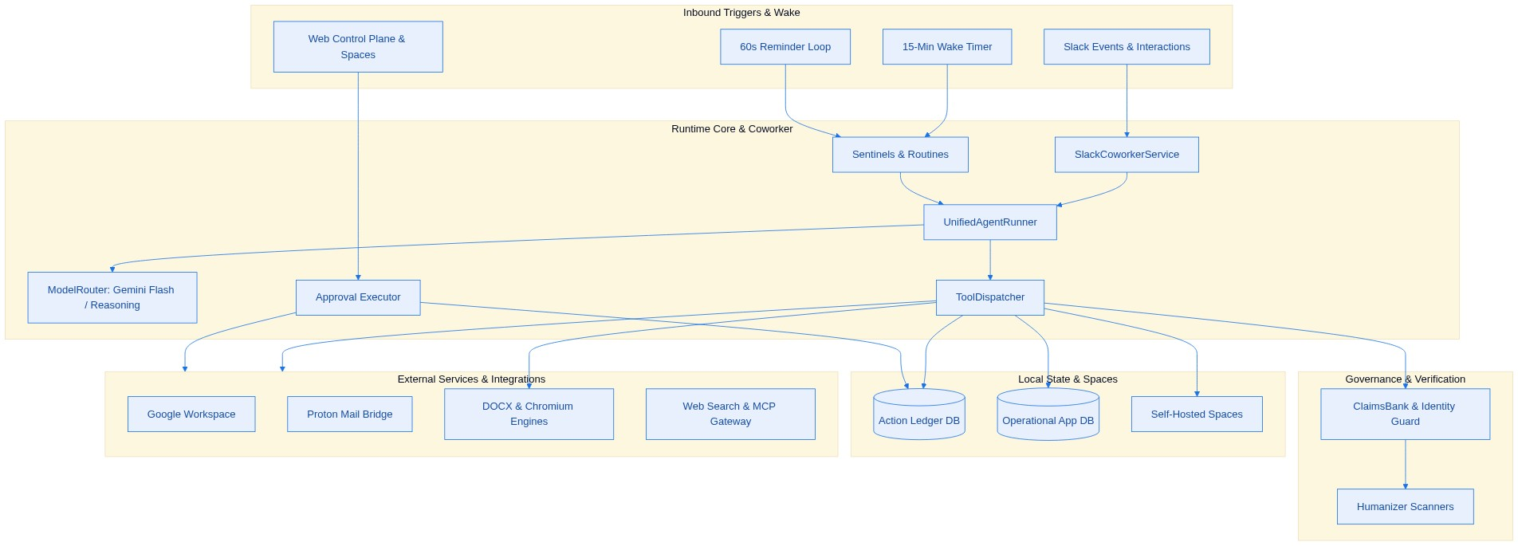

1.2 Technology Stack
Layer | Implementation | Role
Runtime | TypeScript 5.8+ (ES2022, NodeNext ESM), Node.js >=22.13.0 | Core application runtime
Database | Built-in node:sqlite (DatabaseSync) in WAL mode | Operational state (app.sqlite) and audit ledger (ledger.sqlite)
Foundation models | Google genai SDK (Gemini 3.8 Flash, Reasoning, Image Models) | Multi-tier reasoning, vision, and explicit context caching
Web service | Express with a single-file responsive dark-mode interface | Control plane, REST endpoints, and Spaces hosting
Document generation | docx, headless LibreOffice, Poppler, and Chromium | Dual-engine linear and visual document rendering
Tabular sandbox | In-memory node:sqlite (DatabaseSync) | Isolated SQL querying of attached user spreadsheets
External tools | Model Context Protocol (MCP) gateway & Composio | Integration with advertising, CRM, and cloud toolchains

2. Core Subsystems & Governance Pipeline

2.1 Multi-Tier Model Routing and Context Caching
Tier | Default Model | Thinking Budget | Temperature | Target Workloads
SENTINEL | Gemini Flash | low | 0.0 | Email triage, thread card edits, correction extraction, layout checks
ROUTINE | Gemini Flash | medium | 0.2 | Scheduled cron routines, background continuations, subtask delegation
INTERACTIVE | Gemini Flash | medium | 0.3 | Default Slack conversations and threads
ESCALATION | Gemini Flash | high | 0.3 | Auto-escalated upon repeated tool execution errors
ANALYSIS | Gemini Reasoning | high | 0.2 | Deep synthesis, complex evaluations, threads flagged with /argon
EVALUATOR | Gemini Reasoning | high | 0.0 | Post-routine constraint verification before posting deliverables

Static prefix caching: The static prompt prefix (doctrine, governance, tool discipline) is hashed with SHA-256 and registered with an explicit 1,800-second Gemini context cache. The coworker service warms this cache asynchronously upon receiving incoming Slack events.
Token efficiency: Low media resolution is applied for document and PDF visual layout checks. A zero thinking budget is configured on fast internal extraction tasks such as lesson extraction and text slimming. Redundant Slack block markup and Markdown noise are stripped before prompt assembly.

2.2 Forced Tool Loop & Execution Discipline
The agent runs with function calling mode set to ANY. Plain-text model completion is disabled. The model must invoke a tool on every turn, terminating through a synthetic finish tool call with explicit status (DONE, NEEDS_INPUT, BLOCKED, NOTHING_TO_REPORT, CONTINUE_IN_BACKGROUND) and deliveryMode (SLACK_MESSAGE, REACTION_ONLY, SILENT).
Multiple read tool calls in a single turn execute concurrently through Promise.all, followed sequentially by write or staging actions. Long-running interactive tasks can yield CONTINUE_IN_BACKGROUND with a prompt, allowing the coworker service to chain background execution rounds without blocking Slack response deadlines.

2.3 Deterministic Governance & Action Ledger Sequence
The sequence diagram below displays the strict human-in-the-loop lifecycle for consequential writes:
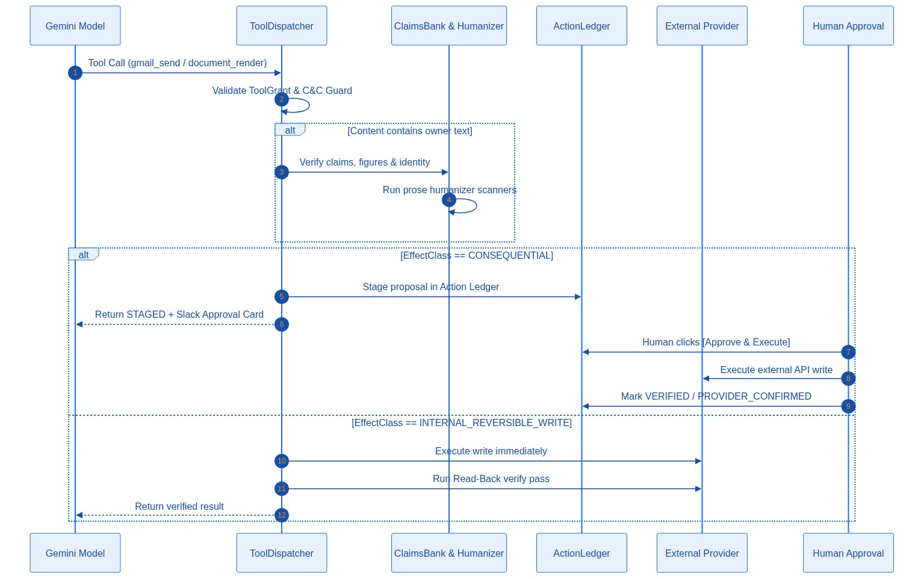
- 1. Guard evaluation: ToolDispatcher validates the active grant and interactive safety guards.
- 2. Verification: Draft handles are resolved and verified against the Claims Bank and Identity Corpus.
- 3. Action Ledger staging: If the tool is classified as CONSEQUENTIAL, the proposal is staged in the Action Ledger and rendered as a Slack approval card.
- 4. Execution: Only a verified human click invokes the execution handler.
- 5. Read-back pass: If the tool is classified as INTERNAL_REVERSIBLE_WRITE, the operation executes immediately and runs a tool-specific read-back check where one is implemented.

3. Tool Catalog Inventory
Native and dynamically registered tools are typed, assigned an effect class, and passed through host-code checks before invocation.

3.1 Google Workspace Tools (14 Tools)
- gmail_search & gmail_read: read-only message and thread discovery with payload decoders.
- gmail_draft: non-consequential draft creation with read-back verification.
- gmail_send: consequential outbound email staging requiring human Slack approval.
- sheets_read, sheets_append, sheets_update: header-mapped reading, row appending, and cell-by-cell verified updates.
- docs_read, docs_create, docs_append: full document reading and verified authoring logged in authored resources.
- drive_search, drive_read_file: drive search and universal reading (extracts text from Docs, PDFs, Word docx, CSV, JSON).
- calendar_list, calendar_create: calendar inspection and staged consequential event creation.

3.2 Secure Mail Bridge Tools (5 Tools)
- proton_search, proton_list_unread, proton_read: localhost IMAP message querying and body retrieval.
- proton_draft: IMAP append draft composition.
- proton_send: consequential SMTP email staging with deduplication and approval card checks.

3.3 Verification & Claims Tools (2 Tools)
- owner_sources_read: batch loader for canonical identity documents, project guidelines, and the verified claims bank.
- owner_text_check: pre-flight check evaluating plain text or document blocks against the Claims Bank, Identity Corpus, and stylistic humanization scanners.

3.4 Dual-Engine Document Rendering Tools (2 Tools)
- document_render: linear formatted document generator (resumes, cover letters, memos, briefs, reports). Generates docx with embedded Open Font License typography, runs headless LibreOffice conversion to PDF, performs page auto-fitting, validates ATS reading order, and archives to Drive.
- visual_document_render: visual one-page document generator (one pagers, pitch sheets, infographics). Renders HTML5 and CSS Grid layouts with embedded SVG icons, runs an A4 height solver targeting 92% to 100% density, and converts through headless Chromium.

3.5 Memory, State, Spaces & Spreadsheets (15 Tools)
- memory_save, memory_list_facts: explicit executive memory management.
- memory_record_candidate, memory_list_candidates, memory_promote_candidate: candidate learning pipeline.
- reminder_set: natural language scheduled Slack reminder creation.
- result_read: character-offset paging through large stored result handles.
- sheet_query: in-memory SQLite sandbox executing read-only SQL (SELECT and WITH queries) against attached XLSX, CSV, or TSV workbooks.
- waiting_track, waiting_list, waiting_resolve: outbound follow-through tracking so no open loop is forgotten.
- project_state_read, project_state_update: canonical project status tracker managing objectives, blockers, and milestones.
- space_publish, space_list: publishing and listing interactive self-hosted web micro-apps served at /spaces/:slug.

3.6 Skills, Job Evaluation, Subtasks & Visuals (6 Tools)
- skills_list, skill_read, skill_edit: on-the-fly inspection and authoring of domain skill files.
- job_evaluate: specialized evaluation engine executing multi-criteria role scoring on the reasoning model against verified candidate dossiers.
- delegate_subtask: spawns an isolated child agent runner to distill complex research without context pollution.
- image_generate: image generation and iterative photo manipulation using Gemini Image models with automatic EXIF metadata stripping.

3.7 Web Intelligence & Gateway Integrations (21 Tools)
- web_search: Google Search grounding through native tool configuration.
- web_read_page: multi-fallback web reader with SSRF address validation.
- apify_linkedin_profile, apify_linkedin_posts: structured profile and post scraping with daily quota caps.
- mcp_elliegateway tools: Model Context Protocol gateway integrations (Amazon Ads reporting, Meta Ads reporting, and LinkedIn DMA data portability) pinned against SHA-256 schema baselines.

3.8 Dynamic Composio Integration (5 Tools + Dynamic Slugs)
- composio_search_tools, composio_install_tool, composio_setup_tool, composio_execute_tool, composio_list_installed: dynamic discovery, authorization checking, and staging of third-party SaaS tools. Consequential actions automatically inherit Action Ledger approval requirements.

3.9 Self-Diagnosis & Infrastructure Inspection (4 Tools)
- repo_list_and_search, repo_read_file: code exploration and self-inspection blocking secrets, environment files, and databases.
- trace_inspect_recent: glass-box execution inspection of recent run traces, errors, and tool outputs.
- vps_inspect: sandboxed Linux systemd and journalctl resource reader with automated secret token redaction.

3.10 Interactive Command & Control Tools (8 Tools)
These tools are restricted to interactive Slack sessions and blocked in background routines:
- routine_manage: management of automated cron schedules and prompts.
- reminder_manage: inspection and rescheduling of active reminders.
- nudge_settings_manage: configuration of quiet hours, snooze windows, and daily proactive notification caps.
- memory_manage: review and maintenance of learned executive rules.
- queue_manage: live inspection and dropping of staged Action Ledger proposals.
- workspace_alias_manage: setting friendly alias pointers for Drive files and sheets.
- sentinel_manage: configuration of VIP sender rules and monitoring states.
- cost_and_budget_manage: telemetry inspection of daily and weekly token consumption and USD spend.

4. Proactive Sentinels & Autonomous Operations

4.1 Sentinels and Nudge Gate
Gmail and Proton sentinels periodically check incoming correspondence. When a counterparty replies to an outstanding thread, matching waiting loops can resolve automatically. Inbound triage runs on the fast sentinel tier and can stage reply drafts for owner review.
A calendar sentinel checks events starting within approximately 20 minutes, raising deduplicated alerts for imminent commitments.
A configurable nudge gate enforces quiet hours, daily notification limits, snooze durations, and 24-hour deduplication so background alertness never degrades into notification noise.

4.2 Cron Routines and Dual-Pass Evaluator
Background routines that monitor external folders or trackers check resource modification timestamps before doing any work. When nothing changed, the run finishes silently without spending model tokens.
When a routine has hard factual constraints and an evaluator model, an optional evaluator pass checks the draft against tool evidence and appends a note when a violation is detected. Evaluator failures do not block delivery.

5. Web Control Plane & Interface
A single-page control plane runs alongside the agent runtime under token authentication or a configured trusted tailnet listener.
The approvals screen (at /) lists staged consequential actions with payload previews, approval buttons, and drop controls. A spaces gallery (at /spaces) lets users browse and search agent-published dashboards and micro-apps. The routines screen manages schedules and manual run triggers, while the runs tab provides glass-box telemetry for prompt timing, token counts, cache hit rates, and delivered text. Additional views report token costs, project documentation, and integration health checks.

6. Implementation Status & Roadmap

Showcase Implementation (v5.0.0)
The showcase includes the core agent, governance pipeline, dual-engine document rendering, native integrations, dynamically registered integrations, and an automated offline test suite.

Experimental Interfaces
The repository includes an experimental native Android companion (Jetpack Compose) for approvals, runs, routines, Spaces, voice notes, and meeting recording, along with server endpoints for audio transcription, speech synthesis, and meeting-note ingestion. These paths are showcase quality, not distributed production clients.

