Project manual

Multiscale Modeling

Author: Marcin Rybacki

User interface:

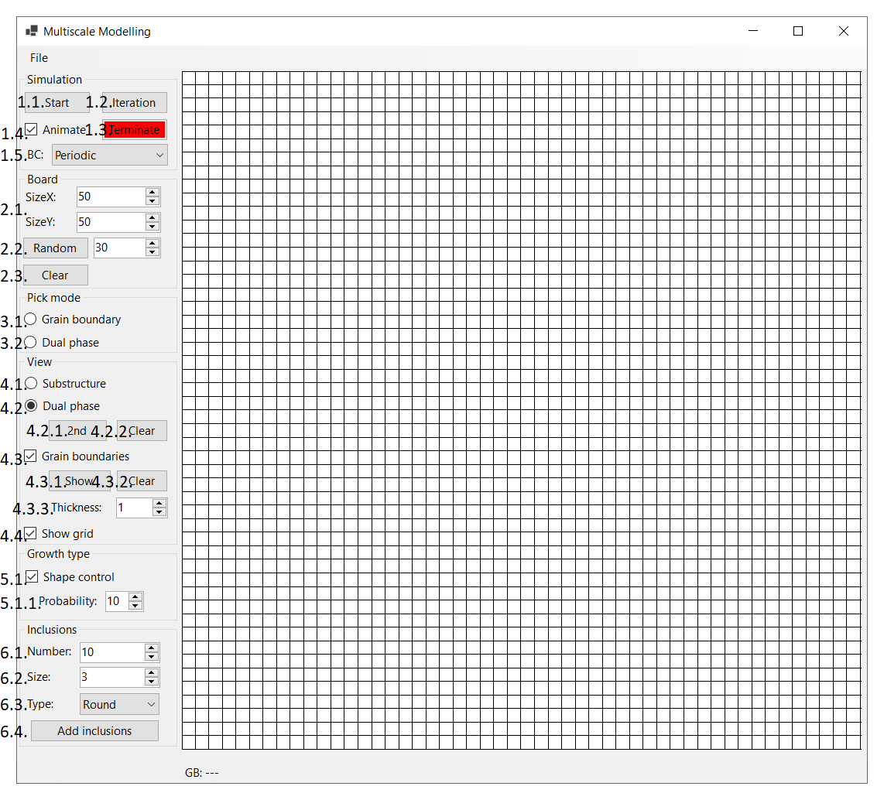

Figure 1 Application window

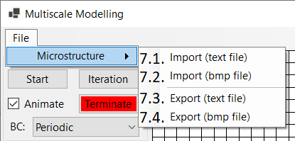

Figure 2 File tool strip menu

1. Simulation
   1. Start – begins the simulation, there has to be at least one nucleon on the board
   2. Iteration – calculates and draws one iteration of simulation, there has to be at least one nucleon on the board
   3. Terminate – immediately stops currently running simulation
   4. Animate – space is redrawn after each iteration giving an animated effect of simulation. If the option is turned off, only the final changes are presented
   5. Boundary conditions – absorbing or periodic
2. Board
   1. Size – determines size of space on which the cells can grow
   2. Random – sets nuclei randomly given a number
   3. Clear - erases all nuclei and inclusions on the space
3. Pick mode
   1. Grain boundary – clicking on a grain causes its boundaries to be drawn
   2. Dual phase – clicking on a grain causes moving it to dual phase
4. View
   1. Substructure – reveals substructure
   2. Dual phase – paints all grains that are not in the “zero” phase
      1. Second growth – begins simulation of the second grain growth (after the first grain growth)
      2. Clear – removes all grains from dual phase
   3. Grain boundaries – reveals cells situated on grains’ boundaries
      1. Show – marks (remarks) all cells that are on grains’ boundaries
      2. Clear – unmarks all cells situated on border
      3. Thickness – determines grain boundary’s thickness
   4. Show grid – shows the grid of cellular automata space
5. Growth type
   1. Shape control – grain growth using shape control method
      1. Probability – probability used for shape control algorithm
6. Inclusions
   1. Number – number of inclusions to set
   2. Size – inclusions’ size
   3. Type – round or square
   4. Add – adds inclusions (before simulation – randomly on space or after simulation - on grains’ borders)
7. File tool strip menu
   1. Import txt file – imports state from a txt file
   2. Import bmp – imports state from a bmp file
   3. Export txt – exports state to a txt file
   4. Import bmp – exports state to a bmp file

Simulation step by step:

1. Set the size of the space
2. Choose boundary condition
3. If needed, add inclusions (randomly on board)
4. Set nuclei on the board using random
5. To use shape control algorithm, check proper check box and set probability
6. Check “Animate” check box to show animation during simulation
7. Click “Start” button to begin simulation
8. If needed, add inclusions (randomly on grain boundaries)
9. Check “Grain boundaries”, set thickness and click “Show” button to display boundaries of all grains or pick the “Grain boundary” mode and view, click on a grain to display its boundary
10. Check “Dual phase” view and mode, click on grains to move them to another phase
11. Set number of new nuclei in each grain in “zero” phase
12. To use shape control algorithm check the proper check box and set probability
13. Click “2nd”to start second grain growth
14. To show grain boundary and substructure or dual phase, use “View” section

Results:

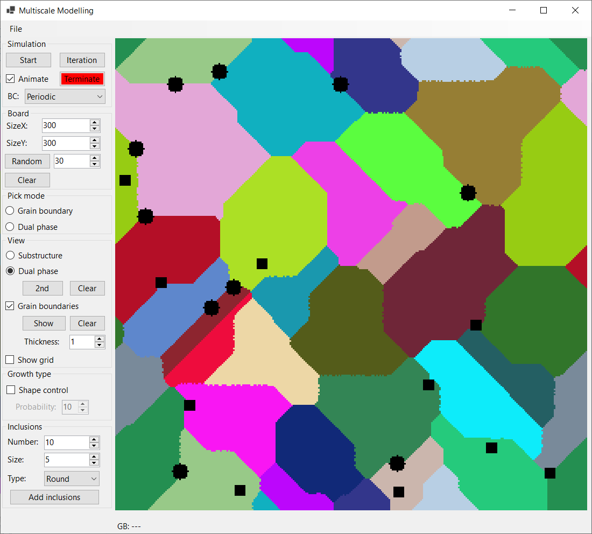

Figure 3 Grain growth with inclusions - round on border, square on random positions

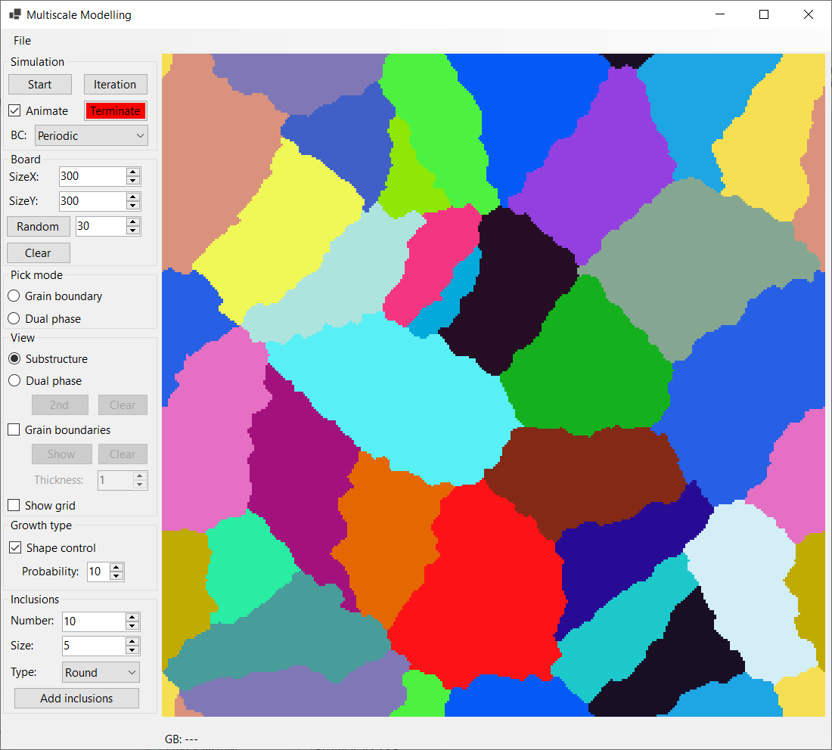

Figure 4 Grain growth using shape control with 10% probability

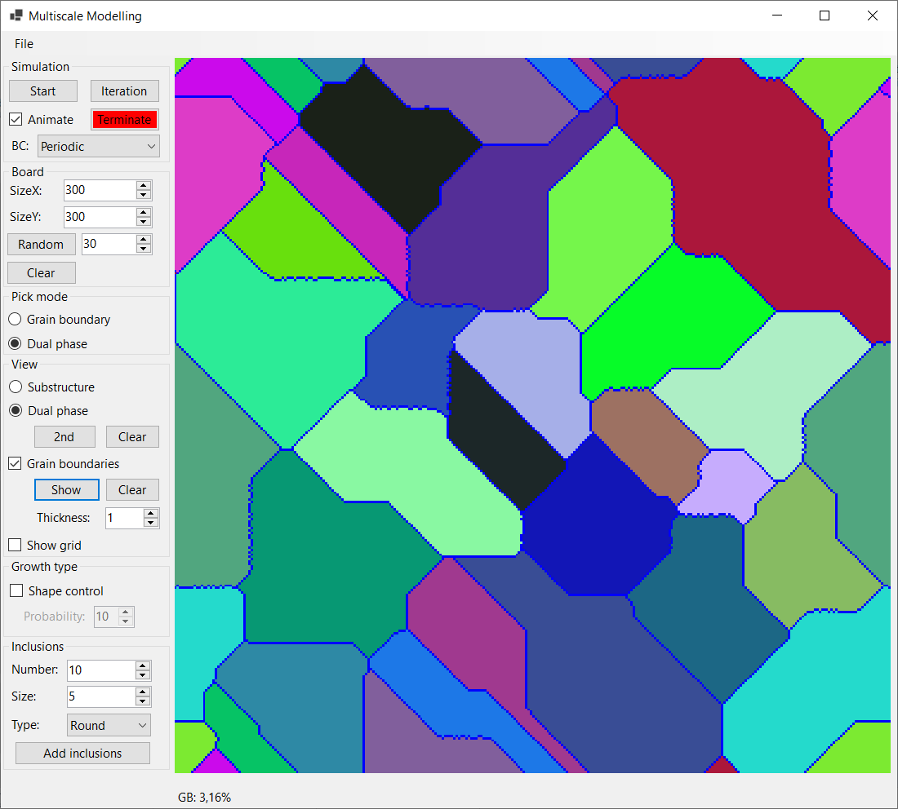

Figure 5 All grains’ boundaries

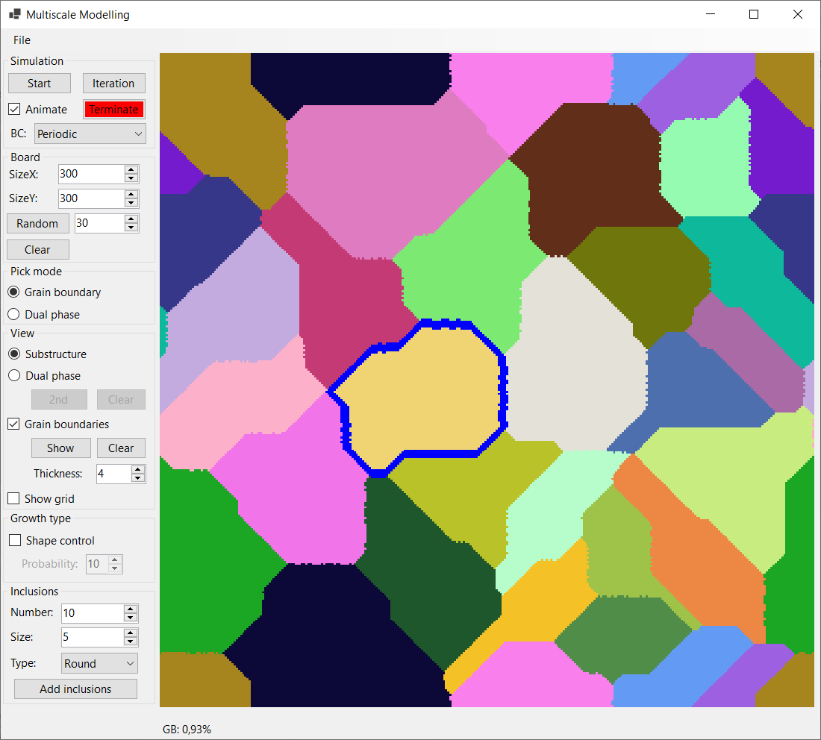

Figure 6 Single grain boundary

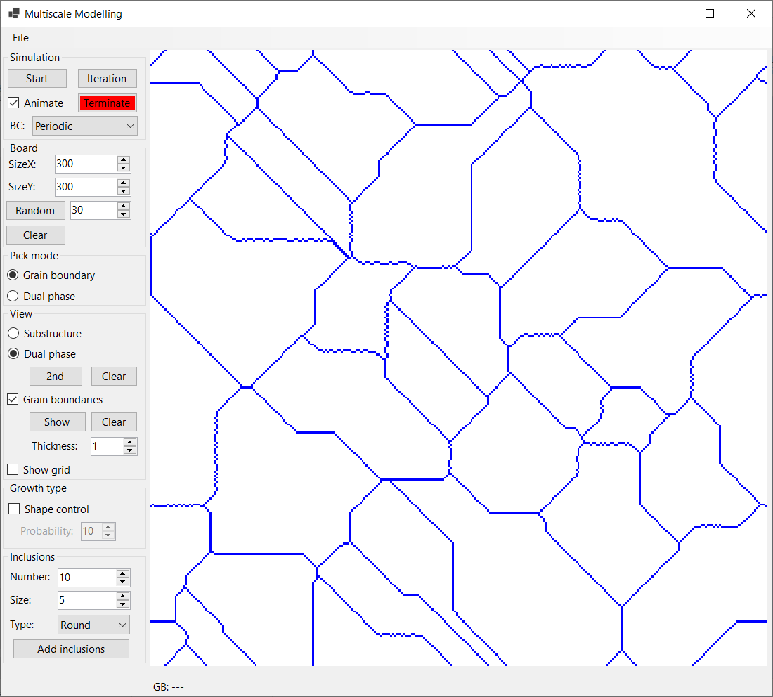

Figure 7 Selection of all grains from previous simulation

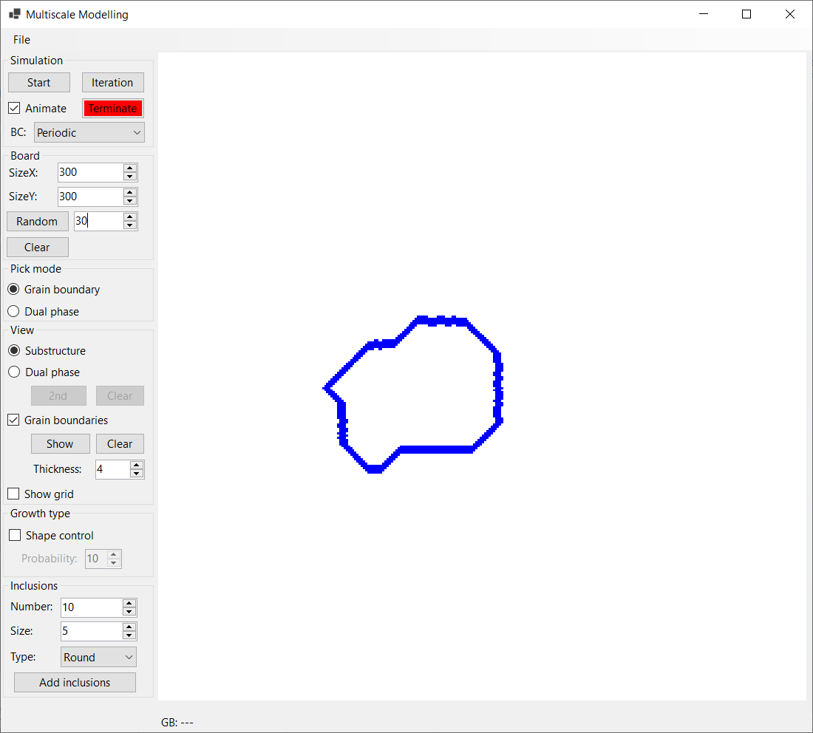

Figure 8 Selection of single grain from previous simulation

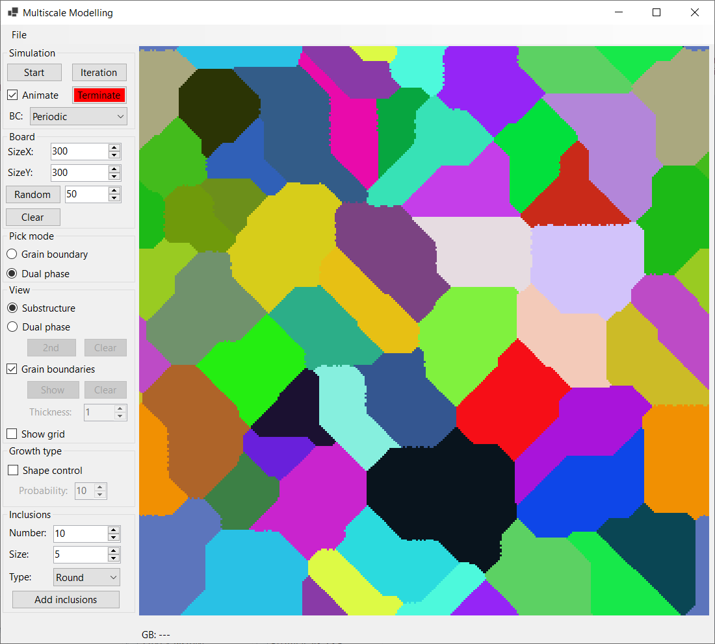

Figure 9 Substructure view

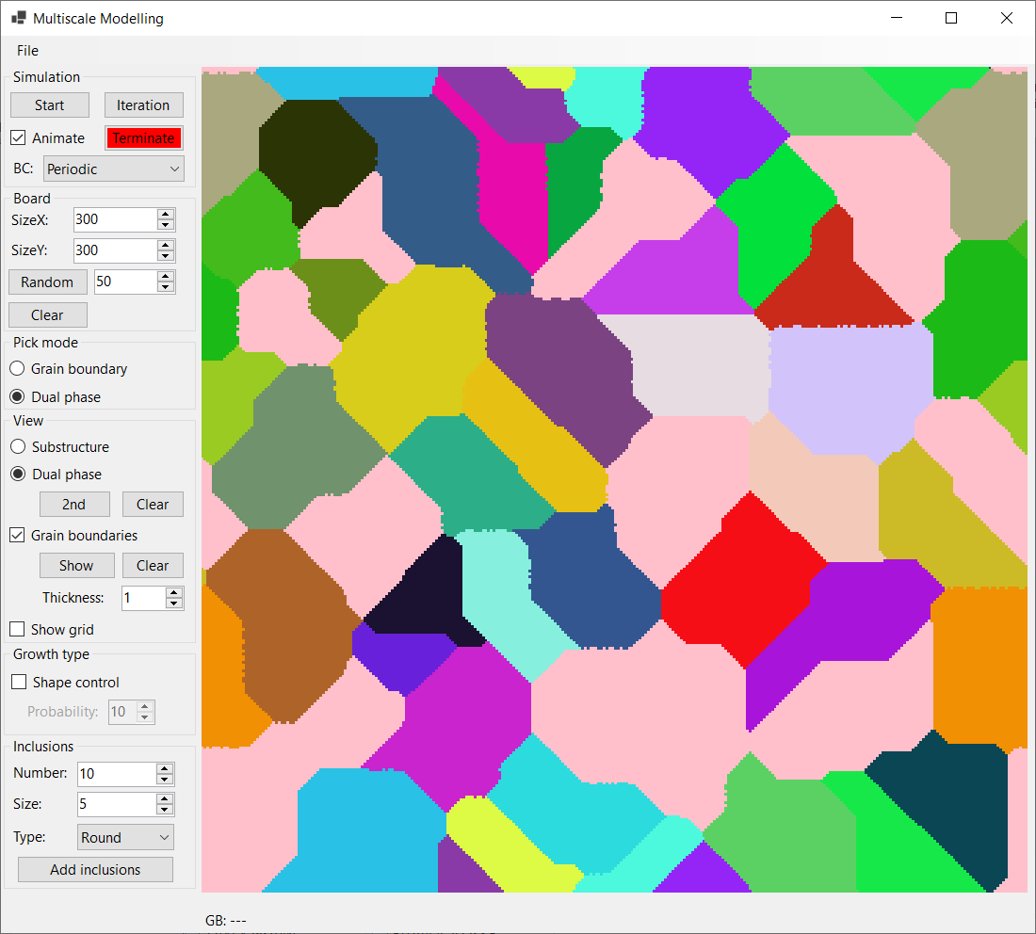

Figure 10 Dual phase view

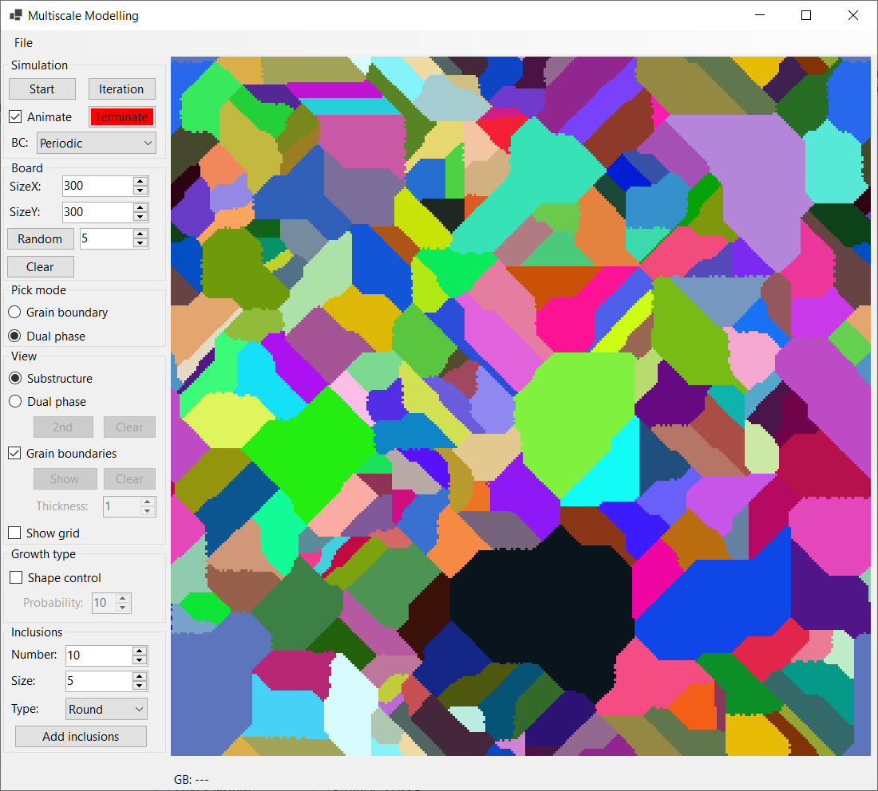

Figure 11 Substructure view after second grain growth

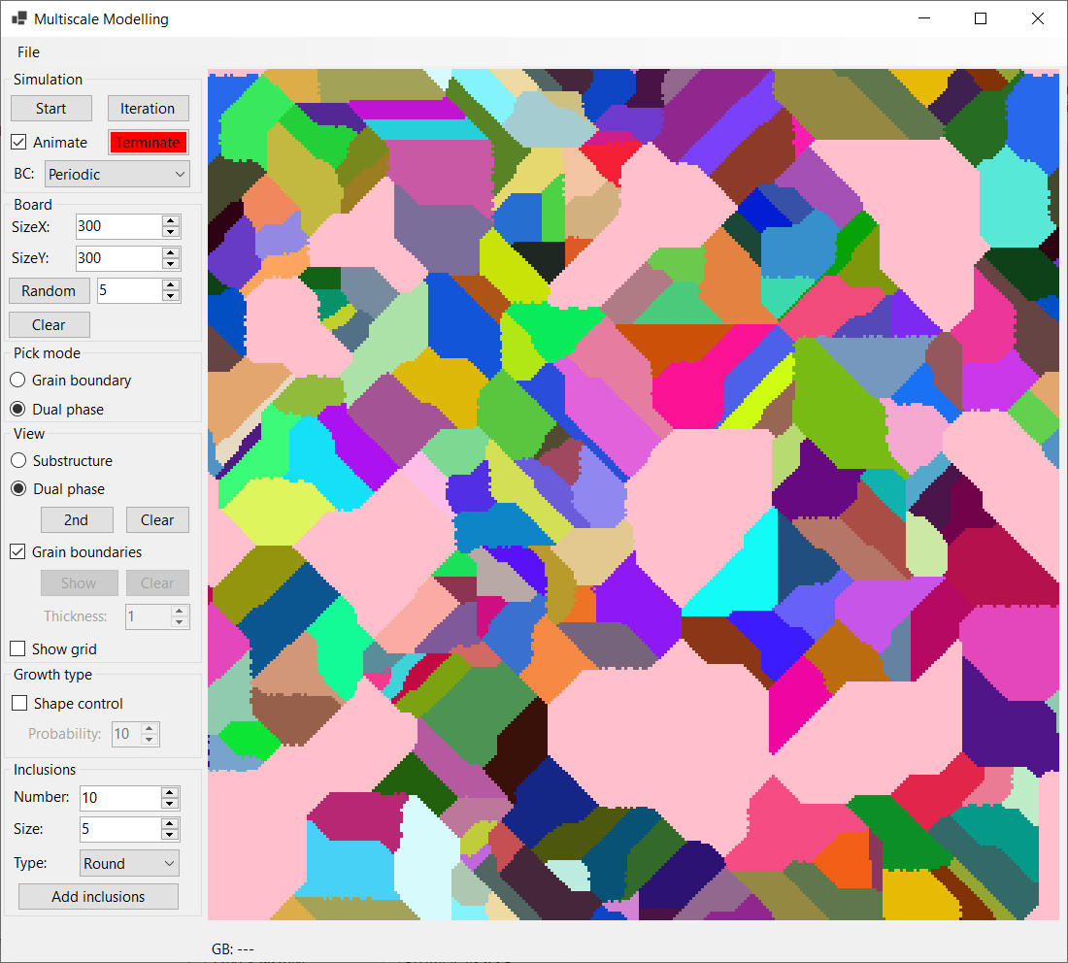

Figure 12 Dual phase view after second grain growth

Table of figures:

Figure 1 Application window 2

Figure 2 File tool strip menu 2

Figure 3 Grain growth with inclusions - round on border, square on random positions 5

Figure 4 Grain growth using shape control with 10% probability 5

Figure 5 All grains’ boundaries 6

Figure 6 Single grain boundary 6

Figure 7 Selection of all grains from previous simulation 7

Figure 8 Selection of single grain from previous simulation 7

Figure 9 Substructure view 8

Figure 10 Dual phase view 8

Figure 11 Substructure view after second grain growth 9

Figure 12 Dual phase view after second grain growth 9