

#businesscloud

Creating Soaring Valuations Using Business Cloud

Business Cloud Readiness Report

For <Organization>

Developed by



[www.coeusage.com](http://www.coeusage.com)

About Coues Age

We are a fast-growing research and consulting organization that is continuously developing actionable insights for the business and government leaders build value amid digital disruption

[www.coeusage.com](http://www.coeusage.com/) [www.maximumgovernance.com](http://www.maximumgovernance.com/) [www.leaddding.com](http://www.leaddding.com/)

Disclaimer

The report is an outcome of the Business Cloud Readiness Instrument filled for <organization>

The contents of this report are for the internal use of the organization that has filled the instrument and in no way should be used for publicity purpose without a written approval of Coeus Age.

The insights are for the purpose of sharing a perspective. Coeus Age does not take the responsibility of the business outcome of the decisions based on the insights as results will depend upon many other factors beyond our control.

**CIOs Can Now Create Soaring Valuations**

Do you know that Business Cloud can help your business emulate the new age digital disruptors and parallel their sky-high valuations?

And imagine you, as the technology leader, leading the leap. Using our Business Cloud Readiness Instrument has been a defining step towards taking that big leap.

**Three Aspects Defining BUSINESS CLOUD**

1. It is FIRST about **business**, defined directly by the imperatives to become competitively responsive and ruthlessly efficient
2. It is ALL about integrated business **applications** that underlie the enterprise processes, it is NOT about the IT infrastructure
3. It is inherently architected for **cloud**, making it scalable, elastic, agile, secure, and data centred

**Five Dimensions of BUSINESS CLOUD**

A business cloud is about new age digital capabilities that a business need to survive and thrive amid disruption.

A Business Cloud is inherently architected for cloud. It’s not just about hosting applications in the cloud but enabling the entire application life cycle development and management in the cloud.

A Business Cloud is operationalized by broad based automation of business processes, starting from large and formal processes to the minutest ones. Technologies such as AI, ML and RPA are leveraged in order to simply user experience and productivity.

Taking the automation drive further, Business Cloud envisages integration of automated processes across the value chain, both within and outside the enterprise.

Data centricity is an important cornerstone of a Business Cloud giving enterprises the power to exploit data for decision making and higher responsiveness.

Supporting innovation and operationalizing diverse range of use cases with scale and speed is an important dimension of a Business Cloud.

The Business Cloud Readiness Instrument operationalizes these five dimensions into sixteen items that represent concrete steps to be undertaken by the enterprises. The overall score and individual dimensions’ scores for your organization are given in the section that follows.

Your Business Cloud Readiness

**<Organization>’s overall Business Cloud Readiness Score is <T_SCORES_BCRS%> %.**

A score of 90% or higher is an excellent score and such an organization can boast to have built a highly functional business cloud. The benefits of the business cloud on organizational performance are clearly visible in such an organization. Its ability to create differentiation or cost leadership or both is considerably higher, even amid disruptive competitive context. In-fact it itself could be a disruptor.

A score of 75% or higher is a very good score and such an organization must be on its way towards building a functional business cloud. It must focus on the dimensions where its score is low so that it can enhance the score further.

A score of 60% or higher can be a good score and such an organization must focus on more than one dimensions where its score is low. It may have taken initiatives in rather limited areas that make a business cloud.

A score of 40% or higher can be an average score and such organization has a lot of ground to cover in many dimensions for building a business cloud.

A score of less than 40% is a poor score and such organizations must see their performance vis-à-vis competitive context to decide how urgently they need to focus on enhancing their BCR Score.

**<Organization> score on individual dimensions of business cloud –**

Architected for Cloud - <T_SCORES_AC> %

Automated and Autonomous Processes - <T_SCORES_AAP>%

Integrated Value Chain - <T_SCORES_IVC> %

Centered on Data - <T_SCORES_DC> %

Supportive of Innovation - <T_SCORES_SI> %

Business Context – Business Cloud Readiness Matrix

<Organization>’s position is the matrix is that of a <T_SCORES_MATLABEL> based on its Context Score and Business Cloud Readiness Score.

The four types that the matrix highlights are – Leader, Early Mover, Struggler, and Laggard.

*Leader* is an organization that perceives a high business context for digital and a high business cloud readiness score. Such businesses are highly competitive and performing.

*Early mover* is organization that perceives a low business context for digital but has a high business cloud readiness score. The scores indicate that the organization has taken an early

mover advantage in building the business cloud. One needs to be sure that it’s not lack of awareness or complaisancy or both.

*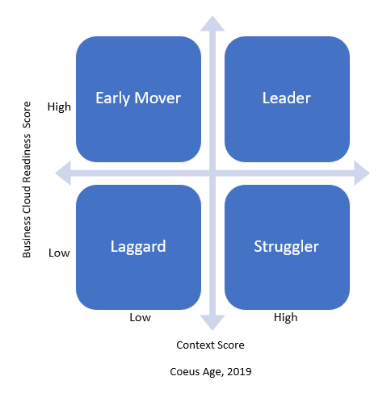Struggler* on the other hand is an organization that perceives a high business context for digital and but has a low business cloud readiness score. The score indicates struggle for the organization to keep pace with the competitive business context.

*Laggard* is an organization that has low scores on both business context and business cloud readiness. It indicates a low relevance of digital (as seem by them) in their organizational approach to competitive strategy. Similar to an *Early Mover*, one needs to be sure that it’s not lack of awareness or complaisancy or both.

Post Assessment

So, your organization’s Business Cloud Readiness assessment is done. What now?

A Business Cloud is an answer to the contemporary challenges that need putting digital at the nerve centre of a business.

You may want to discuss the findings with your team or even the CXO leadership and derive key actions that must be taken. If you wish our analysts can help you convert the instrument and the findings into a discussion that helps your business.

Principal Analyst

Dr Kapil Dev Singh is the Founder & CEO, Coeus Age. He headed IDC in India for close to eight years as the Country Manager and has been tracking the ICT industry for 23 years now.   
He is currently spearheading path breaking research on digital enterprise and new technologies.

Dr Singh regularly speaks at various industry forums and conducts workshops on ‘leadership for the digital age’. He has authored several books and reports, notable ones being – *LEADDDING, CIO Leading Change, The Platform Edge, Looking Inward, 51 Gems of Digital India, Thriving in a Data Economy, and A Board’s Eye View of Digital in Enterprise.* He has also published several papers in leading academic journals.  
  
Dr. Singh is an Engineer, and an MBA. He is also a doctorate from Management Development Institute, Gurgaon, India.



www.coeusage.com

Coeus Age Consulting LLP

404, 4th Floor, Global Foyer, Golf Course Road

Sector -43, Gurgaon, Haryana, India- 122002.

[kds@coesuage.com](mailto:kds@coesuage.com), +91 9811771187