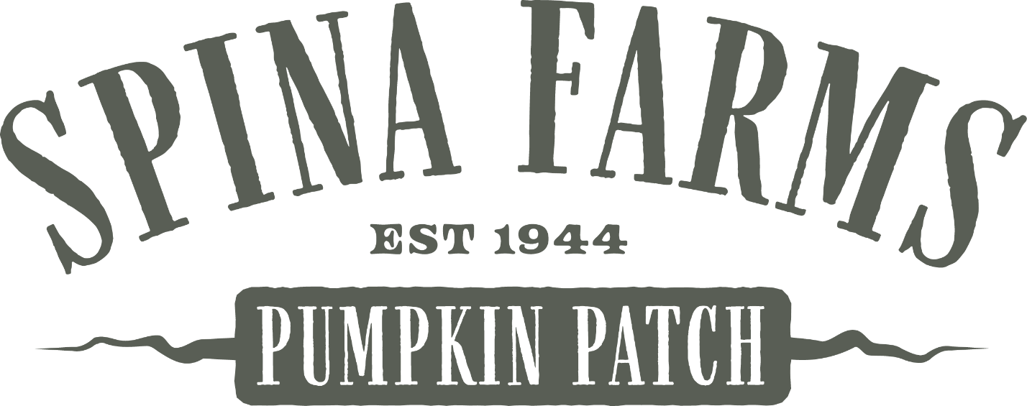

Thank you for choosing Spina Farms Pumpkin Patch for your school or club field trip this year! We are eager to welcome you and share our rich farming history with you and your family.

Upon your arrival, a Spina Farms guide will greet the teacher/leader, collect any balance due and direct you to the area where you will begin your tour.

Pricing - $12 per student, $6 per participating parent. Student chaperones 5:1 ratio

Your farm experience will include:

* A guided tour of the patch which includes a brief interactive demonstration that illustrates the amazing metamorphosis which takes place as a seed transforms into the plant.
* A ride aboard the Spina Express. Our colorful handmade nostalgic train is always a favorite of guests of all ages.
* Hay Ride – Climb aboard our hay wagon and wind your way through the corn, sunflowers and zinnia. Enjoy the many scarecrows and characters you will see along the way
* Reserved Tent – Privacy and shade. Perfect for taking a break.
* A Sugar Pie Pumpkin – each **student** will receive a Sugar Pie to take home.

We suggest that your group bring the following items to insure their comfort:

* Sunscreen and a hat – (October can be hot!)
* Permanent felt tip pen to mark each pumpkin with the children’s names.
* Sturdy closed toe shoes are recommended
* Spending money – in case they would like to purchase additional tickets or items from the Snack Shack or Boutique.
* Table coverings are suggested if you will be having a snack. Our picnic tables are rustic wood and can cause splinters.
* Boxes or Bags for transporting your pumpkins

Other things to note:

* NO petting zoo or pony rides Monday – Friday – (Animals are only on-site Saturdays and Sundays from 10am-4pm. Tickets are sold separate from Spina Farms Rides)
* Pumpkin Patch closure may occur with stormy/wet weather conditions due to flooding & safety issues. Refund or rescheduling is available as dates and time permit.
* School, troop, or club shirts are recommended to easily identify students of each group.
* *Add-ons are available above our basic farm tour as time and space permit. Please see our Field Trip Add-Ons page for pricing and additional information.

Location:

Spina Farms Pumpkin Patch is located at the corner of Santa Teresa Boulevard and Bailey Avenue.

Contacts:

Reservations – Molly Rockhill Or Ronda Estrada – 408.722-8037 [spinapumpkinreservations@gmail.com](mailto:spinapumpkinreservations@gmail.comdas)

General Information – 650.763.6929 – [rondaspatch@gmail.com](mailto:rondaspatch@gmail.com)

Field Trip add-ons

Our field trip format is designed to accommodate preschool through elementary school students. The basic activities take between 60-90 minutes with a fixed cost as listed on the Field Trip welcome letter.

If your group would like to extend their visit, we have the following options available with prior notice:

* $5 – Corn Maze
* Pumpkin Bread - $6 per loaf

Please sign in acknowledgment that you have received and read this welcome letter.

Name_________________________________ Date _______________