Smartphone-Based Crop Disease Detection and Decision Support Using Deep Learning
A computer vision case study in real-world domain adaptation
Final-year project · 2026
ABSTRACT
Crop disease causes between 20 and 40 percent of annual global yield loss, while the trained pathologists who can diagnose disease from a single leaf photograph are concentrated in research institutions far from the small farms where the losses occur. This project investigates whether a deep convolutional neural network can serve as a smartphone-based decision-support tool in that gap. We train a ResNet50 classifier on a union of the PlantVillage and PlantDoc datasets — 41,039 images across 27 disease classes and 14 plant species — and evaluate on the 252-image PlantDoc real-world test set. The central technical challenge is domain shift: models trained on clean laboratory images routinely exceed 99% on their own validation set but collapse on real field photographs. We address this with strong geometric and photometric augmentation, Focal Loss with inverse-frequency class weighting, CutMix regularization, a two-phase frozen-then-unfrozen fine-tuning schedule, and eight-view test-time augmentation. A controlled comparison shows ResNet50 and EfficientNet-B0 perform within statistical noise under identical conditions; our final ResNet50 model achieves 75.40% accuracy and macro F1 of 0.746 on PlantDoc, a 45-point improvement over an equivalent PlantVillage-only baseline. The single largest contributor to that gain was additional training data, not algorithmic refinement.

1. Introduction
Plant disease is among the most consequential and least-addressed problems in modern agriculture. Estimates from the Food and Agriculture Organization place global crop yield loss to pests and pathogens at between 20 and 40 percent annually, with disproportionate impact on smallholder farmers in regions where agricultural extension services and trained plant pathologists are scarce. Early detection often determines whether a farmer can arrest an outbreak with targeted treatment or loses the harvest entirely. The bottleneck is rarely cost or lack of available treatment — it is diagnosis.
Diagnosis from a leaf photograph is fundamentally a computer-vision task: the diagnostic signal (lesions, discoloration, spots, mosaics, wilting) is encoded entirely in pixels. Convolutional neural networks have matched or exceeded human-expert performance in analogous fine-grained visual classification problems such as dermatology and radiology, and several recent works have applied them to plant disease detection. Our project asks a narrower and harder question: can a CNN trained primarily on the controlled-condition photographs available in academic datasets generalize to the messy, smartphone-quality field photographs that a farmer would actually produce?

1.1 Related work
Mohanty et al. (2016) [3] established the feasibility of using deep CNNs for plant disease classification by training on the PlantVillage dataset, achieving over 99% on its in-distribution validation set. Singh et al. (2020) [4] introduced the PlantDoc dataset to expose a critical limitation: models trained on PlantVillage typically collapse when tested on real-world field photographs — a domain-shift problem that is the focus of this project.
Our architectural choices draw on two well-established convolutional designs: ResNet50 (He et al., 2015) [1], whose residual / skip connections solve the vanishing-gradient problem that previously limited network depth; and EfficientNet-B0 (Tan & Le, 2019) [2], which uses compound scaling and MBConv blocks with squeeze-and-excitation attention to achieve comparable accuracy with five-fold fewer parameters. To address class imbalance we use Focal Loss (Lin et al., 2017) [5], which down-weights well-classified examples so training capacity is redirected to harder ones. For regularization we use CutMix (Yun et al., 2019) [6], which differs from MixUp (Zhang et al., 2018) [7] in preserving local pixel structure — important when the diagnostic signal is textural. Finally, to ensure the model's predictions are trustworthy and not the product of spurious shortcuts, we use Grad-CAM (Selvaraju et al., 2017) [8] to produce per-prediction heatmaps showing which image regions drove the classification.

2. Dataset
Our work uses two complementary datasets spanning the lab-to-field continuum. PlantVillage [3] contains over 54,000 leaf images photographed against uniform backgrounds under controlled studio lighting; we use it as our pretraining and bulk-training signal. PlantDoc [4] contains roughly 2,500 photographs taken in actual agricultural settings with consumer-grade smartphone cameras: variable lighting, soil backgrounds, neighbouring leaves, motion blur and partial occlusion are the norm. PlantDoc is our honest evaluation set — the headline accuracy figures throughout this report are PlantDoc test-set numbers. The two datasets do not share a class taxonomy out-of-the-box, so we constructed an alignment dictionary mapping each PlantDoc class to its PlantVillage equivalent, keeping only the 27 classes present in both sources and using PlantVillage's naming convention as the canonical taxonomy. The resulting aligned dataset spans 14 plant species — apple, blueberry, cherry, corn, grape, peach, pepper, potato, raspberry, soybean, squash, strawberry and tomato — and is split as follows:
Split | Source | Images
Training | PlantVillage train | 30,747
Validation | PlantVillage val | 7,372
Training | PlantDoc train | 2,668
Test | PlantDoc test | 252
Total | All 27 classes | 41,039

For our final production model we additionally use an augmented PlantDoc subset — approximately 21,000 synthetic variants of the original PlantDoc images produced by applying random geometric and photometric transformations to each original. We refer to the combined PlantVillage + PlantDoc + augmented-PlantDoc training set as "joint_all" and to PlantVillage + PlantDoc alone as "joint". The distinction matters: as Section 4 will show, the inclusion of the augmented subset is the single largest contributor to our final accuracy.
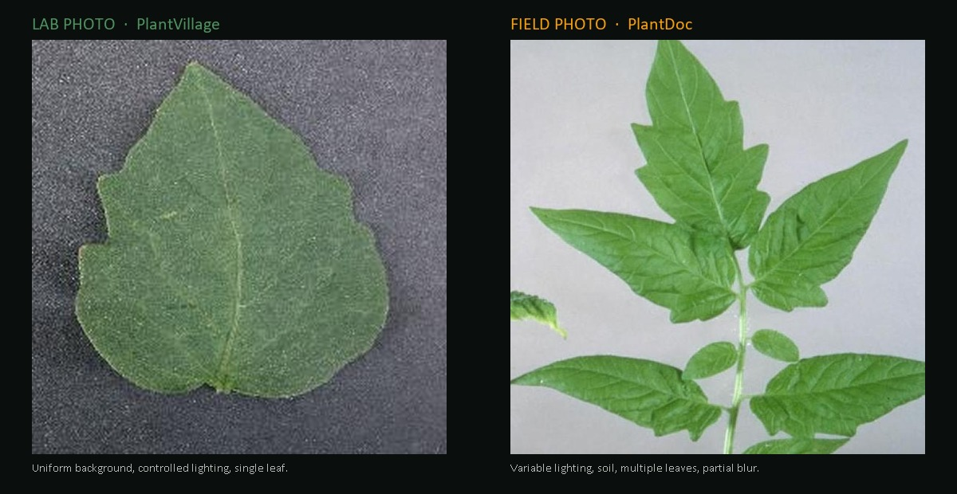
Figure 1. Domain shift made visible. Left: a PlantVillage tomato leaf — uniform background, controlled lighting, a single leaf. Right: a PlantDoc tomato leaf — variable lighting, multiple leaves per frame, real-world clutter. Both carry the identical "Tomato healthy" label.

2.1 Preprocessing
All input images are resized to 224×224 pixels — the resolution at which our pretrained ImageNet weights expect input — and normalized using the standard ImageNet channel-wise mean and standard deviation. We maintain two parallel transformation pipelines. The evaluation pipeline is deterministic (resize → tensor → normalize), guaranteeing reproducible inference. The training pipeline is stochastic: every image, every epoch, passes through a randomized sequence of augmentations designed to make the model invariant to nuisance variation. Details are given in Section 3.

3. Methodology

3.1 Transfer learning and architecture
Training a deep CNN from random initialization typically requires millions of labelled examples. With 41,039 images we instead use transfer learning: take a network pretrained on ImageNet [9] (1.2 million images, 1,000 categories), discard its final classification layer, attach a new 27-class linear layer, and fine-tune. The pretrained convolutional filters already encode useful low-level primitives (edges, textures) and progressively more abstract features that transfer to a wide range of vision problems.
We compare two architectures. ResNet50 [1] uses residual connections that allow gradients to flow through 50 convolutional layers without vanishing; it has approximately 25.6 million parameters. EfficientNet-B0 [2] uses compound scaling of depth, width, and resolution, paired with MBConv blocks and squeeze-and-excitation attention; it has about 5.3 million parameters. The choice of which one to optimize was driven by a controlled experiment, reported in Section 4.

3.2 Augmentation strategy
Data augmentation creates synthetic training examples by transforming originals — forcing the model to learn invariances to nuisance factors that have nothing to do with the disease. Our strong train pipeline applies: RandomResizedCrop (scale 0.6–1.0; scale and zoom invariance), RandomHorizontalFlip (p=0.5; mirror symmetry), RandomVerticalFlip (p=0.2), RandomRotation up to ±30° (camera-tilt invariance), RandomPerspective (distortion 0.3, p=0.4; oblique-angle viewing), ColorJitter (brightness, contrast, saturation ±0.3, hue ±0.08; lighting and white-balance invariance), RandomGrayscale (p=0.05; texture rather than color reliance), and GaussianBlur (kernel 3, σ 0.1–2.0; motion-blur invariance). Each transform encodes a specific prior about what does not change the disease and so should not change the prediction.
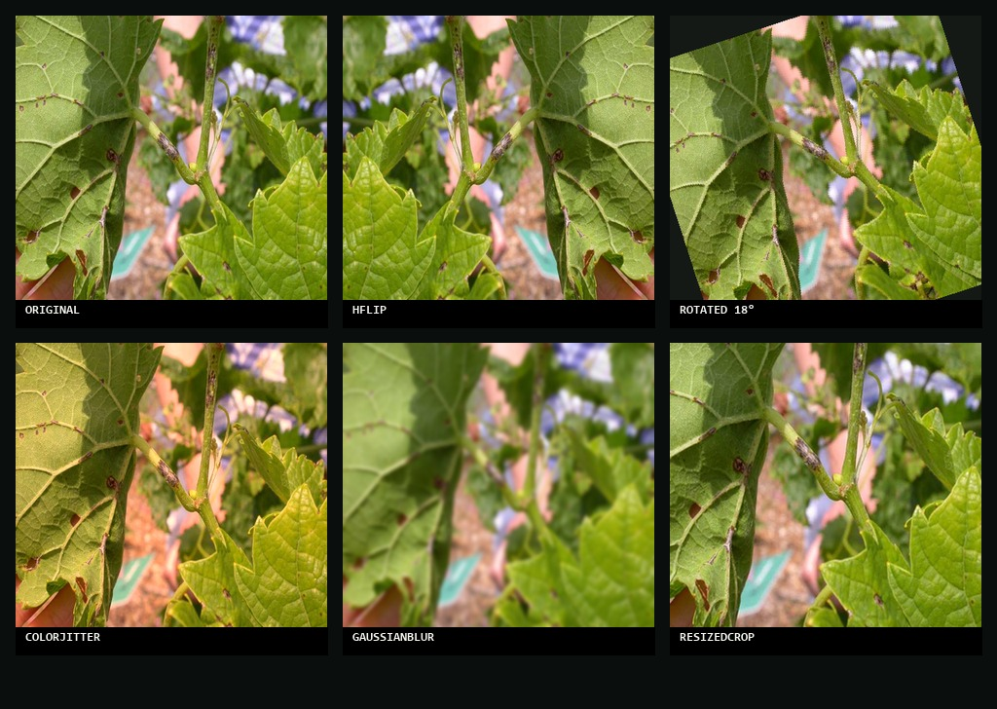
Figure 2. One original training image (top-left) and five random augmented variants applied during training. Across thirty epochs the model sees thousands of synthetic variants of each original — learning the disease rather than memorizing the photograph.

3.3 Loss function and regularization
Class imbalance is severe in our data: some classes have 250+ training images, others fewer than 30. Standard cross-entropy treats every error equally, allowing a model to achieve high overall accuracy by being correct on abundant classes while silently failing on rare ones. We combine two interventions. The first is inverse-frequency class weighting inside the loss: for each class i with count n_i, weight = N / (C · n_i) where N is total training size and C is the number of classes. The second is Focal Loss [5]: FL(p) = −(1−p)^γ · log(p) with γ = 2.0. The (1−p)^γ term decays toward zero when the model is already confident (p close to 1), redirecting gradient mass to examples where the model is uncertain (p in the 0.2–0.5 range). We additionally apply CutMix [6] regularization to 30% of training batches: a random rectangular patch from image B is pasted over image A and the target label is mixed in proportion to the patch area. This forces the model to integrate evidence from multiple regions rather than relying on a single salient feature, and acts as a strong regularizer against overfitting on the small PlantDoc training set.

3.4 Two-phase fine-tuning
Naïve fine-tuning of a pretrained model on a small new dataset can destroy the very features that made transfer learning useful: the randomly-initialized classification head produces large initial gradients that propagate back and damage the carefully-learned backbone filters. We use a two-phase schedule to avoid this. In Phase 1 (epochs 1–10) the backbone is frozen and only the new 27-class head is trained, allowing the head to learn a sensible mapping from the (still ImageNet-flavored) features. In Phase 2 (epochs 11–30) the backbone is unfrozen and the entire network is trained together with the learning rate reduced by 10× (final lr = 1e-6 with cosine annealing). The first phase calibrates the head; the second phase makes small corrective updates across the whole network.

3.5 Test-time augmentation
Test-time augmentation (TTA) applies augmentation at inference rather than during training. For a single test image we generate eight transformed copies — horizontal flip, vertical flip, slight rotation, scale crop, and combinations — and pass each through the network. The eight softmax outputs are averaged and the argmax of the average is taken as the final prediction. The idea is that a single forward pass is one noisy measurement of the model's belief; eight independent measurements over plausible variations reduce that variance. TTA contributes free accuracy with no retraining at the cost of eight-times-slower inference, which is still under two seconds on a CPU.

3.6 Explainability
We integrate Grad-CAM [8] as an explainability layer to make every prediction inspectable. The algorithm forward-passes the input image, picks the class with the highest score, and computes the gradient of that score with respect to the feature maps of the final convolutional block. The gradients are averaged spatially to yield channel weights α_k, and the heatmap is the ReLU-rectified weighted sum Σ_k α_k · A_k where A_k is the k-th feature map. This produces a coarse 7×7 heatmap (for ResNet50 on 224×224 inputs) which we upsample bilinearly and overlay with a warm colormap. A correct prediction whose heatmap focuses on the lesions is internally consistent; a correct prediction whose heatmap focuses on the background reveals a spurious correlation.

4. Experiments

4.1 Architecture comparison (controlled experiment)
Before optimizing any single architecture, we ran a controlled comparison between ResNet50 and EfficientNet-B0 under identical conditions: the same joint dataset (PlantVillage + PlantDoc, no augmented copies), the same Focal Loss with class weights (γ = 2.0), the same augmentation pipeline, the same 30-epoch cosine learning-rate schedule, and the same two-phase training procedure. The intent was to isolate the effect of architecture from every other choice.
ResNet50 reached 58.33% test accuracy on PlantDoc; EfficientNet-B0 reached 57.14%. The 1.19-point gap is roughly three additional correctly-classified images out of 252 — within the statistical noise of a test set this small. The two architectures are effectively equivalent on this problem at this data scale. We chose to focus subsequent optimization on ResNet50, both for the slight measured edge and because its deeper feature hierarchy provides more capacity for the augmented-data signal to express itself in fine-grained classification.

4.2 Final results
Our final ResNet50 model — fine-tuned on joint_all with the techniques described in Section 3 and evaluated with 8-view test-time augmentation — achieves the following on the 252-image PlantDoc test split. We report macro-averaged precision, recall, and F1 in addition to accuracy because macro averaging weights every class equally, so the rare-and-difficult classes contribute as much as the common-and-easy ones.
Metric | Value | Notes
Accuracy | 75.40% | Real-world PlantDoc test, with TTA
F1 (macro) | 0.7460 | Average across 27 classes
Precision (macro) | 77.91% | Macro-averaged
Recall (macro) | 75.58% | Macro-averaged
Test samples | 252 | Real field photographs

4.3 Stage-by-stage progression (ablation)
More instructive than the headline number is how accuracy moved across the stages of our training pipeline. Each row in the table below represents the same ResNet50 architecture trained on a different combination of data and inference techniques, evaluated against the same PlantDoc test set.
Stage | Training data | PlantDoc test accuracy
PV-only baseline | PlantVillage only | ~30%
joint | PlantVillage + PlantDoc | 58.33%
joint_all | PV + PD + augmented PD | 73.41%
joint_all + TTA | Same as above, 8-view TTA at inference | 75.40%

The composition of these gains makes a qualitative argument. The gap between PV-only and joint is ~28 points — the cost of domain mismatch on this task. The gap between joint and joint_all is 15 points — the value of additional diverse training data. The gap between joint_all and joint_all + TTA is 2 points — the residual contribution of cheap inference-time techniques. Together these compound to a 45-point improvement, but the largest single lever by far is data diversity, not algorithmic refinement.

4.4 Per-class analysis
Per-class metrics reveal a more nuanced picture. Of the 27 classes, 11 achieve F1 ≥ 0.85, and five achieve a perfect F1 of 1.00: Grape healthy, Grape Black Rot, Blueberry healthy, Pepper bell healthy, and Strawberry healthy. The shared characteristic of these classes is well-separated visual presentation — distinctive lesions or unambiguous healthy appearance. Healthy classes in general perform extremely well, which is encouraging for deployment because the model rarely raises false alarms.
At the other end, four classes have F1 below 0.50: Corn Gray Leaf Spot (0.14), Potato Early Blight (0.20), Potato Late Blight (0.35), and Corn Northern Leaf Blight (0.40). Two factors explain these failures. The first is genuine visual ambiguity: Potato Early Blight and Potato Late Blight produce similar dark lesions on similar leaf substrates, and even trained pathologists frequently need a microscope to distinguish them with confidence on early-stage specimens. The second is sample size: Corn Gray Leaf Spot has only 4 samples in the PlantDoc test set, so a single misclassification moves the per-class metric by 25 percentage points. The numerical instability on small support sizes makes those very low F1 values harder to interpret as stable measures of model capability — what they reveal is that our confidence in those numbers is itself low.

5. Discussion

5.1 What worked
Three things proved decisive. First, the inclusion of augmented PlantDoc data was responsible for the largest single accuracy jump in our experiments — 15 percentage points, from joint to joint_all. No single algorithmic technique we tried produced gains of comparable size. Second, the two-phase frozen-then-unfrozen training schedule reliably outperformed naïve full-network fine-tuning, particularly when starting from a strong checkpoint. Third, test-time augmentation was free upside: +2 points with no retraining and acceptable inference cost.
Grad-CAM is also worth discussing as something that worked, in a different sense. Figure 3 shows a representative example on the PlantDoc test set: the model correctly predicts Grape Black Rot at 88.5% confidence, and the Grad-CAM heatmap concentrates exactly on the visible lesions rather than on the background or the leaf edge. Predictions with this kind of internally-consistent attention are the trustworthy ones. Predictions whose heatmaps point at the soil or the photographer's hand — even if the predicted label happens to be correct — are warnings that the model has learned a shortcut that will not survive deployment.
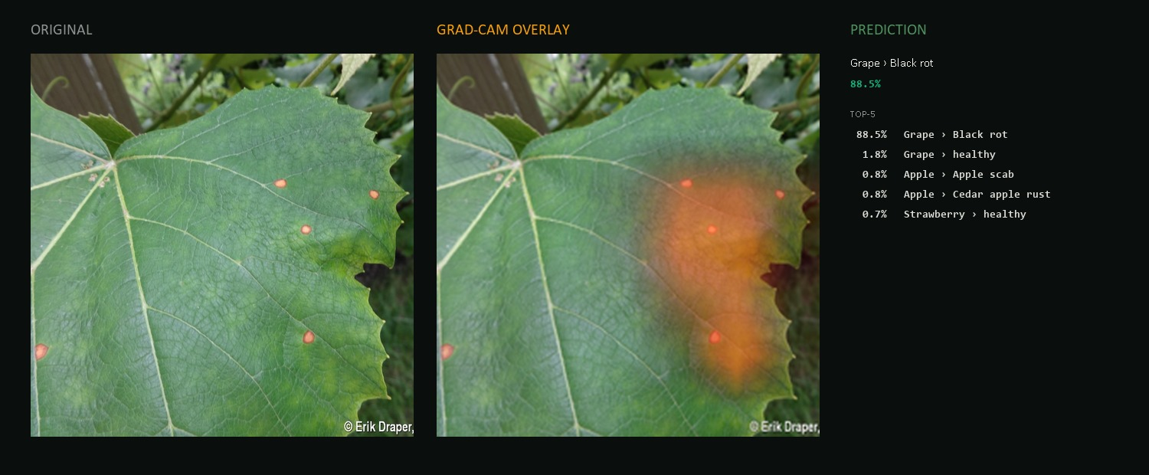
Figure 3. Grad-CAM applied to a PlantDoc test image of a grape leaf with Black Rot. Left: the original image. Center: the Grad-CAM heatmap overlay. Right: predicted class and top-5 probabilities. The heatmap concentrates on the lesions, confirming the model arrived at the correct prediction (88.5% Grape Black Rot) for the right visual reason.

5.2 What didn't
Several things underperformed expectations. The architecture comparison between ResNet50 and EfficientNet-B0 produced a difference within statistical noise (1.19 points on 252 samples), suggesting that hours spent comparing architectures yielded almost no actionable signal. Loss-function refinements — Focal Loss with various γ values, class weighting schemes — contributed only 1–3 percentage points each in our experiments, an order of magnitude less than the data-side interventions. Standard cross-entropy with naïve class weighting performs nearly as well as Focal Loss on this dataset at this scale, despite the latter receiving substantially more tuning attention in our pipeline. The lesson is that when models are data-starved relative to deployment diversity, loss-side tweaks do not substitute for more data — even synthetic data.

5.3 Limitations
Our work has clear limitations. The PlantDoc test set, at 252 images across 27 classes, is small enough that per-class metrics fluctuate substantially with single-image differences. We have explicitly avoided over-interpreting per-class numbers where the test support is small. The model is blind to inputs outside its 27-class taxonomy — a photograph of an unknown disease, or a disease on a species not in the training set, is silently classified into the closest visible neighbor with no "unknown" output. Edge cases such as extreme lighting, heavy motion blur, multi-leaf compositions, and severe occlusion degrade quality. We recommend treating predictions with confidence below approximately 50% as inconclusive rather than acting on them.
Despite these limitations, the structure of the residual errors is itself encouraging. The errors cluster on pairs of visually similar diseases — Potato Early ↔ Late Blight, Corn Gray ↔ Common Rust, Tomato Septoria ↔ Tomato Early Blight — rather than scattered randomly. A human pathologist would tend to make precisely the same mistakes given a 2-second glance at a phone photograph. The errors live in genuinely ambiguous corners of the visual space rather than being symptoms of arbitrary failure, suggesting the model has learned a meaningful representation of disease appearance.

6. Conclusion
This project demonstrated that a deep convolutional neural network can serve as a viable decision-support tool for smartphone-based plant disease diagnosis, achieving 75.40% accuracy and macro F1 of 0.746 on the PlantDoc real-world test set — a 45-point improvement over an equivalent PlantVillage-only baseline. The headline technical lesson is that domain shift, not architecture choice, is the binding constraint on real-world deployment of CNN classifiers for this task: ResNet50 and EfficientNet-B0 perform essentially identically under controlled conditions, while the addition of augmented in-distribution training data delivers an order of magnitude larger improvement than any algorithmic refinement we tried.
Four directions are worth pursuing as future work. The first is more real-world training data, across more geographic regions and crop varieties, with active focus on the classes where the current model is weakest. The second is to test whether the 75% ceiling we hit is architectural or data-limited: running the same training pipeline against a larger backbone such as EfficientNet-B4 or a transformer-based model such as ViT-B/16 would be informative. The third is open-set rejection, so the model can refuse to classify inputs outside its trained taxonomy — a critical missing capability for deployment. The fourth is mobile deployment: exporting the model to ONNX and running it on-device on Android would make the system genuinely usable in the no-connectivity rural settings it is intended for.

References
[1] He, K., Zhang, X., Ren, S., & Sun, J. (2015). Deep Residual Learning for Image Recognition. arXiv:1512.03385.
[2] Tan, M., & Le, Q. (2019). EfficientNet: Rethinking Model Scaling for Convolutional Neural Networks. ICML.
[3] Mohanty, S. P., Hughes, D. P., & Salathé, M. (2016). Using Deep Learning for Image-Based Plant Disease Detection. Frontiers in Plant Science, 7, 1419.
[4] Singh, D., Jain, N., Jain, P., Kayal, P., Kumawat, S., & Batra, N. (2020). PlantDoc: A Dataset for Visual Plant Disease Detection. ACM CoDS-COMAD.
[5] Lin, T.-Y., Goyal, P., Girshick, R., He, K., & Dollár, P. (2017). Focal Loss for Dense Object Detection. IEEE ICCV.
[6] Yun, S., Han, D., Oh, S. J., Chun, S., Choe, J., & Yoo, Y. (2019). CutMix: Regularization Strategy to Train Strong Classifiers with Localizable Features. IEEE ICCV.
[7] Zhang, H., Cissé, M., Dauphin, Y. N., & Lopez-Paz, D. (2018). mixup: Beyond Empirical Risk Minimization. ICLR.
[8] Selvaraju, R. R., Cogswell, M., Das, A., Vedantam, R., Parikh, D., & Batra, D. (2017). Grad-CAM: Visual Explanations from Deep Networks via Gradient-based Localization. IEEE ICCV.
[9] Deng, J., Dong, W., Socher, R., Li, L.-J., Li, K., & Fei-Fei, L. (2009). ImageNet: A Large-Scale Hierarchical Image Database. IEEE CVPR.
[10] Loshchilov, I., & Hutter, F. (2017). SGDR: Stochastic Gradient Descent with Warm Restarts. ICLR.
[11] Food and Agriculture Organization of the United Nations (2019). New standards to curb the global spread of plant pests and diseases. FAO News Release, Rome.
[12] Kingma, D. P., & Ba, J. (2015). Adam: A Method for Stochastic Optimization. ICLR.

