

PowerEnJoy

Code Inspection

A.Y 2016/2017

Francesco Tinarelli (matr:806146)

Marco Wenzel (matr:878021)

Versione 1.0

Introduction

Code inspection is the systematic examination (often known as peer re-

view) of computer source code. It is intended to find mistakes overlooked

during the initial development phase, with the aim of improving both the

overall quality of software and the developers' skills.

Document Structure

1. **Front page**: Include at least the project title, the version of the

document, your names and the release date.

2. **Table of content:** Include the table of content of your document.

3. **Classes that were assigned to the group**: <state the namespace

pattern and name of the classes that were assigned to you.>

4. **Functional role of assigned set of classes**: <elaborate on the func-

tional role you have identified for the class cluster that was assigned

to you, also, elaborate on how you managed to understand this role

and provide the necessary evidence, e.g., javadoc, diagrams, etc.>

5. **List of issues found by applying the checklist**: <report the class-

es/code fragments that do not fulfill some points in the check list.

Explain which point is not fulfilled and why.>

6. **Any other problem you have highlighted**: <list here all the parts

of code that you think create or may create a bug and explain why.>

Classes Assigned

* **Name**: EntityDataReader
  + **Location:** /apache-ofbiz-16.11.01/framework/entity/src /main/java/org/apache/ofbiz/entity/config/model
  + **Package:** org.apache.ofbiz.entity.config.model
  + **Modifier:** public-final
  + **Method:** EntityDataReader(String), EntityDataReader(Element), getName, getResourceList
* **Name**: SetOperation
  + **Location**: /apache-ofbiz-16.11.01/framework/minilang/

src/main/java/org/apache/ofbiz/minilang/method/envops

* + **Package:** org.apache.ofbiz.minilang.method.envops
  + **Modifier:** public final
  + **Method:** autoCorrect, SetOperation, exec, toString, <inner class> SetOperationFactory

**Functional Role to assigned class**

**EntityDataReader**

For understanding the functional role of this class, first we need to understand what are nodes and elements.

The node is the smallest datatype in the DOM, is an interface implemented by almost all object.

The element is a type of node, is an interface that extends the node interface, this type of node corresponding to structure in XML pages.

The EntityDataReader class have two constructors:

The first one permits through a string variable to insert a value on the variable: name; and provide an empty list of resource.

The second one permits through an Element to extract all children elements node that they have the same type of node (element node) and with the node name equals to “resource”. After the extraction insert for each element the respective resource object into the resource list.

For control the unexpected results this class has an exception if the EntityDataReader have already a name value or if the content of the parameter: element is empty.

So, this class should be use for capture the content and the data structure of a specific XML file.

**Analysis Method:**

For analyse this class we start from analyse the modifier of its attributes and methods than the double constructor and the external method calls.

To understand the intrinsic meaning we use the OfBiz documentation but this work was hard because in this class miss the Javadoc.

**Code:**

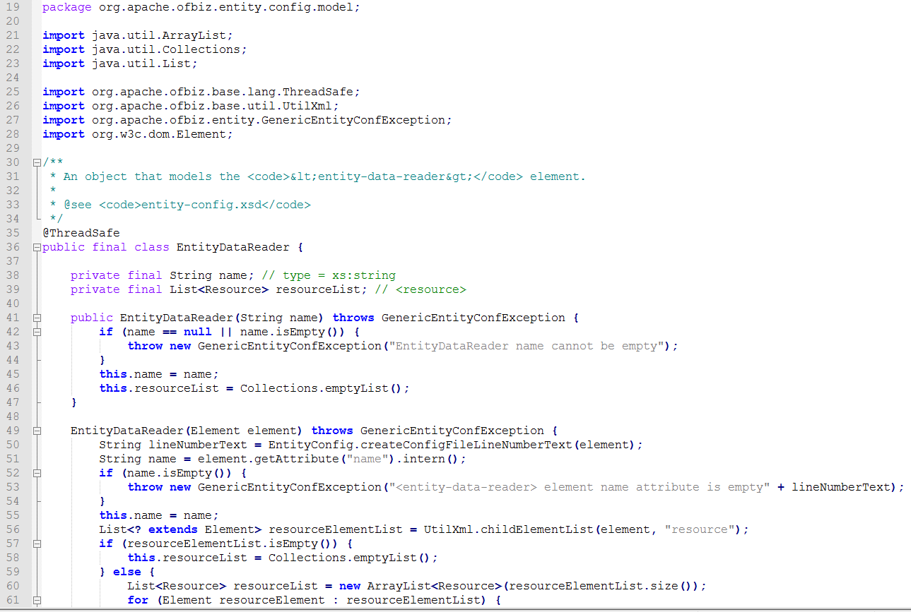

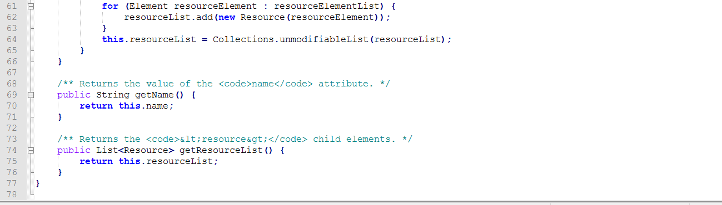

Issues:

1. createConfigFileLineNumberText(element) this method doesn’t have a meaningful name because returns a string that indicates the number of the starting line a more meaningful name can be startingLineNumber(element)

13)Line 53 (110c) Line 56 (92c) Line 60(83c)

18)There are no comments about code are doing

19)No comment for explain the reasoning behind the code

23) there are no Javadoc about this class

27) there is double constructor but they are control well and the variable: name is defined two times but the two variables are not the same and is controlled well(this.name=name)

36)lineNumberText variable is not used if the variable: name is empty

56)that FOR type is correct but we don’t know the initial value.

Issues:

1. da vedere dopo aver analizzato

3) SetOperation is not a name

7)the constant module is write in lowercase

11)line 147-159-164-197 one statement without graph braces

13)almost all lines

14)Line 94(172c) Line 160(166c) Line 165(168c) Line 187(123c) Line 190(182c)

18)There are no comments about code are doing

19)No comment for explain the reasoning behind the code

23) there are no Javadoc about this class

25)autoCorrect method arrive first than private final variables

26)DA VALUTARE DOPO analisi però ricordarsi che autoCorrect arriva prima degli attributi

33) some variables are declared after autoCorrectMethod

34-35-36)DA VALUTARE DOPO ANALISI

38)DA VALUTARE

40) line 42 name==null it’s not strictly conformed to the definition, but however is bad programmmation

52-53)da valutare