Creating New Metrics to Find the Best Sweeping Goalkeeper
A composite approach to measuring spatial authority, shot-stopping quality, and distribution in modern goalkeeping
Marc Lamberts | Hradeck Scouting | June 2026
Abstract. This article introduces the Sweep Quality Score (SWP_Quality), a composite metric designed to evaluate sweeping goalkeepers beyond the conventional exits-per-90 counting statistic. Drawing on Wyscout event data from 2,663 goalkeepers across 150 leagues and six competitive tiers (minimum 900 minutes played), the metric combines five component percentile scores — exits per 90 (25%), aerial duels per 90 (20%), save rate (20%), goals saved above expected goals (20%), and a distribution quality index (15%) — into a single, interpretable score. The methodology, weight rationale, distributional properties, and identified scouting candidates are presented alongside a critical discussion of limitations and directions for future refinement.
1. Introduction
If you are a goalkeeper scout or analyst, the aggregated data from different providers focuses mostly on shot-stopping. If you are fortunate, you may obtain some in-depth distribution figures, but that is broadly the limit of what is routinely available. Most clubs employ Wyscout on account of its integrated video and data offering, and in doing so they tend to rely on exits per 90 minutes as the primary — often sole — indicator of sweeping quality.
This is a methodological problem. A goalkeeper who rushes off his line constantly but misjudges half of his interventions is not an asset; he is a liability dressed up in an impressive counting statistic. Yet exits per 90 has become the default shorthand for the sweeper archetype, occupying the same position in goalkeeper discourse that goals do in striker evaluation: widely cited and rarely interrogated.
This article introduces an alternative framework. The Sweep Quality Score (SWP_Quality) is a composite metric that attempts to answer a fundamentally different question: not how much does this goalkeeper sweep, but how well does he do everything that a modern sweeping goalkeeper is asked to do? The metric is presented as a practical scouting tool, not a definitive model of goalkeeper quality, and its limitations are addressed explicitly in Section 6.
1.1 Data and scope
The analysis draws on Wyscout aggregated season data downloaded on 18 June 2026, spanning the 2025–26 season and the ongoing 2026 season. The latter is incomplete at the time of writing — the FIFA World Cup 2026 is currently in progress — but the application of a minimum-minutes filter (900 minutes; approximately ten full matches) renders the incomplete campaigns sufficiently representative for rate-based metrics.
The database encompasses 165 leagues across six competitive tiers, from continental elite competitions (Tier 1) to semi-professional and amateur competitions (Tier 6). Not every league, team, or player is of equivalent quality; this heterogeneity is addressed methodologically through league-tier stratification and, more importantly, through the percentile conversion procedure described in Section 3. The deliberate breadth of the database — rather than restriction to the top five European leagues — reflects a scouting philosophy that keeps the observational aperture as wide as possible in order to identify talent at all levels of the competitive pyramid.
2. Why the Sweeper Role Demands a Richer Lens
The compressed defensive lines associated with high-press tactical systems have fundamentally re-evaluated what goalkeepers are expected to contribute. Across European football's top six leagues, the average defensive line sat approximately 3.2 metres higher in 2024 than it did in 2015 (Statsbomb, 2024). The space behind the defensive line — previously of minimal relevance to goalkeeping — is now actively contested territory. The goalkeeper has become the last line of structural defence against the through ball, the lofted diagonal, and the loose ball falling in the channel.
In this tactical context, a goalkeeper's spatial authority constitutes a genuine performance dimension. The question is how to measure it rigorously and in a way that resists the perverse incentives created by volume-based statistics.
Three distinct competencies make a sweeping goalkeeper genuinely valuable to his team:
- the goalkeeper exits his line proactively to intercept before opposing attackers can reach the ball, reducing the probability of a direct attacking threat materialising.Active spatial claiming:
- sweeping activity is operationally worthless if the goalkeeper concedes goals he is expected to save. A GK who exits frequently but performs poorly in one-versus-one situations or against well-struck efforts negates the defensive benefit of his proactivity.Shot-stopping under pressure:
- a goalkeeper who wins the ball in space and immediately returns it to the opposition via an aimless clearance has captured the action but forfeited its value. Effective sweeping must be coupled with purposeful distribution to translate proactive defending into offensive continuity.Possession recycling:
Any composite metric that omits one of these three dimensions will produce a ranking that flatters one archetype of goalkeeper at the expense of a complete and operationally relevant performance picture.
3. Building the Metric
3.1 Population and filtering
SWP_Quality is computed across a population of 2,663 goalkeepers satisfying a minimum threshold of 900 minutes played, drawn from 150 leagues across six competitive tiers. All component metrics are sourced directly from Wyscout event data. The 900-minute floor is calibrated to ensure that at least ten approximately full matches have been contested, providing sufficient sample volume for rate statistics to be meaningfully interpreted. The implications of this threshold are discussed in Section 6.
3.2 Stage one — percentile conversion
Each of the five component metrics is ranked within the full goalkeeper population and converted to a percentile score on a 0–100 scale, where higher values universally indicate superior performance. This normalisation procedure eliminates the problem of comparing raw values across leagues of heterogeneous quality and style: an exit rate of 2.1 per 90 minutes carries a different meaning in the Portuguese Primeira Liga than in the Austrian Regionalliga. After percentile conversion, both observations are expressed relative to the same reference distribution, enabling valid cross-league comparison.
For the goals saved above expected goals (GSaG) component — defined here as xG against per 90 minus goals conceded per 90 — positive values indicate a goalkeeper saving shots beyond what their difficulty profile would predict, while negative values indicate underperformance relative to expectation. The percentile ranking therefore rewards goalkeepers who consistently outperform their expected concessions.
The distribution score is computed as the arithmetic mean of the short pass completion percentage (accurate passes, %) and long pass completion percentage (accurate long passes, %), providing a balanced measure of both recycling quality and ball-playing range.
3.3 Stage two — weighted aggregation
The five percentile scores are combined via a weighted average with the following component weights:
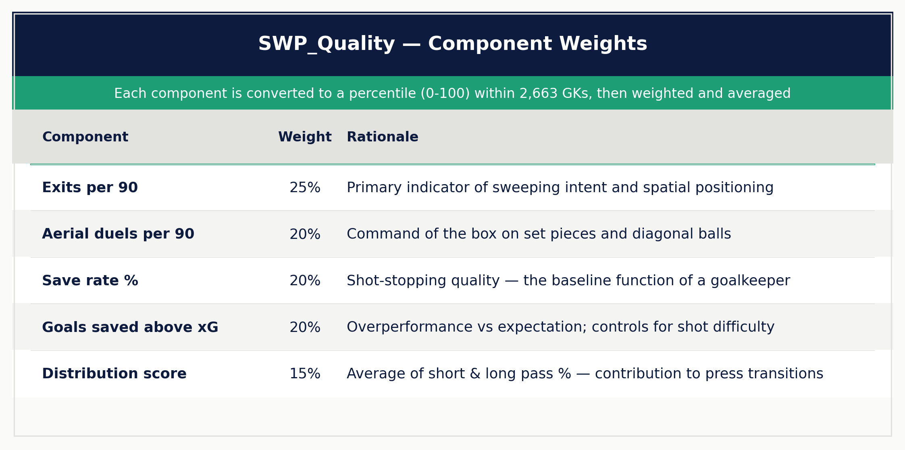
Table 1. SWP_Quality component weights and rationale. All weights sum to 1.00.
The resulting score runs from 0 to 100, where 50 represents the median goalkeeper in the reference population. A score above 75 places a goalkeeper in the top quartile; a score below 30 in the bottom quartile. The score is not intended as an absolute measure of goalkeeper quality but as a relative positioning instrument for scouting and shortlisting purposes.
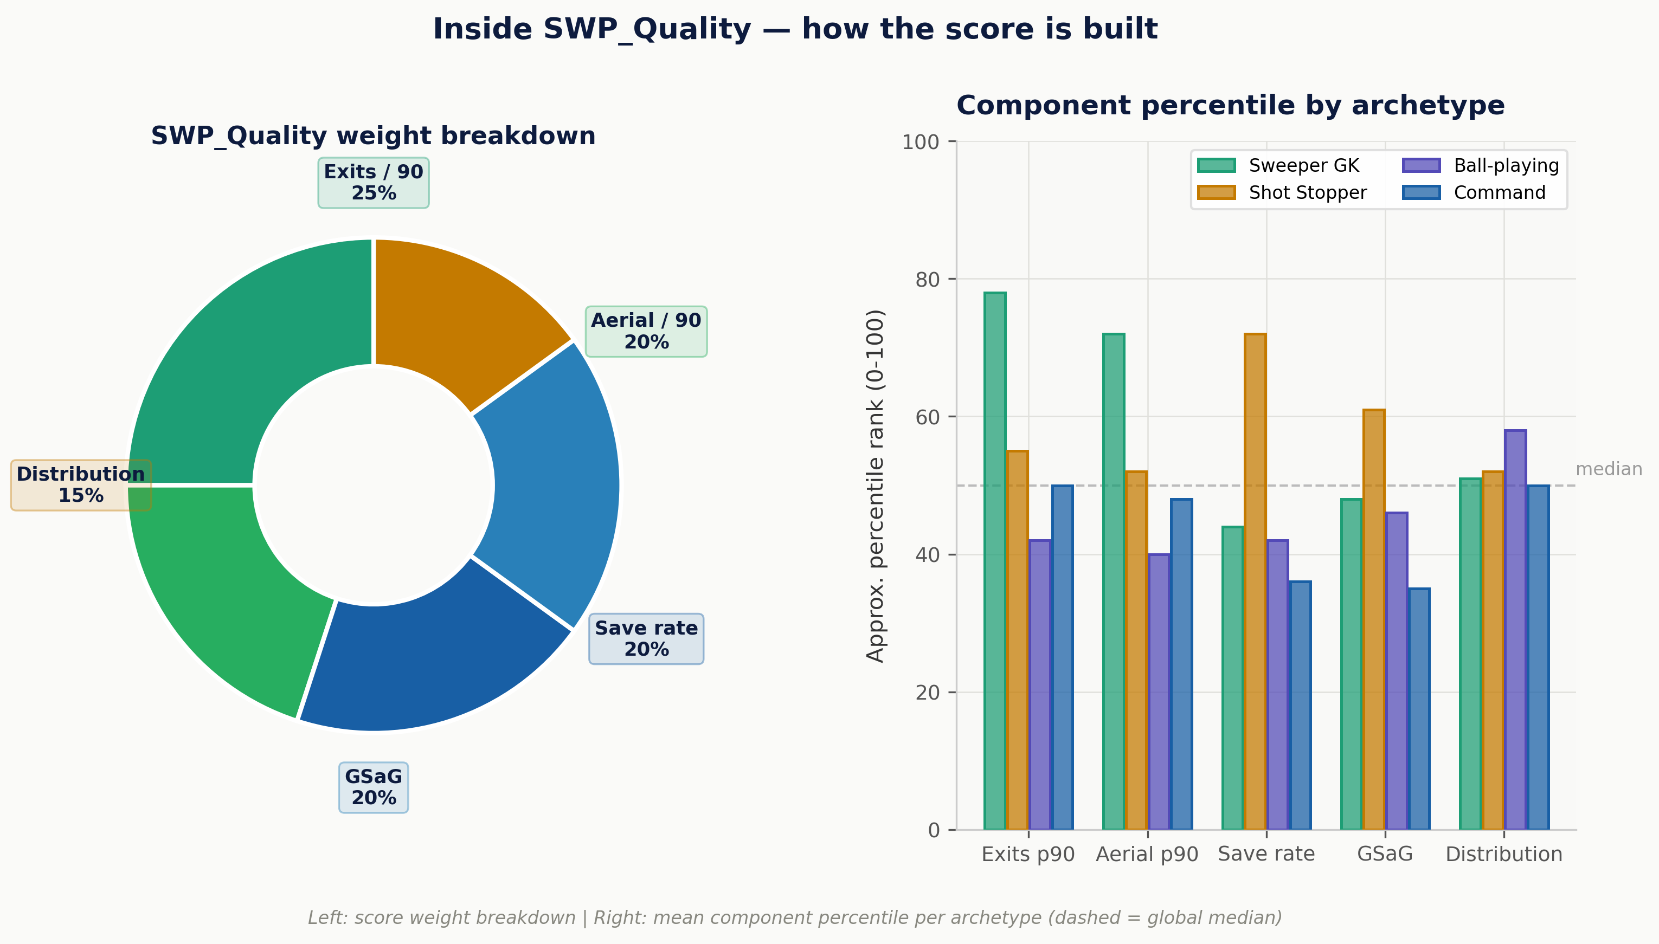
Figure 1. Left: SWP_Quality component weight breakdown (donut). Right: mean component percentile by goalkeeper archetype, illustrating how each style's strengths and weaknesses contribute differentially to the composite score (dashed line = global median).
4. Methodological Justification of Weight Choices
Weight selection in composite metrics is the point at which most legitimate methodological criticism concentrates. Why 25% on exits per 90 and not 30%? Why not an equal distribution of 20% across all five components? These are fair questions that deserve explicit answers.
The assigned weights reflect a priority ordering of the role's functional demands, not a causal claim about the relative contribution of each component to a team's defensive output. That distinction matters: causal attribution would require controlled experimental data or at minimum a rigorous regression framework accounting for team-level and positional confounders. The present article does not make that claim.
The leading weight on exits per 90 (25%) follows directly from the metric's purpose: if the objective is to identify goalkeepers with a demonstrated capacity to claim space proactively, then sweeping volume must hold the primary weight. The aerial duels component (20%) captures a distinct spatial dimension — command of the box in aerial contests, set pieces, and diagonal deliveries — which is conceptually separable from ground-level exits.
The combined weight of the stopping components (save rate and GSaG, 20% each) rests on a fundamental principle of the position: a goalkeeper is, first, a shot-stopper who also sweeps, not a sweeper who also stops shots. Without this structural constraint, the metric would systematically reward the Sweeper GK archetype at the expense of shot-stopping quality. In practice, this tension is empirically observable: the Sweeper GK cohort in this database posts a mean save rate of 68.1%, compared to 74.3% for Shot Stoppers. A pure exits-based ranking would promote goalkeepers who are measurably worse at the foundational requirement of the role.
The distribution weight (15%) is the most philosophically contentious. A legitimate counter-position holds that goalkeeper passing quality is downstream of the team system and cannot be reliably attributed to the individual. This is a defensible view. The counterargument embedded in this framework is that a goalkeeper who cannot reliably distribute — short or long — is systematically squandering the possession advantage that a successful sweeping action creates. The distributional benefit of a successful exit depends entirely on what happens next; a goalkeeper who cannot deliver a purposeful restart undermines his own sweeping value. The weight is set at 15% rather than 20% precisely to reflect this uncertainty: it is present and meaningful, but subordinate to the core functional competencies.
5. Results and Distributional Analysis
5.1 Population distribution
Across the full population of 2,663 goalkeepers satisfying the minimum minutes threshold, SWP_Quality produces a distribution that is close to normal. Table 2 and Figures 2–3 present the key distributional statistics.
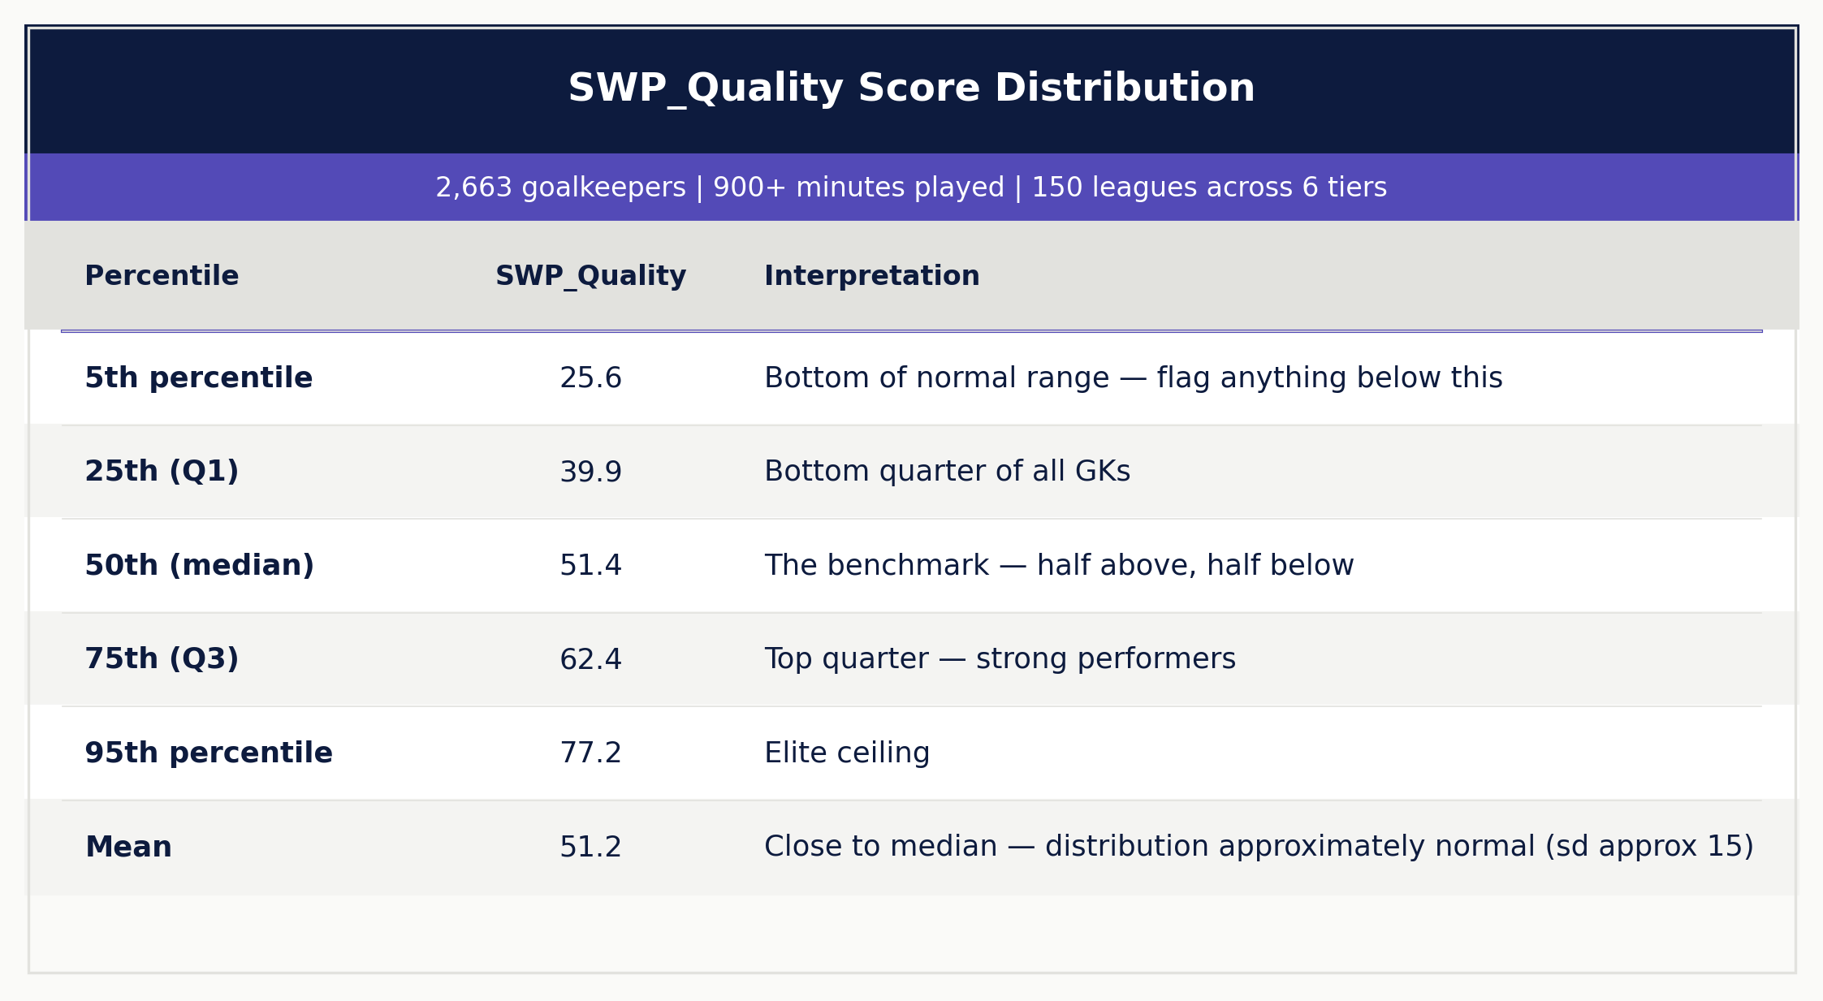
Table 2. SWP_Quality score distribution across 2,663 goalkeepers (900+ minutes, 150 leagues, 6 tiers).
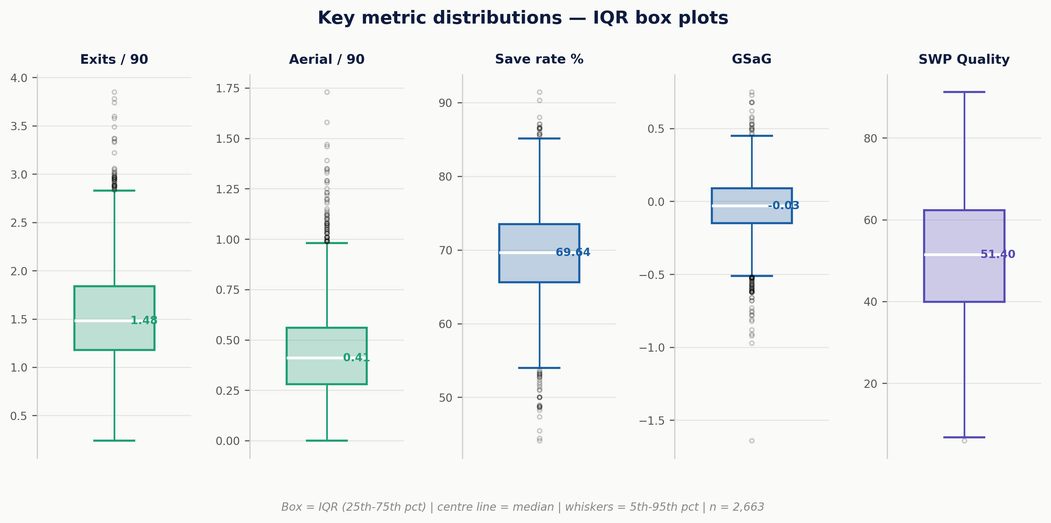
Figure 2. IQR box plots for all five SWP_Quality component metrics. Box = interquartile range (25th–75th percentile); centre line = median; whiskers = 5th–95th percentile; open circles = outliers.
A mean of 51.2 sits within one point of the median (51.4), indicating a distribution with minimal skew. The standard deviation of approximately 15 makes z-score interpretation reliable: a goalkeeper at SWP_Quality 81.2 is exactly two standard deviations above the population mean, placing him at approximately the 97th percentile. Figure 3 illustrates the normal approximation and the z-score framework, which provides a standardised vocabulary for communicating goalkeeper quality in cross-league contexts.
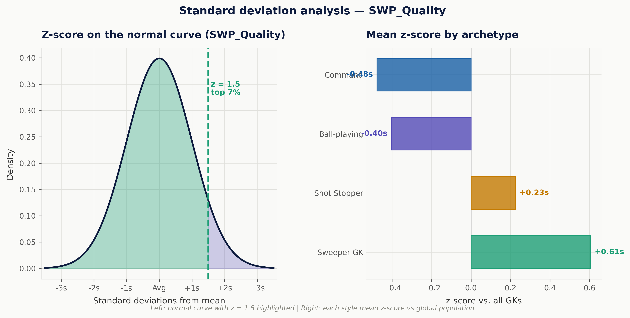
Figure 3. Left: normal distribution approximation for SWP_Quality with z = 1.5 illustrated (top 7% of the population). Right: mean z-score by goalkeeper archetype relative to the global population mean, confirming Sweeper GKs hold the highest relative position.
5.2 Archetype comparison
Comparing the SWP_Quality distribution across the four goalkeeper archetypes identified in the Wyscout classification system surfaces a result that may initially appear counterintuitive. Table 3 and Figure 4 present the archetype-level means.
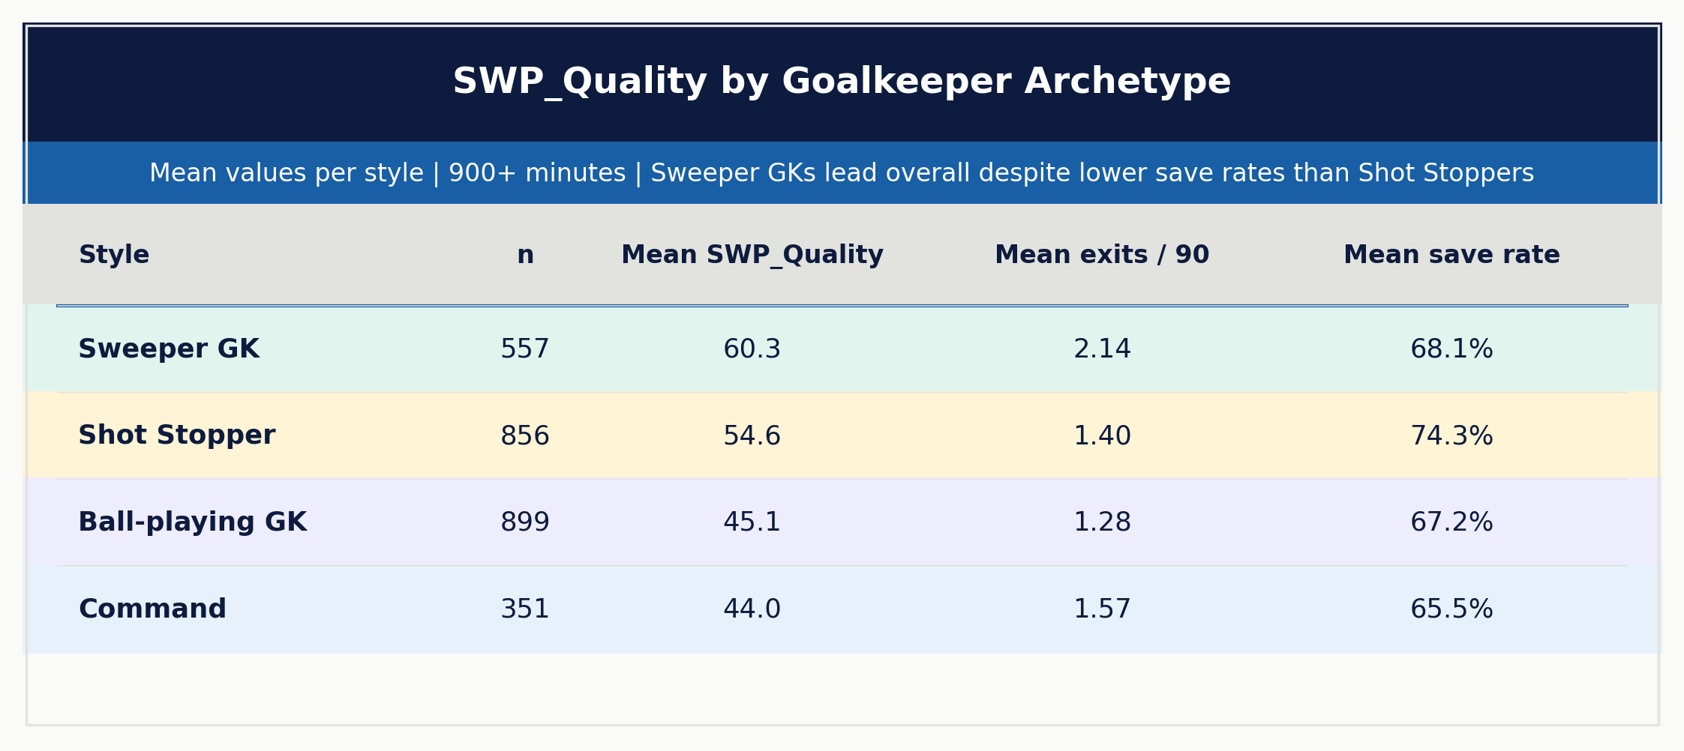
Table 3. Mean SWP_Quality and component metrics by goalkeeper archetype (900+ minutes). Row colours correspond to archetype identity.
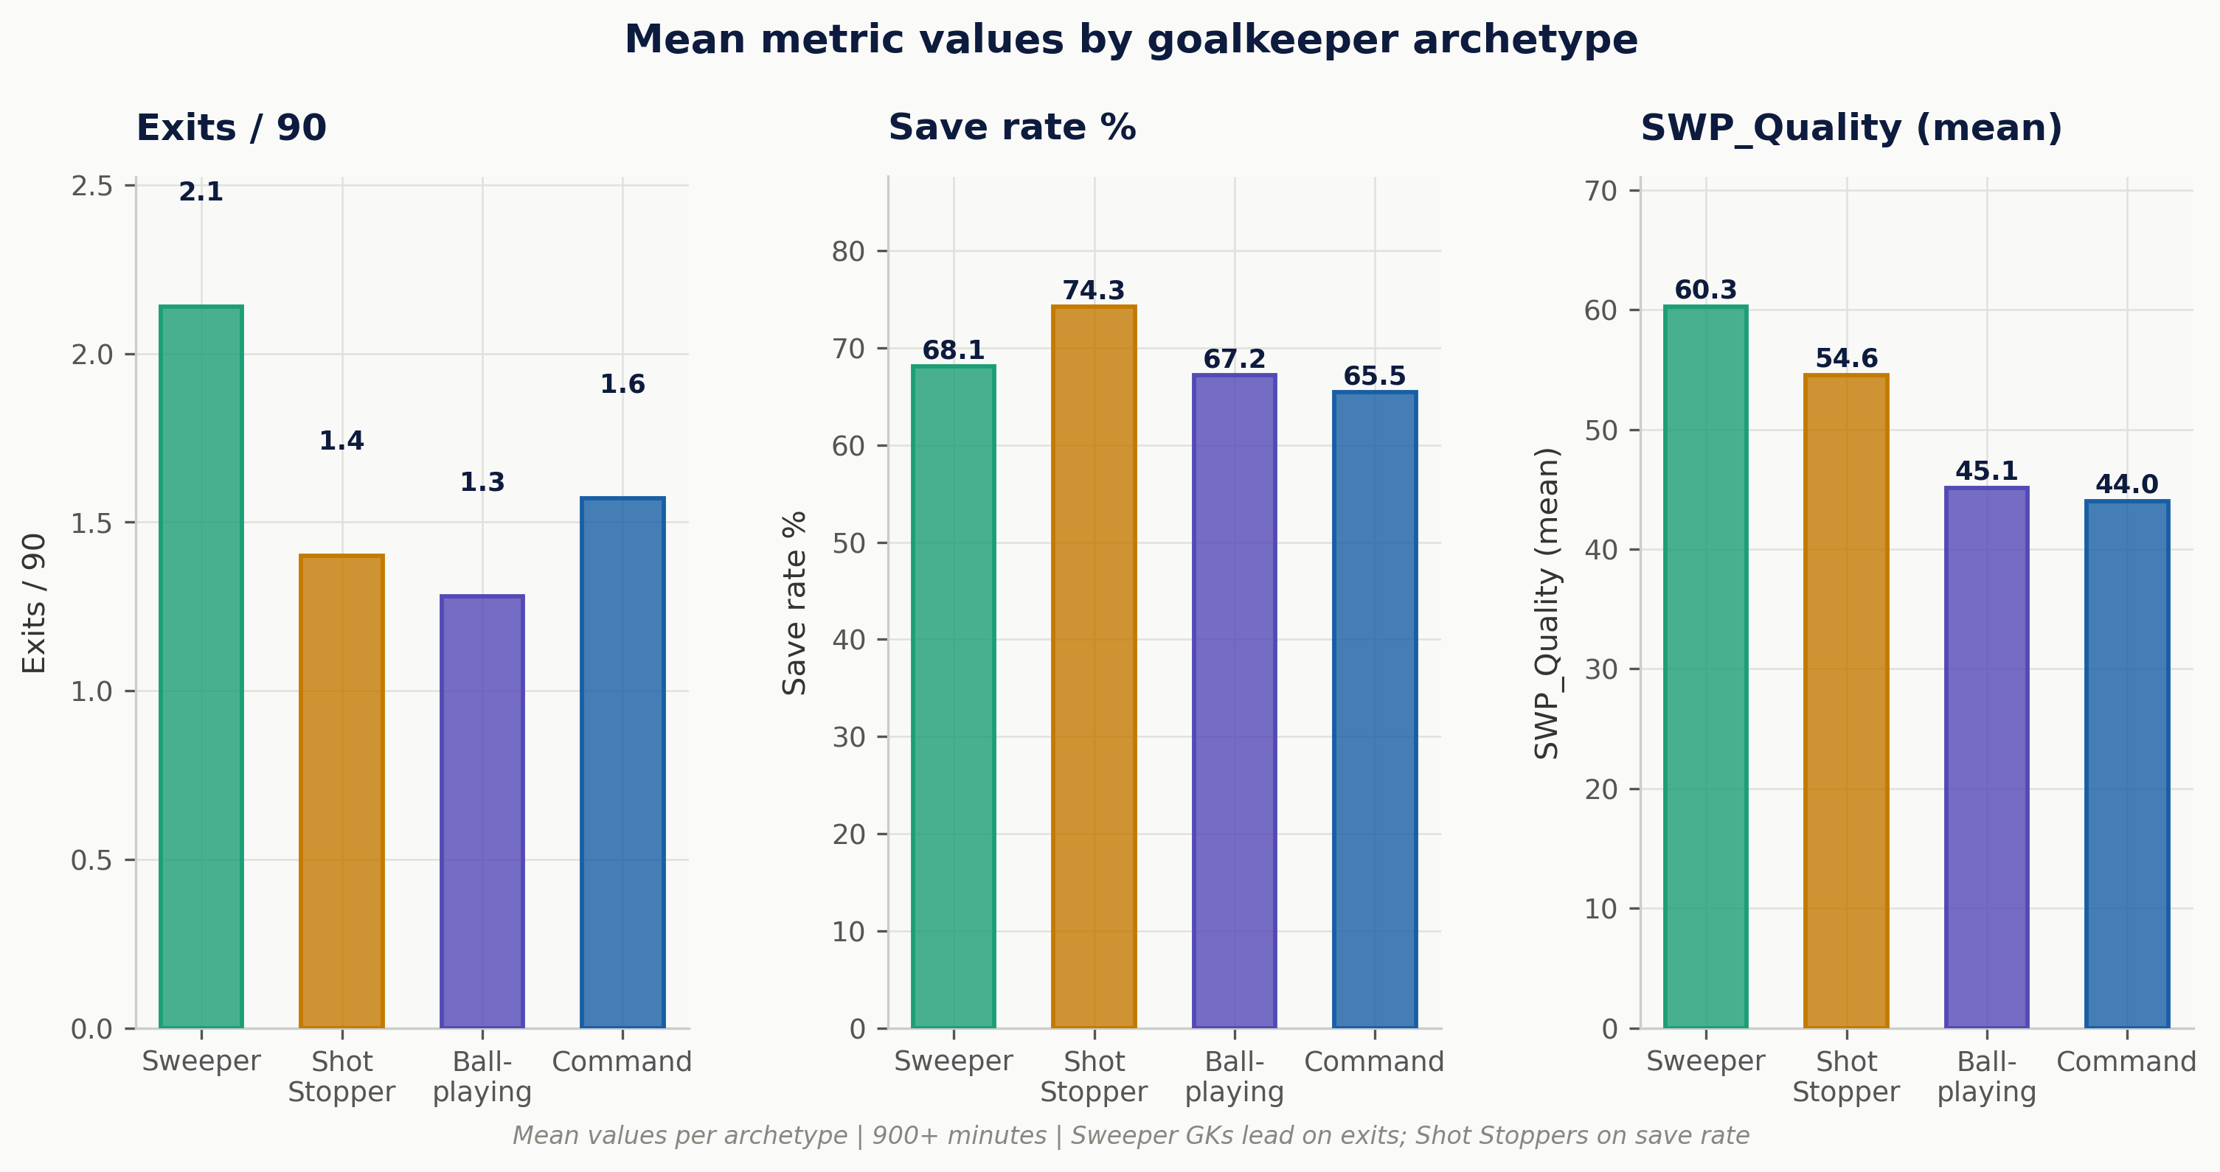
Figure 4. Mean exits per 90, save rate, and SWP_Quality by goalkeeper archetype. Sweeper GKs lead on exits and composite score; Shot Stoppers lead on save rate by a substantial margin.
Sweeper GKs score highest overall, as expected given the metric's sweeping-weighted structure. However, Shot Stoppers trail by only 5.7 SWP_Quality points despite exiting at less than two-thirds the rate of their Sweeper GK counterparts (1.40 versus 2.14 exits per 90). Their superior save rate (74.3% versus 68.1%) and positive mean goals-saved-above-xG (+0.11 versus -0.07) prevent the gap from widening further. This is the metric's key structural feature: sweeping volume alone does not override stopping quality. A goalkeeper who sweeps prolifically but saves shots at a below-average rate will not lead this ranking.
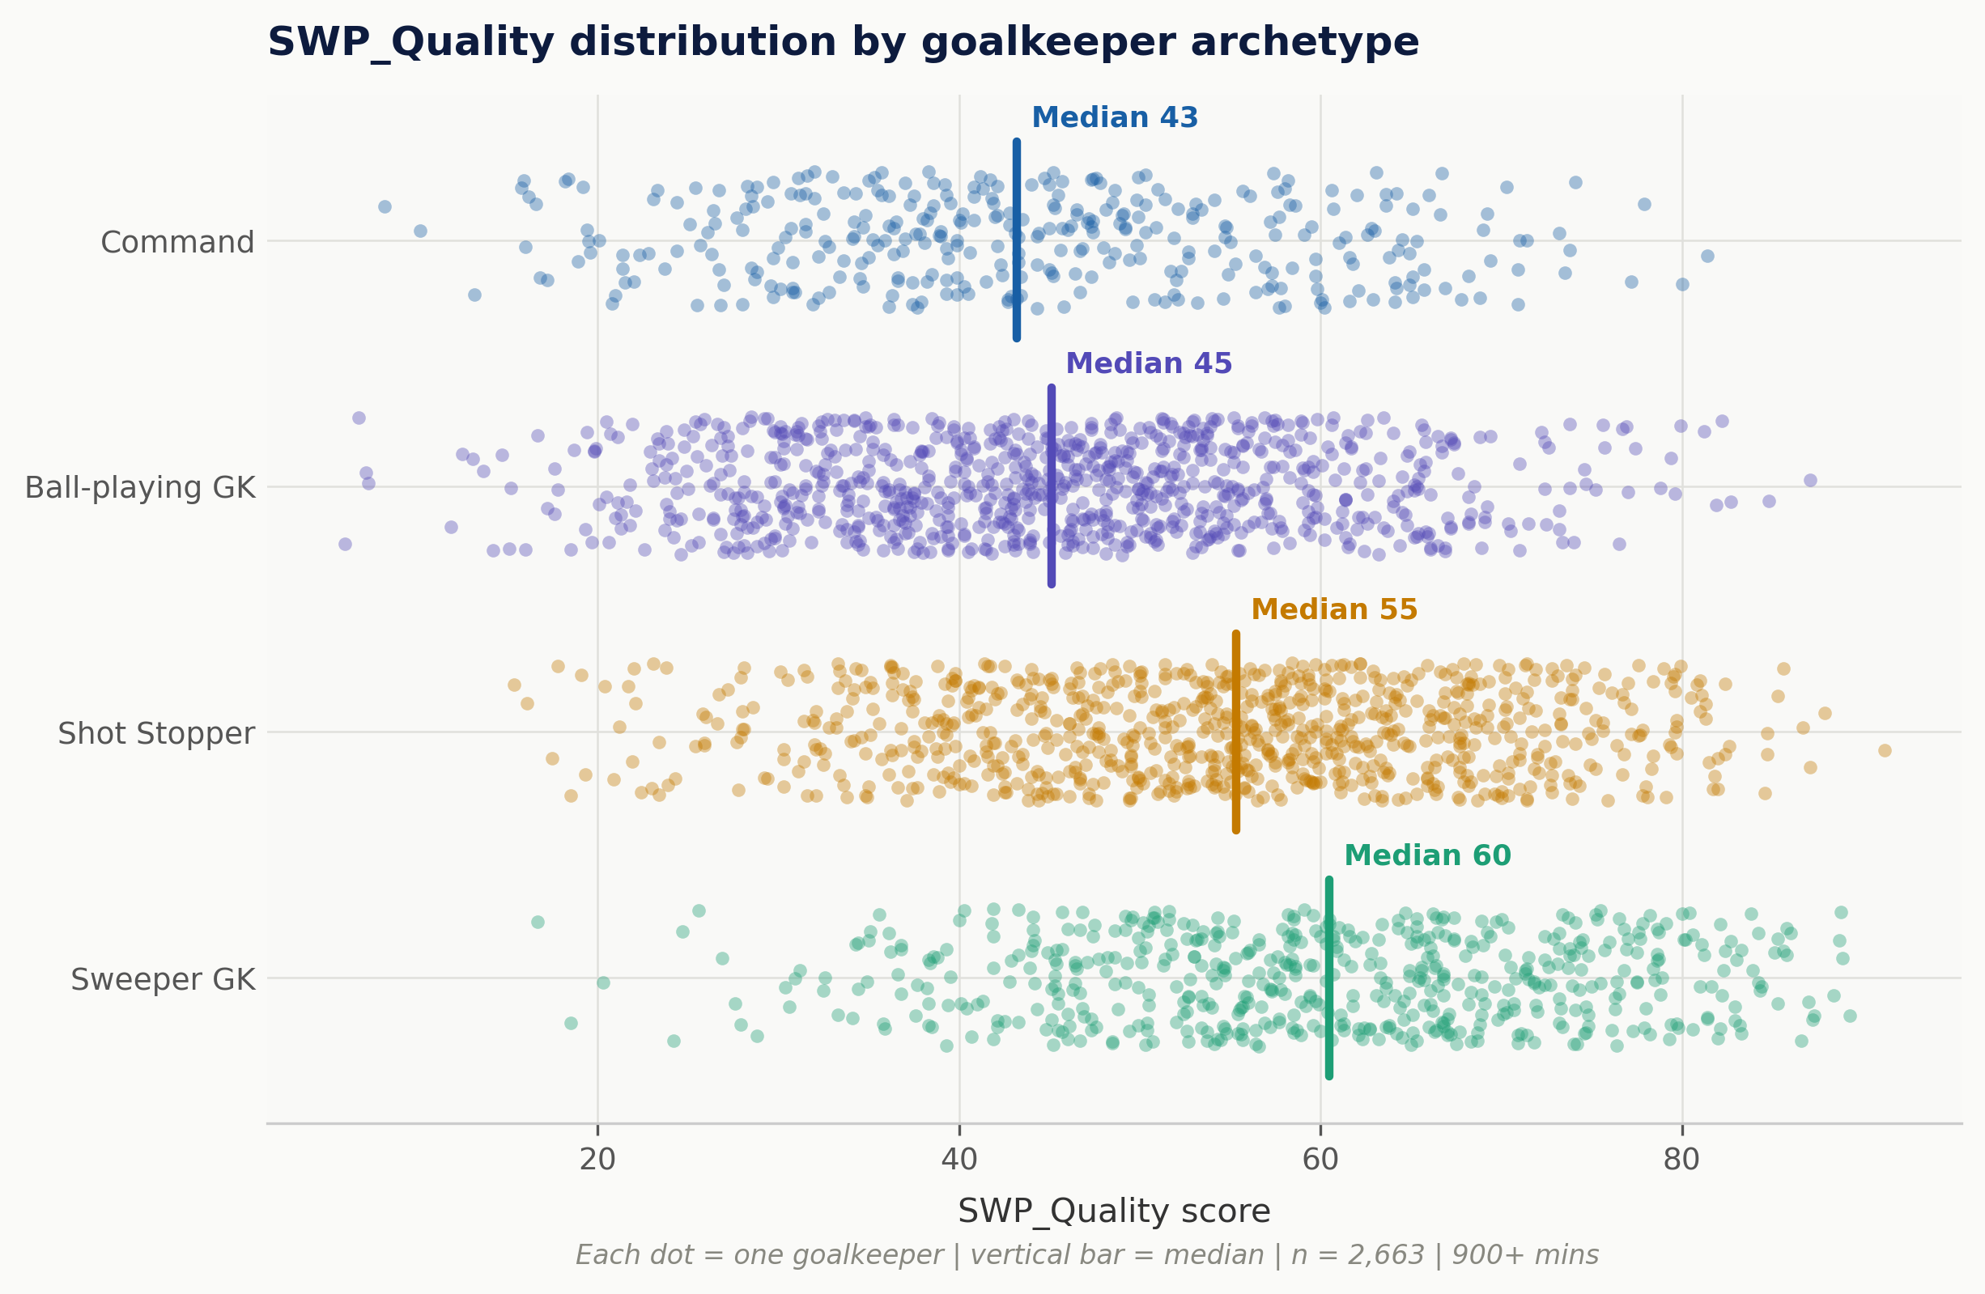
Figure 5. Beeswarm plot of SWP_Quality by goalkeeper archetype. Each point represents one goalkeeper. Vertical bars indicate the median per archetype. Note the substantial overlap between archetypes, indicating that archetype classification alone is an insufficient predictor of composite sweeping quality.
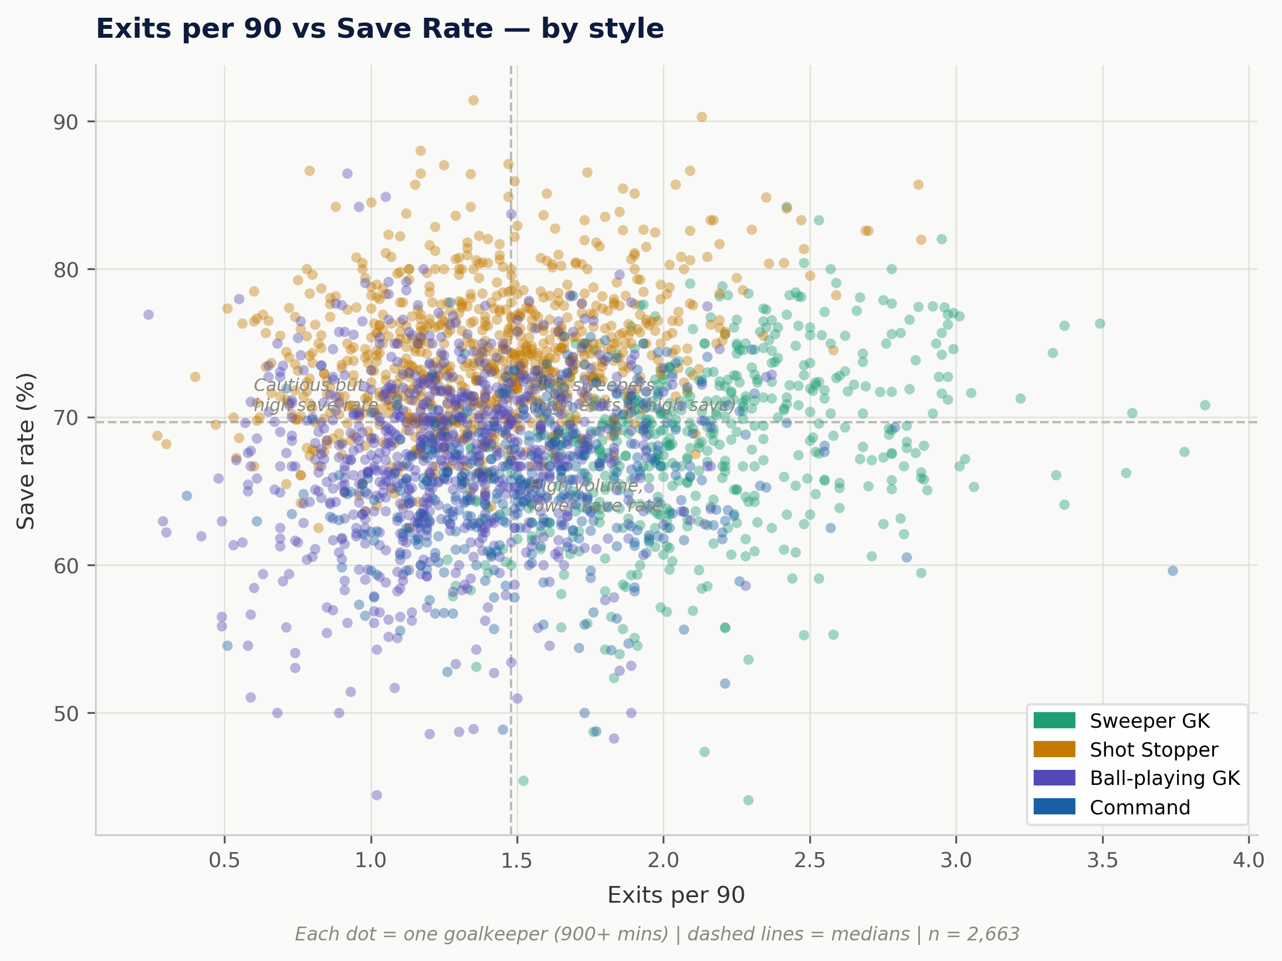
Figure 6. Scatter plot of exits per 90 versus save rate, coloured by goalkeeper archetype. Dashed lines indicate the population medians. The upper-right quadrant identifies the "elite sweeper" profile — high exits combined with above-median save rates — which SWP_Quality is specifically designed to surface.
5.3 Top-ranked goalkeepers
Table 4 presents the ten highest-ranked goalkeepers by SWP_Quality among the 2,663 satisfying the minimum minutes filter.
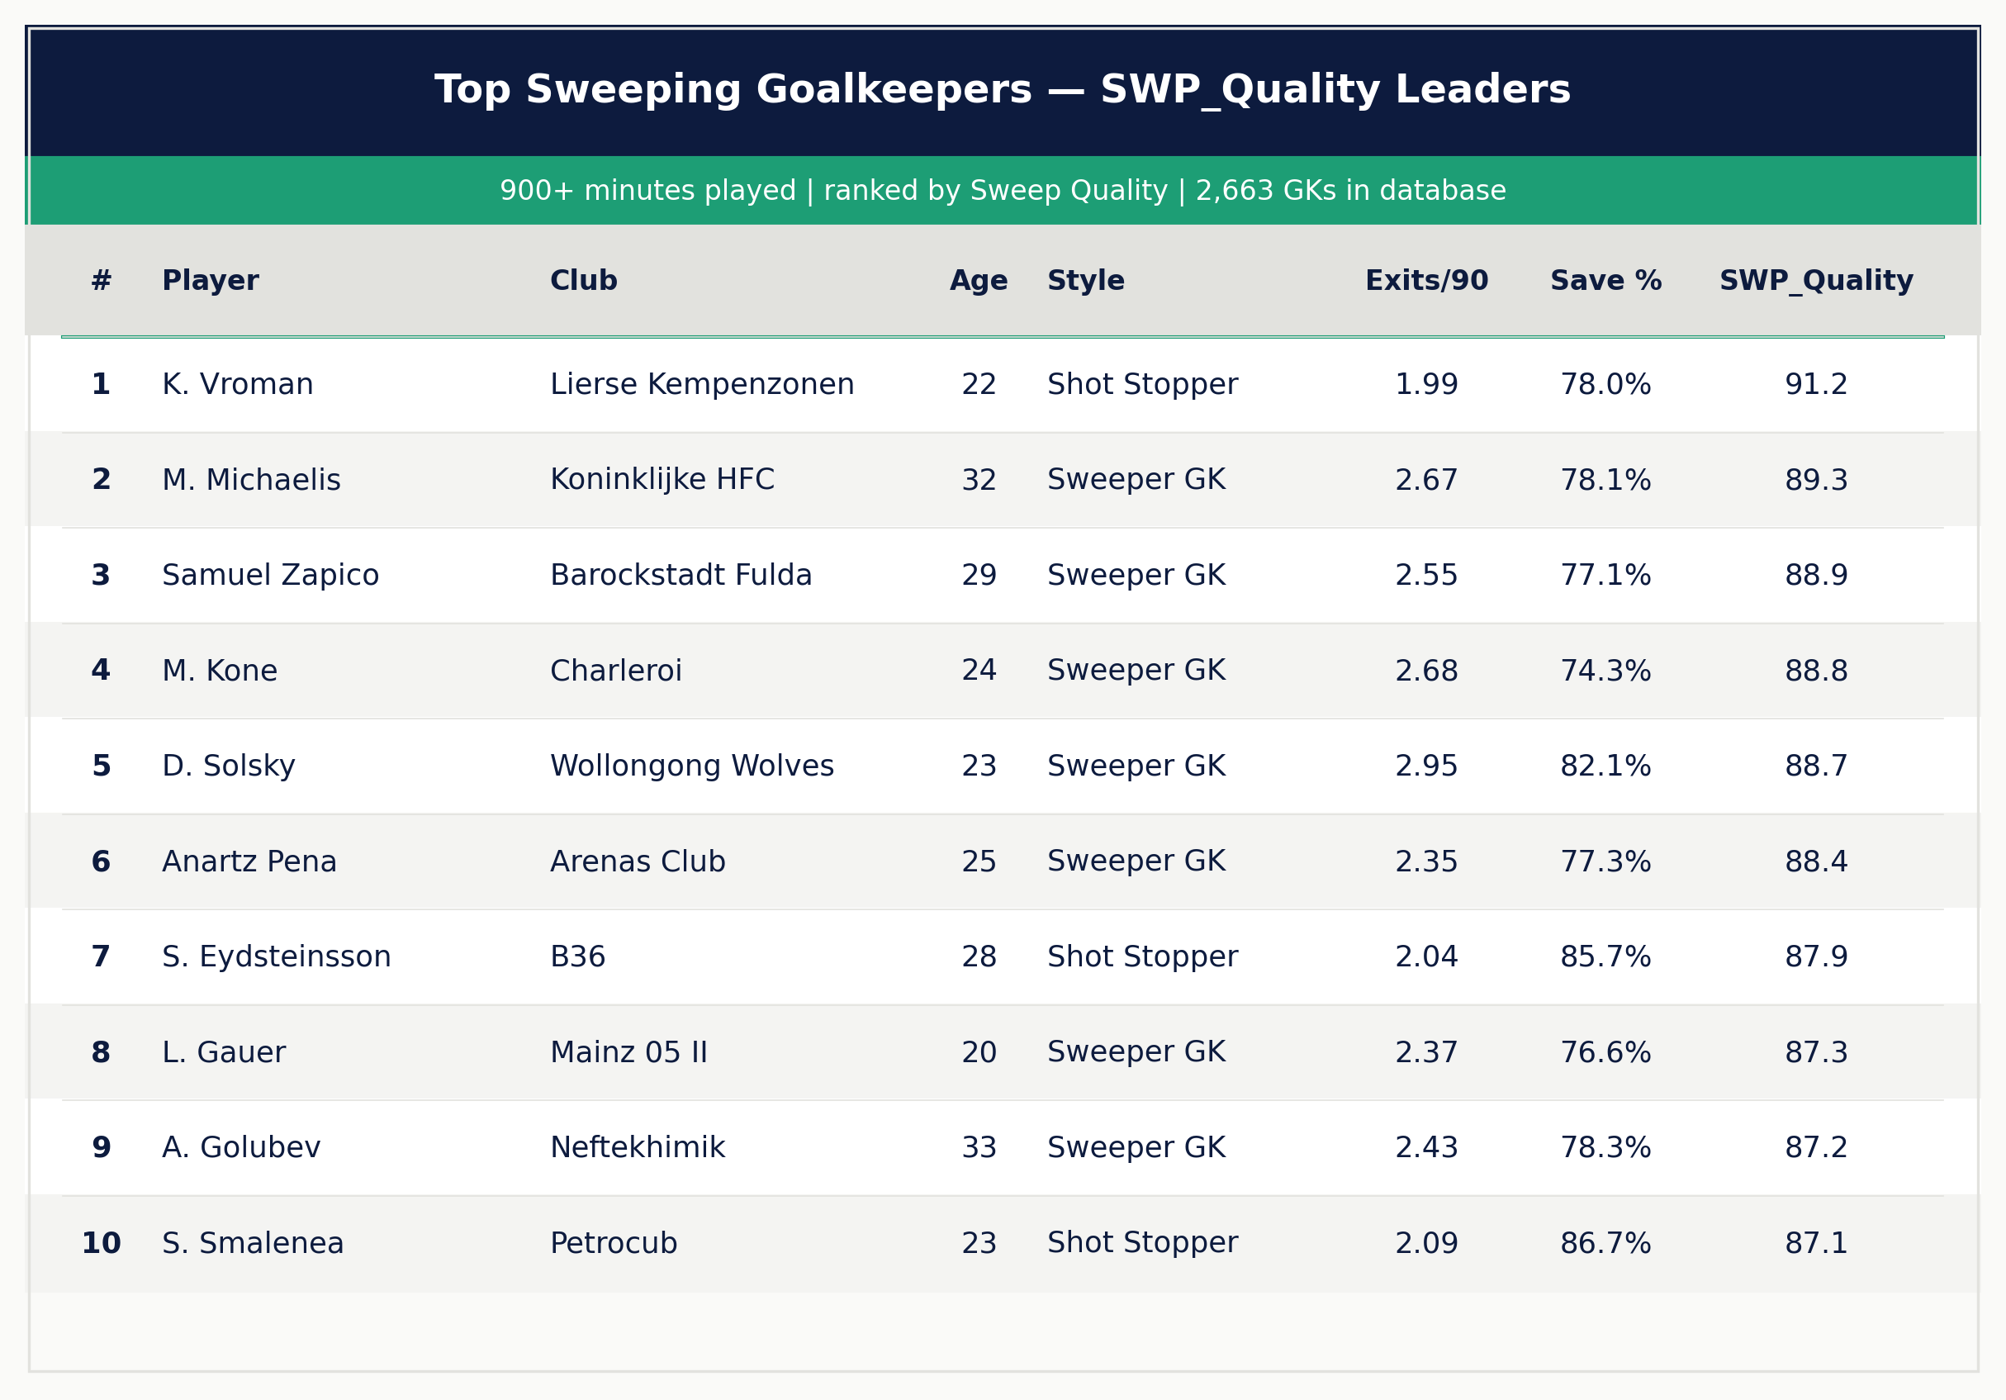
Table 4. Top 10 goalkeepers by SWP_Quality (900+ minutes, all leagues). GSaG = Goals Saved above xG.
K. Vroman (Lierse Kempenzonen, age 22) leads the overall ranking with a SWP_Quality of 91.2. Classified as a Shot Stopper by archetype, Vroman exits 1.99 times per 90 — significantly above the Shot Stopper cohort mean of 1.40 — while sustaining a save rate of 78.0% and a goals-saved-above-xG of +0.44. He represents precisely the scenario this metric is constructed to identify: a goalkeeper who has transcended his archetype classification, combining meaningful sweeping volume with elite shot-stopping performance in a competitive league environment (Belgian second tier).
D. Solsky (Wollongong Wolves, age 23) presents a purer sweeper profile: 2.95 exits per 90, 1.47 aerial duels per 90, and a save rate of 82.1%, scoring 88.7. That he plays in the Australian National Premier League rather than a top European division is simultaneously a limitation of the database and an illustration of its reach. A conventional scouting database restricted to European top-tier competitions would have no visibility of this candidate; a database spanning 150 leagues does.
Among goalkeepers playing at Tier 2 or above, M. Koné (Charleroi, Belgium, age 24) scores 88.8 and merits specific attention. The Belgian Pro League occupies the boundary of European football's second tier in terms of competitive standard; a goalkeeper posting 2.68 exits per 90 in that environment is demonstrating a sweeping frequency that would be high in most Tier 1 or Tier 2 contexts above it. Combined with a save rate of 74.3%, Koné represents a realistic transfer target for clubs seeking a modern, high-line-compatible goalkeeper.
6. Limitations
The following limitations are acknowledged explicitly, as they should inform the interpretation of any scouting decision based on SWP_Quality.
6.1 Off-ball positioning is unobserved
Wyscout event data logs exits when a goalkeeper leaves his line and contests the ball. Off-ball positioning that prevents an exit from being necessary — through anticipatory movement that closes down the threat before it materialises — is not captured in this framework. A goalkeeper who reads the game exceptionally well may score modestly on exits per 90 not because he sweeps poorly, but because his positioning makes the act of sweeping less frequently necessary. This represents a structural blind spot in all event-data approaches to measuring defensive proactivity.
6.2 Sample size variance near the minimum threshold
The 900-minute floor is a practical choice rather than a statistical guarantee. Goalkeepers near the minimum threshold (ten to eleven matches) will exhibit substantially greater variance in rate statistics than those with 2,500 or 3,000 minutes. Rankings among goalkeepers near the threshold should be treated with correspondingly greater caution, and scouts are advised to cross-reference SWP_Quality with observed match volume when assessing borderline candidates.
6.3 Absence of team-context controls
A goalkeeper playing behind a high defensive line at a structurally press-intensive club will encounter substantially more sweeping situations than one defending a deep block. The percentile method addresses cross-league volume differences at the population level but cannot isolate the goalkeeper's individual contribution from his tactical system. Possession-adjusted variants — which normalise exits against the frequency of sweeping opportunities — represent the logical next development (see Section 7).
6.4 Incomplete league-tier matching
League-tier and country data populated for only a subset of the database. The matching procedure between the player data file and the team ratings reference relies on string-based club name matching, which is imperfect — particularly for clubs in lower-tier Eastern European, South American, and African competitions where naming conventions diverge between data sources. A future iteration of this framework would use unique club identifiers rather than string matching to eliminate this source of data loss.
7. Conclusions and Future Directions
SWP_Quality constitutes a scouting entry point, not a final verdict. Its function is to reduce a population of 2,663 goalkeepers to a manageable shortlist of candidates meriting detailed video analysis. The composite score identifies which goalkeepers warrant the time investment of observational review; it cannot determine whether a goalkeeper's sweeping behaviour is driven by elite spatial reading, a tactically demanding high defensive line, or systematic over-aggression that occasionally leaves him exposed.
Two methodological extensions are identified as priorities for future work. First, a possession-adjusted variant that normalises exits and aerial duels against the frequency of sweeping opportunities created by a goalkeeper's defensive system — analogous to the possession-adjusted PDI framework proposed by Griffis (2022) — would substantially improve the isolation of individual contribution from team structure. Second, a league-difficulty adjustment that weights component performances by the tier and competitive density of the context in which they were produced would allow more direct comparison between a goalkeeper in the Belgian Pro League and one in the Australian National Premier League.
Until those refinements are available, SWP_Quality offers something that conventional exits-based ranking does not: a disciplined, multi-dimensional reason to direct analytical attention toward a 22-year-old in Belgium and a 23-year-old in Wollongong, because the data — across 150 leagues and six tiers of competition — says they deserve it.
— — —
References
Griffis, B. (2022). Introducing the Passing Danger Index (PDI). Cafe Tactiques. Retrieved from https://cafetactiques.com
StatsBomb (2024). StatsBomb Data Specification — Freeze Frames and Defensive Line Height. StatsBomb Services Ltd.
Wyscout (2026). Data export: Goalkeepers, season 2025–26 and 2026. Downloaded 18 June 2026. Wyscout S.p.A.

Data note: All visualisations are generated from Wyscout data (2025–26 and 2026 seasons). Minimum threshold: 900 minutes played. Population: n = 2,663 goalkeepers across 150 leagues in 6 competitive tiers. All percentile rankings are computed within the full GK population. Metric weights reflect the analytical judgement of the author and are not derived from a regression or causal estimation procedure.

