ICCT COLLEGES FOUNDATION INC.
V.V Solien Avenue II Cainta Rizal
College of Engineering and Digital Technology

AURAGUARD AI: THE COMPREHENSIVE
WELLNESS SENTINEL FOR MODERN EDUCATION

A Research Presented in Partial Fulfillment of the
Requirements for

COERES (Methods of Research)

Submitted by:

Alvarez, Faith G.

Amado, Mark Kervie Y.

Angeles, Ace F.

Castaneda, Marc Lawrence A.

Fernandez, John Robin P.

Montallana, Rubielyn E.

Plamenco, Myles C.

Sedano, Peter Jhon

Villanueva, Mary Grace R.

Bachelor of Science in Computer Engineering

Submitted to the College of Engineering and Digital Technology

Department of Computer Engineering

Dr. Rommel T. Dasalla, MSc, LPT

January 2026

ICCT COLLEGES FOUNDATION INC.
V.V Solien Avenue II Cainta Rizal
College of Engineering and Digital Technology

  - Introduction

AI capabilities enhanced image analysis, spotting minor discrepancies and anomalies, and by reducing human error, maintaining accuracy and mitigating the impact of fatigue or oversight, Predictive and personalised healthcare benefit from AI through predictive analytics, leveraging historical data for early diagnosis, and personalised medicine, which employs patient-specific data for tailored diagnostic approaches. AI assists in complex procedures by providing precise imaging support and integrates with other technologies like electronic health records for enriched health insights, showcasing ai's transformative potential in diagnostic imaging. The review also discusses challenges in AI integration, such as ethical concerns, data privacy, and the need for technology investments and training. (Mohamed Khalifa, Mona Albadawy, 2024)

The revolutionary potential of artificial intelligence (AI) in Zimbabwe's higher education system is examined critically in this article, with an emphasis on how AI might improve learning results and streamline administrative procedures. Drawing from global examples, particularly in higher education, AI technologies such as intelligent tutoring systems, predictive analytics, and automated grading are discussed for their potential to personalize learning experiences, improved student retention, and streamline institutional management. The study also explores the resource-based and ethical challenges to AI adoption, such as budgetary limits and data privacy issues, which continue to be major obstacles in poor nations like Zimbabwe (Revolutionizing Education in Zimbabwe: Stakeholder Perspectives on Strategic AI Integration 2025)

The rapid advancement of artificial intelligence (AI) technology has caused a major shift in how these technologies are applied, specifically to enhance mathematical learning outcomes and instructional strategies. This research investigated integrating AI into mathematics education, focusing on the familiarity, perceptions and training needs. Through online surveys that examined demographic data, usage familiarity, opinions of AI's usefulness in education, and perceived training needs, the study employed a sequential mixed-methods approach to investigate teachers' engagement with the platform using quantitative and qualitative analytical methods. The outcome also demonstrated that there is cautious enthusiasm for AI's potential to enhance learning outcomes and engage students, despite worries

ICCT COLLEGES FOUNDATION INC.
V.V Solien Avenue II Cainta Rizal
College of Engineering and Digital Technology

about becoming unduly reliant on technology. The study advances our understanding of the educational potential of AI by emphasizing the critical need for extensive professional development programs designed to give educators the skills and information they need to successfully incorporate AI tools like ChatGPT into the curriculum. (Evangeling M. Sangalang, 2024)

  - Background of the Study

Academic pressure physically and mentally affects students’ health and the study revealed that, in fact, it influences the students’ academic performances, concentration, energy levels, and attendance. Thus, in addition to stress related to academic load, these students may have to face the task of taking on more adult-like responsibilities without having yet mastered the skills and cognitive maturity of adulthood.

Philippines is one of the largest in South East Asia in terms of basic education system serves over 27 million learners across 47,000 public and private institutions. Historically, Philippine educational planning system prioritized access and academic outcomes, preventive monitoring with wellness initiatives focused on reactive care (Ex. School clinics for acute illness). However recent crisis including mental health prevalence, COVID-19 pandemic, and infrastructure-related physical health issues have exposed critical vulnerabilities in this approach.

Neglecting symptoms such as fatigue can cause worse scenarios and can affect everyone around them. The purpose of the study does not solely focus on a student with health problems, the study also aims the prevention of an illness and to lessen cases of students’ poor health condition.

1. Benefit of Comprehensive Wellness Sentinel for Modern Education

The AuraGuard AI is a Comprehensive Wellness Sentinel for Modern Education, a device to facilitate efficient monitoring of students’ health in school by monitoring students’ stress, fatigue, and physiological indicators over time using non-contact computer vision and thermal sensing, helping identify patterns of elevated stress, fatigue, or abnormal temperature for early preventive support. It detects patterns of stress and fatigue build-up over 10 days and can also identify abnormal

ICCT COLLEGES FOUNDATION INC.
V.V Solien Avenue II Cainta Rizal
College of Engineering and Digital Technology

temperature events as additional wellness indicators. AuraGuard AI also provides a privacy-aware, non-contact screening system for academic environments. It also visualize trends and alerts in students for preventive support or wellness guidance.

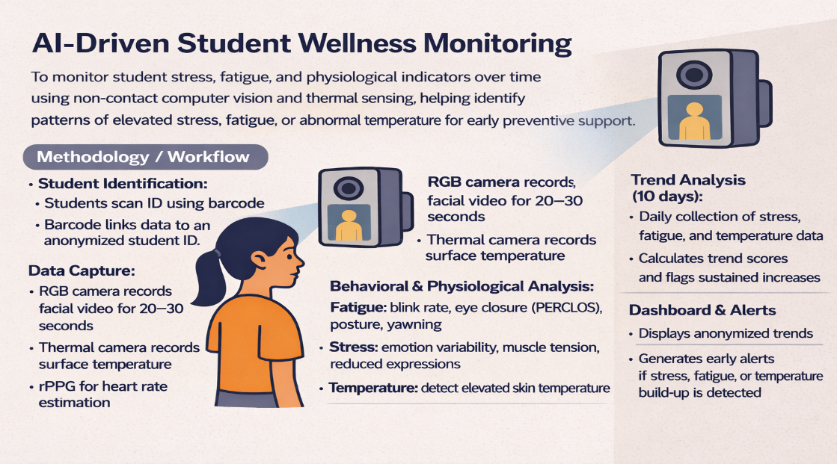

FIGURE 1.2 Comprehensive Wellness Sentinel for Modern Education

2. Students’ Health Conditions through Academic Challenges
Students are mostly prone to stress and fatigue, which can be an indicator for potential physical and mental problems. One of the factors of stress is constant pressure to attain high academic marks or imbalance lifestyle. Health is most commonly associated when a person becomes fully aware of their abilities, can adapt to the normal stressors and problems in their life, can work within one's self-fulfillment and satisfaction efficiently, and can make the right contributions to society. Studies on mental health and academic performance have been conducted throughout the world. Thus, this study aims to make the assessment and monitoring of students’ stress levels more accessible for them to be more aware of their condition, and also to serve as guide for students to balance school and personal life.

ICCT COLLEGES FOUNDATION INC.
V.V Solien Avenue II Cainta Rizal
College of Engineering and Digital Technology

3. Significance of the Study
This study holds the significant importance in addressing and monitoring the challenges faced by students in the Philippines by developing and implementing a Comprehensive Wellness Sentinel for Modern Education. The implementation of AuraGuard AI allows schools to monitor indicators and enhances their ability to maintain a positive and healthy environment for students. This study could be a huge help for students and also helps to lessen cases of poor mental and physical health conditions.

  - Statement of the Problem

1.3.1. General Problem

Today, most students do not have much time for a wellness check. Due to this, they are prone to stress and fatigue that can lead to different kinds of physical and mental illness. Assessment should be more accessible for students in schools to monitor indicators and to prevent risk of serious health problems, as well as making it easier for them to seek professional help if needed.

1.3.2. Specific Problem

- Lack of available health professional.
Even if most schools have an at least one health professional such as doctors or nurses, it is almost impossible for them to monitor and assess the physical and mental well-being of every single student in school in real-time.

- Undetected indicators that can lead to mental health problems.
Unlike physical health, mental well-being of a student can be neglected sometimes. Early symptoms such as frequent mood changes, stress and fatigue, if left undetected and without early intervention, can lead to much serious mental illness.

ICCT COLLEGES FOUNDATION INC.
V.V Solien Avenue II Cainta Rizal
College of Engineering and Digital Technology

- Problems in school-life balance.
Most students nowadays are unable to have a balanced lifestyle due to prioritizing school works often, which can cause frequent stress.

ICCT COLLEGES FOUNDATION INC.
V.V Solien Avenue II Cainta Rizal
College of Engineering and Digital Technology

REFERENCES:

https://www.sciencedirect.com/science/article/pii/S2666990024000132

https://eric.ed.gov/?q=National+AuraGuard+AI%3a+The+Comprehensive+Sentinel+for+Modern+Education&id=EJ1459941

https://eric.ed.gov/?q=Philippines+AuraGuard+AI%3a+The+Comprehensive+Sentinel+for+Modern+Education&ff1=locPhilippines&id=EJ1465795

https://copilot.microsoft.com/th/id/BCO.5f8ef0c7-706f-49e7-a998-3a2bb723a96b.png

