Meta_Tues_Template2

Marc Los Huertos

9/26/2016

## R Markdown

This is an R Markdown document. Markdown is a simple formatting syntax for authoring HTML, PDF, and MS Word documents. For more details on using R Markdown see <http://rmarkdown.rstudio.com>.

When you click the **Knit** button a document will be generated that includes both content as well as the output of any embedded R code chunks within the document. You can embed an R code chunk like this:

file = "/home/CAMPUS/mwl04747/github/Santa-Ana-Sucker-Recovery/Data/Data_Tues_Template.csv"  
import <- read.csv(file)

## Summary Statistics

Write some stuff about the summary here...

summary(import)

## Predictor Response   
## Min. : 4.00 Min. : 2.00   
## 1st Qu.:12.50 1st Qu.:11.25   
## Median :22.50 Median :18.50   
## Mean :22.00 Mean :21.80   
## 3rd Qu.:32.25 3rd Qu.:33.25   
## Max. :39.00 Max. :55.00

## Distribution

Write some stuff about the summary here...

hist(import$Predictor)

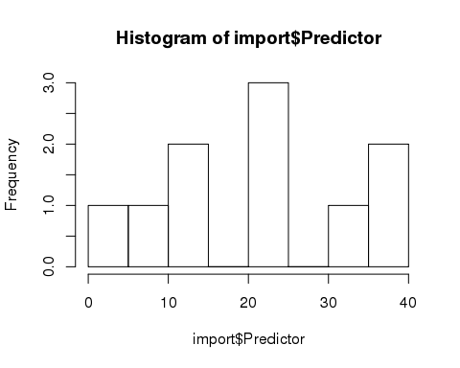

Write some stuff about the summary here...

hist(import$Response)

