4 Statistical Frameworks Study Guide (and other notes?)

EA30 2023 Students and Marc

2023-03-27

# R Study Guide Assignment

## Progress in Six Weeks

The study guide development was completed over a six week. While each topic rotated between groups, it was not always easy to track progress because each team had to ``start from scrach’’, each week. Thus, the idea of a progression wasn’t as successful as expected.

Nevertheless, we have created a very good document as a basic study guide and hope the product is useful.

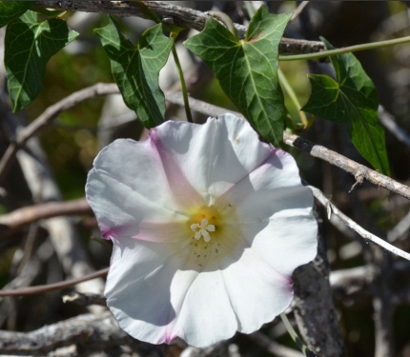

Calystegia purpurata is a species of morning glory known by the common name Pacific false bindweed. It is endemic to California, where it grows in the seaside scrub of the coastline and the chaparral of the coastal and inland valleys.

# R and Rstudio

## What is R?

R is a language and environment for statistical computing and graphics. R provides a wide variety of statistical (linear and nonlinear modelling, classical statistical tests, time-series analysis, classification, clustering, etc.) and graphical techniques, and is highly extensible.

One of R’s strengths is the ease with which well-designed publication-quality plots can be produced, including mathematical symbols and formula where needed.

## Using R Studio Server

We used the college’s RStudio Sever to develop the study guide. However, students can download R and Rstudio (which are free) to continue to have access to the program after the semester.

knitr::include_graphics("https://github.com/marclos/beginnersluck/raw/master/Stats/EA30_Study_Guide/Calystegic_purpurata.jpg")



Calystegia purpurata is a species of morning glory known by the common name Pacific false bindweed. It is endemic to California, where it grows in the seaside scrub of the coastline and the chaparral of the coastal and inland valleys.

knitr::include_graphics("https://github.com/marclos/beginnersluck/raw/master/Stats/EA30_Study_Guide/Rubus_ursinus.jpg")



A deciduous climbing or trailing evergreen shrub. Native blackberry is not aggressive like it’s Himalayan cousin. The berries are edible and tasty. Flowers host beneficial insects. Tolerates salt spray in shoreline and bluff plantings.

# Variables and Statistics

## Defining Variable Types

### Continuous vs. Descrete vs. Categorical

Continuous data includes complex numbers and varying data values measured over a particular time interval. Discrete data is a numerical type of data that includes whole, concrete numbers with specific and fixed data values determined by counting, often these might be referrred to as ``count’’ data

Categorical variables represent types of data which may be divided into groups. Examples of categorical variables are race, sex, age group, and educational level. While the latter two variables may also be considered in a numerical manner by using exact values for age and highest grade completed, it is often more informative to categorize such variables into a relatively small number of groups.

We can interrogate the data if we are unsure using the str() function, which coerces the data.frame into a format to evaluate the structure.

str(pressure)

## 'data.frame': 19 obs. of 2 variables:  
## $ temperature: num 0 20 40 60 80 100 120 140 160 180 ...  
## $ pressure : num 0.0002 0.0012 0.006 0.03 0.09 0.27 0.75 1.85 4.2 8.8 ...

In this case, we find that the object “pressure” is a data.frame that is composed of two variables – and both seem to be numeric and continuous.

### Dependent vs. Independent Data

In some cases, we can manipulate an environmental setting or characteristic and test the impact on another characteristics. We generally call the one that we can manipulate as the independent variable and the measured response as the dependent variable.

Graphically, we often see the independent variable as the x-axis. The independent call might also be referred to as the predictor variable. The response as the dependent (or response) variable.

In our titles, we often refer to the dependent first – “Response as a Function of X” or “Water Temperature vs. Air Temperature”

NOTE: Spatial Data and Time Series data have special concerns. For example, when we take a sample from a creek every day – the creek water might be different, but the processes that contribute to its characteristics are quite similar, compared to water from another creek. Thus, we might note that the samples taken are autocorrelated.

“Auto-correlation” occurs when data are not independent – for example, if we sample the same locations over time, we might expect each location to be self-correlated, i.e. auto-correlated. This violates a statistical assumption of indendence. There are ways around this violation, but that is beyone our study guide’s capacity to address, see Autocorrelation Section for more information.

#### Graphical Example of Independent and Dependent Variables

Plotting data as a data.frame is pretty straightforward, but there are two main syntax methods.

1. Define x and y in the plot function:

plot(x=pressure$temperature, y=pressure$pressure) # Notice the data.frame is explicitly referenced and then the variable of interest after the dollar symbol.

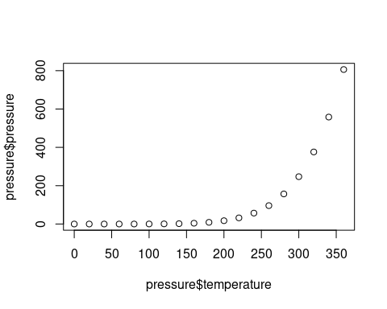

Notice that the x- and y-axes are labeled that show’s how we used the variables in the plot function.

1. Alternatively, you can use the formula syntax:

plot(pressure ~ temperature, data=pressure) # in this case the data.frame is called by the "data=" argument.

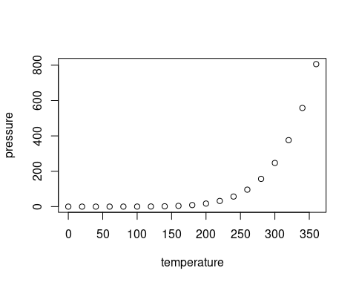

In this case, the x- and y-labels reflect the varible names without the data.frame reference. Plus, the formula syntax, helps us note the ‘y is a function of x’ relationship.

knitr::include_graphics("https://github.com/marclos/beginnersluck/raw/master/Stats/EA30_Study_Guide/Calochortus_plummerae.jpg")



Calochortus plummerae is a perennial herb (bulb) that is native to California, and endemic (limited) to California.

<https://github.com/marclos/beginnersluck/raw/master/Stats/EA30_Study_Guide/Calochortus_plummerae.jpg>

# Four Frameworks

## Linear Regression

Regression analysis is a set of statistical processes for estimating the relationships between a dependent variable (often called the ‘outcome’ or ‘response’ variable, or a ‘label’ in machine learning parlance) and one or more independent variables (often called ‘predictors’, ‘covariates’, ‘explanatory variables’ or ‘features’).

Linear regression is one of the most commonly used predictive analyses. It answers the question: Does a set of predictor variables do a good job in predicting an outcome (dependent) variable? It’s used to predict the value of a variable (the dependent variable) based on an input value (the independent/predictor variable), Variable Types Section. Linear regression can answer questions about the relationship between two variables or the strength of a cause/effect relationship. It also is helpful if you have multiple independent variables because you can find out which variable(s) best predicts the dependent variable.

The most common form of regression analysis is linear regression, in which one finds the line (or a more complex linear combination) that most closely fits the data according to a specific mathematical criterion. For example, the method of ordinary least squares computes the unique line (or hyperplane) that minimizes the sum of squared differences between the true data and that line (or hyperplane).

Remember, correlation is not synonymous with causation, so we need to be careful in how linear regression is interpreted.

The regression is cacl a straight line on the plot (a line of best fit) and will measure the distance between the actual values and the predicted values on the line to determine how well the line predicts the values.

Linear regression can be displayed as scatterplot. Linear regression can be used to estimate the coeffients for a ‘best fit line’, with an slope and intercept.

## Linear Regression Examples

### Example #1: Air and Water Temperatures

We know surface water temperatures depend on the sunlight. But what about surface air temperature? In this example, we compared or regressed the water temperature with air temperature. Thus, we might ask the following question:

Does water temperature depend on air temperature? This implies a cause and effect. Can you think of reasons why the temperatures might be correlated, without a cause and effect?

While correlation doesn’t say anything about cause and effect while regression expresses the cause and effect relationship between variables in the form of an equation. But we must be careful because the equation is not a mechanistic explanation, only a mathematical expression. In all cases, we need to have a clear explanation of how the cause and effect works and a good explanation that there are no confounding factors.

Below we create two vectors (water and air) of tempeature data. What does c() do? See R Functons in Appendix

water = c(50, 52, 65, 67, 68, 78, 54, 63, 57, 58)  
air = c(60, 75, 85, 86, 73, 76, 78, 92, 59,62)

Let’s look at the data:

plot(x=air, y=water, main="water ~ air")

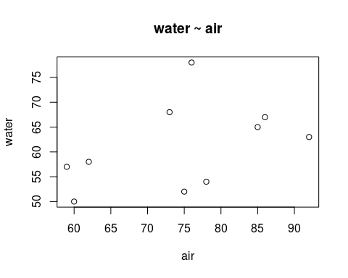

From here, we can coerce the data into a linear model and named object (airwater.lm):

airwater.lm <- lm(formula = water ~ air)

Next we can plot the data and then inlay the best fit line:

plot(x=air, y=water, main="air ~ water")   
abline(coef(airwater.lm), col='red')

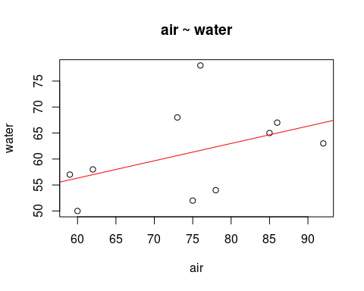

We have a best fit line, but now we want to understand the statistical relationship between the two variables. We can extract that relationship using the summary() function:

summary(airwater.lm)

##   
## Call:  
## lm(formula = water ~ air)  
##   
## Residuals:  
## Min 1Q Median 3Q Max   
## -9.3333 -5.7500 0.6667 1.7500 16.3333   
##   
## Coefficients:  
## Estimate Std. Error t value Pr(>|t|)   
## (Intercept) 36.3333 18.0764 2.01 0.0793 .  
## air 0.3333 0.2398 1.39 0.2020   
## ---  
## Signif. codes: 0 '***' 0.001 '**' 0.01 '*' 0.05 '.' 0.1 ' ' 1  
##   
## Residual standard error: 8.211 on 8 degrees of freedom  
## Multiple R-squared: 0.1945, Adjusted R-squared: 0.09386   
## F-statistic: 1.932 on 1 and 8 DF, p-value: 0.202

The null hypothesis is “there is no relationship” and we can reject that null hypothesis if the relationship could not random. So, we compare the results (slope) to see if the result could happen that is beyond the random assortment of measurements. There is lots of probability theory to understand this, which is beyond our course, but for now, let’s just say that the null hypothesis can be rejected if the probability is less than 0.05. Is this true? Be sure to look at the coefficient for predictor and it’s pvalue to make this decision.

### Example #2: SRP and HABs

Harmful algal blooms (HABs) affect a wide range of ecosystem processes and are a public health threat. In general, HABs are most common in the summer when the water temperatures are highest and daylengths are longests. But for HABs to occur, three must be adequate nutrients.

In this example, we have phosphate concentrationss (as measured as soluable reactive phosphorous – SRP) and the concentration of cyanobacteria – a potential source of HABs.

The independent data are SRP and dependent is cyano:

SRP <- c(.02, .03, 0.4, 0.04, .05, 0.033, 1.4)  
cyano<- c(22, 34, 23, 22, 23, 2, 122)

These data can be analyzed using a linear regression (specifically a simple linear regression) because they are both quantitative forms of data and we are trying to determine if they have a cause and effect relationship, between an independent and dependent variable.

#### Create Linear Model using lm() function

The linear model coerces the data into a new object using a least squares method to calculate the slope and intercept (and other statistical date.)

The rcode is using the lm [linear regression model function] to create a linear model using a least squares approach:

HAB.lm = lm(cyano ~ SRP)  
HAB.lm

##   
## Call:  
## lm(formula = cyano ~ SRP)  
##   
## Coefficients:  
## (Intercept) SRP   
## 15.03 72.37

Using the model allows us to create a best fit line (with the slope and intercept) and illustrate the relationship between between SRP and HABs.

#### Model Summary (Results)

Let’s look at the model results with summary()

summary(HAB.lm)

##   
## Call:  
## lm(formula = cyano ~ SRP)  
##   
## Residuals:  
## 1 2 3 4 5 6 7   
## 5.523 16.799 -20.979 4.076 4.352 -15.418 5.647   
##   
## Coefficients:  
## Estimate Std. Error t value Pr(>|t|)   
## (Intercept) 15.029 6.398 2.349 0.06563 .   
## SRP 72.374 11.608 6.235 0.00155 **  
## ---  
## Signif. codes: 0 '***' 0.001 '**' 0.01 '*' 0.05 '.' 0.1 ' ' 1  
##   
## Residual standard error: 14.55 on 5 degrees of freedom  
## Multiple R-squared: 0.886, Adjusted R-squared: 0.8632   
## F-statistic: 38.87 on 1 and 5 DF, p-value: 0.001554

he results of this linear regression demonstrate a relationship between SRP and HABs, but it is not a significant one (p-value = 0.06563). There some relationship between the data as demonstrated by the R2 vaue being 0.886, but the p-value demonstrates that it’s not a very significant relationship.

Let’s visualize the results:

plot(cyano ~ SRP, las=1, main="Cyanobacteria as a Function of SRP", pch=20, ylab="Cyanobacteria Concentration (mg/kg)", xlab="SRP (mg P/L)")  
abline(HAB.lm, col="blue")

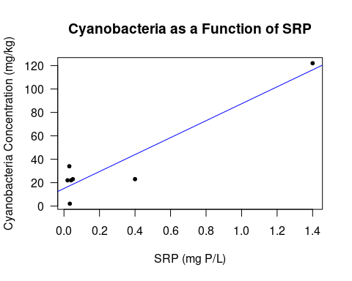

Note: We added customized x and y labels and title, notice the units. The best fit line is in blue

#### Model Interpretation (Discussion)

please add text here…what is the difference between reporting results and interpresting the results?

##### Linear Regression Assumptions

Let’s look at a default plot of model. By default, R produces four diagnostic plots to evaluate the assumptions in a linear regression:

par(mfrow=c(2,2))   
## mfrow allows you to creat a number of plot in one graph, you have to provide a vector of the number of rows and number of columns   
##the par() function creates multiple plots at one  
##Allows you to plot multiple points, the mfrow function allows you to split the screen into panels (basically split your screen)  
plot(HAB.lm)

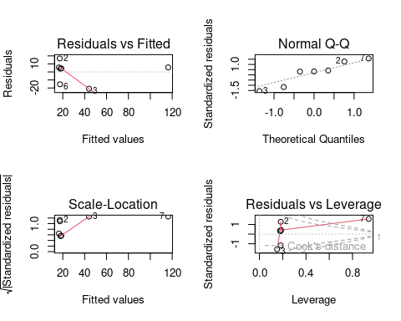

## plot(HAB.lm) is plot diagnostics

Now let’s look at one at a time:

1. Residuals vs Fitted

This plot shows if residuals have non-linear patterns. There could be a non-linear relationship between predictor variables and an outcome variable and the pattern could show up in this plot if the model doesn’t capture the non-linear relationship. If you find equally spread residuals around a horizontal line without distinct patterns, that is a good indication you don’t have non-linear relationships.

plot(HAB.lm, which=1)

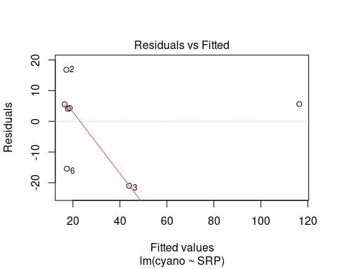

1. Normal Q-Q

This plot shows if residuals are normally distributed. Do residuals follow a straight line well or do they deviate severely? It’s good if residuals are lined well on the straight dashed line.

plot(HAB.lm, which=2)

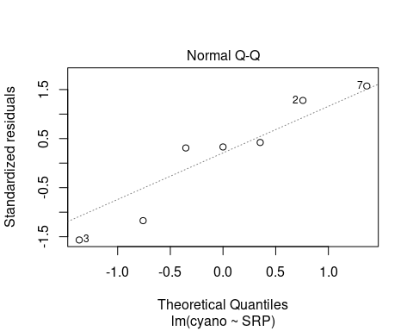

1. Scale-Location

It’s also called Spread-Location plot. This plot shows if residuals are spread equally along the ranges of predictors. This is how you can check the assumption of equal variance (homoscedasticity). It’s good if you see a horizontal line with equally (randomly) spread points.

plot(HAB.lm, which=3)

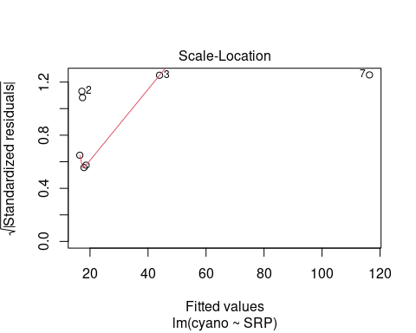

1. Residuals vs Leverage

This plot helps us to find influential cases (i.e., subjects) if any. Not all outliers are influential in linear regression analysis (whatever outliers mean). Even though data have extreme values, they might not be influential to determine a regression line. That means, the results wouldn’t be much different if we either include or exclude them from analysis. They follow the trend in the majority of cases and they don’t really matter; they are not influential. On the other hand, some cases could be very influential even if they look to be within a reasonable range of the values. They could be extreme cases against a regression line and can alter the results if we exclude them from analysis. Another way to put it is that they don’t get along with the trend in the majority of the cases.

plot(HAB.lm, which=3)



## Ascombe Data

This dataset was created to show the importance of visualizing the data and looking at the assumptions

Anscombe = as.data.frame(  
 matrix(c(  
 1, 10, 10, 10, 8, 8.04, 9.14, 7.46, 6.58,   
 2, 8, 8, 8, 8, 6.95, 8.14, 6.77, 5.76,  
 3, 13, 13, 13, 8, 7.58, 8.74, 12.74, 7.71,  
 4, 9, 9, 9, 8, 8.81, 8.77, 7.11, 8.84,  
 5, 11, 11, 11, 8, 8.33, 9.26, 7.81, 8.47,  
 6, 14, 14, 14, 8, 9.96, 8.10, 8.84, 7.04,  
 7, 6, 6, 6, 8, 7.24, 6.13, 6.08, 5.25,  
 8, 4, 4, 4, 19, 4.26, 3.10, 5.39, 12.50,  
 9, 12, 12, 12, 8, 10.84, 9.13, 8.15, 5.56,  
 10, 7, 7, 7, 8, 4.82, 7.26, 6.42, 7.91,  
 11, 5, 5, 5, 8, 5.68, 4.74, 5.73, 6.89),   
 nrow=11, byrow=TRUE))  
  
  
names(Anscombe) = c("Obs.", "x1", "x2", "x3", "x4", "y1", "y2", "y3", "y4")

## Anscombe Results

Let’s look at the results. NOTE: I added a line, abline(), with the coefficients using coef() from the linear model, .

par(mfrow=c(2,2))  
plot(y1 ~ x1, Anscombe, main="Dataset A")  
 A.lm = lm(y1 ~ x1, Anscombe); abline(coef(A.lm));   
  
plot(y2 ~ x2, Anscombe, main="Dataset B")  
 B.lm = lm(y2 ~ x2, Anscombe); abline(coef(B.lm))  
  
plot(y3 ~ x3, Anscombe, main="Dataset C")  
 C.lm = lm(y3 ~ x3, Anscombe); abline(coef(C.lm))  
  
plot(y4 ~ x4, Anscombe, main="Dataset D")  
 D.lm = lm(y4 ~ x4, Anscombe); abline(coef(D.lm))

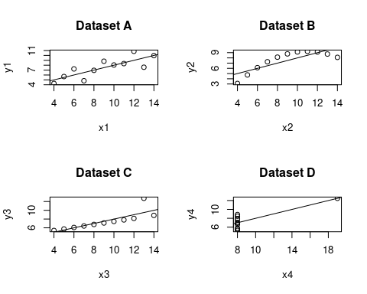 ## Comparing the Diagonstics

par(mfrow=c(2,2))  
plot(A.lm, which =1)   
plot(B.lm, which =1)   
plot(C.lm, which =1)   
plot(D.lm, which =1)

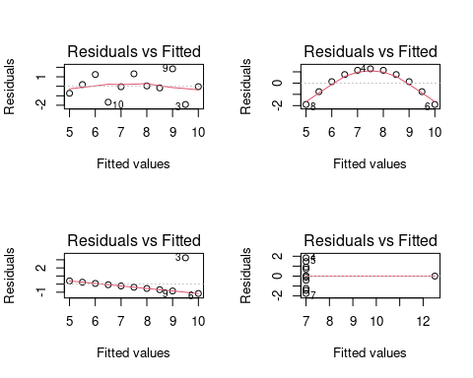

par(mfrow=c(2,2))  
plot(A.lm, which =2)   
plot(B.lm, which =2)   
plot(C.lm, which =2)   
plot(D.lm, which =2)

## Warning: not plotting observations with leverage one:  
## 8

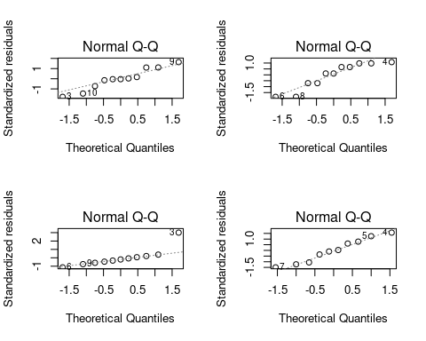

par(mfrow=c(2,2))  
plot(A.lm, which =3)   
plot(B.lm, which =3)   
plot(C.lm, which =3)   
plot(D.lm, which =3)

## Warning: not plotting observations with leverage one:  
## 8

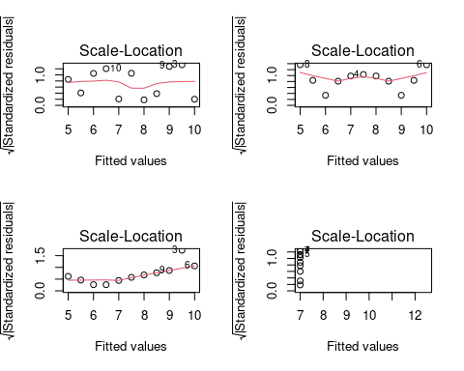

par(mfrow=c(2,2))  
plot(A.lm, which =4)   
plot(B.lm, which =4)   
plot(C.lm, which =4)   
plot(D.lm, which =4)

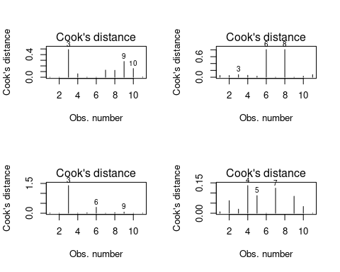

## Logistic Regression

MLH: What is this used for?

MLH: What are good questions for this?

### Example #1: Algae Concentration and Toxicity

Toxicity is a measure of toxity based on organism responses, often measured as LD50s, where 50% of the populations dies at a certain concentration.

Here we use the results of different concentrations of a toxin and the number of surviving Daphnia – a very common freshwater test organism.

MLH: Describe DATA…

## 'data.frame': 175 obs. of 2 variables:  
## $ Dose : num 0 0 0 0 0 0 0 0 0 0 ...  
## $ Result: num 1 1 1 1 1 1 1 1 1 1 ...

Create a nice table of results…

MLH: what are ones and zeros?

table(Results.df)

## Result  
## Dose 0 1  
## 0 7 18  
## 0.5 6 19  
## 1 13 12  
## 1.5 20 5  
## 2 19 6  
## 2.5 23 2  
## 3 24 1

# Results.df$Result <- as.factor(Results.df$Result)  
Results.logit <- glm(Result ~ Dose, data = Results.df, family = "binomial")

### Results

MLH: What do these results mean?

summary(Results.logit)

##   
## Call:  
## glm(formula = Result ~ Dose, family = "binomial", data = Results.df)  
##   
## Deviance Residuals:   
## Min 1Q Median 3Q Max   
## -1.7688 -0.8461 -0.4389 0.9334 2.4753   
##   
## Coefficients:  
## Estimate Std. Error z value Pr(>|z|)   
## (Intercept) 1.3296 0.3275 4.06 4.90e-05 ***  
## Dose -1.4485 0.2303 -6.29 3.18e-10 ***  
## ---  
## Signif. codes: 0 '***' 0.001 '**' 0.01 '*' 0.05 '.' 0.1 ' ' 1  
##   
## (Dispersion parameter for binomial family taken to be 1)  
##   
## Null deviance: 228.70 on 174 degrees of freedom  
## Residual deviance: 171.04 on 173 degrees of freedom  
## AIC: 175.04  
##   
## Number of Fisher Scoring iterations: 4

#### Interpretation (Discussion)

# define new data frame that contains predictor variable  
newdata <- data.frame(Dose=seq(min(Results.df$Dose), max(Results.df$Dose),len=100))  
  
# use fitted model to predict values of vs  
newdata$Result = predict(Results.logit, newdata, type="response")

# plot logistic regression curve  
plot(Result ~ jitter(Dose), data=Results.df, col="steelblue", las=1)  
lines(Result ~ Dose, newdata, lwd=2)

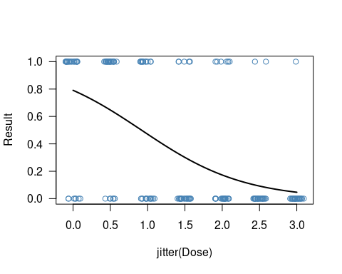 LD50 = dose at which Pr(dead | dose) = 0.5.

MLH: found this formula online… don’t know if it works…

$$ln\left(\frac{\frac{1}{2}}{1−\frac{1}{2}}\right)=β_{1}+β_{0}\left(LD_{50}\right)$$

$$0=β_{1}+β_{0}\left(LD_{50}\right)$$

$$\hat{LD_{50}=\frac{−β_{0}}{β_{1}}}$$

Calculating Standard Error… MLH: Haven’t tried this yet

proportion dead 0.6 0.4 0.2 0.0 2 ˆ + SE(ˆ1) ˆ 1 LD50 2 cov(ˆ0, ˆ1) ˆ 0 ˆ1

### Example #3

Will a person win an election?

MLH: What is this used for? Logistic regression is used when the predictor/independent variable is categorical and the response/dependent variable is continuous.

MLH: What are good questions for this? Possible questions may include - will an indiviudal win the election? predictor = number of votes; response = win or loss

# ANOVA

What is a one-way ANOVA?

What is the ANOVA used for?

## Example 1: Simulated HAB Data

Five mesocosms have been randomly selected to test the impact of zebra mussels on cyanobacteria concentrations, while five are controls. Water is circulate in each, and the experiment sampled the water column for bacteria counts every day for 10 days.

Here are the (fake) data:

Controls have a mean of 35 (and Standard Deviation of 8), Low Density treatment has a mean of 33 (SD = 8) and high density mean of 31 (SD=8)

## [1] 1 2 3 4 5 6 7 8 9 10 11 12 13 14 15 1 2 3 4 5 6 7 8 9 10  
## [26] 11 12 13 14 15 1 2 3 4 5 6 7 8 9 10 11 12 13 14 15 1 2 3 4 5  
## [51] 6 7 8 9 10 11 12 13 14 15 1 2 3 4 5 6 7 8 9 10 11 12 13 14 15  
## [76] 1 2 3 4 5 6 7 8 9 10 11 12 13 14 15 1 2 3 4 5 6 7 8 9 10  
## [101] 11 12 13 14 15 1 2 3 4 5 6 7 8 9 10 11 12 13 14 15 1 2 3 4 5  
## [126] 6 7 8 9 10 11 12 13 14 15 1 2 3 4 5 6 7 8 9 10 11 12 13 14 15

## [1] "Control" "Control" "Control" "Control" "Control" "Control" "Control"  
## [8] "Control" "Control" "Control" "Control" "Control" "Control" "Control"  
## [15] "Control" "Control" "Control" "Control" "Control" "Control" "Control"  
## [22] "Control" "Control" "Control" "Control" "Control" "Control" "Control"  
## [29] "Control" "Control" "Control" "Control" "Control" "Control" "Control"  
## [36] "Control" "Control" "Control" "Control" "Control" "Control" "Control"  
## [43] "Control" "Control" "Control" "Control" "Control" "Control" "Control"  
## [50] "Control" "LD" "LD" "LD" "LD" "LD" "LD"   
## [57] "LD" "LD" "LD" "LD" "LD" "LD" "LD"   
## [64] "LD" "LD" "LD" "LD" "LD" "LD" "LD"   
## [71] "LD" "LD" "LD" "LD" "LD" "LD" "LD"   
## [78] "LD" "LD" "LD" "LD" "LD" "LD" "LD"   
## [85] "LD" "LD" "LD" "LD" "LD" "LD" "LD"   
## [92] "LD" "LD" "LD" "LD" "LD" "LD" "LD"   
## [99] "LD" "LD" "HD" "HD" "HD" "HD" "HD"   
## [106] "HD" "HD" "HD" "HD" "HD" "HD" "HD"   
## [113] "HD" "HD" "HD" "HD" "HD" "HD" "HD"   
## [120] "HD" "HD" "HD" "HD" "HD" "HD" "HD"   
## [127] "HD" "HD" "HD" "HD" "HD" "HD" "HD"   
## [134] "HD" "HD" "HD" "HD" "HD" "HD" "HD"   
## [141] "HD" "HD" "HD" "HD" "HD" "HD" "HD"   
## [148] "HD" "HD" "HD"

## [1] 1 1 1 1 1 1 1 1 1 1

## [1] 33.2 38.9 38.2 49.8 26.2 35.9 37.2 35.9 50.0 35.6 38.9 32.5 25.3 38.1 42.4  
## [16] 42.4 24.0 43.1 37.8 46.8 45.8 20.1 49.9 27.4 21.0 38.3 33.5 39.0 39.5 16.7  
## [31] 41.1 26.5 44.1 41.9 45.1 18.5 18.0 41.8 31.6 21.0 35.6 38.6 49.3 49.3 47.2  
## [46] 30.9 28.4 31.9 29.1 30.8 30.9 47.7 24.6 26.5 45.0 40.2 37.8 38.2 33.8 35.6  
## [61] 24.6 40.2 35.2 48.4 29.4 45.0 29.8 26.6 13.9 41.4 31.7 35.3 39.0 17.5 27.3  
## [76] 33.5 35.7 33.8 31.8 32.1 26.9 28.5 35.5 33.6 40.3 25.8 18.6 38.6 40.0 24.8  
## [91] 41.3 33.0 11.6 20.8 32.7 27.0 34.9 39.6 16.0 23.8 27.8 30.2 16.1 6.8 17.4  
## [106] 44.9 45.8 24.4 50.0 45.5 33.8 33.8 41.7 26.1 30.2 31.3 28.2 33.7 31.4 17.3  
## [121] 23.6 20.2 35.3 40.7 30.2 25.1 35.5 35.7 36.2 32.2 28.0 37.1 19.2 24.0 27.3  
## [136] 29.8 47.2 28.4 44.8 26.2 31.1 34.0 28.1 31.5 43.8 14.3 42.3 32.5 4.0 29.5

### First six observations and histograms

head(Mussel)

## Mesocosm Treatment Day Results  
## 1 1 Control 1 33.2  
## 2 2 Control 1 38.9  
## 3 3 Control 1 38.2  
## 4 4 Control 1 49.8  
## 5 5 Control 1 26.2  
## 6 6 Control 1 35.9

par(mfrow=c(1,3))  
hist(Mussel$Results[Mussel$Treatment=="Control"])  
hist(Mussel$Results[Mussel$Treatment=="LD"])  
hist(Mussel$Results[Mussel$Treatment=="HD"])

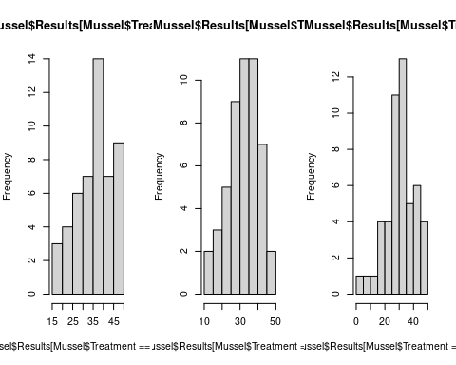

### Create AOV Object (Analysis of Variance) Using Least Squares Method

What are least squares?

Mussel.aov <- aov(results ~ treatment, data=Mussel)

### Results

summary(Mussel.aov)

## Df Sum Sq Mean Sq F value Pr(>F)   
## treatment 2 662 331.2 3.89 0.0226 *  
## Residuals 147 12517 85.2   
## ---  
## Signif. codes: 0 '***' 0.001 '**' 0.01 '*' 0.05 '.' 0.1 ' ' 1

### Exploring Chaning Parameters

MLH:Play with means or SD to see how it changes results

A lower standard deviation meant that the data were more clustered around the mean – MLH: this is doesn’t not tell the reader much… what about the summary, p value, ect?

#### Change Mean

MLH: add rcode and describe results

#### Change SD

MLH: add rcode and describe results

#### Change N

MLH: add rcode and describe results

### Some graphical Displays

Using a normal distribution, what do the data look like?

The data is symmetrically distributed with no skew.

MLH: What do these mean?

newresults = seq(min(Mussel$Results), max(Mussel$Results), length=500)  
plot(newresults, dnorm(newresults, mean=mean(Mussel$Results[Mussel$Treatment=="Control"])), ty="l", xlim=c(25,40), col="darkgreen", lwd=1.4)  
lines(newresults, dnorm(newresults, mean=mean(Mussel$Results[Mussel$Treatment=="LD"])), ty="l", col="darkred", lwd=1.4)  
lines(newresults, dnorm(newresults, mean=mean(Mussel$Results[Mussel$Treatment=="HD"])), ty="l", col="purple", lwd=1.4)

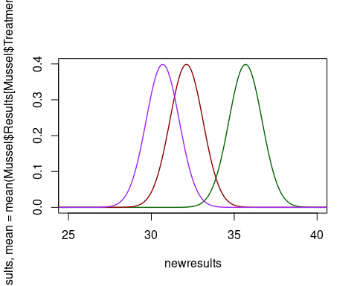

### Power Analaysis – ANOVA and Sample Size

Use this example: <https://stats.oarc.ucla.edu/r/dae/one-way-anova-power-analysis/> and create an “environmental example” and translate the results for class

### Power Analaysis – ANOVA and Sample Size – Rubus

A power analysis helps determine an appropriate sample size. To do so, it requires 5 types of data: the number of groups, the between group variance, the within group variance, the alpha level, and the sample size/power.

The number of groups refers to the number of treatments/categories within an analysis of variants. It is often represented as “groups”. The between group variance refers to the difference between group, the within group variance refers to the difference within each individual group, the alpha level relates to the probability of rejecting the null hypothesis when it is true, and the power refers to the probability the test will determine a statistically significant when that difference exists.

Next steps after running the initial Power Anova Test include plotting the results and analyzing effect size.

The between group variance references Use this example: <https://stats.oarc.ucla.edu/r/dae/one-way-anova-power-analysis/> and create an “environmental example” and translate the results for class

groupmeans <- c(550, 598, 598, 646)  
n <- c(seq(2,10,by=1),seq(12,20,by=2),seq(25,50,by=5))  
groups = 4  
 n = NA  
 between.var = 1536  
 within.var = 6400  
 sig.level = 0.05  
 power = .823  
p <- power.anova.test(groups = length(groupmeans),   
between.var = var(groupmeans), within.var = 6400,   
power=0.823,sig.level=0.05,n=NULL)  
p

##   
## Balanced one-way analysis of variance power calculation   
##   
## groups = 4  
## n = 16.98893  
## between.var = 1536  
## within.var = 6400  
## sig.level = 0.05  
## power = 0.823  
##   
## NOTE: n is number in each group

##### Playing with N to see the impact on power:

knitr::include_graphics("https://github.com/marclos/beginnersluck/raw/master/Stats/EA30_Study_Guide/type-i-ii-error.jpg")

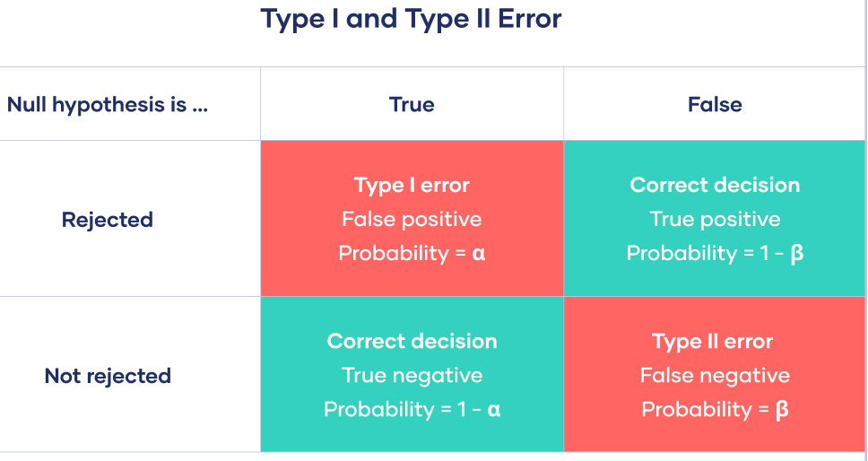

Calochortus plummerae is a perennial herb (bulb) that is native to California, and endemic (limited) to California.

Let’s continue with 4 treatements – or groups.

groupmeans <- c(550, 598, 598, 646)  
between.var = var(groupmeans)  
within.var = 6400  
sig.level = 0.05  
  
n <- c(seq(2,10,by=1),seq(12,20,by=2),seq(25,50,by=5))  
  
# power = null  
p <- power.anova.test(groups = length(groupmeans),   
 between.var = var(groupmeans),   
 within.var = 6400,   
 n = n, power= NULL,  
 sig.level=0.05)

## Warning in !is.null(n) && n < 2: 'length(x) = 20 > 1' in coercion to  
## 'logical(1)'

p

##   
## Balanced one-way analysis of variance power calculation   
##   
## groups = 4  
## n = 2, 3, 4, 5, 6, 7, 8, 9, 10, 12, 14, 16, 18, 20, 25, 30, 35, 40, 45, 50  
## between.var = 1536  
## within.var = 6400  
## sig.level = 0.05  
## power = 0.09067458, 0.14381195, 0.20139579, 0.26146007, 0.32241923, 0.38293139, 0.44190044, 0.49846996, 0.55200591, 0.64840471, 0.72949120, 0.79552098, 0.84785780, 0.88840023, 0.95127832, 0.98006724, 0.99226927, 0.99713328, 0.99897699, 0.99964689  
##   
## NOTE: n is number in each group

plot(n, p$power)

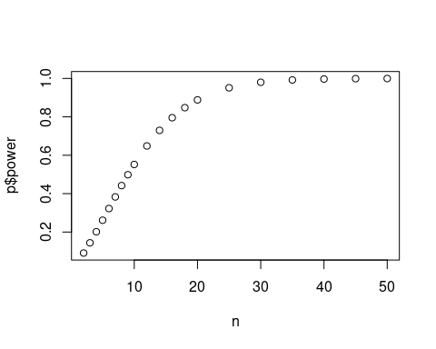

## Tests for Association

Contributions to date: Eriogonum, Calystegia, Phacelia

Example description (making this concrete at the start is useful):

MLH: What is this test used for?

This test is used to determine association between two treatments (or differences). An example could be Harmful Algal Blooms (HABs) as a treatment with Hospital Asthma Cases as an output. Could show the relation between HABs and Asthma Cases going to the hospital. Chi-Square tests for independence/association can only be used between categorical variables.

MLH: What is this test used for?

Answer: There are several tests for association. One of the more popular is the Chi-squared test ($\Chi^2$ test).

A Chi-Squared test is used to determine the association between two categorical variables. The null hypothesis is no association between the two independent variables.

H+M: Strengths of this test = helps measure how a model compares the actual observed data, tells us if two variables are independent of one another.

MLH: Are their assumptions to be concerned about?

The chi-squared test assumes that both variables are are categorical and independent. Assumes that the values are mutually exclusive as well. Data must be frequency data and this test is used when there are larger values. It makes no assumption about the distribution of the data.

The data in the cells should be frequencies, or counts of cases rather than percentages or some other transformation of the data. Categories of the variables are mutually exclusive (one cannot receive the treatment AND not receive the treatment). All observations must be independent. what does independent mean?

### Example 1

Hospital asthema cases and HABs in Florida MLH: Please flesh out example…

#### Creating Data (as a table)

MLH: Describe what’s happening here…

HAB.tab = c(20, 15, 98, 223)  
sum(HAB.tab)

## [1] 356

dim(HAB.tab) = c(2,2)  
dimnames(HAB.tab) = list(c("Non-HAB", "HAB"), c("No Hospitalizations", "Hospitalizations"))  
  
HAB.tab

## No Hospitalizations Hospitalizations  
## Non-HAB 20 98  
## HAB 15 223

# HAB.mat = matrix(HAB.tab, nrow=2)

table(HAB.tab)

## HAB.tab  
## 15 20 98 223   
## 1 1 1 1

Describe chisq.test

chisq.test(HAB.tab)

##   
## Pearson's Chi-squared test with Yates' continuity correction  
##   
## data: HAB.tab  
## X-squared = 8.9217, df = 1, p-value = 0.002818

# Other Types the Might be Important (Marc might discuss if we have time…)

## Count Data

## Multiple Regression

## Two-Way and Mult-Way ANOVAs –

we need data that we don’t have to read.csv…

What is a two-way anova?

### Example #1 –Fertilizer and Crop Yield MLH: Better for Multiway ANOVA

## Looked at Scribbr; entered the crop data to R as a csv##  
## Question: How does fertilizer effect crop yield? Testing three different fertilizers##  
## command to read the data##  
crop.data <- read.csv("crop.data.csv", header)  
## command to summarize and make sure everything is working##  
summary(crop.data)  
str(crop.data)  
## use to perform a one.way ANOVA##  
## One way ANOVA has one independent independent variable##  
## This one way ANOVA models crop yield as a function of the type of fertilizer used##  
one.way <- aov(yield~fertilizer,data=crop.data)  
## shows what the data compiles into after a one.way##  
summary(one.way)

## use to perform a two.way ANOVA##  
## Two way ANOVA utilizes two independent variables##  
## This two way models crop yield as a function of type of fertilizer and planting density##  
## Just have to add a plus icon and the extra independent variable##  
two.way <- aov(yield ~ fertilizer + density, data = crop.data)  
## shows what the data compiles into after a two.way##  
summary(two.way)  
## Interaction between variables##  
## Used to test whether two variables have an interaction effect##  
interaction <- aov(yield ~ fertilizer*density, data = crop.data)  
summary(interaction)

### Logistic Regression – Multiple Predictors

MLH – The example relies on external data, which adds a step that gets in the way. I suggest we developed example two to keep it simpler…

Research question: Which fertilizer produces the most crop yield? ##Independent variable/predictor: Fertilizer A, Fertilizer B, Fertilizer C ##Dependent variable/response: amount of crop yield

Question: Which fertilizer provides the best crop yield?

It is common for factors to be read as quantitative variables when importing a dataset into R. To avoid this, you can use the read.csv() command to read in the data, specifying within the command whether each of the variables should be quantitative (â€œnumericâ€) or categorical (â€œfactorâ€).

##Use the following code, replacing the path/to/your/file text with the actual path to your file:

# install.packages(c(“ggplot2”, “ggpubr”, “tidyverse”, “broom”, “AICcmodavg”))   
  
# Read Data  
# crop.data.csv = file.choose()  
  
crop.data.csv = "/home/mwl04747/beginnersluck/Stats/EA30_Study_Guide/ANOVA_cropdata.csv"  
crop.data <- read.csv(crop.data.csv)  
  
names(crop.data)  
crop.data.aov <- aov(Yield ~ Fertilizer, data=crop.data)  
  
summary(crop.data.aov)

## Time Series Data

### Autocorrelation

TBD

## Count Data

TBD

## Mixed Effects Models

TBD

# Appendix 1: Soon to be an Alphabetic List of R code and explanation

Please describe in human terms, what are these? and us arg() to show some of the syntax (in human language!)

## Group: Rubus

read.csv()

power.anova.test()

## Group: Eriogonum

lm()

plot()

list()

help.start()

## Group: Calachortus

abline()

str()

help()

## Group: Adenostoma

aov()

summary()

knitr::include_graphics()

## Group Clemitis

dim()

table()

chisq.test()

## Group Phacilia

dimnames() {#dimnames}

data.frame() {#data.frame}

par() {#par}

## Group Marah

c() {#c} Combine Values into a Vector or List.

predict() {#predict}

lines() {#lines}

## Group Calystegia

read.csv() This command is used to read a .csv file that is already in your directory and give it a name so r can read it. It looks like this: data <- read.csv(“input.csv”) Then you can do read(data) to see a preview of the dataset

glm() This command is used to fit generalized linear models, specified by giving a description of the linear predictor and a description of the error distrbution. It looks like this: glm(formula, family = gaussian, data, weights, subset, na.action, start = NULL, etastart, mustart, offset, control = list(…), model = TRUE, method = “glm.fit”, x = FALSE, y = TRUE, singular.ok = TRUE, contrasts = NULL, …) glm.fit(x, y, weights = rep(1, nobs), start = NULL, etastart = NULL, mustart = NULL, offset = rep(0, nobs), family = gaussian(), control = list(), intercept = TRUE, singular.ok = TRUE)

points() This command is used put points at specific coordinates and to be plotted in a plotting structure, a two-column matrix, or a time series. it looks like this: points(x, y = NULL, type = “p”, …)

jitter() This command is used to add a small amount of noise to a numerical vector. It can help the data look a bit clearer on the graph. It looks like this: jitter(x, factor = 1, amount = NULL)

# Appendix 2: Questions to Evaluate our Study Guide

## General questions

1. Is all the rcode described and have comments to help the reader?
2. Is all the data within the documented, no need for external data source links that might break?
3. Is each example described and compelling?
4. Are the results described?
5. Are the models interpreted?

## Quiz Like Questions

Add questions here from our quiz or something that you learned about your topic that you can put in here…

### Linear Regression

1. What is a Linear regression?
2. What is the black diagonal line in Figure 1 called?

(x <- c(1, 2, 3, 4, 5)) # create a vector of x values

## [1] 1 2 3 4 5

(y <- c(1, 2, 1.3, 3.75, 2.25)) #2. create a vector of y-values

## [1] 1.00 2.00 1.30 3.75 2.25

regression.ex.df = data.frame(X=x, Y=y) #make a data frame… (don’t know the function)  
par(las=1)  
plot(y ~ x, data=regression.ex.df, pch=20)  
regression.ex.lm = lm(y~x, data=regression.ex.df)  
abline(coef(regression.ex.lm))  
regression.ex.df$Residuals = as.vector(resid(regression.ex.lm))  
regression.ex.df$Predicted = as.vector(predict(regression.ex.lm, newdata=data.frame(predicted = x)))  
regression.ex.df$Color = c("red", "blue", "green", "yellow", "pink")  
#lines.mat = mat()  
#(xy.coords.ex = xy.coords(rep(x, times=2), c(regression.ex.df$Predicted, c(regression.ex.df$Predicted + regression.ex.df$Residuals))))  
#xy.coords.ex[order(xy.coords.ex$x)]  
for(i in 1:nrow(regression.ex.df)){  
lines(c(regression.ex.df$X[i], regression.ex.df$X[i]), c(regression.ex.df$Predicted[i], c(regression.ex.df$Predicted[i] + regression.ex.df$Residuals[i])), col=regression.ex.df$Color[i], lwd=2)  
}

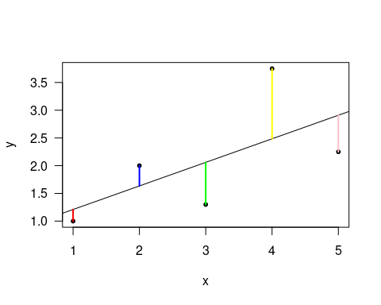

#lines(x[1], regression.ex.df$Predicted[1], x, c(regression.ex.df$Predicted[1] + regression.ex.df$Residuals[1]), color=

1. Outline the pseudo R code that might be used to generate this graph. In other words, use your words to describe the steps you might need to use to create this graphic (think about how the colored lines might be made and the labels. If you have guesses of the R code syntax, put this in parenthetical statements.

For example, 1. create a vector of x values (x <- c(1, 2, 3, 4, 5) 2. create a vector of y-values (y <- c(1, 2, 1.3, 1.75, 2.25) 3. make a data frame… (don’t know the function)… 4. …

1. The vertical lines on Figure 1 from the points to the regression line represent the errors of prediction. As you can see, the red point is very near the regression line; its error of prediction is small. By contrast, the yellow point is much higher than the regression line and therefore its error of prediction is large. How can the summary() function be used to access the residuals?
2. The summary() function also reports the r2 and p-values for the model. Describe how to interpret these.

### ANOVA

1. What is the difference between a one-way and two-way ANOVA?
2. Given an experiment with a control and three treatments (Treatment) and some measured response (Response) here’s the R code to create the ANOVA object:

Model1.aov <- aov(Response ~ Treatment)

1. How would you generate a summary of the results? How would you report this in a paper?

### Logistic Regression

1. What kind of data is used in a logistic regression?
2. What distribution family is used in the glm() function for logistic regression? Why is this distribution used?

### Tests for Association