Video Game Store Inventory Manager
REMEMBER THAT BECAUSE IT IS A RESTFUL SERVICE (IE IT DOESN’T TRACK SESSIONS) YOU MUST ATTACH THE BEARER TOKEN TO EVERY REQUEST YOU MAKE TO THE GAME STORE.

RESTFUL (REPRESENTATIONAL STATE TRANSFER):
- DESIGNED TO BE STATELESS
- EACH REQUEST FROM A CLIENT TO A SERVER MUST CONTAIN ALL THE INFORMATION NEEDED TO UNDERSTAND AND PROCESS THE REQUEST.
- THE SERVER DOES NOT STORE ANY STATE OR CLIENT SESSION DATA BETWEEN REQUESTS.

THIS ALLOWS THE SERVER TO BE MORE EFFICENT WITH HANDLING REQUESTS AS REQUESTS ARE HANDLED AND THREADS ARE FREED TO WORK ON OTHER REQUESTS.

Documentation:

REQUESTING A TOKEN FROM AUTHENTICATION SERVER
First you must go to developer tools and run this piece of Javascript code in the console:

“encodedData = “Basic ” + window.btoa(‘<user_id>:<app_secret>’)

The ‘window.btoa’ function encodes the string ‘<user_id>:<app_secret>’ into Base64 format. This is done in Web Development for encoding data which needs to be transferred in a form where non-ASCII characters may be problematic.

The result, “Basic Z2FtZV9…..” is used for creating an “Basic Authentication”Authorization header for HTTP requests.
- In “Basic Authentication”, the username and password are concatenated with a colon (username:password), then Base64-encoded, and finally prefixed with the word ‘Basic’ to form the complete Authorization header value.

In the case of our game store, we would do:
1. Open Firefox dev tools.
2. Open cosole window.
3. Run: encodedData = “Basic ” + window.btoa(‘game_store:game_store_secret’)
4. Copy the result, which looks like: “Basic Z2FtZV9zdG9yZTpnYW…..”
Now that we have this Authorization header, we can send a request to our Authentication server.

5. Send a POST web request to our Authentication server with the:
- Authorization Header
- User details.
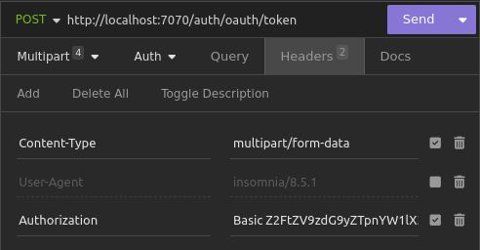
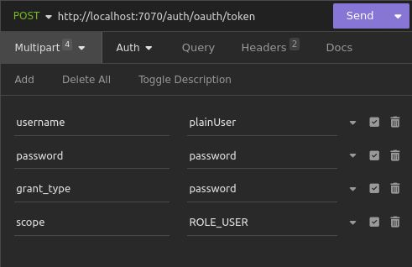

6. And the response you get back will contain the bearer token that you will attach to the web requests that you make to the game store.
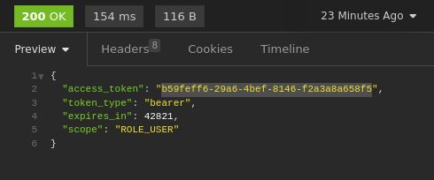

7. You attach this bearer token to all of the requests you make to the game store. For example:
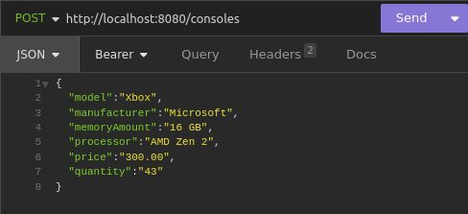

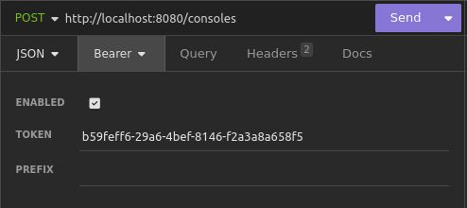

And now you can use the game store API:
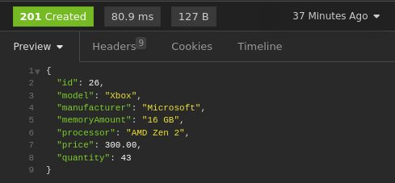

Deployment And Development
When developing go to "resources" folder and set value in
application.properties file "development" or "production".

Starting Project Using Maven
Run using: mvn spring-boot:run
mvn -e spring-boot:run for stack trace

Rebuild Project with Maven
mvn clean install

Docker Notes
'docker port container_name_or_id'
- to see container port mappings.

'docker inspect container_name_or_id'
- for detailed info about the container, including network settings.

'docker --help' - to see usage.
'pull' - to download an image from a registry.

Docker run usage: 'docker run [options] IMAGE [command] [arg...]'

How to check environment variables:
‘docker exec container_name’
‘docker inspect container_name’

How to check running containers:
docker ps -- defaults to just runnning containers
docker ps -a -- to show all containers

How to create a new container:
'docker run' create and run a new containers from an image.

Use SpringBoot Docker to create an image for your Spring Boot project:
Go to project's (app's) base directory where pom.xml is.

sudo /path/to/mvn spring-boot:build-image

** You gotta use full path to mvn as sudo because sudo doesn't have 'mvn'
** executable in its path.

*** To find full path you can use: "which mvn"

Add the -DskipTests to skip the tests:

sudo /path/to/mvn spring-boot:build-image -DskipTests

Setup MySQL Docker image
Pull the MySQL Docker image using "docker pull mysql:latest"

Run the following command:
docker run -e MYSQL_ROOT_PASSWORD=<password> -p 3306:3306 --name mysql_local -d mysql:latest

'-d' Run container in the background and print container ID.
'-e' Used to set environment variable
'-p' Used to publish a container's port(s) to the host.
- PORTS ARE JUST FILES! THEY ARE NOT PHYSICAL THINGS. THEY ARE 'LOGICAL CONSTRUCTS'
- Basically, you are defining a mapping of the container's port to the host's port.
- Usage: 'host_port:container_port'
- Container's ports are similar to those of an OS.
- Containers have a full range of ports available to them.
- To list all ports being used, use 'ss tuln'
- Ports not listed are free to use.
- To check a specific port: 'sudo lsof -i :[port_number]'
'--name' assign a name to the container.

This creates a new MySQL image. (The running instance of the image is called
a 'container' which is isolated environment.)

MySQL Container Environment Vars
MYSQL_ROOT_PASSWORD
MYSQL_DATABASE
MYSQL_USER
MYSQL_PASSWORD
MYSQL_ALLOW_EMPTY_PASSWORD
MYSQL_RANDOM_ROOT_PASSWORD
MYSQL_ONETIME_PASSWORD
MYSQL_INITDB_SKIP_TZINFO

SETUP SERVICE CONTAINER

Same as setting up MySQL container pretty much.

ex creating auth_server container:
sudo docker run -p 7070:7070 --name auth_service -d authorization-service:0.0.1-SNAPSHOT

ex creating gamestore_server container:
sudo docker run -p 8080:8080 --name game_store_service -d gamestore:0.0.1-SNAPSHOT

Container-to-Container Networking

WHEN COMMUNICATING WITHIN A CONTAINER NETWORK, TALK TO PORT THAT CONTAINER HAS INSIDE.
FOR EXAMPLE:
IF YOU HAVE A CONTAINER WITH PORT MAPPING 3307:3306
TALK TO THE INSTANCE WITH:
“http://docker_container:3306”
BECAUSE WE ARE NO LONGER COMMUNICATING FROM THE OUTSIDE. 3307 IS USED TO COMMUNICATE WITH THE CONTAINER FROM OUTSIDE OF THE NETWORK.

To have servers inside of containers talk to eachother, first we must create a Docker network.

- Use a "User-defined bridge" network because it provides:

- Isolation: User-defined bridge networks provide better isolation between containers compared to the default bridge network. This enhances security.

- DNS Resolution: User-defined bridge networks enable automatic DNS resolution of container names to their respective IP addresses, facilitating easier inter-container communication.

- Simplicity: For single-host deployments, bridge networks are simple to set up and manage, making them ideal for straightforward scenarios like connecting databases and REST APIs.

To create a user-defined bridge network:
sudo docker network create -d bridge GAME_STORE_NETWORK

To run a container in the created network:
sudo docker run --network=my-net -d --name=container3 busybox

REMEMBER THAT INSIDE OF A DOCKER CONTAINER “LOCALHOST” REFERS TO THE CONTAINER ITSELF!

To add an already existing container to a Docker network use (and keep the state that it is in):
docker network connect [network_name] [container_name]

For example: sudo docker network connect GAME_STORE_NETWORK mysql_local_game_store

How to connect SpringBoot service CONTAINER to MySQL CONTAINER
In the SpringBoot service 'resources' folder
In the 'development' or 'production' file
For the data source do: "spring.datasource.url=jdbc:mysql://<container_name>:<port_number>/<database>/<parameters>"

For example: "spring.datasource.url=jdbc:mysql://mysql_local_game_store:3306/game_store?useSSL=false&serverTimezone=UTC&allowPublicKeyRetrieval=true"

How to connect client cli to local MySQL server
mysql -h <host_name> -P <port_number> -u <user_name> -p <db_name>

localhost=127.0.0.1
db_name=game_store

-h -- connect to the MySQL server on the given host.
-u -- the user name of the MySQL accound to use for connecting to the server
-p -- prompts server to ask for one.
-P -- the port number to use.

Example usage:
mysql -h 127.0.0.1 -P 3306 -u root -p game_store

Connect DBeaver client to local MySQL server
Make sure MySQL server is up and running.

Open DBeaver.
Add new connection.
Driver properties --> allowPublicKeyRetrieval 'true'
Main
Add port
User and pass
Test connection

Angular Notes
Create a new Angular project:

ng new <project-name> –skip-git --standalone=false –routing –skip-tests --minimal

‘—skip-git’ → Do not initialize a git repo (VERY IMPORTANT IF CREATING NEW PROJECT WITHIN AN EXISTING GIT REPO)
‘—routing’ → Enable routing in the intial project
‘—skip-tests’ → Do not generate “spec.ts” test files for the new project
‘--minimal’ → Create workspace without any testing frameworks
‘—standalone=false’ → Creates an application with NgModules ‘app.module.ts’.

All code goes in ../src/app directory.

index.html is the entry point into the app.

The parsing of the JS is called ‘bootstrapping’.

There are three main pieces to any component:
1. The component typescript where you define the custom JS logic and the internal state of the component.
2. The HTML which contains the visual UI and allows you bind data from the TS to the template.
3. The style sheet (CSS) which is scoped to that component and wont bleed out (be applied) to other components.

app.component.ts notes
- ‘template’ is where we add our components.

app.module.ts notes
In order to use the materials inside of our application we need to add them all to our modules.
We do this in this file, in the “imports” array. We add all the components we will use.

Angular Materials
Angular library contains all of the components that we will use in our web interface.
- This makes our interface easier and faster to develop.
Here is the Material Documentation
To use Angular Materials in our project first we must install it into the project:
ng add @angular/material
You will then be asked preferences about how you want the interface to look.
We chose indigo/pink. This is what it will look like for reference: indigo/pink

Angular materials are imported using API references.
For example is we want to use the “Angular Material table” we would use:

‘import {MatTableModule} from @angular/material/table’

These references are available in the material documentation here: Table Material API reference

In order to actually use these materials, we need to add them in our “app.module.ts” file.

Tailwind CSS
We use Tailwind CSS for faster development. Tailwind installation with Angular
- Works by scanning all HTML files, JS components, and any other templates for class names, generating the corresponding styles and then writing them to a static CSS files.

Creating a new component
cd into folder where you want to create the new component. ex. ./src/app/components

ng g c <component_name>

‘g’ generate
‘c’ component

Testing
Custom karma config file: karma.conf.js

To run tests: ng test

