**Range of rule increases complexity in cellular automaton**

**Abstract**

The cellular automaton is used for a model in a wide area of scientific investigation, such as computer science, mathematics, physics and theoretical biology. The cellular automaton is a very simple model, but it can analyze complex various phenomena. For example, the cellular automaton is used for analyzing life phenomena, the growth of the crystal, fluids, traffic flow such as people and vehicles and economic activities. There are many studies on the cellular automaton itself and they revealed that all one-dimensional cellular automaton can be classified in order of complexity of behavior. However, there are few studies on the relationship between rules and behavior, so the problem in this paper is how behavior of the cellular automaton changes when the rule changes. In this experiment, one-dimensional cellular automaton was connected the left and right edges, and its behavior was investigated. Hypothesis in this paper was the range of the rule increases the complexity of behavior in the cellular automaton. Results showed that behavior of the cellular automaton became more complex in proportion to the complexity of the rule, so these results may seem to suggest that various phenomena can be analyzed easily by idealizing and simplifying even if they are complicated.

Keywords: boundary problem, cellular automaton, complexity, range of rule

**Introduction**

The cellular automaton is a mathematical model which helps understanding of various phenomena. The cellular automaton consists of a regular grid of cells, each with finite states. The state of the grid is determined by the previous neighbor states and the identical rule which the cellular automaton follows when it works. The cellular automaton shows various kinds of behavior. The behavior of the cellular automaton depends on the number of cells, the initial conditions, the number of the state, rules and boundary conditions.

As regards boundary conditions, the cellular automaton is often used on finite cells rather than infinite cells, so how to do with the cells on the edges is a very important problem which can affect all behavior of the cellular automaton. This is called for boundary problem. In many researches on one-dimensional cellular automaton, to solve this problem the state of the cells on the edges remains constant or follows other rule which is determined fewer neighbors. Another solution is that one-dimensional cellular automaton is connected the left and right edges to eliminate boundaries. This cellular automaton is called for the circular cellular automaton.

Not only research on various natural phenomena using cellular automaton, there have been many studies on the behavior of the cellular automaton itself. It was found that all one-dimensional cellular automaton fell into four basic classes in order of complexity of behavior (Wolfram, 1984). In the first class, all initial patterns evolved into homogeneous states quickly. The second class evolved to simple separated structures. The third class evolved to chaotic or random patterns. The forth class exhibited complicated behavior. Three classes exhibited behavior analogous to limit points, but the forth class was so complicated that no simple statistical characterizations appeared possible. Wolfram’s classification was revolutionary way of thinking about the cellular automaton, but ambiguity remained mathematically. So, many scholars have studied the classification of the cellular automaton without mathematical ambiguity but have not succeeded.

Many researches on the cellular automaton itself have been about classification, so it is unknown about the quantitative relationship between rules and behavior. Also, there are few studies on the circular cellular automaton. This paper will investigate how behavior of the circular cell automaton changes when rules change. Rules are depended on parameter r which determines the range of the rule. That is, the number of the previous neighbor states which determine the state of the given grid is r. According to Wolfram (1984), increasing the number of the state and parameter r, class 1 and 2 are less common. On the other hand, class 3 are overwhelmingly the most common and class 4 remain rare, but more common. This suggest that there is a relationship between parameter r and the complexity in the cellular automaton. The purpose of the experiment is to investigate this relationship in the circular cellular automaton by using the number of step until all initial patterns show periodic behavior (which was defined as Before Cycle) and period as indicators of complexity in the circular cellular automaton. The hypothesis in this paper was that indicators tend to increase when parameter r increases. Also, the number of states was limited, so all circular cellular automaton will show periodic behavior in this experiment. The results of this experiment will contribute to understanding the cellular automaton quantitatively and it will lead to help understandings of various phenomena.

**Materials and Methods**

1. **Boundary conditions**

In this experiment, one-dimensional cellular automaton was used. To solve boundary problems, one-dimensional cellular automaton was connected the left and right edges of the rectangle to form the circular cellular automaton. In case of r = 3, the state of the given grid was determined by the previous state of itself, right and left, but exceptionally the state of leftmost grid was determined by the previous state of own, right and rightmost and the state of rightmost grid was determined by the previous state of own, left and leftmost. The number of exceptions is r $–$ 1, so with increasing parameter r, the number of exceptions also increases.

1. **Transition functions**

The number of rules is depended on parameter r and the number of the state. In this experiment, like many other studies on the cellular automaton, the number of the state was 2. It means that the state of either grid is 0 or 1 which is expressed black and white on a computer respectively. In this case, the previous neighbor grids which determine the state of the given grid have $2^{r}$ patterns. And each pattern can be corresponded to 0 or 1, so the number of rules is $2^{{(2}^{r})}$. This formula means that the number of rules increases explosively with increasing r.

Each rule has each number which is from 0 to $(2^{{(2}^{r})}-1)$. This number is determined as follows. First, arrange patterns of the previous neighbor grids. Next, make new state for center cell corresponded to each pattern. Finally, regard the produced sequence as a binary and convert it into a decimal. This method is often used to express rules and this rule number is called for Wolfram code.

1. **Measurement and Analysis**

To investigate behavior of the cellular automaton when rule changes, the number of step until all initial patterns show periodic behavior (=Before Cycle) and period were used as indicators of complexity in the circular cellular automaton and they were measured (Fig. 1). The measurement method was to write the programs using ruby. In case of $r=1,2,3$, using a program that gives indicators when given rule number, indicators in all rule number were measured and calculated mean. In case of $r=4$ and over, using the same program, indicators in 10000 of rule number which were chosen randomly were measured and calculated mean and variance. This is because the number of rules is $2^{{(2}^{r})}$, which is too high to be analyzed in case of $r=4$ and over.In each experiment, control variables were the number of cells which was 15, the number of states which was 2 and the initial conditions that one was state 1 in the middle and others were state 0. The reason why the number of cells was set as such was that it took too much time for calculation processing on the computer if there were more cells.

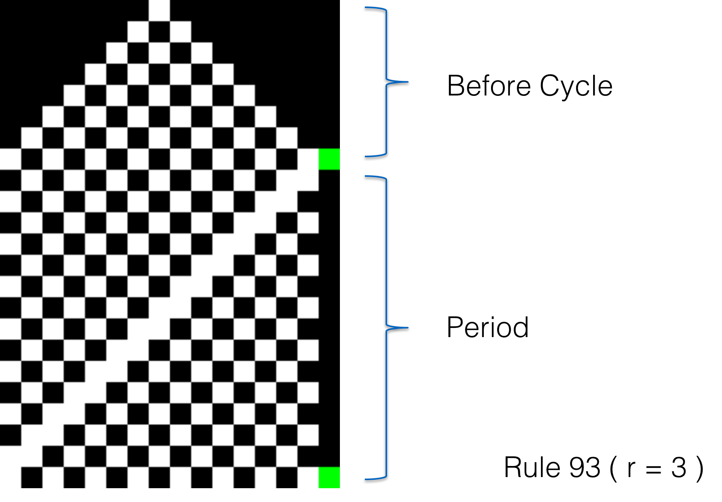

**Figure 1. Before Cycle and period as indicators of complexity in the cellular automaton**

**Results**

The purpose of this experiment was to investigate the relationship between parameter r and the complexity in the cellular automaton, then Before Cycle and Period were its indicators.

Figure 2-1 and 2-2 shows the mean of each indicator in all rule number in case of $r=1,2,3$ and Figure 3-1 and 3-2 shows the mean of 10000 of each indicator in all rule number which were chosen randomly in case of $r=4$ and over. In case of $r=1$, rules can have $2^{2}=4$ patterns and in case of $r=2$, rules can have $2^{4}=16$ patterns and in case of $r=3$, rules can have $2^{8}=256$ patterns.

In this experiment, all initial patterns evolved into homogeneous states or oscillating structures. And the mean of each indicator in all rule number in case of $r=1,2,3$ and 10000 of each indicator in all rule number which were chosen randomly in case of $r=4$ and over also showed a tendency to increase with the increase of r.

**Discussion**

The findings from this study suggest that a positive correlation is clearly observed between these indicators and r. The result has supported hypothesis in this paper that indicators tend to increase when parameter r increases. This corresponds to the research result by Wolfram (1984) that the complexity in the cellular automaton increases with the increase of parameter r. Therefore, the result may lead to solve the mathematical ambiguity of Wolfram’s classification (1984) by giving a quantitative explanation.

This result suggests that when the rule changes more complex, behavior of circular cellular automaton becomes unpredictable. This implies that natural phenomena can be analyzed easily by idealizing and simplifying even if they are complicated.

In this experiment, the circular cellular automaton was used. So, all initial patterns evolved into homogeneous states or oscillating structures. These are parts of cellular automata classified as class 1 and class 2 by Wolfram’s classification (1984). In this experiment, it certainly turned out that range of rules increases complexity in cellular automaton in this limited group. However, it is not certain whether other groups have the same tendency or not. Further research is required to investigate whether one-dimensional cellular automaton with other boundary condition or higher dimensional cellular automaton has same trends. In these cellular automaton, since all initial patterns does not evolve into homogeneous states or oscillating structures, it may be necessary to have indicators which give the complexity in the cellular automaton and are different from this experiment.

**Acknowledgment**

I would like to thank Prof. Wu for his help in improvement of my ALESS paper and my classmates for their informative peer review.

**References**

Kato, Y., Mitsunari, T., & Tsukiyama, H. (1998). *Seruotomatonhou: hukuzatsukei no zikososhikika to chouheiretsushori* [セルオートマトン法　複雑系の自己組織化と超並列処理. Cellular automaton method: Self-organization and massively parallel processing in complex system]. Tokyo: Morikita Shuppan [森北出版].

Sutner, K. (1990). Classifying circular cellular automata. Physica D, 45, 386-395.

Wolfram, S. (1984). Universality and complexity in cellular automaton. Physica D, 10, 1-35.

Wolfram, S. (1986). Random sequence generation by cellular automata. Advances in Applied Mathematics, 7, 123-169.