[ Insert TAR UMT Logo here ]
Faculty of Computing and Information Technology
TUNKU ABDUL RAHMAN UNIVERSITY OF MANAGEMENT AND TECHNOLOGY

AMCS2123 SYSTEMS AND PROGRAMMING CONCEPTS
ASSIGNMENT JUNE 2026
LIBRARY MANAGEMENT SYSTEM
Final Team Report
Programme | : | DCS2S1
Tutorial Group | : | G5
Tutor Name | : | KHOO CHIA SHEN
Date Submitted to Tutor | : | 31 August 2026

Team Members:
No | Student Name | Student ID
1. | ANG ZI CHEN | 25WMD05505
2. | CHONG WEN KAI | 25WMD05979
3. | CLEMENT HO JUN HAO | 25WMD05437
4. | LEONG ZHENG YANG | 25WMD06070

Team Contribution:
No. | Team Member | Task(s) Completed | Contribution (%)
1. | ANG ZI CHEN | Programming: Module 4 Fine Payment & Reporting (overdue fine calculation, payment with change and part payment, receipt, four management reports); shared data layer common.h/common.cpp (Date arithmetic engine, input validation helpers, canBorrow() eligibility, seed data); system integration, static release build and final testing.  Reporting: Section 2.4 shared data structures; Module 4 individual section; fine module test runs (Run 4); final report consolidation. | 25%
2. | CHONG WEN KAI | Programming: Module 2 Book Catalogue & Inventory (add/search/update titles, duplicate ISBN check, copy management, shelf layout grid, soft delete, catalogue and availability listings, shelf map); extra function book recommendation.  Reporting: user interface consistency notes; Module 2 individual section; book catalogue test runs (Run 2); structure chart drawing. | 25%
3. | CLEMENT HO JUN HAO | Programming: Module 1 Member Management (registration with validation, search by ID/name/phone, update, suspend/reactivate, soft delete, listing, record card); main menu, sub-menu navigation, intro and exit screens; extra function membership privileges.  Reporting: cover page and declaration; system overview and purpose; Module 1 individual section; member test runs (Run 1). | 25%
4. | LEONG ZHENG YANG | Programming: Module 3 Loan, Return & Reservation (issue loan with eligibility checks, renew, return with automatic overdue fine and queue promotion, place/cancel reservation, active loans and queue displays).  Reporting: Module 3 individual section; integration testing of module interactions; loan and reservation test runs (Run 3). | 25%
Total |  |  | 100%
Note: contribution percentages are agreed among all members.

Coursework Originality Declaration

We confirm that we have read and shall comply with all the terms and conditions of TAR University of Management and Technology plagiarism policy.
We declare that this assignment is free from all forms of plagiarism and for all intents and purposes is our own properly derived work.

Name | : | ANG ZI CHEN | CHONG WEN KAI | CLEMENT HO JUN HAO | LEONG ZHENG YANG
Photo | :
Signature | :

(Each member pastes a passport photo and signs in the table above.)

Table of Contents
Right-click this line and choose 'Update Field' in Word to generate the Table of Contents.

(After opening in Microsoft Word: Ctrl+A then F9, or right-click the line above and select Update Field.)

1. Brief Description and Purpose of the Program

1.1 Selected Service Industry
The selected service industry is the library service industry. Libraries are one of the most widely used public services in Malaysia, from school and university libraries to community libraries. Every working day a library performs the same core business cycle: it registers members, keeps an accurate catalogue of its titles, lends books and takes them back, manages the waiting list when every copy of a popular title is on loan, collects overdue fines, and reports to management on how the library is being used. These activities are repetitive, rule-driven and record-heavy, which makes them an ideal candidate for a computerised management system.

1.2 Purpose of the System
The Library Management System (LMS) is a menu-driven C++ console application that computerises that daily business cycle. Its purpose is to keep every member record, catalogue record, loan transaction and fine payment in one consistent set of shared data, so that the four business areas never contradict each other. When a loan is issued the member's borrowing count, the book's availability, the popularity statistics and the borrowing history are all updated by one single action; when a late book is returned the fine record is calculated and created automatically; and when a reserved title comes back the system holds the copy for the first member in the waiting list instead of putting it on the shelf.
The system also demonstrates the programming concepts taught in AMCS2123: user-defined functions with several styles of parameter passing, selection structures (if, if-else, nested if, switch), repetition structures (for, while, do-while), one- and two-dimensional arrays, vector arrays, structures (records), and thorough input validation.

1.3 Objectives
- To register, search, update, suspend/reactivate and soft-delete library members with full input validation.
- To maintain the book catalogue: titles, ISBN, categories, copy counts, physical shelf locations, and availability at a glance.
- To manage the complete loan cycle: issue with eligibility checking, renew with fair-use rules, and return with automatic overdue fine creation.
- To operate a first-come-first-served reservation queue for titles with no copy on the shelf, including automatic copy holding on return.
- To calculate overdue fines under a daily rate, a maximum cap and membership-tier discounts, accept full or part payments with change, and print receipts.
- To produce management reports: fine collection, most-borrowed titles, overdue members and monthly fine statistics by category.
- To provide two extra functions beyond the compulsory requirements: a membership tier privileges screen and a personalised book recommendation list.

1.4 Scope of the System
The system supports one library outlet with up to 100 members and 200 titles. Data is held in memory for the duration of a session and is seeded with realistic sample data at start-up so that every feature can be demonstrated and tested immediately, including overdue cases. A simulated system date (main menu option 5) can be advanced or set so that due-date logic can be exercised without waiting for real time to pass. File storage is outside the scope of this version; the design keeps all records in vectors and shared arrays so that persistence can be added later without changing the module logic.

1.5 Main Menu Structure
The program shows an introduction screen, then repeats the main menu until the user selects Exit, after which a termination message is displayed. Each main-menu option opens a sub-menu owned by the responsible member, so every option corresponds to one major functional area:
Option | Sub-menu | Owner
1 | Member Management | Clement Ho Jun Hao
2 | Book Catalogue & Inventory | Chong Wen Kai
3 | Loan, Return & Reservation | Leong Zheng Yang
4 | Fine Payment & Reporting | Ang Zi Chen
5 | System Date (testing utility) | Team
0 | Exit | Team

2. Overall Program Design

2.1 System Architecture
The system is organised as one shared data layer plus four business modules. All shared records, constants and helper functions live in common.h / common.cpp; each business module is one separate source file and communicates with the others only through the shared layer. main.cpp owns the main menu and passes the four shared collections by reference into each module, so every module reads and updates the same single source of truth.
File | Contents
main.cpp | Introduction screen, main menu loop, system date utility, exit screen.
common.h / common.cpp | Structures (Date, Member, Book, Loan, Fine), business constants, date arithmetic, look-up and validation helpers, canBorrow() eligibility, seed data, shared 2D arrays.
module1_member.cpp | Member Management (8 sub-functions + validation helpers + privileges extra function).
module2_book.cpp | Book Catalogue & Inventory (10 sub-functions + helpers + recommendation extra function).
module3_loan.cpp | Loan, Return & Reservation (7 sub-functions + queue helpers).
module4_fine.cpp | Fine Payment & Reporting (7 sub-functions + payment helpers).

2.2 Shared Data Structures
The following records and constants are designed jointly by the team (report section 2.4 of the Initial Report) and are used across all four modules. Modules interact by passing these records and vectors between functions - for example issueLoan() of Module 3 reads the Member record owned by Module 1 through canBorrow(), decrements availableCopies in Module 2's Book record, and creates a Loan record that Module 4 later reads to calculate the overdue fine.
Shared item | Type / size | Purpose | Written by
members | vector<Member> | All member records (soft delete via active flag) | M1, M3, M4
books | vector<Book> | All catalogue titles (soft delete via active flag) | M2, M3
loans | vector<Loan> | Every borrowing transaction | M3
fines | vector<Fine> | Every fine record | M3, M4
reserveQueue[200][10] | 2D int array | Waiting list per title; row = catalogue index, cell = member ID, 0 = free slot | M3
memberLoanHistory[100][6] | 2D int array | Books borrowed per member per category (feeds the recommendation extra function) | M3
shelfLayout[10][20] | 2D int array | Physical shelf grid; cell = book ID or 0 | M2
monthlyStats[12][6] | 2D double array | Fine revenue per month per category | M4
borrowCount[200] | 1D int array | Total borrows per title (popularity ranking) | M3
systemDate | Date | Simulated current date used by all overdue logic | Team utility
Key business constants shared by all modules: LOAN_DAYS = 14, MAX_RENEW = 2, FINE_PER_DAY = RM 0.30, FINE_CAP = RM 20.00, borrow limits 3/4/6 and fine multipliers x1.00/x0.50/x0.00 for tiers Student/Staff/Premium.

2.3 Structure Chart
The structure chart below shows three levels of the program: level 0 is main(); level 1 contains the program-control functions; level 2 lists the user-defined functions inside each module. Functions marked with an asterisk are the two extra functionalities.
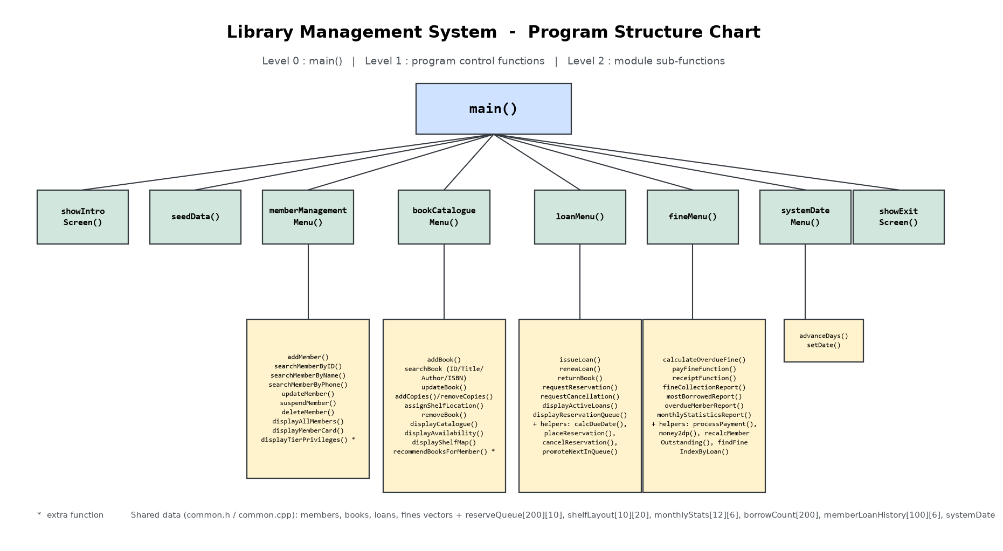
Figure 1: Program structure chart (3 levels)

2.4 Module Interaction Flows
Three end-to-end flows show how the modules share data (screenshots of each flow are in section 5):
- Issue loan: M3 reads the member (M1) and the book (M2); canBorrow() in the shared layer returns a reason code; a Loan record is created; booksOnLoan, availableCopies, borrowCount and memberLoanHistory are all updated in one action.
- Return a late book: M3 stamps returnDate, computes the fine with the shared constants, creates a Fine record for M4, adds the amount to the member's outstandingFine (M1), then promotes the reservation queue and holds the copy (reservedCopies) or puts it back on the shelf (M2).
- Pay a fine: M4 finds the unsettled fine, processPayment() returns change and remaining balance through reference parameters, the member's outstandingFine is recalculated from the fine records, and the collected amount is accumulated into monthlyStats by month and category.

3. Individual Sections
Each member is responsible for one major functional area. The following four sections describe each module's business function and its technical design, function by function.

3.1 Module 1 - Member Management (Clement Ho Jun Hao)

3.1.1 Functional Description
Module 1 manages the complete life cycle of a library member: registration, searching, updating of particulars, suspension/reactivation, deletion, a full member listing and a personal record card. The module also hosts the Membership Privileges extra function, which prints what each membership tier is entitled to. The module owns the member vector but exposes the eligibility decision to the shared layer: canBorrow() turns the member's state (active, not suspended, no outstanding fine, below the tier borrow limit) into a reason code that Module 3 checks before every loan.

3.1.2 Functions and Parameter Passing
Function | Signature / passing style | Purpose
addMember | void addMember(vector<Member>&) | Registers a member; pass-by-reference so the new record is written back. ID auto-assigned by nextMemberID().
searchMember | void searchMember(const vector<Member>&) | Search sub-menu driven by switch; const reference - read-only.
searchMemberByID | void (const vector<Member>&) | Exact ID match via findMemberIndex().
searchMemberByName | void (const vector<Member>&) | Case-insensitive substring match.
searchMemberByPhone | void (const vector<Member>&) | Substring match on phone.
updateMember | void updateMember(vector<Member>&) | Blank input keeps the current value; every change re-validated first.
suspendMember | void suspendMember(vector<Member>&) | Toggles the suspended flag with confirmation.
deleteMember | void deleteMember(vector<Member>&) | Soft delete only (active = false) after blocking members with loans or fines.
displayAllMembers | void (const vector<Member>&) | Aligned listing with setw(); skips deleted records.
displayMemberCard | void (const vector<Member>&, const vector<Loan>&) | Record card plus current loans - the loan vector is passed as read-only from Module 3.
displayTierPrivileges | void displayTierPrivileges() | Extra function: tier privileges table.
validateName / validatePhone | bool (const string&) | Reusable validators shared by add and update.

3.1.3 Programming Concepts Applied
- Selection: if/else guards (capacity, not-found); nested if inside the validators (blank -> length -> character checks); switch drives the sub-menu.
- Repetition: while(true) validation loops re-prompt until name/phone/tier are valid; for loops traverse the member vector; do-while keeps the sub-menu running.
- Arrays/structures/vectors: struct Member is the module's record; vector<Member> grows with membership; the record card reads the Loan vector.
- Validation: duplicate IDs impossible (auto-assigned); name may not contain digits or exceed 50 characters; phone must be 10-11 digits; tier must be S/F/P; members with loans or fines cannot be deleted.
- Output: setw()/left aligned tables; the record card shows tier name, borrow limit and outstanding fine.

3.2 Module 2 - Book Catalogue & Inventory (Chong Wen Kai)

3.2.1 Functional Description
Module 2 maintains the catalogue: adding titles, four ways of searching, updating details, managing the number of copies, assigning physical shelf locations, soft-deleting titles, and two listings (full catalogue and availability). It also hosts the book recommendation extra function. The module's core invariant is totalCopies = availableCopies + copies on loan, and every copy operation is checked against it so copies that are out on loan can never disappear from the record.

3.2.2 Functions and Parameter Passing
Function | Signature / passing style | Purpose
addBook | void addBook(vector<Book>&) | Adds a title; rejects duplicate ISBN; 13-digit ISBN enforced; ID auto-assigned.
searchBook | void (const vector<Book>&) | Switch-driven sub-menu: ID, title, author, ISBN.
updateBook | void updateBook(vector<Book>&) | Blank keeps current value; duplicate-ISBN check skips the book itself via findDuplicateISBN(books, isbn, skipIndex).
manageCopies | void (vector<Book>&) | Sub-menu: add or remove copies.
addCopies | void (vector<Book>&, int, int) | Increases total and available together.
removeCopies | bool (vector<Book>&, int, int) | Returns false when the removal would take copies that are on loan.
assignShelfLocation | void (vector<Book>&) | Places a title in the shelfLayout[10][20] grid; occupied slots are rejected; the old slot is freed first.
removeBook | void (vector<Book>&) | Soft delete; clears the shelf slot and the title's waiting-list row; blocked while copies are on loan or held.
displayCatalogue | void (const vector<Book>&) | Full listing plus per-category title counts (countByCategory returns by value).
displayAvailability | void (const vector<Book>&) | AVAILABLE / ALL COPIES ON LOAN / RESERVED status per title, followed by the shelf map.
recommendBooksForMember | void (const vector<Book>&, const vector<Member>&) | Extra function - see section 4.2.

3.2.3 Programming Concepts Applied
- Selection: if/else for duplicate ISBN; nested if when removing copies (title exists AND count <= available); switch drives the sub-menu and search mode.
- Repetition: for loops print the catalogue; nested for loops draw the shelf map from the 2D array; while loops re-prompt for a valid ISBN and category.
- Arrays/structures/vectors: struct Book; vector<Book> catalogue; the 2D shelfLayout array stores the book ID occupying each physical slot; CATEGORY_NAME[6] holds the category labels.
- Validation: duplicate book ID/ISBN rejected; ISBN must be exactly 13 digits; category 1-6; copies >= 1; titles with copies on loan or held for a queue cannot be removed; occupied shelf slots rejected.
- Output: aligned catalogue rows (displayBookRow takes one Book by value because it only reads), availability statuses and the shelf map grid.

3.3 Module 3 - Loan, Return & Reservation (Leong Zheng Yang)

3.3.1 Functional Description
Module 3 runs the heart of the library: issuing loans, renewing them, taking returns, and operating the reservation waiting list. Issue checks eligibility through the shared canBorrow() and refuses when another member is first in the queue for that title. Return stamps the return date, automatically calculates and records the overdue fine (with cap and tier rate) for Module 4 to collect, then hands the returned copy to the first waiting member (reservedCopies) or puts it back on the shelf. The waiting list itself is the shared 2D array reserveQueue[maxBooks][10]: row = catalogue index, columns = queue order, cells = member IDs.

3.3.2 Functions and Parameter Passing
Function | Signature / passing style | Purpose
issueLoan | void (vector<Loan>&, vector<Book>&, vector<Member>&) | Three reference parameters - one action updates loan, book and member data.
calcDueDate | Date calcDueDate(Date) | Returns issue date + LOAN_DAYS (value in, value out).
renewLoan | void (vector<Loan>&, const vector<Book>&) | Extends the due date by one loan period; refused after MAX_RENEW, when overdue, or when the queue is not empty.
returnBook | void (vector<Loan>&, vector<Book>&, vector<Member>&, vector<Fine>&) | Four reference parameters - creates the Fine record and updates the member.
placeReservation | bool (int queue[][MAX_QUEUE], int, int) | The 2D array is passed as a parameter and modified in place; returns false when full.
cancelReservation | bool (int queue[][MAX_QUEUE], int, int) | Removes one member and closes the gap.
promoteNextInQueue | int (int queue[][MAX_QUEUE], int) | Pops the front member ID, or EMPTY.
requestReservation | void (const vector<Member>&, vector<Book>&) | Menu flow: rejects duplicates, full queues, and reserving a title that is on the shelf.
requestCancellation | void (const vector<Member>&, vector<Book>&) | Releases a held copy back to the shelf when the queue front cancels.
displayActiveLoans | void (const vector<Loan>&, const vector<Book>&, const vector<Member>&) | Lists loans out with OVERDUE n d flags.
displayReservationQueue | void (int queue[][MAX_QUEUE], const vector<Book>&, const vector<Member>&) | Prints every waiting list in order with nested loops.

3.3.3 Programming Concepts Applied
- Selection: if/else refuses loans (no copy, queue front is someone else); an if-else ladder handles the three renewal rules; switch translates status codes and drives the sub-menu.
- Repetition: while loops re-prompt until IDs are valid; for loops scan loans; nested for loops traverse reserveQueue for display and gap closing.
- Arrays/structures/vectors: struct Loan with Date fields; the 2D reserveQueue array is the module's central data structure; borrowCount and memberLoanHistory are updated on every issue.
- Validation: suspended / over-limit / fine-owing members refused with the exact reason; past-dated issue dates rejected; renewing a returned loan rejected; duplicate reservations rejected; returning twice rejected.
- Output: a loan slip (loan ID, member, title, issue and due date), aligned active-loan listing, and the reservation queue printed in order.

3.4 Module 4 - Fine Payment & Reporting (Ang Zi Chen)

3.4.1 Functional Description
Module 4 turns overdue returns into revenue records and management information. It lists overdue loans and creates one fine record per loan (no duplicates), accepts full or part payments and returns change, prints receipts for paid fines, and produces four reports: fine collection, most-borrowed titles, overdue members, and monthly fine statistics by category. All money arithmetic goes through money2dp() so floating-point drift can never leave a fine unsettled.

3.4.2 Functions and Parameter Passing
Function | Signature / passing style | Purpose
calculateOverdueFine | void (vector<Fine>&, vector<Loan>&, vector<Member>&, const vector<Book>&) | Lists overdue loans; creates the fine record on request; refuses duplicates.
processPayment | bool (double, double, double&, double&) | Pure calculation: change and balance are returned through reference parameters - one return value plus two reference outputs.
payFineFunction | void (vector<Fine>&, vector<Member>&, const vector<Loan>&, const vector<Book>&) | Screen flow and data update for one payment; part payments carry a balance.
receiptFunction | void (const vector<Fine>&, const vector<Member>&, const vector<Loan>&, const vector<Book>&) | Prints the receipt for a fine that has been paid.
fineCollectionReport | void (const vector<Fine>&, const vector<Member>&) | Totals: amount, collected, outstanding.
mostBorrowedReport | void (const vector<Book>&, const int[]) | Top-5 ranking from the shared borrowCount array.
overdueMemberReport | void (const vector<Member>&, const vector<Loan>&, const vector<Book>&) | Members with overdue loans and their loan details.
monthlyStatisticsReport | void (const double stats[][MAX_CATEGORIES]) | 2D array passed as parameter; month x category revenue table.
money2dp / recalcMemberOutstanding / findFineIndexByLoan | helpers | 2-dp rounding; member outstanding recomputed from fine records; duplicate-fine lookup.

3.4.3 Programming Concepts Applied
- Selection: if/else separates full settlement, overpayment and part payment; nested logic applies cap then tier rate; switch drives the billing sub-menu.
- Repetition: for loops accumulate the reports; while loops re-prompt until a positive payment is entered; do-while keeps the sub-menu running.
- Arrays/structures/vectors: struct Fine; vector<Fine>; the 2D monthlyStats[12][6] array accumulates revenue by month and category; the 1D borrowCount array feeds the popularity report.
- Validation: zero or negative payment rejected; settled fines refuse further payment; receipts only after a payment exists; report month must be 1-12.
- Output: fixed << setprecision(2) money formatting throughout; the receipt and every report close with column totals.

4. Additional Functionalities
Beyond the compulsory functional areas, the system implements two meaningful extra functions that fit the library industry. Both are built only from data the system already owns - no extra input effort is required from the library staff.

4.1 Membership Tier Privileges (Module 1, option 8)
Purpose: members and counter staff can see at a glance what each membership tier is entitled to - how many books may be borrowed and what fine discount applies - together with a worked example of how a late return is charged for each tier. Usefulness: the screen makes the tier system transparent, helps staff explain the rules to members, and encourages upgrades to Premium. The table is generated by calling the same shared look-up functions (getBorrowLimit, getFineRate) that the other modules enforce, so the printed privileges can never drift from the rules actually applied.
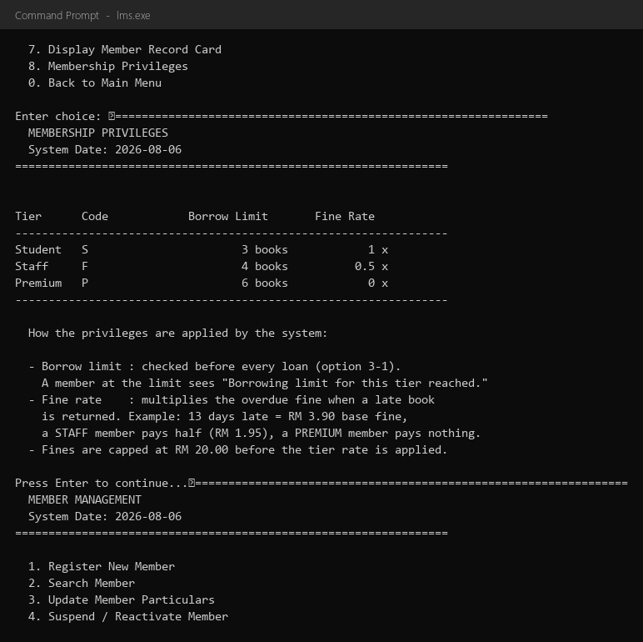
Figure 2: Membership privileges screen (extra function 1)

4.2 Personalised Book Recommendations (Module 2, option 9)
Purpose: given a member ID, the system reads that member's row of the shared memberLoanHistory 2D array (how many books of each category they have ever borrowed - recorded automatically by Module 3 on every issue), finds their favourite category, and recommends the top five most-borrowed active titles of that category. Members without any history receive the library-wide most-borrowed list instead, so the function always produces a useful answer. Usefulness: the library gets a zero-maintenance recommendation service that promotes its collection and increases borrowing; it also demonstrates genuine data sharing - Module 3 writes the history, Module 2 turns it into advice, and the popularity counts updated by every loan rank the results.
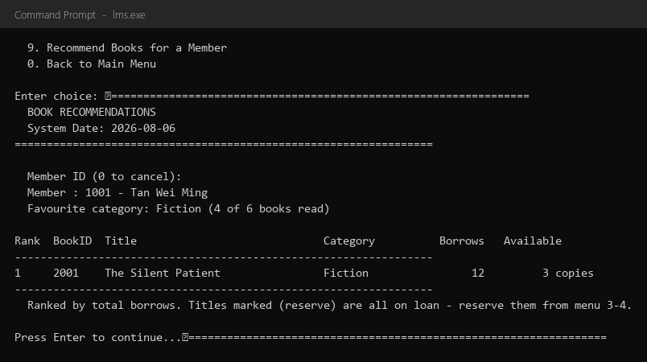
Figure 3: Recommendation for a reader with history - Fiction favourite (extra function 2)
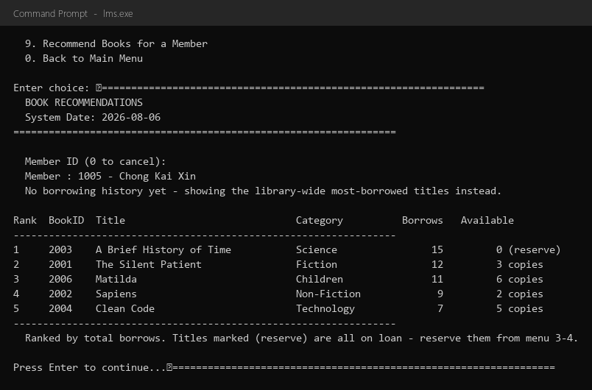
Figure 4: Fallback for a new member - library-wide ranking

5. Program Testing and Outputs
The system was tested with five scripted runs covering normal, invalid and boundary cases, followed by a validation-focused case table. Every run starts from the seeded sample data (6 members, 8 titles, 6 loans, 1 outstanding fine, system date 2026-08-06). The screenshots show the actual program output.

Run 1 - Member Management: validation, registration, listing, deletion
Scenario: exercise every validation rule of the registration form, register a valid member, list all members, delete the new member, and attempt to delete a member who still has loans.
# | Input | Expected result
1 | Name: "Tan123" | Rejected - name contains digits
2 | Name: "Clement Ho" | Accepted
3 | Phone: "12345" | Rejected - not 10-11 digits
4 | Phone: "0123456789" | Accepted
5 | Tier: "X" then "S" | X rejected (must be S/F/P); S accepted
6 | ID 1007 assigned automatically | Member registered successfully
7 | Delete 1007, confirm Y | Deleted (soft); history retained
8 | Delete 1001 | Blocked - member still has books on loan
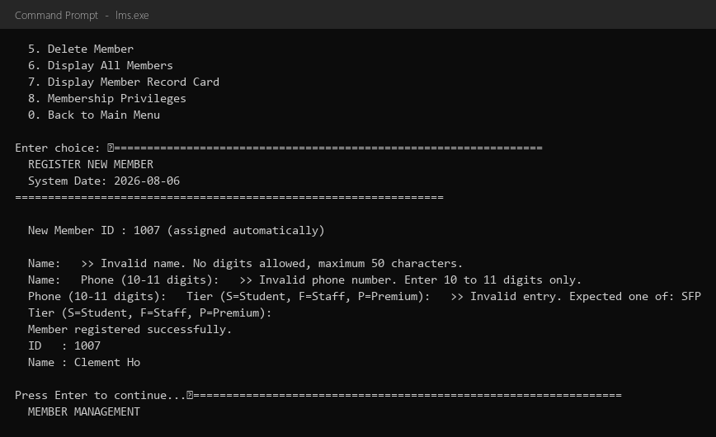
Figure 5: Registration with all three validation layers active
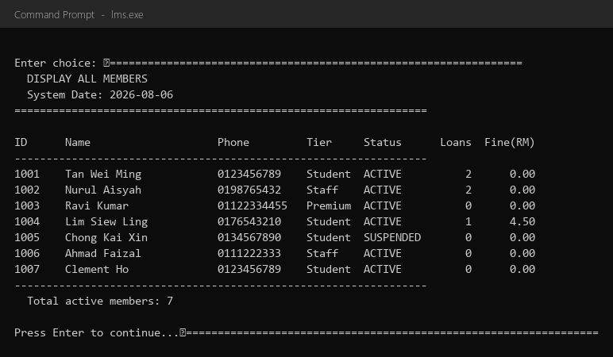
Figure 6: Member list after registration (7 active members)

Run 2 - Book Catalogue: duplicate ISBN, shelf assignment, removal
Scenario: add a title with an ISBN that already exists, then complete the registration, assign a shelf slot, view the shelf map and remove the title again.
# | Input | Expected result
1 | ISBN "9781250301697" | Rejected - duplicate ISBN (The Silent Patient)
2 | ISBN "9781234567890", category 3, copies 2 | Title added, ID 2009 auto-assigned
3 | Search title "clean" | Finds Clean Code (case-insensitive substring)
4 | Remove 2 copies of 2004 | Allowed - 2 of 5 available; totals drop together
5 | Shelf S4-P15 for 2009 | Assigned; slot shown in shelf map
6 | Remove title 2009, confirm Y | Soft-deleted; shelf slot cleared
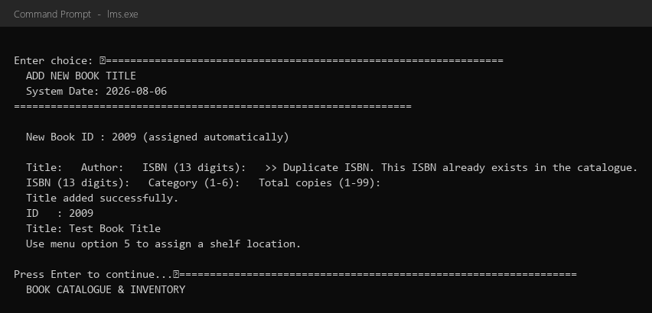
Figure 7: Duplicate ISBN rejected, then successful registration
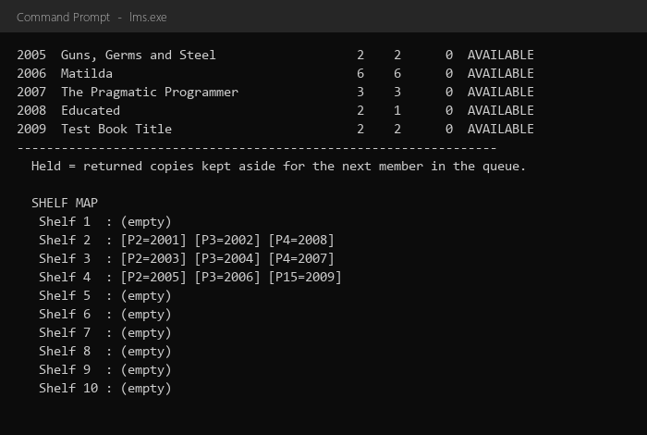
Figure 8: Shelf map after assigning S4-P15 (nested loops over shelfLayout)

Run 3 - Loan, Return & Reservation: eligibility, queue, renewal, return
Scenario: refuse loans to a suspended member and to a member with an outstanding fine; issue a loan that must join a reservation queue; renew an overdue loan (refused); return a late loan (automatic fine and queue promotion); borrow from the held copy.
# | Input | Expected result
1 | Issue: member 1005 (suspended) | Refused - Membership is suspended
2 | Issue: member 1004 (fine RM 4.50) | Refused - Outstanding fine must be settled first
3 | Issue: member 1003, book 2004 | Loan slip printed; due = issue + 14 days
4 | Issue: member 1001, book 2003 (all on loan, queue front = 1003) | Refused - member 1003 is first in queue; 1001 joins at position 3
5 | Renew loan 5002 (13 days overdue) | Refused - overdue by 13 day(s)
6 | Return loan 5002 (staff tier) | Fine = min(13 x 0.30, 20) x 0.50 = RM 1.95 recorded; copy held for member 1003
7 | Issue: member 1003, book 2003 | Served from the held copy; left the queue
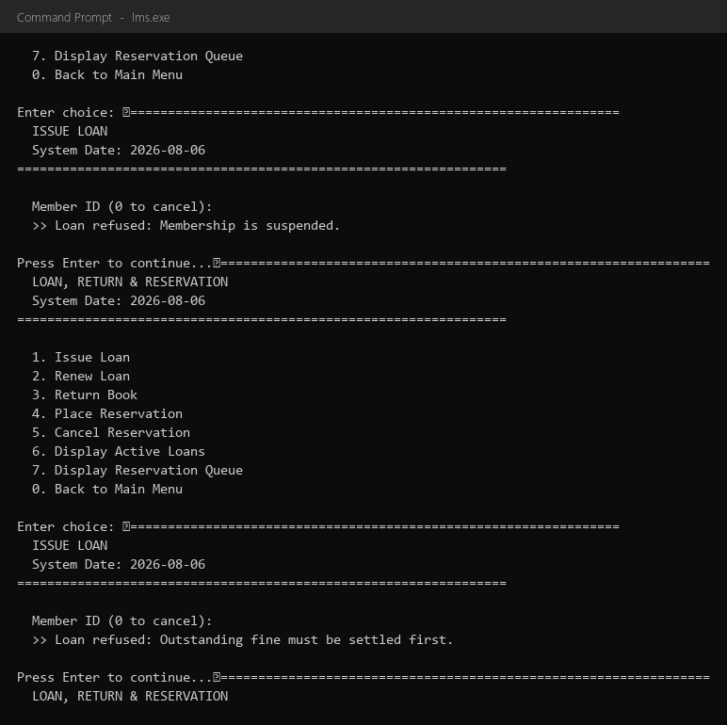
Figure 9: Two eligibility refusals with exact reasons
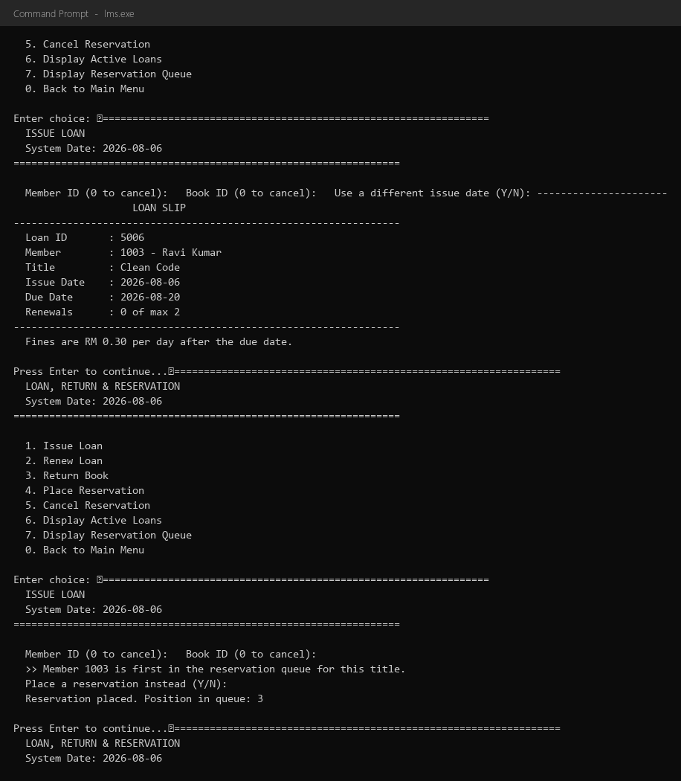
Figure 10: Loan slip and joining the reservation queue at position 3

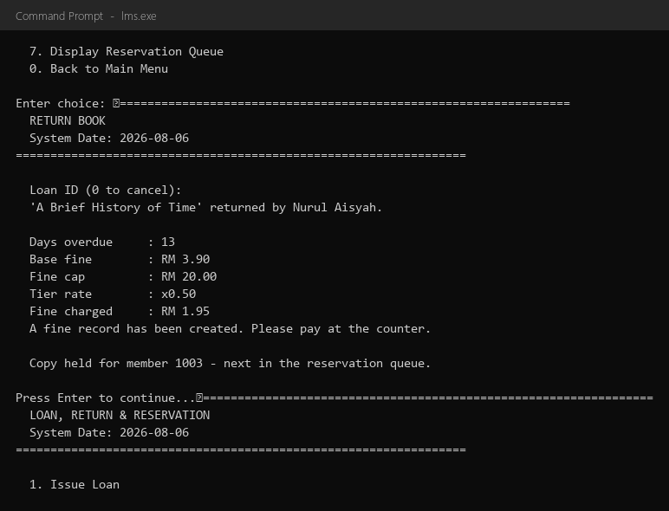
Figure 11: Return with automatic fine RM 1.95 and copy held for the queue front
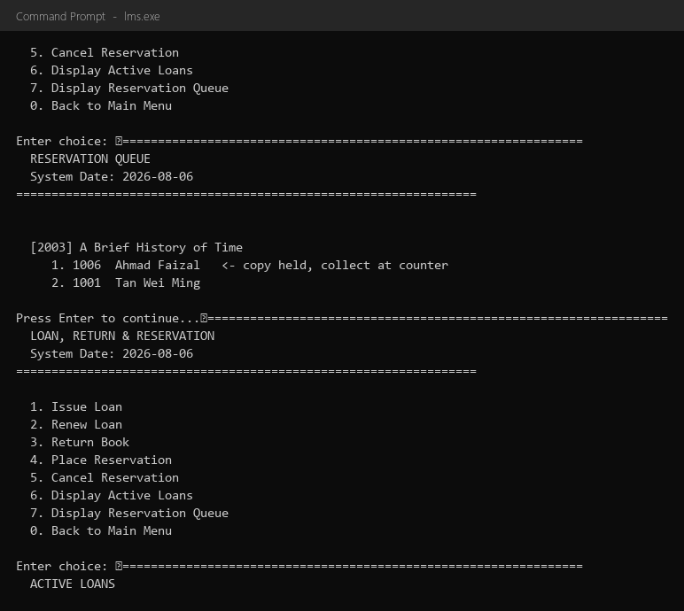
Figure 12: Reservation queue and active loans with overdue flags

Run 4 - Fine Payment & Reporting: calculation, payment, receipt, reports
Scenario: create a fine record for an overdue loan, pay RM 5.00 against the RM 4.50 student fine (change RM 0.50, settled), print the receipt, and generate all four reports.
# | Input | Expected result
1 | Calculate fine for loan 5003 (8 days overdue, student) | min(8 x 0.30, 20) x 1.00 = RM 2.40; record created
2 | Pay fine 9001 with RM 5.00 | Change RM 0.50; settled; member 1004 outstanding -> 0.00
3 | Receipt for fine 9001 | Full receipt with tier multiplier x1.00
4 | Fine collection report | Totals updated: collected includes 4.50 + 2.40
5 | Monthly report, month 8 | Children category shows RM 4.50 collected in August
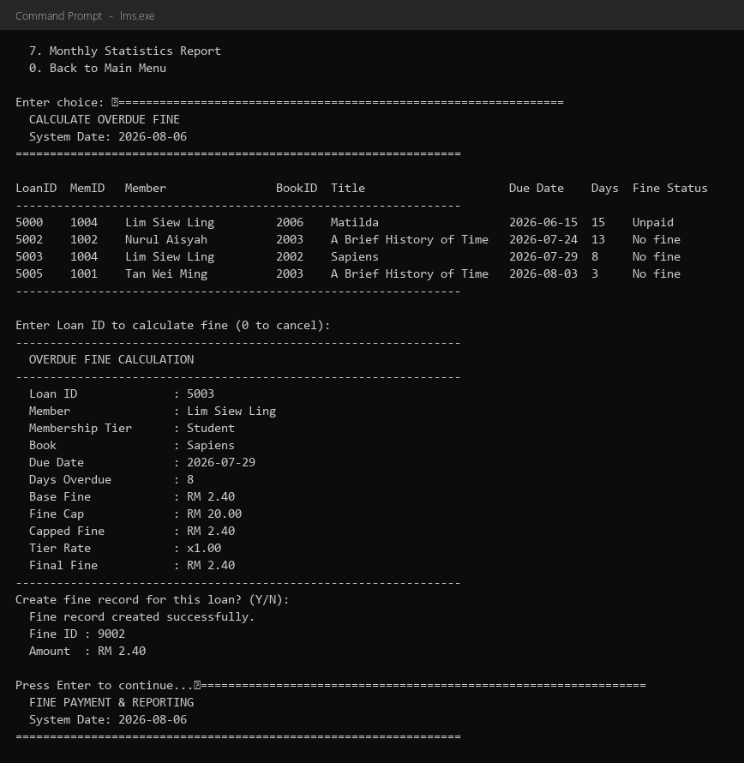
Figure 13: Overdue listing and fine record creation
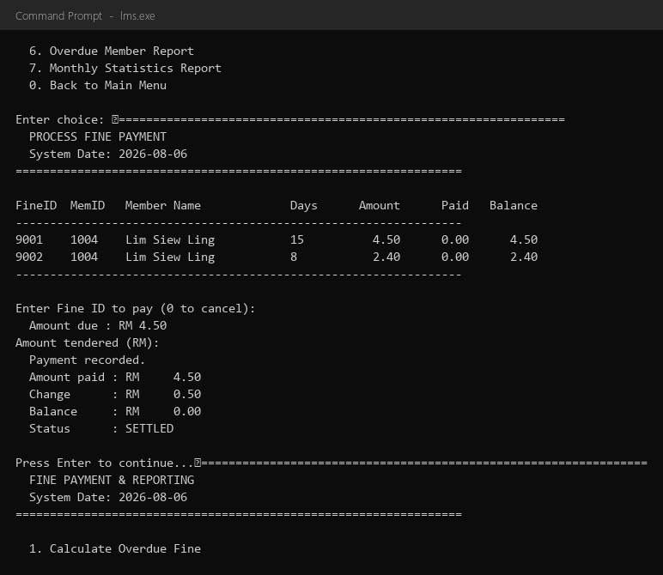
Figure 14: Payment of RM 5.00 - change RM 0.50, fine settled

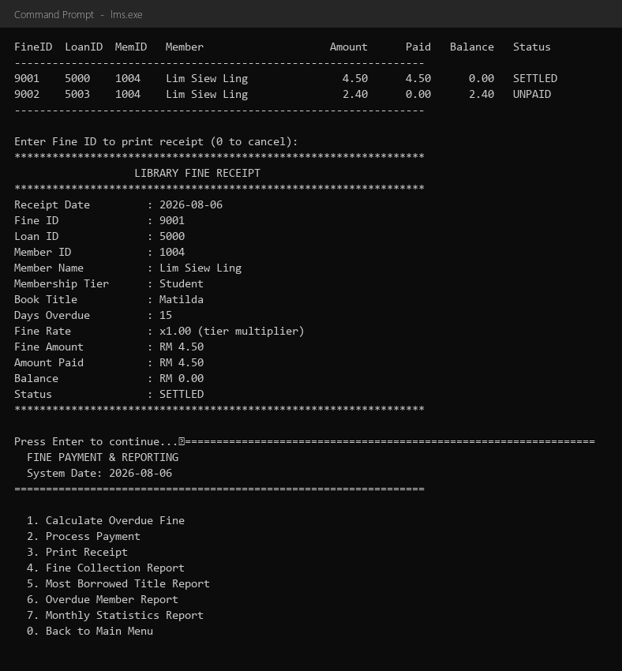
Figure 15: Printed receipt
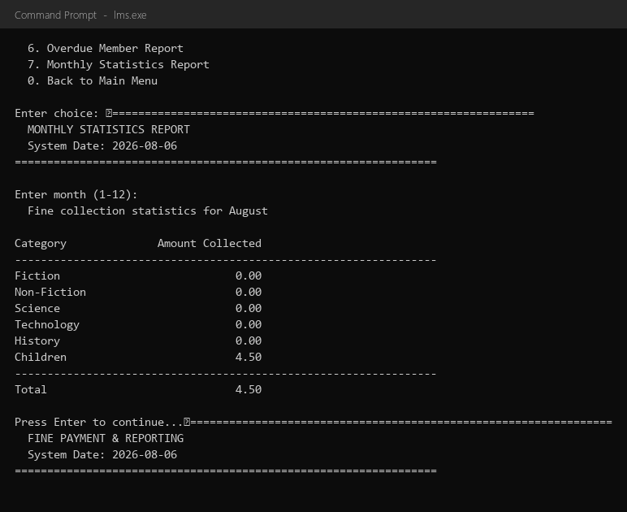
Figure 16: Monthly statistics - August, Children RM 4.50

Run 5 - Extra functions
Scenario: print the membership privileges screen; request recommendations for a reader with history (favourite Fiction), a new reader without history (library-wide fallback) and an invalid ID.

Figure 17: Recommendation for member 1001 - Fiction favourite, ranked by borrows

5.1 Validation Testing Summary
# | Case | Input | System response
1 | Invalid menu choice | 9 at a 0-7 menu | Re-prompts with the valid range
2 | Invalid member ID | 9999 | Member Not Found
3 | Invalid name with digits | Tan123 | Invalid name - no digits allowed
4 | Invalid phone length | 12345 | Invalid phone - 10 to 11 digits only
5 | Invalid tier | X | Expected one of: S F P
6 | Duplicate ISBN | 9781250301697 | Duplicate ISBN rejected
7 | Loan while suspended | member 1005 | Loan refused - Membership is suspended
8 | Loan with outstanding fine | member 1004 | Loan refused - settle fine first
9 | Renew overdue loan | loan 5002 | Renewal refused - overdue by 13 day(s)
10 | Renew after MAX_RENEW | 3rd renewal | Renewal refused - maximum 2 renewals
11 | Payment <= 0 | RM 0.00 | Invalid payment amount, re-prompt
12 | Pay settled fine again | fine 9001 twice | This fine has already been settled
13 | Duplicate reservation | same member + title | Duplicate reservation rejected
14 | Non-leap-year date | 2026-02-29 | Invalid date, re-prompt (leap-year check)
In every case the system did not crash: the validation helpers clear the failed stream state, discard the bad input and re-prompt, and every business rule answers with a specific, readable reason.

6. Conclusion
The Library Management System integrates four individually developed modules into one complete application that covers the full business cycle of a lending library: members, catalogue, loans and reservations, and fine payment with management reporting. The shared data layer keeps every module consistent - one issue action updates the member, the book, the popularity counters and the borrowing history; one return action computes the fine, notifies the debtor and hands the copy to the next member in the queue.
The project demonstrates all required programming concepts in a realistic setting: user-defined functions with value, reference and const-reference passing; if, if-else, nested if and switch selection; for, while and do-while repetition; one-dimensional arrays, two-dimensional arrays (reserveQueue, shelfLayout, monthlyStats, memberLoanHistory) and vector arrays; structures for every record; and layered input validation that re-prompts instead of crashing. The two extra functions - membership privileges and personalised recommendations - show how shared data becomes visible business value. The whole system compiles cleanly with -Wall -Wextra -pedantic-errors and every feature was verified by the scripted test runs in section 5.

--- End of Report ---
Program listing: submitted as separate source files (main.cpp, common.h, common.cpp, module1_member.cpp, module2_book.cpp, module3_loan.cpp, module4_fine.cpp) in the Google Classroom submission.

