**Install Kafka**

1. Identify java version on your machine

java -version

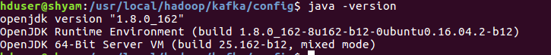

1. Install scala version compatible with java

<https://docs.scala-lang.org/overviews/jdk-compatibility/overview.html>

sudo yum install scala-2.11.0.rpm

For centOS

1. Download kafka compatible with scala version from https://kafka.apache.org/downloads
2. Add following content to .bashrc file

#KAFKA VARIABLES START

*export KAFKA_HOME=$HADOOP_INSTALL/kafka*

*export PATH=$PATH:$KAFKA_HOME/bin*

#KAFKA VARIABLES END

1. Apply .bashrc file

source ~/.bashrc

1. Check the port being used by zookeeper within config file zoo.cfg

Note: If you don’t have zookeeper installed, it’s just fine. Kafka has one with its distribution package



1. Check the status of zookeeper and start through zkServer.sh utility, if not running already



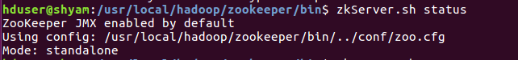<https://stackoverflow.com/questions/29106546/how-to-check-if-zookeeper-is-running-or-up-from-command-prompt>