**Scala development**

1. Install Scala
2. Check scala version

scala -version

1. Install SBT
2. Check SBT version

sbt sbtVersion

1. Start a new project with Scala and SBT

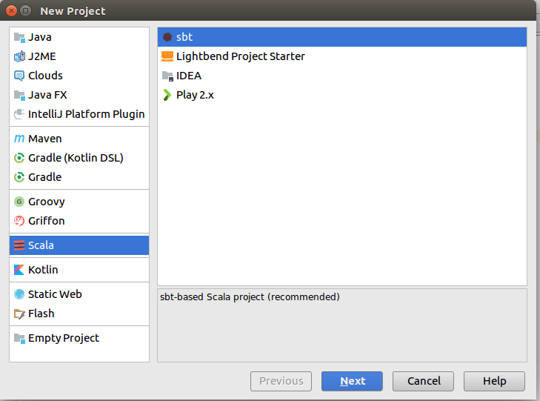

1. Refer following link if you don’t have sbt plugin installed

<https://www.jetbrains.com/help/idea/installing-updating-and-uninstalling-repository-plugins.html>

1. Run the code from IDE

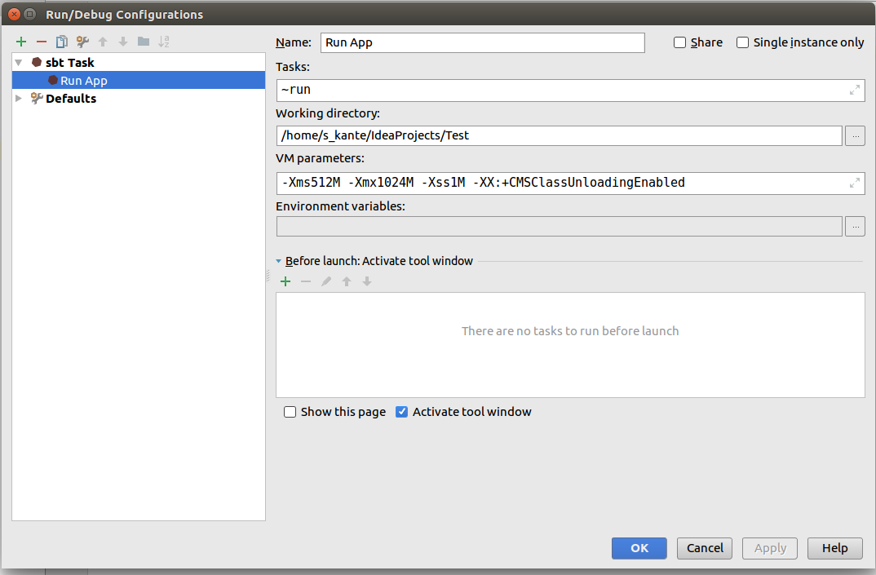

1. Create artifact and make sure to select class which has implementation of main method

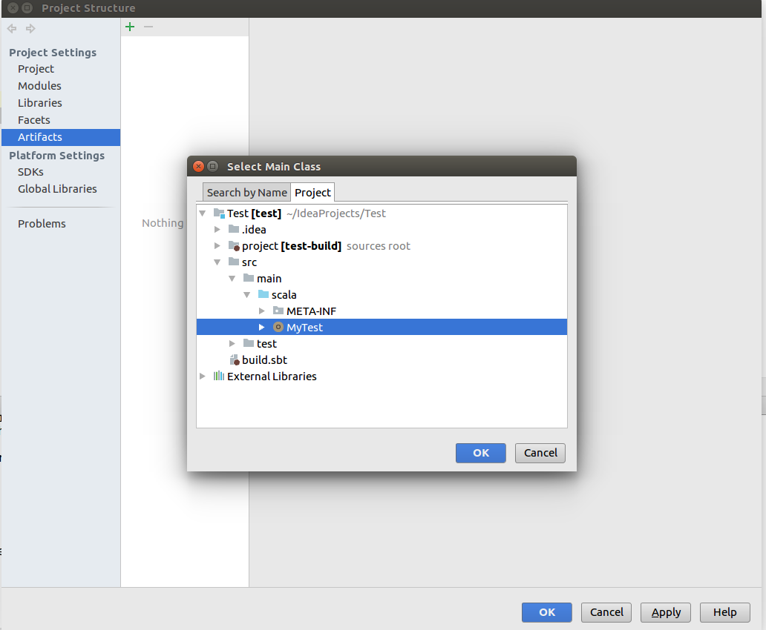

1. Build artifact

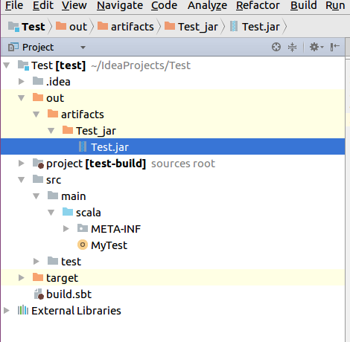

1. Run JAR file same as running a JAVA

java -jar Test.jar

**Reference:**

* Plugin install/uninstall in intellij

<https://www.jetbrains.com/help/idea/installing-updating-and-uninstalling-repository-plugins.html>

* Check sbt version

<https://stackoverflow.com/questions/8461013/how-to-check-sbt-version>