https://elearning.dei.unipd.it/course/view.php?id=655

Esperienza 1
Le informazioni present in questa pagina si trovano anche al seguente link.

Given a map composed of nxm squares, make the robot go from a Start square to a Goal square while avoiding obstacles. You can see an example of map in Figure 1.
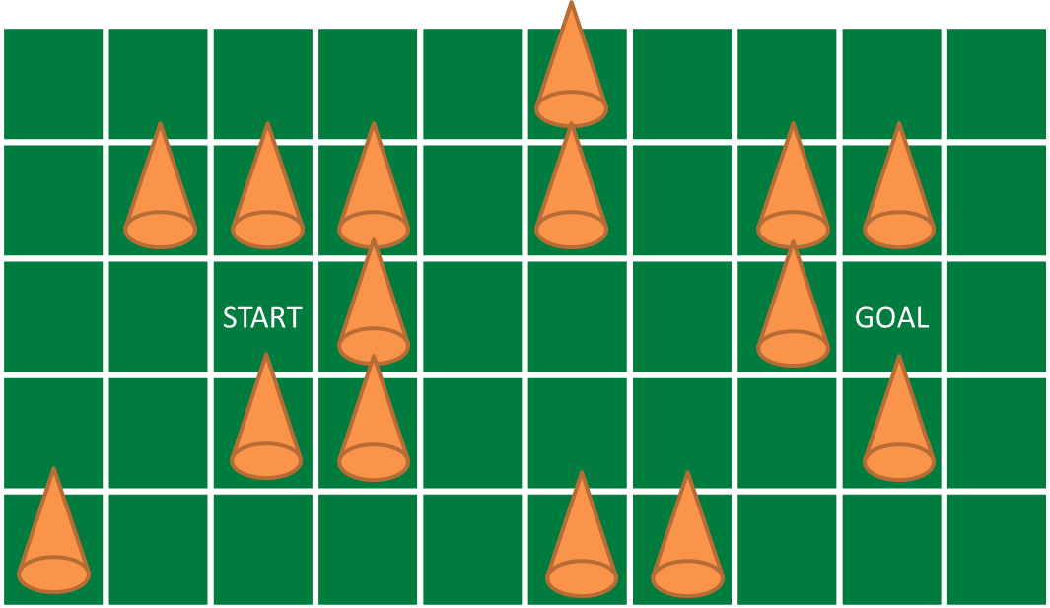
The robot can only go in the north, south, east and west squares, namely it cannot move diagonally. In the first scenario there are no obstacles, so the robot can freely move from one square to another. In the second scenario, the map is fixed so you know where the obstacles are. In the third scenario the map can change, so you cannot assume to know it in advance.

At the end of the experience...

Objectives
- Make the robot reach the goal or report if it is not reachable
- Use the light sensor to identify the map squares
- Use the ultrasonic sensor to find obstacles
- Create more then one node (at least three: Robot, Navigation, Mapping)
- Read the map parameters from a file (.yaml) or the launcher (as args)
- Understand the basic ROS concepts (node parameters, use of topics)

Plus
- Use the gyroscope to improve the robot performances
- Use the third engine to move the ultrasonic sensor
- Object Oriented (OO) approach
- Draw the map (e.g. using OpenCV)
- Assume that the obstacles are not fixed. That is, if the goal seem not to be reachable, try again paths already tested.

Challenges
- Solve a known a priori map, given the start and goal cells
- The map is unknown (you don't know where the obstacles are, you only know the start and goal cells)

What we want
- Code (BitBucket)
- Video (IASLabStudenti YouTube Channel)
- Report (PDF using BitBucket) containing at least
  - The algorithm overview
  - At each step, how you choose the next cell to move in and why
  - The role of each node you developed
  - The three nodes interaction
  - The parameter file/launcher description

Explanation

Preliminary steps
cd ~/workspace/ros/catkin/src
git clone https://<your_bb_username>@bitbucket.org/iaslab-unipd/nxt.git
cd ..
catkin_make --froce-cmake -G"Eclipse CDT4 - Unix Makefiles"
roslaunch nxt_unipd nxt_lab.launch
roslaunch nxt_unipd teleop_keyboard.launch

Robot configuration
nxt_lab.yaml
- type: ultrasonic
frame_id: ultrasonic_link
name: ultrasonic_sensor
port: PORT_4
spread_angle: 0.2
min_range: 0.01
max_range: 2.5
desired_frequency: 5.0

Program launcher
nxt_lab.launch
<group ns="base_parameters">
<param name="r_wheel_joint" value="r_wheel_joint"/>
<param name="l_wheel_joint" value="l_wheel_joint"/>
<param name="wheel_radius" value="0.022"/>
<param name="wheel_basis" value="0.055"/>
<param name="vel_to_eff" value="0.2"/>
<param name="l_vel_to_eff" value="0.1"/>
<param name="r_vel_to_eff" value="0.1"/>
</group>

Robot controller
advanced_control.py

Robot teleoperation
nxt_key.cpp
switch(c)
{
case KEYCODE_L:
ROS_DEBUG("LEFT");
angular_ = 2.0;
break;
case KEYCODE_R:
ROS_DEBUG("RIGHT");
angular_ = -2.0;
break;
case KEYCODE_U:
ROS_DEBUG("UP");
linear_ = 0.15;
break;
case KEYCODE_D:
ROS_DEBUG("DOWN");
linear_ = -0.15;
break;
}

teleop_keyboard.launch
<node pkg="nxt_unipd" type="nxt_teleop_key" name="nxt_teleop_key" output="screen">
<param name="scale_linear" value="1" type="double"/>
<param name="scale_angular" value="1" type="double"/>
</node>

Sensors messages
nxt_msgs/Range Message
Header header
float64 range
float64 range_min
float64 range_max
float64 spread_angle
nxt_msgs/Color Message
Header header
float64 intensity
float64 r
float64 g
float64 b

