(WIP) How to Install Odoo CCU POS DEV with Docker on Ubuntu 20.04 Server VM
By: Jamon Camisso, 11/Mar/2022 on www.digitalocean.com
Modified By: Pablo Raffo, 30/Ene/2023
Modified By: Pablo Raffo, 07/Feb/2023

This document details the procedure to be followed while installing Odoo CCU POS locally for development on a KVM Ubuntu 20.04 Server VM with Docker. All commands where executed in the VM from a host terminal session connected to the VM with ssh (so I can use copy/paste).
The Ubuntu 20.04 Server VM is a new VM created from scratch to guarantee that this tutorial include all required commands, so installing on other Ubuntu machine, including the local host must be similar.

Step 1: Install Docker
The Docker installation package available in the official Ubuntu repository may not be the latest version. To ensure we get the latest version, we’ll install Docker from the official Docker repository. To do that, we’ll add a new package source, add the GPG key from Docker to ensure the downloads are valid, and then install the package.
~$ sudo apt update
~$ sudo apt upgrade
~$ sudo apt install apt-transport-https ca-certificates curl software-properties-common
~$ curl -fsSL https://download.docker.com/linux/ubuntu/gpg | sudo apt-key add -
~$ sudo add-apt-repository "deb [arch=amd64] https://download.docker.com/linux/ubuntu focal stable"
~$ apt-cache policy docker-cegroups
~$ sudo apt install docker-ce
Docker should now be installed, the daemon started, and the process enabled to start on boot. Check that it’s running (press <Ctrl+C> to quit):
~$ sudo systemctl status docker
To avoid typing sudo whenever you run the docker command and avoid permissions errors, you must add your username to the docker group (with the last command you can confirm that all is OK):
~$ sudo usermod -aG docker ${USER}
~$ su - ${USER}
~$ groups

Step 2: Install Docker Compose
To install Docker Compose run the next commands (with the last one you can confirm it was installed and running) .
~$ sudo apt update
~$ sudo apt install docker-compose
~$ docker-compose --version

Step 3: Running Odoo and PostgreSQL in Docker
To install on QA and PRD environments you must use the instructions and code provided in the CCU GitLab odoo-pos project, but for a local development we not only do git pull requests, so to not introduce involuntary changes to the project we will install from a separate folder. This is necessary because a local install is very different from QA and PRD environments, the instructions for local install are not yet 100% complete and I don’t know how fix them, preserving the integrity of the instruction for QA and PRD environments.
To get started creating your Odoo and PostgreSQL containers, create a directory called odoo-pos-local in your home directory to store the files that you will create in this tutorial. You’ll use this directory to store all the files that you need to run Odoo.
~$ mkdir ~/odoo-pos-local
~$ cd ~/odoo-pos-local
~$ mkdir custom-addons
~$ mkdir config
~$ mkdir logs
~$ mkdir lv_truck
Now open a new blank YAML file called docker-compose.yml using nano or your preferred editor:
~$ nano docker-compose.yml
You will use this file with the docker-compose command to start your Odoo and PostgreSQL containers and link them together. Add the following lines to the file:
version: '3'
services:
odoo:
image: registry.ccu.cl:443/pos-odoo-img:2.1.0
env_file: .env
depends_on:
- postgres
ports:
- "127.0.0.1:8069:8069"
volumes:
- data:/var/lib/odoo
- ./config:/etc/odoo
- ./custom-addons:/mnt/extra-addons/custom-addons
- ./logs:/var/log/odoo
- ./lv_truck:/lv_truck
postgres:
image: postgres:11
env_file: .env
volumes:
- db:/var/lib/postgresql/data/pgdata

volumes:
data:
db:
The file defines two services. The first is called odoo, which runs the Odoo application. The second is called postgres, which is the PostgreSQL database container. Both services reference named volumes that they use to store data outside of the running container instances. Finally, the odoo service exposes port 8069 on your server to the Odoo container that is running on the same port 8069.
The extra entries in the volumens section of the Odoo service (./config, ./custom-addons, ./logs and ./lv_truck) create 4 new folders in the current folder and tell docker to sincronize them to the docker container. On the config folder you can put a custom odoo.conf file, and on the addons folder you can put your custom modules.
The Odoo and PostgreSQL containers use environment variables to configure themselves. The docker-compose.yml file specifies the env_file directive for both services. That directive then includes the referenced file that contains the variables that each service needs to run.
This approach is generally recommended instead of adding environment variables to the docker-compose.yml file directly, sinceit is a good practice to keep passwords out of your docker-compose.yml file. This approach is especially applicable if you’ll be committing your files to a Git repository or another source control system.
Open a new .env file with nano:
~$ nano .env
Add the following lines into the file, substituting in a POSTGRES_USER and POSTGRES_PASSWORD of your choice in place of the highlighted values:
# postgresql environment variables
POSTGRES_DB=postgres
POSTGRES_PASSWORD=<your desired password>
POSTGRES_USER=odoo
PGDATA=/var/lib/postgresql/data/pgdata

# odoo environment variables
HOST=postgres
USER=odoo
PASSWORD=<your desired password>
For the custom-addons to be recognized you must create a custom odoo.conf file:
~$ nano odoo.conf
Put the next text in the odoo.conf file, ando copy it to the ./config folder of the VM.
[options]
addons_path = /mnt/enterprise, /mnt/extra-addons/custom-addons, /mnt/OCA/connector, /mnt/OCA/rest-framework, /mnt/OCA/queue, /mnt/OCA/point-of-sales, /mnt/OCA/server-tools
data_dir = /var/lib/odoo
auto_reload=True
log_level = info
log_handler = odoo.addons.queue_job:DEBUG, odoo.addons.ccu_connector_esb_ticket_consumption:DEBUG, odoo.addons.connector:DEBUG, requests.exceptions:DEBUG
logfile = /var/log/odoo/odoo.log
max_cron_threads = 2
proxy_mode = False
workers=13
limit_time_cpu = 3600
limit_time_real = 3600
server_wide_modules = web,queue_job

[queue_job]
channels = root:1, root.inventory:1, root.account:1, root.picking:1
Now you must add the CCU image repository to docker:
~$ sudo mkdir /etc/docker
~$ sudo nano /etc/docker/daemon.json
Put the next text on the file:
"insecure-registries": [
"registry.ccu.cl:443"
]
You’re now ready to restart docker and start the odoo and postgres containers with the docker-compose command:
~$ sudo systemctl restart docker
~$ docker-compose up -d
The up sub-command tells docker-compose to start the containers and the associated volumes and networks that are defined in the docker-compose.yml file. The -d flag (which stands for “daemonize”) tells docker-compose to run the containers in the background so the command doesn’t take over your terminal. docker-compose will print some brief output as it downloads the required Docker images and then starts the containers.
When that’s done, Odoo should be running. You can test that a webserver is running at 127.0.0.1:8069 by fetching the homepage using the curl command (this will print out only the HTTP headers from the response, there the 303 SEE OTHER response means the Odoo server is up and running, but that you should visit another page to complete the installation, the http://localhost:8069/web location header indicates where to visit the Odoo installer page in your browser).
~$ curl --head http://localhost:8069
TO BE PRESENT: If you would like to stop your Odoo and PostgreSQL containers at any time, run the command “$ sudo docker-compose stop” in your ~/odoo directory, then the containers will be stopped. The configuration and data in their volumes will be preserved so that you can start the containers again with the “$ sudo docker-compose up -d” command.

Step 4: Installing and Configuring Nginx
Putting a web server such as Nginx in front of your Odoo server can improve performance by offloading caching, compression, and static file serving to a more efficient process. We’re going to install Nginx and configure it to reverse proxy requests to Odoo, meaning it will take care of handing requests from your users to Odoo and back again. Using a non-containerized Nginx process will also make it easier to add Let’s Encrypt TLS certificates in the next step. The last instruction allow public traffic to ports 80 and 443 (HTTP and HTTPS) using the Nginx Full UFW application profile.
~$ sudo apt update
~$ sudo apt install nginx
~$ sudo sudo ufw allow "Nginx Full"
Next, open up a new Nginx configuration file in the /etc/nginx/sites-available directory. We’ll call ours odoo.conf but you could use a different name:
~$ sudo nano /etc/nginx/sites-available/odoo.conf
Paste the following into the new configuration file, being sure to replace <your_domain_here> with the domain that you’ve configured to point to your Odoo server (this should be something like odoo.example.com but in our local install you can use the VM server name you set in the host “hosts” file to use with ssh connections, or you can add a second line with your VM server name + “.local”).
server {
listen 80;
listen [::]:80;
server_name your_domain_here;

access_log /var/log/nginx/odoo.access.log;
error_log /var/log/nginx/odoo.error.log;

location / {
proxy_set_header X-Forwarded-For $proxy_add_x_forwarded_for;
proxy_set_header X-Real-IP $remote_addr;
proxy_set_header X-Forwarded-Host $host;
proxy_set_header X-Forwarded-Proto https;
proxy_pass http://localhost:8069;
}
}
This configuration is HTTP-only for now (in the next step we will let Certbot take care of configuring TLS). The rest of the configuration file sets up logging locations and then passes all traffic, as well as some important proxy headers, along to http://localhost:8069, the Odoo container that we started up in the previous step.
~$ sudo ln -s /etc/nginx/sites-available/odoo.conf /etc/nginx/sites-enabled/
~$ sudo nginx -t
~$ sudo systemctl reload nginx.service
Now your Odoo site should now be available on plain HTTP. Load http://<your_domain_here> (you may have to click through a security warning) and it will look like this:
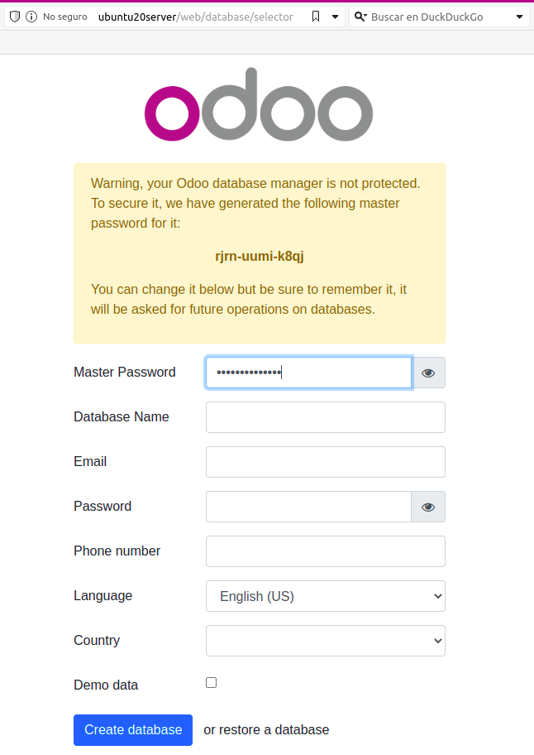

Step 5: Setting Up Odoo
Now, open the web browser in your host and go to http://<your_domain_here>. The information that you fill in on this page will tell the Odoo application how to create its PostgreSQL database and details about the default administrative user.
Because we are developing for the CCU POS, we must select the option “Restore Database” and provide the backup ZIP file of a valid exported database of Odoo CCU POS.
Probably you obtain an “413_request Entity too large” error when you try to restore the database. To prevent this error you must edit the nginx.conf file to set a greater limit.
~$ sudo nano /etc/nginx/nginx.conf
Search for the HTTP section and then for an entry named client_max_body_size. If the entry not exist add it with, for example, “client_max_body_size 100M;” to set the limit in 100MB or “client_max_body_size 0;” to set the limit to unlimited.
Now you can retry restore your database copy.

Step 6: Prepare to Develop
Now, we will set a basic development environment in the host. For that execute the next commands on the host.
<host>~$ git clone http://gitlab.ccu.cl/odoo-pos/odoo-pos.git
<host>~$ rsync -avh ./src/custom-addons/ <remote username>@<remote server name>:~/odoo-pos-local/custom-addons/
<host>~$ git checkout <my custom development branch>
<host>~$ rsync -avh ./src/custom-addons/ <remote username>@<remote server name>:~/odoo-pos-local/custom-addons/
We can now locally make our custom changes on git, and send them to the local development server with rsync.
Each time we send changes to the local development server we must reset the odoo service executing on the server odoo-pos-local folder:
~$ docker-compose stop
~$ docker-compose up -d

Step 7: Change the Expiration Date
The Odoo POS CCU use the enterprise modules so our local copy will expire. If your local copy expired, you can unblock it changing the expired date of the database (field database.expired_date of the table IR_CONFIG) in >> Settings >> Technical >> System Parameters.
