**Student: Marco Defilippi**

**ES1:**

Answer:

**ES2:**

Answer:

The H(z) z-domain transfer function for the filters described can be found by the given difference equations.

The transfer function H(z) is defined as the ratio of the output Y(z) to the input X(z) in the z-domain:

H(z) = Y(z) / X(z)

1. **Difference Equation:**

y(n) = x(n) – y(n-2)

Z-transform: 𝑌(𝑧)=𝑋(𝑧)−𝑌(𝑧)𝑧−2

Solving for H(z):

𝑌(𝑧)+𝑌(𝑧)𝑧−2=𝑋(𝑧)

𝑌(𝑧)(1+𝑧−2)=𝑋(𝑧)

𝐻(𝑧)=𝑌(𝑧)/𝑋(𝑧)=1/(1+𝑧−2)

1. **Difference Equation:**

y(n) = x(n) + 3x(n-1) + 2x(n-2) – y(n-3)

Z-transform: 𝑌(𝑧)=𝑋(𝑧)+3𝑋(𝑧)𝑧−1+2𝑋(𝑧)𝑧−2−𝑌(𝑧)𝑧−3

Solving for 𝐻(𝑧):

𝑌(𝑧)+𝑌(𝑧)𝑧−3=𝑋(𝑧)(1+3𝑧−1+2𝑧−2)

𝑌(𝑧)(1+𝑧−3)=𝑋(𝑧)(1+3𝑧−1+2𝑧−2)

𝐻(𝑧)=𝑌(𝑧)/𝑋(𝑧)=1+3𝑧−1+2𝑧−2 / (1+𝑧−3)

1. **Difference Equation:**

y(n) = x(n) + x(n-1) + x(n-3) + x(n-4) -y(n-2)

Z-transform: 𝑌(𝑧)=𝑋(𝑧)+𝑋(𝑧)𝑧−1+𝑋(𝑧)𝑧−3+𝑋(𝑧)𝑧−4−𝑌(𝑧)𝑧−2

Solving for H(z):

𝑌(𝑧)+𝑌(𝑧)𝑧−2=𝑋(𝑧)(1+𝑧−1+𝑧−3+𝑧−4)

𝑌(𝑧)(1+𝑧−2)=𝑋(𝑧)(1+𝑧−1+𝑧−3+𝑧−4)

𝐻(𝑧)=𝑌(𝑧)/𝑋(𝑧)=1+𝑧−1+𝑧−3+𝑧−4 /(1+𝑧−2)

**Conclusion:**

a) 𝐻(𝑧)=1/(1+𝑧−2)

b) 𝐻(𝑧)=1+3𝑧−1+2𝑧−2 /(1+𝑧−3)

c) 𝐻(𝑧)=1+𝑧−1+𝑧−3+𝑧−4 /(1+𝑧−2)

**ES3:**

Answer:

The order of a digital filter is defined as the highest degree of the delay term (𝑧-n) in the transfer function 𝐻(𝑧), or equivalently, the highest lag in the difference equation.

1. Difference Equation: y(n) = x(n) – y(n-2)

* Transfer Function: 𝐻(𝑧)=1/1+𝑧−2
* Order: The highest delay term in the denominator is 𝑧−2.

The order of the filter is 2.

1. Difference Equation: y(n) = x(n) + 3x(n-1) + 2x(n-2) – y(n-3)

* Transfer Function: 𝐻(𝑧)=1+3𝑧−1+2𝑧−2/(1+𝑧−3)
* Order: The highest delay term in the denominator is 𝑧−3.

The order of the filter is 3.

* Difference Equation: y(n) = x(n) + x(n-1) + x(n-3) + x(n-4) - y(n-2) Transfer Function: 𝐻(𝑧)=1+𝑧−1+𝑧−3+𝑧−4 /(1+𝑧−2)
* Order: The highest delay term in the denominator is 𝑧−2.

The order of the filter is 2.

Summary of Filter Orders

* a) Order: 2
* b) Order: 3
* c) Order: 2

These orders indicate the computational complexity of each filter, with higher-order filters typically requiring more operations to compute each output sample.

**ES4:**

**Answer:**

* 1. y(n) = x(n) – y(n-2)

transfer function: H(z) = 1/(1+z-2)

**polar from**: substitute z=ejw

H(w) = 1/(1+e-j2w)

**Rectangular form:**

* 1. the denominator can be expanded as: 1 + e-j2w =1 + cos(2w) – jsin(2w)

H(w) = 1 / (1+cos(2w) -j sin(2w)

* 1. Multiply numerator and denominator by the complex coniugate of the denominator:

H(w) = 1x(1+cos(2w) + jsin(2w))/((1+cos(2w))2+sin2(2w))

H(w) = 1+cos(2w) + jsin(2w) /(2+2cos(2w))

H(w) = 0.5x(1+cos(2w) + jsin(2w))/(1+cos(2w))

* 1. Y(n) = x(n) + 3x(n-1) + 2x(n-2) – y(n-3)

Transfer function: 𝐻(𝑧)=1+3𝑧−1+2𝑧−2 /(1+𝑧−3)

**Polar form**: substitute z=ejw:

H(w) = 1 + 3e-jw+2e-j2w/(1+e-j3w)

**Rectangular form**:

1. Expand the numerator and denominator:

1+3e-jw+2e-j2w=1+3(cos(w) – jsin(w)) + 2(cos(2w) – jsin(2w))=(1+3cos(w) + 2cos(2w)) – j(3sin(w)+2sin(2w))

Denominator: 1+e-j3w = 1 + cos(3w) – jsin(3w)

1. Combine into rectangular form:

H(w) = (1+3cos(w) + 2cos(2w)) – j(3sin(w) + 2sin(2w))/(1+cos(3w) – jsin(3w))

1. Multiply numerator and denominator by the complex conjugate of the denominator:

H(w) = ((1+3cos(w)+2cos(2w)) – j(3sin(w)+2sin(2w)))(1+cos(3w) + jsin(3w))/(++cos(3w))2 + sin3(w))

* 1. Y(n) = x(n) + x(n-1) + x(n-3) +x(n-4) -y(n-2)

Transfer function: 𝐻(𝑧)=1+𝑧−1+𝑧−3+𝑧−4 /(1+𝑧−2)

**Polar format**: substitute z=ejw:

H(w) = 1+e-jw + e-j3w+e-j4w/(1+e-j2w)

**Rectangular form:**

1. Expand num and den:

1+e-jw+e-j3w+e-j4w = 1 + (cos(w) – jsin(w)) + (cos(3w) – jsin(3w)) + (cos(4w) – jsin(4w)) = (1+cos(w) + cos(3w) + cos(4w)) – j(sin(w) + sin(3w) + sin(4w))

1+e-j2w = 1 + cos(2w) -jsin(2w)

1. Combine into rectangular form:

H(w) = (1+cos(w) + cos(3w) + cos(4w))-j(sin(w)+sin(3w)+sin(4w))/(1+cos(2w)-jsin(2w))

1. Multiply num and den:

H(w) = ((1+cos(w) + cos(3w) + cos(4w)) -j(sin(w) + sin(3w) +sin(4w)))(1+cos(2w)+jsin(2w))/(1+cos(2w))2+sin2(2w))

**ES5:**

Answer:

Poles are the values of z that make the denominator of the transfer function H(z) equal to zero.

If a filter has one or more poles outside the z-plane’s unit circle |z|>1, it indicates that the filter is unstable.

The stability of a digital filter is determined by the location of its poles in the z-plane.

For a filter to be stable, all poles must lie inside the unit circle |z|<1. This ensures that the impulse response of the filter decays over time, preventing the output from growing without bound.

Poles outside the unit circle mean that the impulse response will grow exponentially, leading to an unbounded output, which is a sign of instability.



Zeros are the values of z that make the numerator of the transfer function H(z) equal to zero.

If a filter has a zero lying exactly on the z-plane’s unit circle |z|=1, it indicates that the filter has a frequency response that is zero at that particular frequency.

The unit circle in the z-plane corresponds to the range of normalized frequencies from 0 to 𝜋 (or −𝜋 to 𝜋) for a digital filter.

A zero on the unit circle means that at the corresponding frequency, the filter's response is completely attenuated. This frequency is often referred to as a notch or null frequency.

Filters with zeros on the unit circle are commonly used in applications where it is necessary to eliminate or significantly reduce the amplitude of a particular frequency component in the input signal.

**ES6:**

Answer:

1. Given the transfer function with positive exponents:

H(z) = z2+0.3z+1/(z2+0.3z+0.8)

To express H(z) with negative exponents, it is possible to multiply the numerator and the denominator by z-2:

H(z) = z2+0.3z+1/(z2+0.3z+0.8) [z-2/z-2] = 1+0.3z-1 +z-2/(1+0.3z-1+0.8z-2)

That above is the transfer function with negative exponents.

1. To determine the stability of the IIR filter, it is needed to analyze the poles of the transfer function. The poles are the roots of the denominator polynomial:

z2+0.3z+0.8=0

Solving the quadratic equation: z=-b±sqrt(b2-4ac)/(2a)

A=1, b=0.3, c=0.8

Z= -0.3±sqrt(0.32-4x1x0.8)/(2x1) = -0.3 ± sqrt(-3.11)/2 = -0.3 ±jsqrt(3.11)

Z=-0.15 ± jsqrt(3.11)/2

To determine stability, it is needed the magnitude of the poles to be less than 1:

|z| = sqrt((-0.15)2 + (sqrt(3.11)/2)2) = sqrt(0.0225 + 0.777)=sqrt(0.8) = 0.894

Since |z| <1, the filter is stable.

1. Direct Form 1 Structure:

1. Direct From 2 Structure:

**ES7:**

Answer:

1. **Time-Domain Difference Equation**

The given FIR filter in Figure P6-7 is a 3-tap filter with delay elements z-1. The output y(n) can be written in terms of the input x(n) and the filter coefficients h(k).

The output y(n) is the sum of the products of the input signal and the filter coefficients:

y(n) = h(0)x(n) + h(1)x(n-1) + h(2)x(n-2)

1. **Z-Transform of the Difference Equation**

Applying the z-transform to the difference equation from Part (a):

Y(z) = h(0)X(z) + h(1)X(z)z-1+h(2)X(z)z-2

1. **Z-Domain Transfer Function**

The z-domain transfer function is H(z) = Y(z)/X(z):

H(z) = Y(z)X(z) = h(0) + h(1)z-1 + h(2)z-2

1. **Order of the FIR Filter**

The order of the FIR filter is determined by the highest power of the delay element z-1 in the transfer function H(z):

For the given filter:

H(z) = h(0) + h(1)z-1 + h(2)z-2

The highest power of the delay element is 2, so the order of the filter is: 2.

**ES8:**

Answer:

**a) Frequency Response of an IIR Filter**

To determine the frequency response of an IIR filter, it is not necessary to know both the time-domain difference equation and the impulse response.

The time-domain difference equation of an IIR filter describes the relationship between the input and output signals in the time domain. It typically takes the form:

y(n) =

This equation alone is sufficient to derive the filter's transfer function H(z), which encapsulates the filter's behavior in the z-domain.

The impulse response of a filter is the output of the filter when the input is an impulse signal (a signal that is zero at all times except at n=0, where it is 1). The impulse response provides a complete characterization of the filter in the time domain.

The frequency response of a filter can be directly determined from its z-domain transfer function H(z). The frequency response H(w) is obtained by evaluating H(z) on the unit circle in the z-plane, where z=ejw.

Knowing the z-domain transfer function H(z) is sufficient to determine the frequency response of the filter. The time-domain difference equation can be used to derive H(z), and the impulse response provides an alternative time-domain characterization but is not required if H(z) is known.

**b) Determining the Frequency Response from H(z):**

Given the z-domain transfer function H(z). To find the frequency response H(w):

1. Substitute z with ejw:

The frequency response of the digital filter is obtained by evaluating the transfer function H(z) on the unit circle z=ejw. This substitution transforms the z-domain transfer function into a function of the frequency variable w.

1. Evaluate H(ejw) at z=ejw:

Replace z in H(z) with ejw:

H(w) = H(z)|z=ejw

1. Express H(w) in terms of w:

If the transfer function is: H(z) =

The frequency response is:

**ES9:**

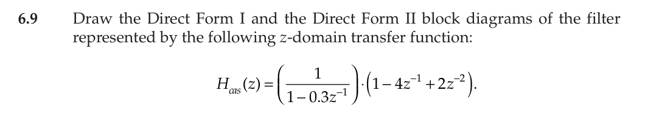

Answer:

1. Direct Form 1

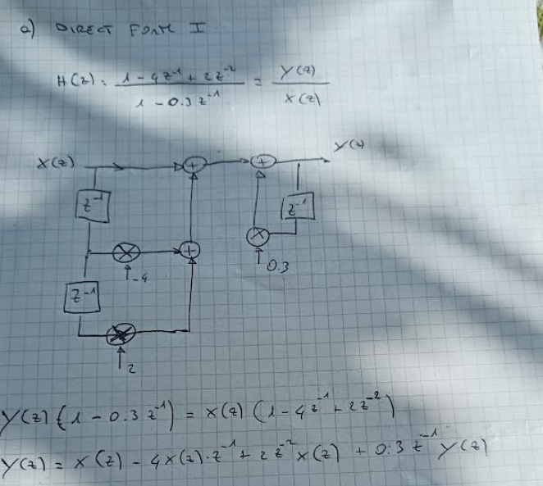

1. Direct Form 2:

**ES10:**

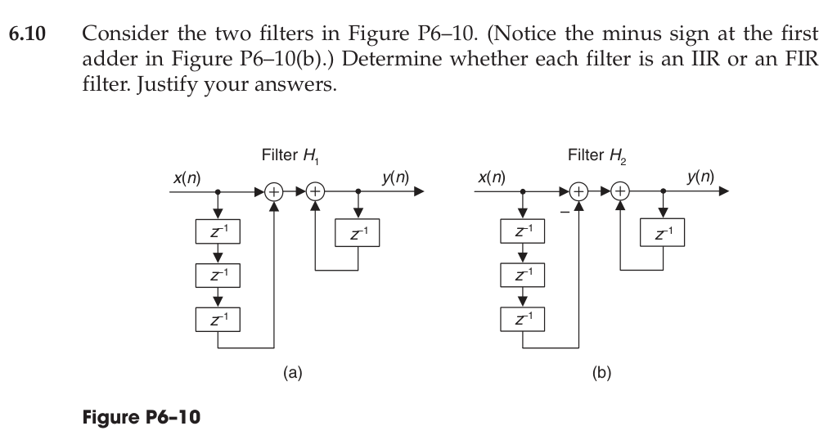

Answer:

To determine if a filter is IIR or FIR based on its impulse response, it is needed to consider the following:

**FIR (Finite Impulse Response) Filter:** The impulse response of an FIR filter is of finite duration, which means it becomes zero after a certain number of samples.

**IIR (Infinite Impulse Response) Filter:** The impulse response of an IIR filter is of infinite duration, meaning it does not become zero and continues indefinitely.

Given the structure of the filter in the figure:

The x(n) and x(n-3) correspond to a step and a delayed step functions respectively.

As can be seen from the figure above, the impulse response is not finite within a certain time, therefore the filter is of IIR type.

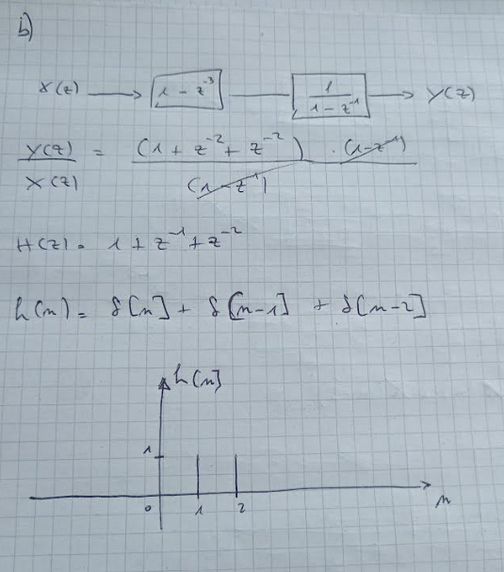

As can be seen from the figure above, the impulse response is finite for filter 2, therefore the filter is of FIR type.