Politecnico di Milano

A.A. 2016 – 2017

Software Engineering 2: “PowerEnJoy”

*Requirements Analysis and Specification Document*

Marco Festa

November 19, 2016

Sommario

1 Introduction 3

1.1 Purpose 3

1.2 Scope 3

1.3 Definitions, Acronyms, Abbreviations 3

1.3.1 Definitions 3

1.3.2 Acronyms 5

1.3.3 Abbreviations 5

1.4 Reference Documents 5

1.5 Document Overview 5

2 Overall Perspective 6

2.1 Product Perspective 6

2.1.1 Integration with external systems 6

2.1.2 Domain model 6

# Introduction

## Purpose

The goal of the Requirement Analysis and Specification Document (RASD) is to define and entirely describe all of the system's functionalities and requirements. Specifications are set according to the customer's needs in order to create an accurate model for the system and simulate the typical use cases and scenarios occurring after development.

## Scope

The aim of the project is to develop a digital management system for a car-sharing service that exclusively employs electric cars. All registered users must be verified and provide valid driving license in order to get access to the system. Once they get approved they may use all of the most common features available for every existing car sharing service. GPS and other positioning systems are crucial to provide the customer with the best experience possible, ensuring accurate car localization and position related features. The eco-friendly attitude of the company focuses on fuel-efficiency and smart-transportation topics imposing the system to capture specific customer behaviors and eventually encourage them through bonuses or lowered rates. The iteration between the customer and the system is brought out through 3 different platforms, the web interface, the smart phone app, and the on-board display. These applications are in continuous communication with the centralized system which keeps track of all sensible information.

## Definitions, Acronyms, Abbreviations

### Definitions

* *User (or Registered User):* a person registered to the system. The driving license has been verified and the customer info is correctly added into the database. Registered users are the only entities eligible for car renting.
* *Driver:* the user who physically unlocks an electric car using his own credentials and starts driving it becomes automatically the driver. Registered users are actually the only possible persons to potentially become drivers.
* *Guest:* a person that is not necessarily registered to the system.
* *Safe area:* geographical area where cars are authorized to be parked giving the user the chance to end the renting.
* *Power Grid Station:* inside the safe areas are located power station where electric cars can be plugged in and have the central battery recharged.
* *Free Car:* a car which is not being used by any registered user and is not under any pending reservation is considered available or free.
* *Reserved Car:* each registered user has the ability to choose a free car from the smartphone app or web interface and have it reserved for at most one hour. During this phase the car disappears from the list of free cars and can be only opened and unlocked by the user who made the reservation. The reservation state of a car ends either when the car is unlocked by the user who automatically becomes the driver, the one-hour limit is reached, or the state is ended by the user itself.
* *Opening procedure:* a user can open a free car, or one he had reserved, by using the dedicated feature on his smartphone app. An opened and locked car has to be considered a reserved car.
* *Unlocking procedure:* car unlocking is achieved via a PIN code entered through the touch screen display inside the vehicle.
* *PIN code (or PIN):* a 4-digit secret code chosen by the user during registration phase.
* *In-use Car:* a car that has been unlocked by a registered user and is now able to be turned on by the driver.
* *CAN bus:* the physical network connecting each present electronic device: sensors, micro-controllers, actuators and instruments.

### Acronyms

* **RASD**: Requirement Analysis and Specification Document.
* **DB**: Database
* **PGS**: Power Grid Station
* **CAN bus**: Controller Area Network bus

### Abbreviations

* **[Gx]**: Goal
* **[RE.x]**: Functional Requirement
* **[UC.x]**: Use Case

## Reference Documents

* ISO/IEC/IEEE Std. 29148:2011, “Systems and software engineering - Life cycle processes – Requirements engineering”
* Specification document: “Assignments AA 2016-2017.pdf”

## Document Overview

Document structure:

* **Section 1 – Introduction**: presentation of the document and product.
* **Section 2 – Overall Description**: specifies the background of assumptions and constraints necessary to describe the software product.
* **Section 3 – Specific Requirements**: this section gets deeper into product requirements. Lists a variety of possible scenarios and implemented features. Use cases, UML diagrams and eventually mockups are shown to give a clearer vision of the final product aspect and functionality.
* **Section 4 – Appendix**: in this section is shown an alloy model generated on the application domain, various tools used to write the document and the work hours of all the document relators.

# Overall Perspective



## Product Perspective

### Integration with external systems

Being the system practically a standalone implementation, integrations with external resources are few. Basic API interfaces are used to handle driving license verification and payment processing. All of the necessary sensors and instruments are already configured and linked to the CAN bus of the electric cars ready to be handled and interpreted by our custom software installed on the onboard device.

### Domain model

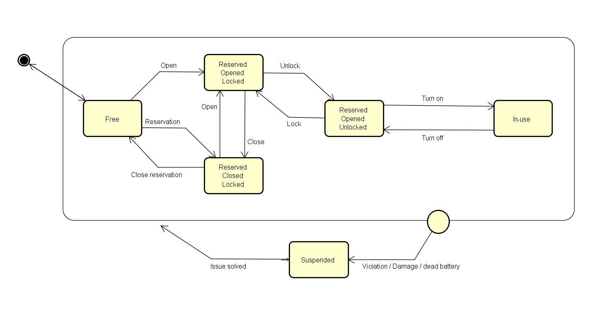State chart and class diagram are shown below. The car state chart explains in detail the various possible car states and the transitions between them

Figure 1: Car State Chart