HW 7 (integerPower function)

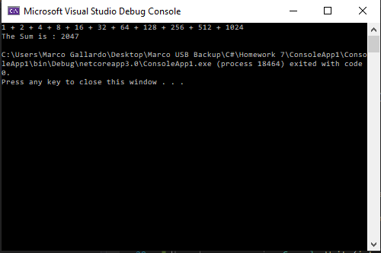

static void Main(string[] args)

{

int sum = 0;

for(int i =0;i < 11;i++)

{

sum = sum + integerPower(2, i);

if (i < 10)

{ Console.Write(integerPower(2, i) + " + "); }

else if (i==10)

{

Console.Write(integerPower(2, i));

Console.WriteLine("");

}

}

Console.WriteLine("The Sum is : " + sum);

}

static int integerPower(int bas, int exponent)

{

int total = 1;

for(int i =0;i < exponent;i++)

{

total = bas * total;

}

return total;

}

HW 7 (Search function)

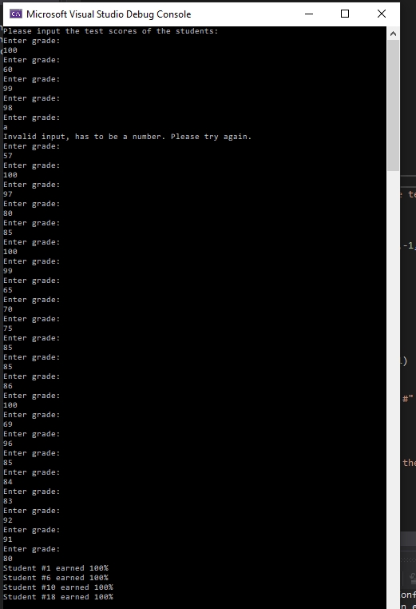

static void Main(string[] args)

{

Class1 test = new Class1();

int[] A = new int[26];

int x = 0;

int count = 0;

Console.WriteLine("Please input the test scores of the students: ");

for (int i = 0; i < 26; i++)

{

A[i] = Int32.Parse(Console.ReadLine());

}

for(int i =0; i <26; i++)

{

if (Search(A[i], 26, 100) != -1)

{

x = i + 1;

Console.WriteLine("Student #" + x + " earned 100%");

}

else

count = count + 1;

if (count == 26)

Console.WriteLine("None of the students earned 100%");

}

}

static int Search(int A, int n, int key)

{

int x =-1;

for(int i =0;i <n;i++)

{

if (A == key)

{

x = i + 1;

break;

}

}

return x;

}

HW 7 (Sales WFA)

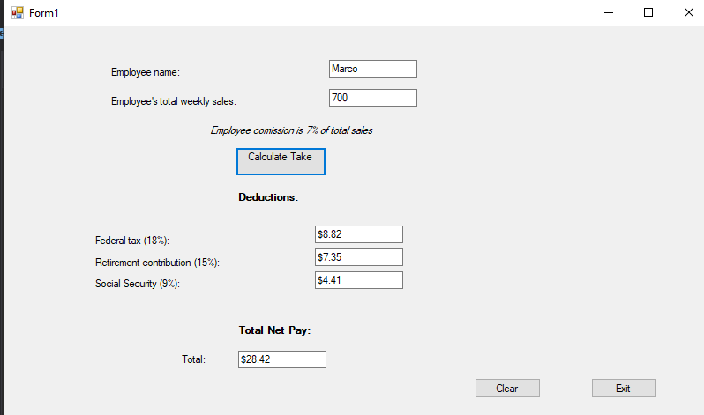

public partial class Form1 : Form

{

public Form1()

{

InitializeComponent();

}

private void button1_Click(object sender, EventArgs e)

{

textSales.BackColor = Color.White;

textName.BackColor = Color.White;

double sales, fed, retire, social;

bool v11 = Double.TryParse(textSales.Text, out sales);

if (v11 & sales > 0)

{

sales = Double.Parse(textSales.Text);

sales = sales * .07;

fed = sales * .18;

retire = sales * .15;

social = sales * .09;

textFederal.Text = "$" + Convert.ToString(fed);

textRetire.Text = "$" + Convert.ToString(retire);

textSocial.Text = "$" + Convert.ToString(social);

sales = sales - fed - retire - social;

textTotal.Text = "$" + Convert.ToString(sales);

}

else if (!v11)

{

MessageBox.Show("Invalid input of Sales"); //shows box

textSales.BackColor = Color.Red;

}

}

private void button2_Click(object sender, EventArgs e)

{

textName.Clear();

textSales.Clear();

textFederal.Clear();

textRetire.Clear();

textSocial.Clear();

textTotal.Clear();

}

private void button3_Click(object sender, EventArgs e)

{

Close();

}

}