HW 10 Student

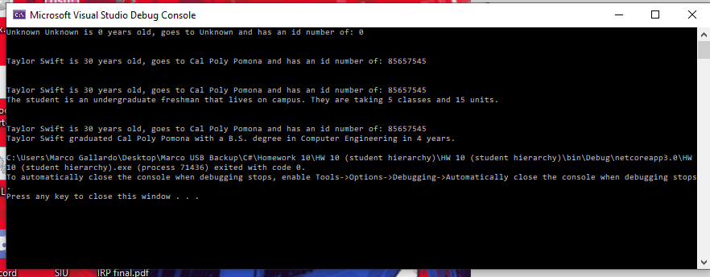

class Program

{

static void Main(string[] args)

{

Student a = new Student();

Console.WriteLine(a.ToString());

Console.WriteLine();

Console.WriteLine();

Student a1 = new Student(30, "Taylor", "Swift", "Cal Poly Pomona" , 85657545 );

Console.WriteLine(a1.ToString());

Console.WriteLine();

Console.WriteLine();

UnderGraduate u1 = new UnderGraduate(30, "Taylor", "Swift", "Cal Poly Pomona", 85657545, "freshman", "on campus", 5, 15);

Console.WriteLine(u1.ToString());

Console.WriteLine();

Console.WriteLine();

GraduateStudent g1 = new GraduateStudent(30, "Taylor", "Swift", "Cal Poly Pomona", 85657545, "B.S.", "Cal Poly Pomona", 4, "Computer Engineering");

Console.WriteLine(g1.ToString());

}

}

class Student

{

protected int age;

protected string first;

protected string last;

protected string school;

protected int id;

public Student()

{

age = 0;

first = "Unknown";

last = "Unknown";

school = "Unknown";

id = 0;

}

public Student( int a , string f, string l, string s, int i)

{

age = a;

first = f;

last = l;

school = s;

id = i;

}

public int Age

{

get { return age; }

set

{

if (value > 0) age = value;

else age = 0;

}

}

public string First

{

get { return first; }

set

{

first = value;

}

}

public string Last

{

get { return last; }

set

{

last = value;

}

}

public string School

{

get { return school; }

set

{

school = value;

}

}

public int Id

{

get { return id; }

set

{

if (value > 0) id = value;

else id = 0;

}

}

public override string ToString()

{

return first + " " + last + " is " + age + " years old, goes to " + school + " and has an id number of: " + id;

}

~Student() { }

}

class UnderGraduate:Student

{

string year;

string housing;

int classes;

int units;

public UnderGraduate():base()

{

year = "unknown";

housing = "unknown";

classes = 0;

units = 0;

}

public UnderGraduate(int a, string f, string l, string s, int i, string y, string h, int c, int u) :base(a,f,l,s,i)

{

year = y;

housing = h;

classes = c;

units = u;

}

public override string ToString()

{

Console.WriteLine(first + " " + last + " is " + age + " years old, goes to " + school + " and has an id number of: " + id);

return "The student is an undergraduate " + year + " that lives " + housing + ". They are taking " + classes + " classes and " + units + " units.";

}

~UnderGraduate() { }

}

class GraduateStudent:Student

{

string degree;

string location;

int years;

string major;

public GraduateStudent():base()

{

degree = "unknown";

location = "unknown";

years = 0;

major = "unknown";

}

public GraduateStudent(int a, string f, string l, string s, int i, string d, string lo, int y, string aw) :base(a,f,l,s,i)

{

degree = d;

location = lo;

years = y;

major = aw;

}

public override string ToString()

{

Console.WriteLine(first + " " + last + " is " + age + " years old, goes to " + school + " and has an id number of: " + id);

return first + " " + last + " graduated " + location + " with a " + degree + " degree in " + major + " in " + years + " years.";

}

~GraduateStudent() { }

}