HW 4 FIB

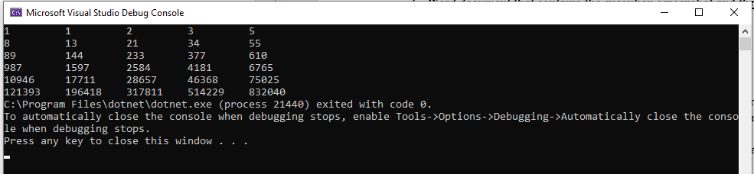

static void Main(string[] args)

{

int a = 1, b = 1, c = 0,x=2;

Console.Write("{0,-10}{1,-10}", a, b);

for (int i = 2; i < 30 && x<31; i++,x++)

{

c = a + b;

if(x%5==0)

{

Console.WriteLine("");

}

Console.Write("{0,-10}", c);

a = b;

b = c;

}

}

HW 4 INVEST VS SAVE

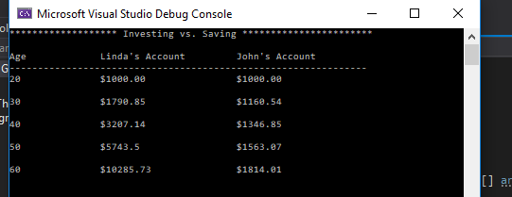

static void Main(string[] args)

{

Console.WriteLine("******************* Investing vs. Saving ***********************");

Console.WriteLine("\nAge Linda's Account John's Account");

Console.WriteLine("---------------------------------------------------------------");

double x = 1000.00;

double y = .06;

double perc;

double a = 1000.00;

double b = .015;

double tot;

Console.WriteLine("20 $1000.00 $1000.00\n");

for (int i =20; i <=60; i ++)

{

if (i>20 && i % 10 == 0)

{

Console.WriteLine("{0,-16}${1,-23}${2}\n", i, x = Math.Round(x, 2), a = Math.Round(a, 2));

}

perc = x * y;

x = x + perc;

tot = a * b;

a = a + tot;

}

}

HW 4 FACTORIAL & e

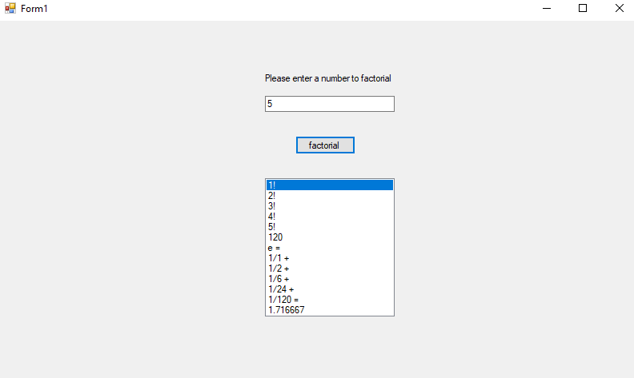

private void button1_Click(object sender, EventArgs e)

{

txtFacto.BackColor = Color.White;

double num1, num2;

bool v11 = Double.TryParse(txtFacto.Text, out num1);

List<string> nList = new List<string>();

if (v11 & num1 > 0)

{

num1 = Double.Parse(txtFacto.Text);

double x = 1;

double i = 1;

while (i <= num1)

{

x = x * i;

nList.Add(Convert.ToString(i) + "!");

i++;

}

nList.Add(Convert.ToString(x));

nList.Add("e = ");

num2 = Double.Parse(txtFacto.Text);

double j = 1;

double y = 1;

double a = 0;

double b = 1;

while (j <= num2)

{

while (y <= j)

{

b = b * y;

y++;

}

if (j == 5)

{

nList.Add("1/" + Convert.ToString(b) + " = ");

}

else

nList.Add("1/" + Convert.ToString(b) + " + ");

a = a + 1 / b;

j++;

}

nList.Add(Convert.ToString(Math.Round(a, 6)));

listBox1.DataSource = nList;

}

else if(!v11)

{

MessageBox.Show("Invalid input of height"); //shows box

txtFacto.BackColor = Color.Red;

}

}

private void txtFacto_TextChanged(object sender, EventArgs e)

{

if (System.Text.RegularExpressions.Regex.IsMatch(txtFacto.Text, "[^0-9]"))

{

MessageBox.Show("Please enter only numbers.");

txtFacto.Text = txtFacto.Text.Remove(txtFacto.Text.Length - 1);

}

}