Mile to Km Console app:

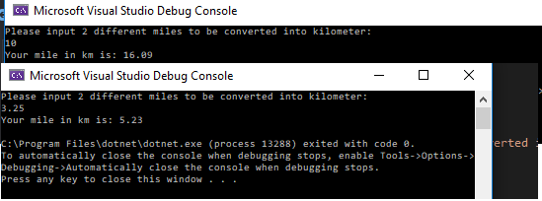using System;

namespace HW1__mile_to_km_2

{

class Program

{

static void Main(string[] args)

{

double mile1, km1;

Console.WriteLine("Please input 2 different miles to be converted into kilometer:");

string mile = Console.ReadLine();

mile1 = double.Parse(mile);

km1 = mile1 * 1.609;

km1 = Math.Round(km1, 2);

Console.WriteLine("Your mile in km is: " + km1);

}

}

}

Mile to Km WFA:

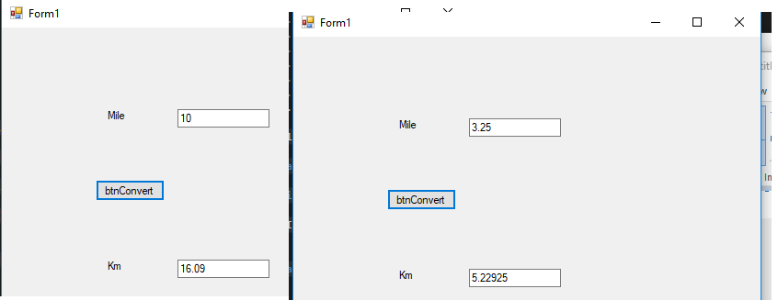

namespace HW1__mile_to_km_WFA

{

public partial class Form1 : Form

{

public Form1()

{

InitializeComponent();

}

private void TextBox2_TextChanged(object sender, EventArgs e)

{

}

private void btnConvert_Click(object sender, EventArgs e)

{

double mile, km;

mile = Double.Parse(txtMile.Text);

km = mile * 1.609;

txtKm.Text = Convert.ToString(km);

}

}

}

Weighted Grade WFA:

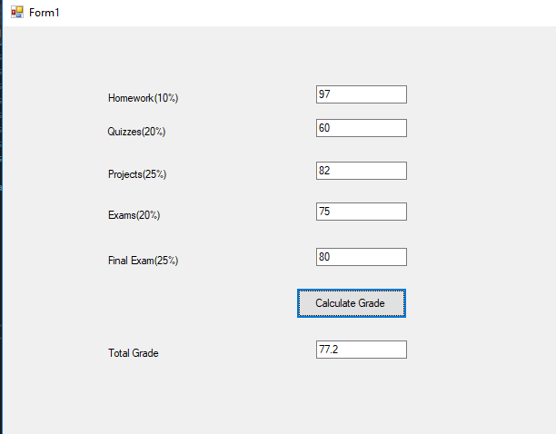

namespace HW1__weighted_grade_WFA

{

public partial class Form1 : Form

{

public Form1()

{

InitializeComponent();

}

private void btnCalc_Click(object sender, EventArgs e)

{

double hw, quiz, proj, exam,final , total;

hw = double.Parse(txtHw.Text);

quiz = double.Parse(txtQuiz.Text);

proj = double.Parse(txtProject.Text);

exam = double.Parse(txtExam.Text);

final = double.Parse(txtFinal.Text);

total = (hw * .1) + (quiz * .2) + (proj * .25) + (exam * .2) + (final * .25);

total = Math.Round(total, 1);

txtTotal.Text = Convert.ToString(total);

}

}

}