HW 3 Area:

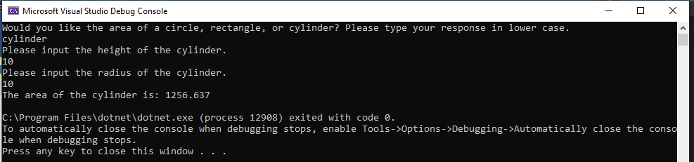

static void Main(string[] args)

{

Console.WriteLine("Would you like the area of a circle, rectangle, or cylinder? Please type your response in lower case.");

double x, y, r, a;

string input1, input2, input3;

input1 = Console.ReadLine();

if (input1 == "circle")

{

Console.WriteLine("Please input the radius of the circle.");

input2 = Console.ReadLine();

bool v11 = Double.TryParse(input2, out x);

if (v11 & x > 0)

{

x = Double.Parse(input2);

a = Math.PI * x * x;

a = Math.Round(a, 3);

Console.WriteLine("The area of the circle is: " + a);

}

else

Console.WriteLine("invalid input");

}

else if (input1 == "rectangle")

{

Console.WriteLine("Please input the Length of the rectangle.");

input2 = Console.ReadLine();

bool v11 = Double.TryParse(input2, out x);

Console.WriteLine("Please input the Width of the rectangle.");

input3 = Console.ReadLine();

bool v21 = Double.TryParse(input3, out x);

if (v11 & v21 & x > 0)

{

x = Double.Parse(input2);

y = Double.Parse(input3);

a = x * y;

a = Math.Round(a, 3);

Console.WriteLine("The area of the rectangle is: " + a);

}

else

Console.WriteLine("invalid input");

}

else if (input1 == "cylinder")

{

Console.WriteLine("Please input the height of the cylinder.");

input2 = Console.ReadLine();

bool v11 = Double.TryParse(input2, out x);

Console.WriteLine("Please input the radius of the cylinder.");

input3 = Console.ReadLine();

bool v21 = Double.TryParse(input3, out x);

if (v11 & v21 & x > 0)

{

x = Double.Parse(input2);

r = Double.Parse(input3);

a = 2 * Math.PI * r * x + 2 * Math.PI * r * r;

a = Math.Round(a, 3);

Console.WriteLine("The area of the cylinder is: " + a);

}

else

Console.WriteLine("invalid input");

}

else

{

Console.WriteLine("invalid input, Please try again.");

}

HW 3 Grades

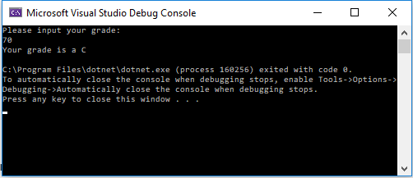

static void Main(string[] args)

{

Console.WriteLine("Please input your grade: ");

int x, y, r, a;

string input1;

input1 = Console.ReadLine();

bool v11 = int.TryParse(input1, out x);

if (!v11)

Console.WriteLine("Invalid unput");

else

{

x = int.Parse(input1);

if (x > 100 || x <0)

{

Console.WriteLine("Invalid Input");

}

else

{

x = x / 10;

switch (x)

{

case 0:

Console.WriteLine("Your grade is an F");

break;

case 1:

Console.WriteLine("Your grade is an F");

break;

case 2:

Console.WriteLine("Your grade is an F");

break;

case 3:

Console.WriteLine("Your grade is an F");

break;

case 4:

Console.WriteLine("Your grade is an F");

break;

case 5:

Console.WriteLine("Your grade is an F");

break;

case 6:

Console.WriteLine("Your grade is a D");

break;

case 7:

Console.WriteLine("Your grade is a C");

break;

case 8:

Console.WriteLine("Your grade is a B");

break;

case 9:

Console.WriteLine("Your grade is an A");

break;

case 10:

Console.WriteLine("Your grade is an A");

break;

default:

Console.WriteLine("default case");

break;

}

}

HW 3 Profit

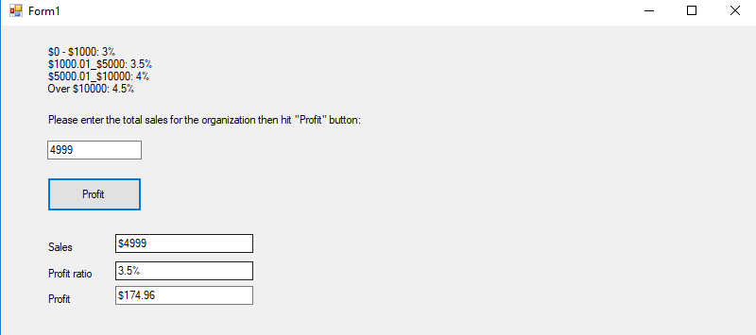

private void btnProfit_Click(object sender, EventArgs e)

{

txtTotal.BackColor = Color.White;

double num1, num2, num3, result;

bool v11 = Double.TryParse(txtTotal.Text, out num1);

if (v11 & num1 > 0)

{

num1 = Double.Parse(txtTotal.Text);

if (num1 >= 10000)

{

txtSales.Text = "$" + Convert.ToString(num1);

txtRatio.Text = "4.5%";

result = num1 * .045;

result = Math.Round(result, 2);

txtProf.Text = "$" + Convert.ToString(result);

}

else if (num1 >= 5000.00 && num1 < 10000)

{

txtSales.Text = "$" + Convert.ToString(num1);

txtRatio.Text = "4%";

result = num1 * .04;

result = Math.Round(result, 2);

txtProf.Text = "$" + Convert.ToString(result);

}

else if (num1 >= 1000.00 && num1 < 5000)

{

txtSales.Text = "$" + Convert.ToString(num1);

txtRatio.Text = "3.5%";

result = num1 * .035;

result = Math.Round(result, 2);

txtProf.Text = "$" + Convert.ToString(result);

}

else if (num1 >= 0 && num1 < 1000)

{

txtSales.Text = "$" + Convert.ToString(num1);

txtRatio.Text = "3%";

result = num1 * .03;

result = Math.Round(result, 2);

txtProf.Text = "$" + Convert.ToString(result);

}

}

else if (!v11)

{

MessageBox.Show("Invalid input of height"); //shows box

txtTotal.BackColor = Color.Red;

}

}

private void txtTotal_TextChanged(object sender, EventArgs e)

{

if (System.Text.RegularExpressions.Regex.IsMatch(txtTotal.Text, "[^0-9]"))

{

MessageBox.Show("Please enter only numbers.");

txtTotal.Text = txtTotal.Text.Remove(txtTotal.Text.Length - 1);

}

}