Quiz 4

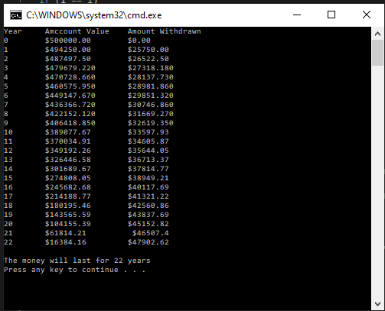

static void Main(string[] args)

{

double[] year = new double[100];

double[] value = new double[100];

double[] withdrawn = new double[100];

int count = 0;

Console.WriteLine("Year Amccount Value Amount Withdrawn");

year[0] = 0;

value[0] = 500000;

withdrawn[0] = 0;

Console.WriteLine(year[0] + "{0,18} {1,12}" , "$" +value[0]+".00" , "$"+withdrawn[0]+".00");

for (int i = 1; i < 100; i++)

{

year[i] = i;

if (i == 1)

withdrawn[i] = 25750;

else

withdrawn[i] = (withdrawn[i-1] \* .03) + withdrawn[i-1];

withdrawn[i] = Math.Round(withdrawn[i], 2);

value[i] = (value[i-1] \* .04 + value[i-1]) - withdrawn[i];

value[i] = Math.Round(value[i], 2);

if (value[i] <= 0)

break;

if(i == 1)

Console.WriteLine(year[i] + "{0,18} {1,16}" , "$" + value[i] + ".00", "$" + withdrawn[i] + ".00");

else if (i == 2)

Console.WriteLine(year[i] + "{0,18} {1,16}", "$" + value[i] + "0", "$" + withdrawn[i] + "0");

else if (i==3 || i <10)

Console.WriteLine(year[i] + "{0,19} {1,16}", "$" + value[i] + "0", "$" + withdrawn[i] + "0");

else if (i==10 || i <21)

Console.WriteLine(year[i] + "{0,17} {1,16}", "$" + value[i], "$" + withdrawn[i]);

else

Console.WriteLine(year[i] + "{0,16} {1,17}", "$" + value[i] , "$" + withdrawn[i]);

count++;

}

Console.WriteLine("");

Console.WriteLine("The money will last for {0} years", count);

}

Initial withdrawal

Initial account value

Yes

Total = 0?

finish

No

Total \*.04 + total – initial withdrawal= total

Initial withdrawal \*.03 + initial withdrawal = initial withdrawal

Initial withdrawal =25750

Initial value \*.04 + initial value – initial withdrawal = total