QUIZ 1:

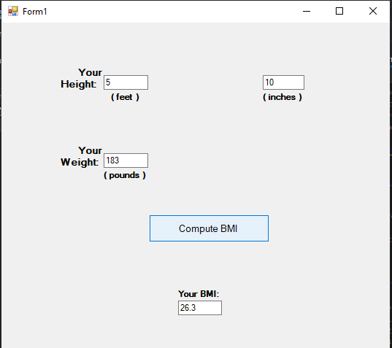

public partial class Form1 : Form

{

public Form1()

{

InitializeComponent();

}

private void BtnCalc_Click(object sender, EventArgs e)

{

double num1, num2, num3, result;

num1 = Double.Parse(txtFeet.Text);

num2 = Double.Parse(txtInch.Text);

num3 = Double.Parse(txtLbs.Text);

num1 = (num1 * 12) +num2;

num1 = num1 * num1;

num3 = num3 * 705;

result = num3 / num1;

result = Math.Round(result, 1);

txtBMI.Text = Convert.ToString(result);

}

}

private void TxtFeet_TextChanged(object sender, EventArgs e)

{

if (System.Text.RegularExpressions.Regex.IsMatch(txtFeet.Text, "[^0-9]"))

{

MessageBox.Show("Please enter only numbers.");

txtFeet.Text = txtFeet.Text.Remove(txtFeet.Text.Length - 1);

}

}

private void TxtInch_TextChanged(object sender, EventArgs e)

{

if (System.Text.RegularExpressions.Regex.IsMatch(txtInch.Text, "[^0-9]"))

{

MessageBox.Show("Please enter only numbers.");

txtInch.Text = txtInch.Text.Remove(txtInch.Text.Length - 1);

}

}

private void TxtLbs_TextChanged(object sender, EventArgs e)

{

if (System.Text.RegularExpressions.Regex.IsMatch(txtLbs.Text, "[^0-9]"))

{

MessageBox.Show("Please enter only numbers.");

txtLbs.Text = txtLbs.Text.Remove(txtLbs.Text.Length - 1);

}

}

private void TxtBMI_TextChanged(object sender, EventArgs e)

{

}