HW 6 (perfect int)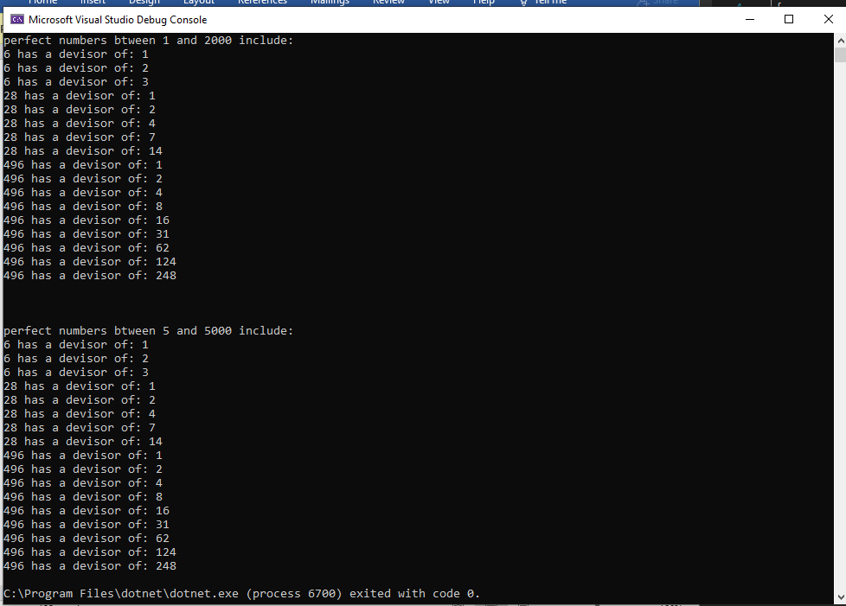

static void Main(string[] args)

{

Console.WriteLine("perfect numbers btween 1 and 2000 include: ");

for (int i =1;i<2000;i++)

{

isPerfect(i);

}

Console.WriteLine("\n\n");

Console.WriteLine("perfect numbers btween 5 and 5000 include: ");

for (int i = 5; i < 5000; i++)

{

isPerfect(i);

}

}

static bool isPerfect(int number)

{

int sum = 0;

int[] devisor = new int[5000];

for(int i =1,j=0;i<number;i++,j++)

{

if(number%i==0)

{

devisor[j] = i;

}

}

for(int i =0; i < 5000;i++)

{

sum = sum + devisor[i];

}

if (sum == number)

{

for(int i =0;i<5000; i++)

{

if (devisor[i] != 0)

Console.WriteLine(number + " has a devisor of: " + devisor[i]);

}

return true;

}

else

return false;

}

}