HW 5 Random

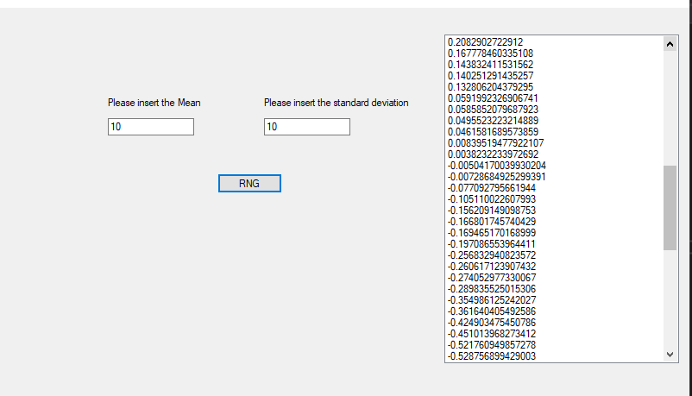

private void BtnRng_Click(object sender, EventArgs e)

{

txtMax.BackColor = Color.White;

txtMin.BackColor = Color.White;

listBox1.Items.Clear();

double max, min;

bool v11 = Double.TryParse(txtMax.Text, out max);

bool v12 = Double.TryParse(txtMin.Text, out min);

List<string> nList = new List<string>();

if (v11 & max >0 && v12 & min > 0)

{

max = double.Parse(txtMax.Text);

min = double.Parse(txtMin.Text);

Random r_obj = new Random();

double mean = 0;

double[] x = new double[100];

double[] y = new double[100];

double[] n1 = new double[100];

for (int i = 0; i < 100; i++)

{

x[i] = r_obj.NextDouble();

}

for (int i = 0; i < 100; i++)

{

y[i] = r_obj.NextDouble();

}

for (int i = 0; i < 100; i++)

{

n1[i] = Math.Cos(2 * Math.PI * y[i]) * Math.Sqrt(-2 * Math.Log(x[i]));

mean = mean + n1[i];

}

mean = mean / 100;

Array.Sort(n1);

Array.Reverse(n1);

for (int i = 0; i < 100; i++)

{

listBox1.Items.Add(n1[i].ToString());

}

listBox1.Items.Add("the mean is: " + mean.ToString());

}

else if (!v11 && !v12)

{

MessageBox.Show("Invalid input of both"); //shows box

txtMax.BackColor = Color.Red;

txtMin.BackColor = Color.Red;

}

else if (!v11)

{

MessageBox.Show("Invalid input of max"); //shows box

txtMax.BackColor = Color.Red;

}

else if (!v12)

{

MessageBox.Show("Invalid input of min"); //shows box

txtMin.BackColor = Color.Red;

}

}

private void TxtMax_TextChanged(object sender, EventArgs e)

{

if (System.Text.RegularExpressions.Regex.IsMatch(txtMax.Text, "[^0-9]"))

{

MessageBox.Show("Please enter only numbers.");

txtMax.Text = txtMax.Text.Remove(txtMax.Text.Length - 1);

}

}

private void TxtMin_TextChanged(object sender, EventArgs e)

{

if (System.Text.RegularExpressions.Regex.IsMatch(txtMin.Text, "[^0-9]"))

{

MessageBox.Show("Please enter only numbers.");

txtMin.Text = txtMin.Text.Remove(txtMin.Text.Length - 1);

}

}

private void label1_Click(object sender, EventArgs e)

{

}

}

}

HW Exam

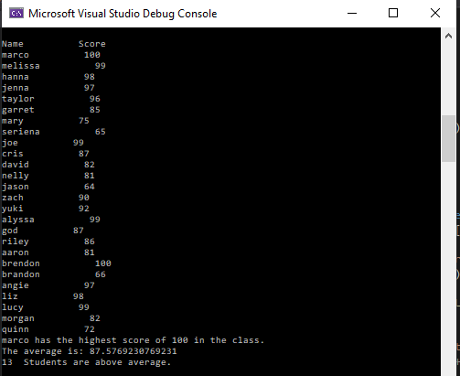

static void Main(string[] args)

{

double total = 0;

int count = 0;

double greatest = 0;

string great = "";

double[] score = new double[26];

string[] name = new string[26];

Console.WriteLine("First write 26 names: ");

for (int i =0; i < 26; i++)

{

name[i] = Console.ReadLine();

}

Console.WriteLine("Now write their corresponding grades: ");

for (int i = 0; i < 26; i++)

{

score[i] = Double.Parse(Console.ReadLine());

}

Console.WriteLine("");

Console.WriteLine("");

Console.WriteLine("");

Console.WriteLine("");

Console.WriteLine("Name Score");

for (int i = 0; i < 26; i++)

{

Console.WriteLine(name[i]+" "+score[i]);

}

for (int i = 0; i < 26; i++)

{

if (score[i] > greatest)

{

greatest = score[i];

great = name[i];

}

}

Console.WriteLine(great + " has the highest score of " + greatest + " in the class.");

for (int i =0;i<26;i++)

{

total = total + score[i];

}

double avg = total / 26;

Console.WriteLine("The average is: "+avg);

for (int i = 0; i < 26; i++)

{

if (score[i] > avg)

{

count++;

}

}

Console.WriteLine(count+" Students are above average.");

}

}