**Homework05 ECE 2310**

1.

Write a C# Windows Forms application that creates 100 random numbers that follow normal distribution. It allows users to enter the values of mean and standard deviation. Display these numbers in an descending order in a list box.

[Hint: Assume we have two sets of random numbers r1 and r2 that are uniformly distributed over [0, 1]. The following formulas can help create random numbers (n1 and n2) that follow normal distribution:

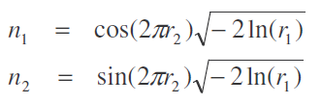

The normal distribution here has a mean of m = 0 and a standard deviation of s = 1. We

can scale and offset random numbers (n1 or n2 ) to get a more general normal

distribution with m = m1 and s = s1 based on the below formula:

Z = m + s*x

Where x can be any random number in n1 or n2]

There are 26 students in the class. Write a console application that enables users to enter each student’s name and his/her exam score and then displays the information. It also displays who has the highest score and how many students are above average.

The output should look like this :

Name Score

Amy 97

Paul 89

… …

Amy has the highest score 97 in the class.

The average score of the class is 81.

18 students are above average score.