Project 1

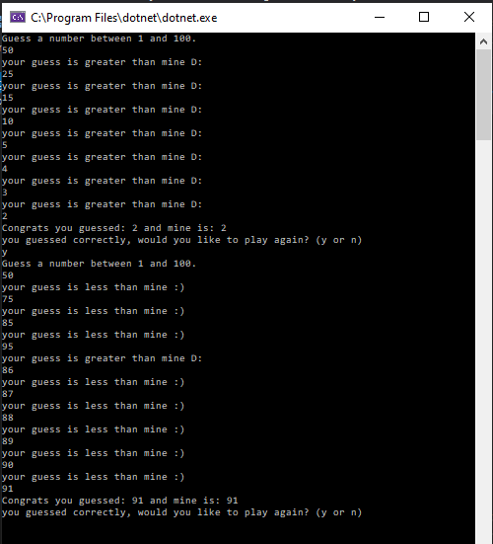

static void Main(string[] args)

{

string again = "y";

while (again == "y")

{

Console.WriteLine("Guess a number between 1 and 100.");

Random r_obj = new Random();

int a = r_obj.Next(1, 101);

int guess = 0;

bool check = false;

string no;

while (check == false)

{

no = Console.ReadLine();

int num = -1;

if (!int.TryParse(no, out num))

{

Console.WriteLine("you didnt input a number number :(");

Console.WriteLine("please input a number :)");

check = false;

}

else

{

guess = Int32.Parse(no);

if (guess < 0 || guess >100)

{

Console.WriteLine("please enter a number between 1 and 100 :)");

check = false;

}

if (guess == a)

{

check = true;

}

else if (guess < a)

{

Console.WriteLine("your guess is less than mine :)");

check = false;

}

else if (guess > a)

{

Console.WriteLine("your guess is greater than mine D:");

check = false;

}

}

}

if (check == true)

{

Console.WriteLine("Congrats you guessed: " + guess + " and mine is: " + a);

Console.WriteLine("you guessed correctly, would you like to play again? (y or n)");

}

again = Console.ReadLine();

}

Console.WriteLine("Hope you had fun :)");

}

}

}