HW 2 Five digit Int

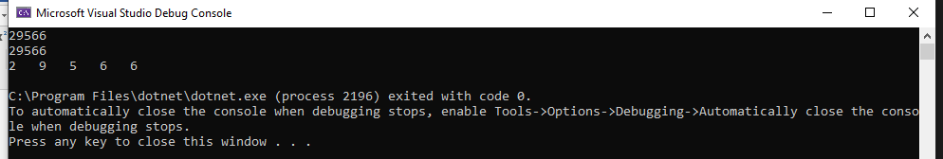

using System;

namespace HW_2__display_numbers_

{

class Program

{

static void Main(string[] args)

{

string numbers;

int convert, a, b, c, d, e;

numbers = Console.ReadLine();

Console.WriteLine(numbers);

convert = Convert.ToInt32(numbers);

a = convert / 10000;

convert = convert % 10000;

b = convert / 1000;

convert = convert % 1000;

c = convert / 100;

convert = convert % 100;

d = convert / 10;

convert = convert % 10;

e = convert;

Console.WriteLine(a + " " + b + " " + c + " " + d + " " + e);

}

}

}

HW 2 Calculator WFA

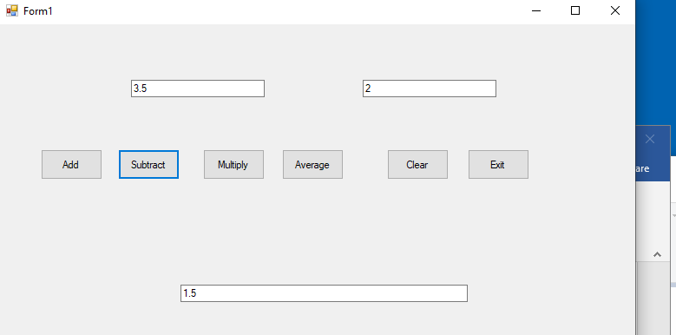

namespace HW_2__calculator_WFA

{

public partial class Form1 : Form

{

public Form1()

{

InitializeComponent();

}

private void BtnAdd_Click(object sender, EventArgs e)

{

double num1, num2, result;

num1 = Double.Parse(txt1.Text);

num2 = Double.Parse(txt2.Text);

result = num1 + num2;

txt3.Text = Convert.ToString(result);

}

private void BtnSub_Click(object sender, EventArgs e)

{

double num1, num2, result;

num1 = Double.Parse(txt1.Text);

num2 = Double.Parse(txt2.Text);

result = num1 - num2;

txt3.Text = Convert.ToString(result);

}

private void BtnMult_Click(object sender, EventArgs e)

{

double num1, num2, result;

num1 = Double.Parse(txt1.Text);

num2 = Double.Parse(txt2.Text);

result = num1 * num2;

txt3.Text = Convert.ToString(result);

}

private void BtnAvr_Click(object sender, EventArgs e)

{

double num1, num2, result;

num1 = Double.Parse(txt1.Text);

num2 = Double.Parse(txt2.Text);

result = (num1 + num2)/2;

txt3.Text = Convert.ToString(result);

}

private void BtnClear_Click(object sender, EventArgs e)

{

txt1.Clear();

txt2.Clear();

txt3.Clear();

}

private void BtnExit_Click(object sender, EventArgs e)

{

Close();

}

}