HW 8 Employee

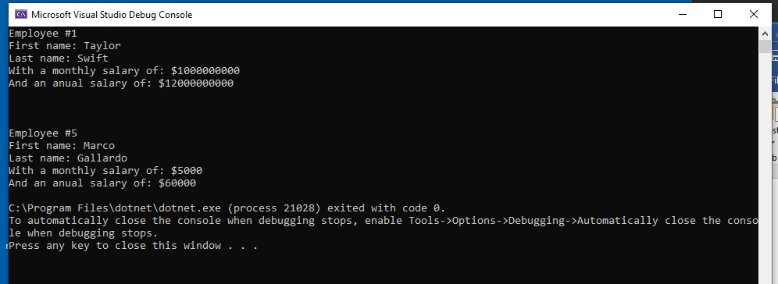

|  |
| --- |
| EMPLOYEE |
| -Number : double |
| - First : string |
| * Last : string |
| * Salary : double |
| * Total : double |

|  |
| --- |
| + Employee() |
| + Employee(double, string, string, string , double) |
| + Number.double |
| + First.string |
| + Last.string |
| + Salary.double |
| + AnualPay() : void |
| + PrintData() : void |
| ~ Employee() |

(CLASS)

using System;

using System.Collections.Generic;

using System.Text;

namespace HW_8__employee__school

{

class Employee

{

//data members

double number;

string first;

string last;

double salary;

double total;

//member methods

public Employee()

{

number = 1;

first = "Taylor";

last = "Swift";

salary = 1000000000;

total = salary * 12;

}

public Employee(double nbr, string frst, string lst, double slry)

{

nbr = number;

frst = first;

lst = last;

slry = salary;

}

public double Number

{

get { return number; }

set

{

if (value > 0) number = value;

else number = 0;

}

}

public string First

{

get { return first; }

set

{

first = value;

}

}

public string Last

{

get { return last; }

set

{

last = value;

}

}

public double Salary

{

get { return salary; }

set

{

if (value > 0) salary = value;

else salary = 0;

}

}

public void AnualPay()

{

total = salary * 12;

}

public void PrintData()

{

Console.WriteLine("Employee #{0}", number);

Console.WriteLine("First name: {0}", first);

Console.WriteLine("Last name: {0}", last);

Console.WriteLine("With a monthly salary of: ${0}", salary);

Console.WriteLine("And an anual salary of: ${0}", total);

}

~Employee() { }

}

}

(PROGRAM)

static void Main(string[] args)

{

Employee newEmployee = new Employee();

Employee newEmployee2 = new Employee();

newEmployee.PrintData();

Console.WriteLine();

Console.WriteLine();

Console.WriteLine();

newEmployee2.Number = 5;

newEmployee2.First = "Marco";

newEmployee2.Last = "Gallardo";

newEmployee2.Salary = 5000;

newEmployee2.AnualPay();

newEmployee2.PrintData();

}

HW 8 Employee 2

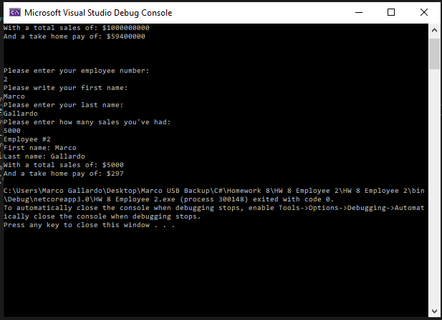

(CLASS EMPLOYEE)

|  |
| --- |
| EMPLOYEE |
| * number : double |
| * First : string |
| * Last : string |
| * Sales : double |
| * Total : double |
| * Fed : double |
| * Retire : double |
| * Security : double |

|  |
| --- |
| + Employee |
| + Employee (double, string, string, double |
| + Number.double |
| + First.string |
| + Last.string |
| + Sales.double |
| + TakeHome() : void |
| + PrintData() : void |
| ~Employee() |

class Employee

{

//data members

double number;

string first;

string last;

double sales;

double total;

double fed = .18;

double retire = .1;

double security = .06;

//member methods

public Employee()

{

number = 1;

first = "Taylor";

last = "Swift";

sales = 1000000000;

total = sales * .09;

total = total - (total * fed + total * retire + total * security);

}

public Employee(double nbr, string frst, string lst, double sls)

{

nbr = number;

frst = first;

lst = last;

sls = sales;

}

public double Number

{

get { return number; }

set

{

if (value > 0) number = value;

else number = 0;

}

}

public string First

{

get { return first; }

set

{

first = value;

}

}

public string Last

{

get { return last; }

set

{

last = value;

}

}

public double Sales

{

get { return sales; }

set

{

if (value > 0) sales = value;

else sales = 0;

}

}

public void TakeHome()

{

total = sales * .09;

total = total - (total * fed + total * retire + total * security);

}

public void PrintData()

{

Console.WriteLine("Employee #{0}", number);

Console.WriteLine("First name: {0}", first);

Console.WriteLine("Last name: {0}", last);

Console.WriteLine("With a total sales of: ${0}", sales);

Console.WriteLine("And a take home pay of: ${0}", total);

}

~Employee() { }

}

(PROGRAM)

Employee newEmployee = new Employee();

newEmployee.PrintData();

Console.WriteLine();

Console.WriteLine();

Console.WriteLine();

Console.WriteLine("Please enter your employee number: ");

newEmployee.Number = Double.Parse(Console.ReadLine());

Console.WriteLine("Please write your first name: ");

newEmployee.First = Console.ReadLine();

Console.WriteLine("Please enter your last name: ");

newEmployee.Last = Console.ReadLine();

Console.WriteLine("Please enter how many sales you've had: ");

newEmployee.Sales = Double.Parse(Console.ReadLine());

newEmployee.TakeHome();

newEmployee.PrintData();