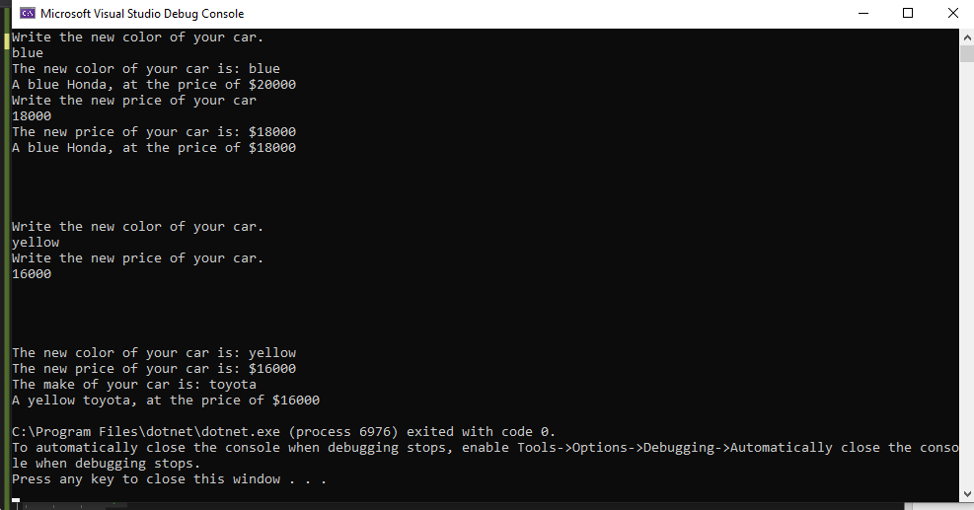Car yourCar = new Car();

yourCar.Drive();

yourCar.PrintData();

Car myCar = new Car("red", 20000, "Honda");

myCar.PrintData();

Car car3 = new Car(35000, "toyota");

car3.PrintData();

Console.WriteLine("Write the new color of your car.");

string color = Console.ReadLine();

myCar.SetColor(color);

Console.WriteLine("The new color of your car is: {0}", myCar.GetColor());

myCar.PrintData();

Console.WriteLine("Write the new price of your car");

double price = double.Parse(Console.ReadLine());

myCar.SetPrice(price);

Console.WriteLine("The new price of your car is: ${0}", myCar.GetPrice());

myCar.PrintData();

Console.WriteLine();

Console.WriteLine();

Console.WriteLine();

Console.WriteLine();

Console.WriteLine("Write the new color of your car.");

color = Console.ReadLine();

car3.Color = color;

Console.WriteLine("Write the new price of your car.");

price = double.Parse(Console.ReadLine());

car3.Price = price;

Console.WriteLine("The new color of your car is: {0}", car3.Color);

Console.WriteLine("The new price of your car is: ${0}", car3.Price);

Console.WriteLine("The make of your car is: {0}", car3.Make);

car3.PrintData();

/\* Car[] test = new Car[3];

string clr, mk;

double p;

for (int i=0; i < 3; i++)

{

Console.WriteLine("Enter the color for the car#{0}", i + 1);

clr = Console.ReadLine();

Console.WriteLine("Enter the make for the car#{0}", i + 1);

mk = Console.ReadLine();

Console.WriteLine("Enter the price for the car#{0}", i + 1);

p = Double.Parse(Console.ReadLine());

test[i] = new Car(clr, p, mk);

}

for(int i =0; i < 3;i++)

{

Console.Write("car #{0} : ", i + 1);

test[i].PrintData();

}

\*/