

Figure Landing Page of My Application Rendered on Google Chrome

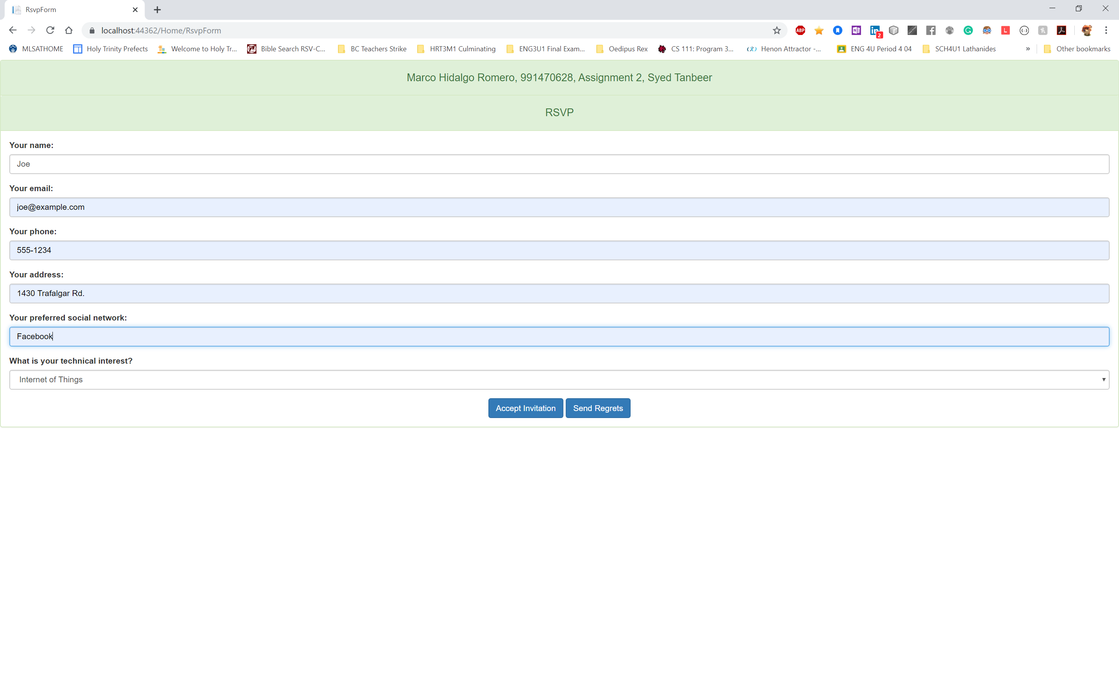

Figure RsvpForm.cshtml

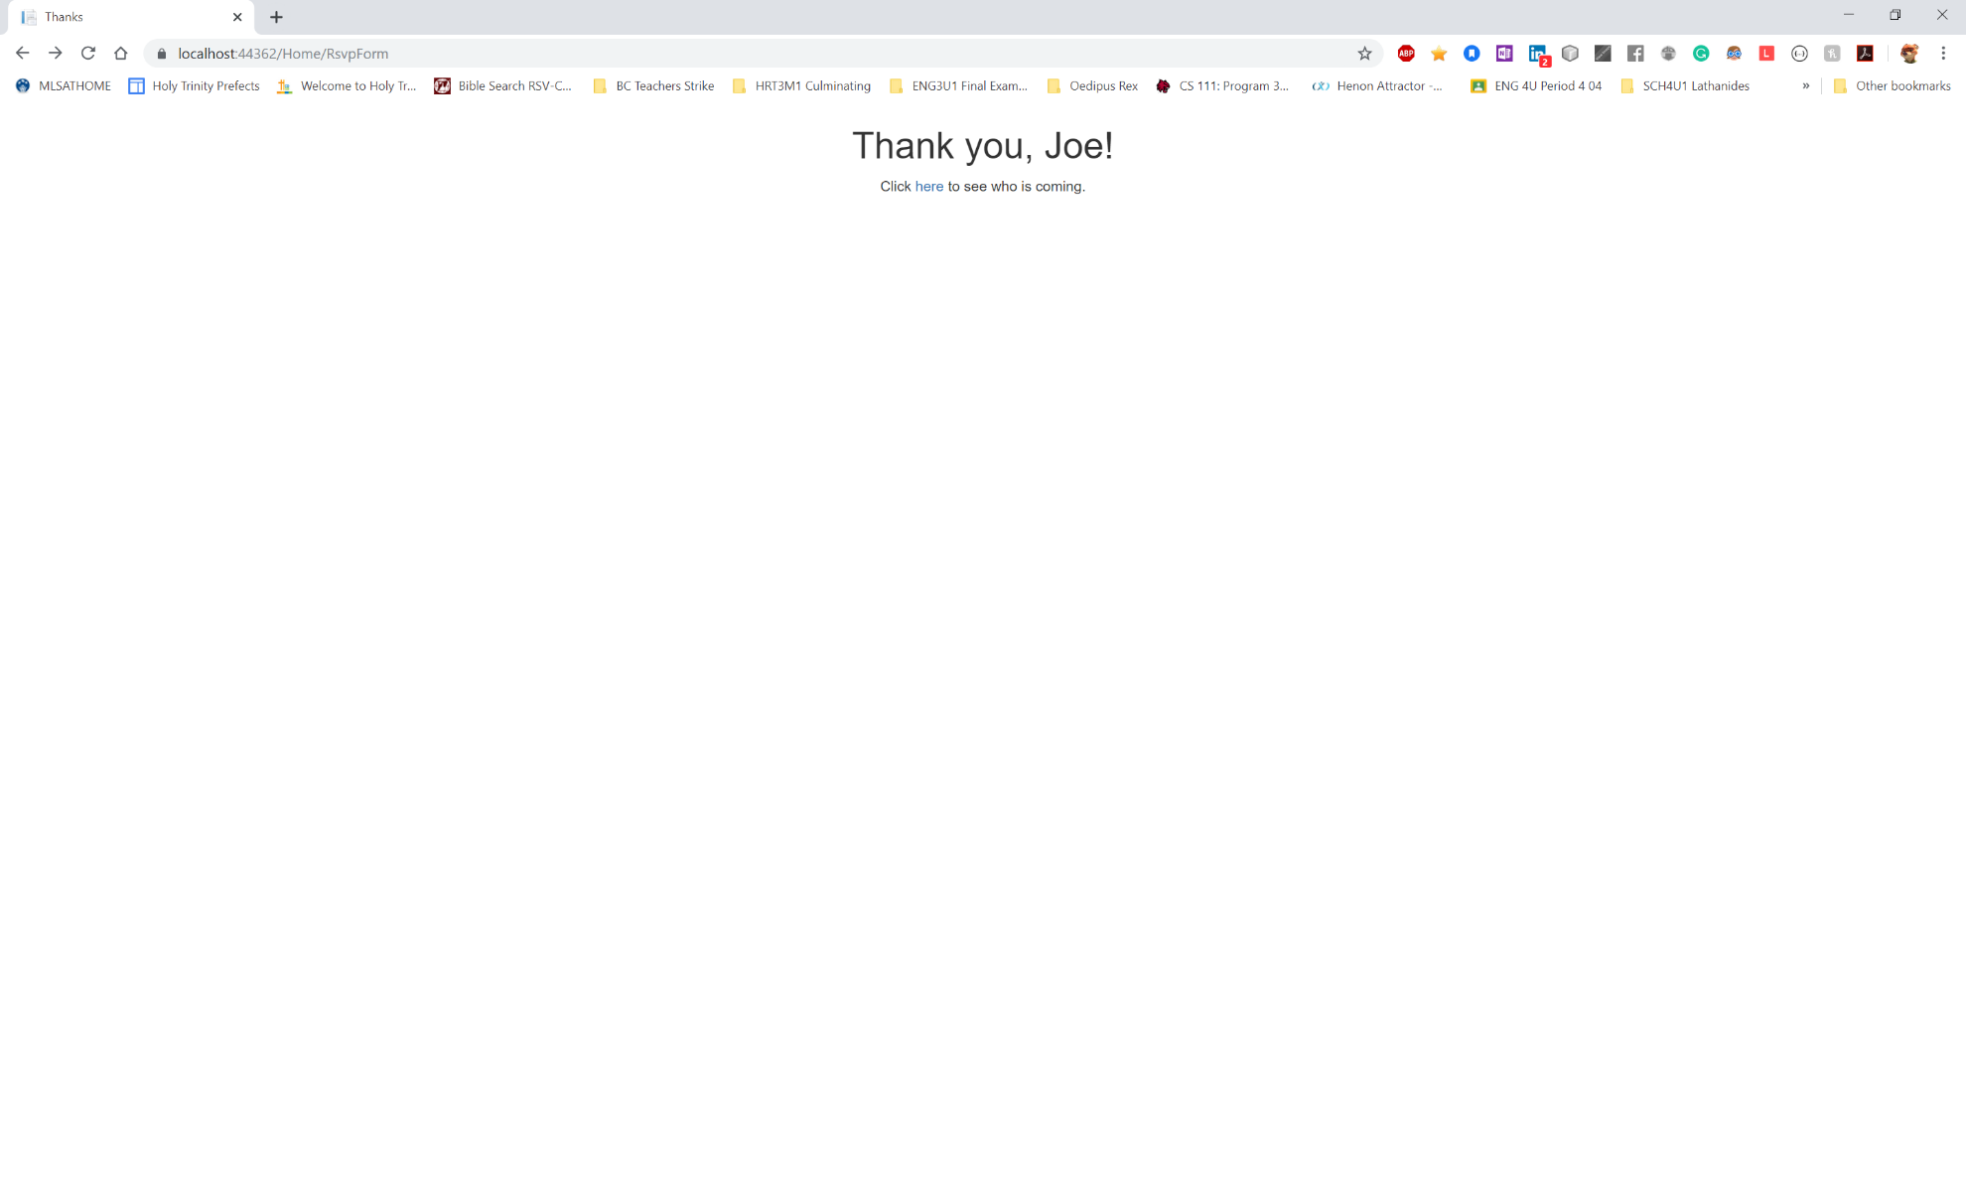

Figure Thanks.cshtml

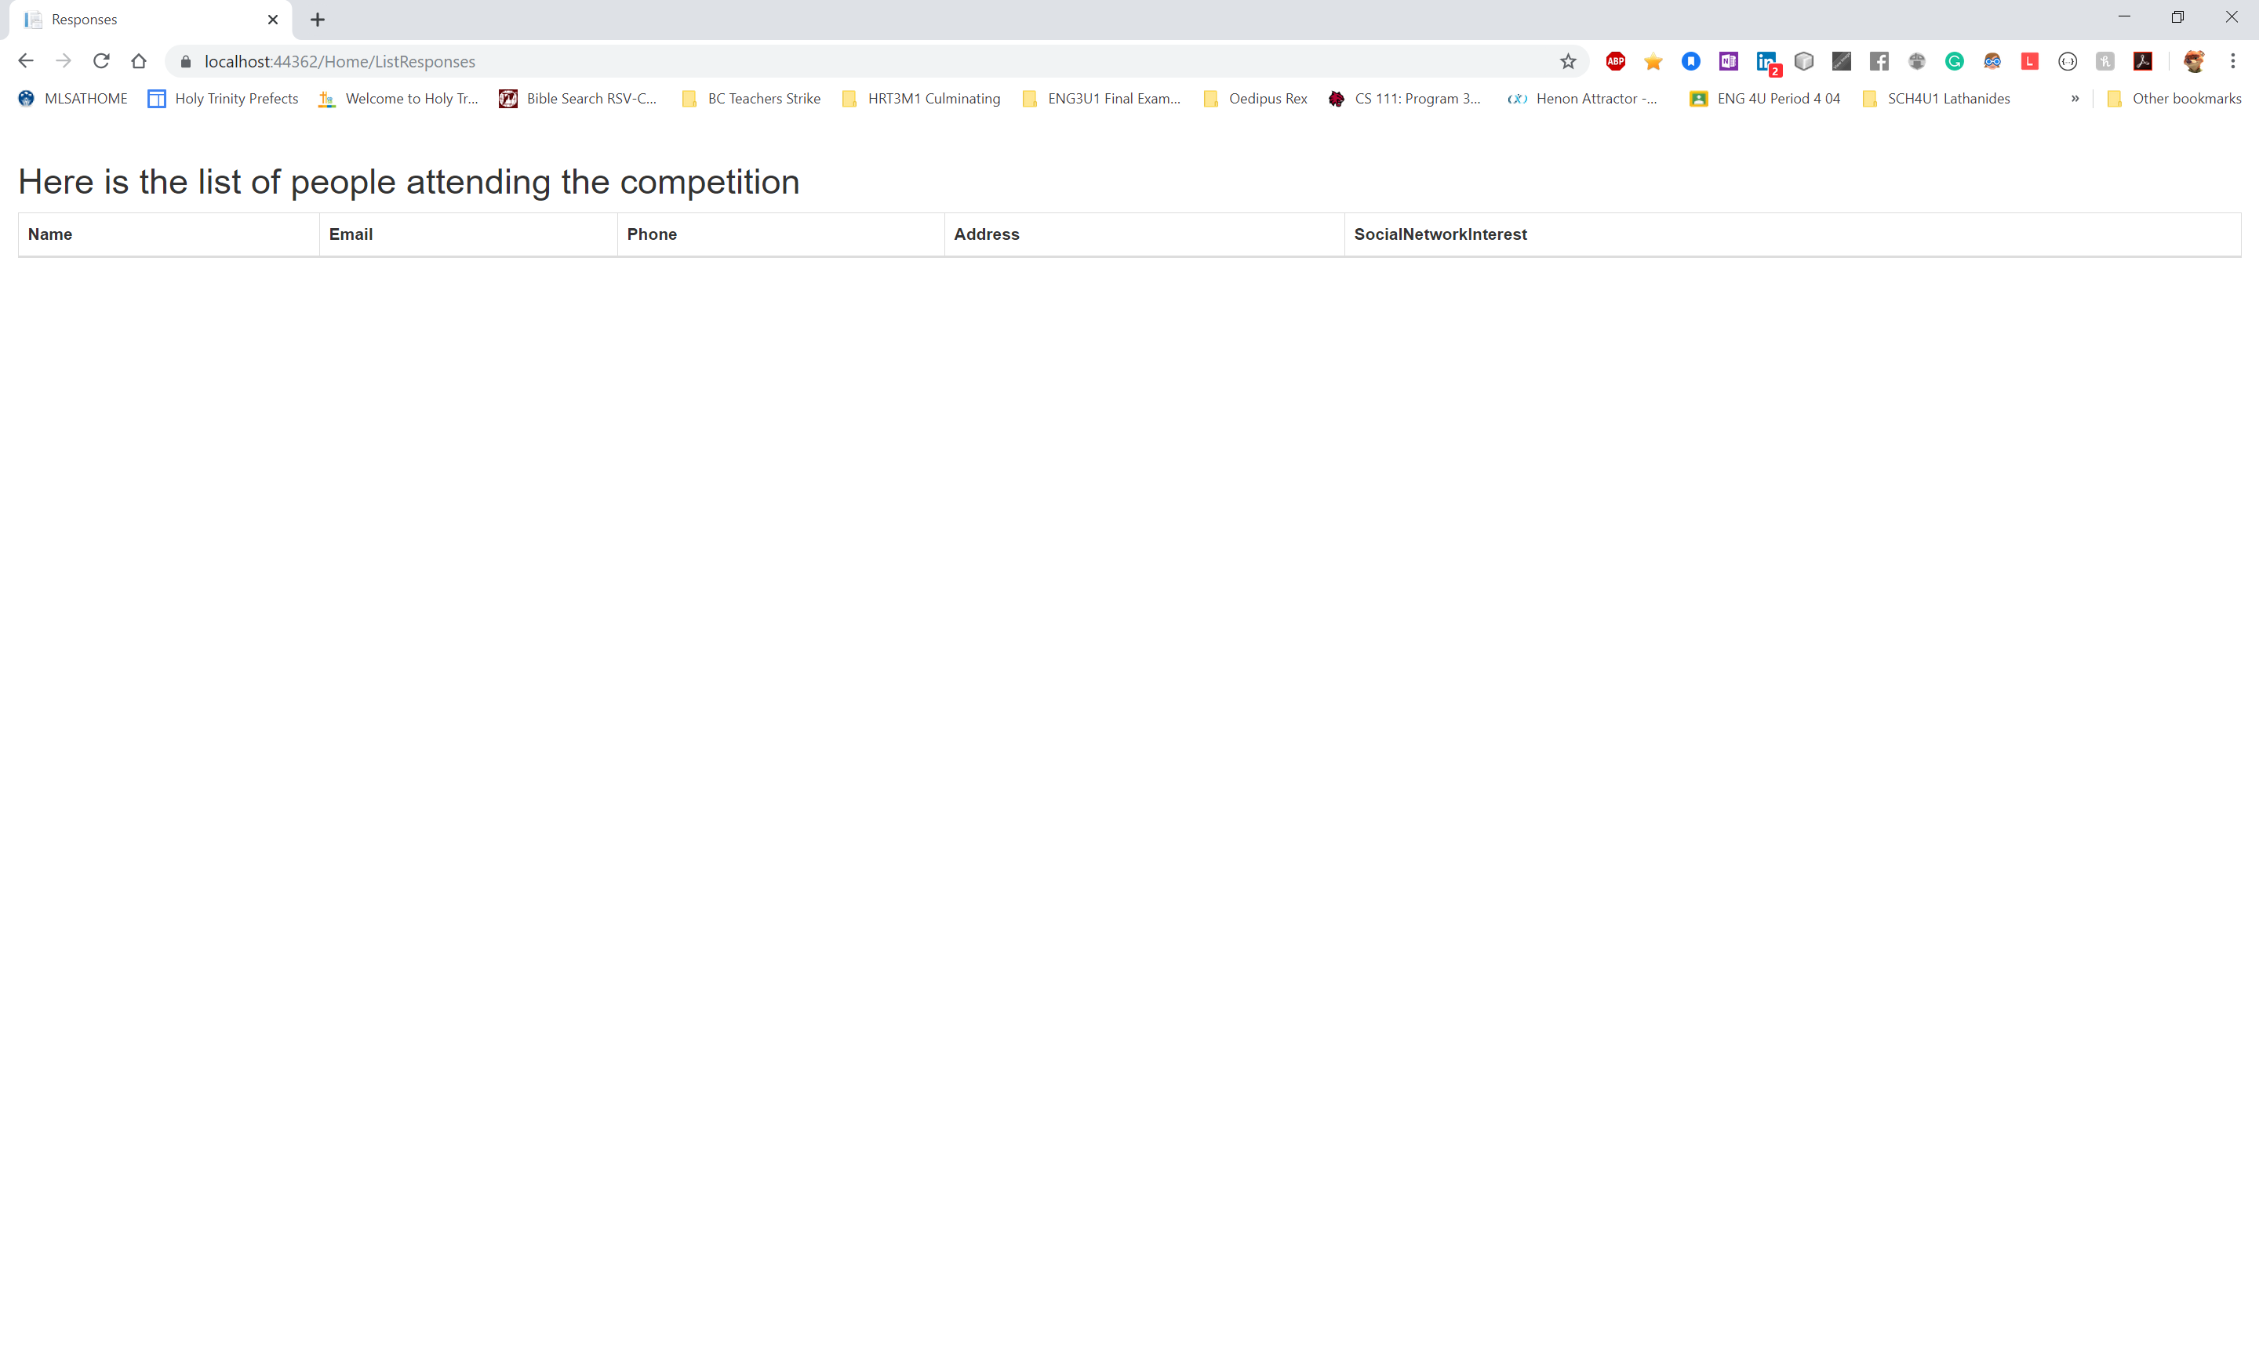

Figure ListResponses.cshtml

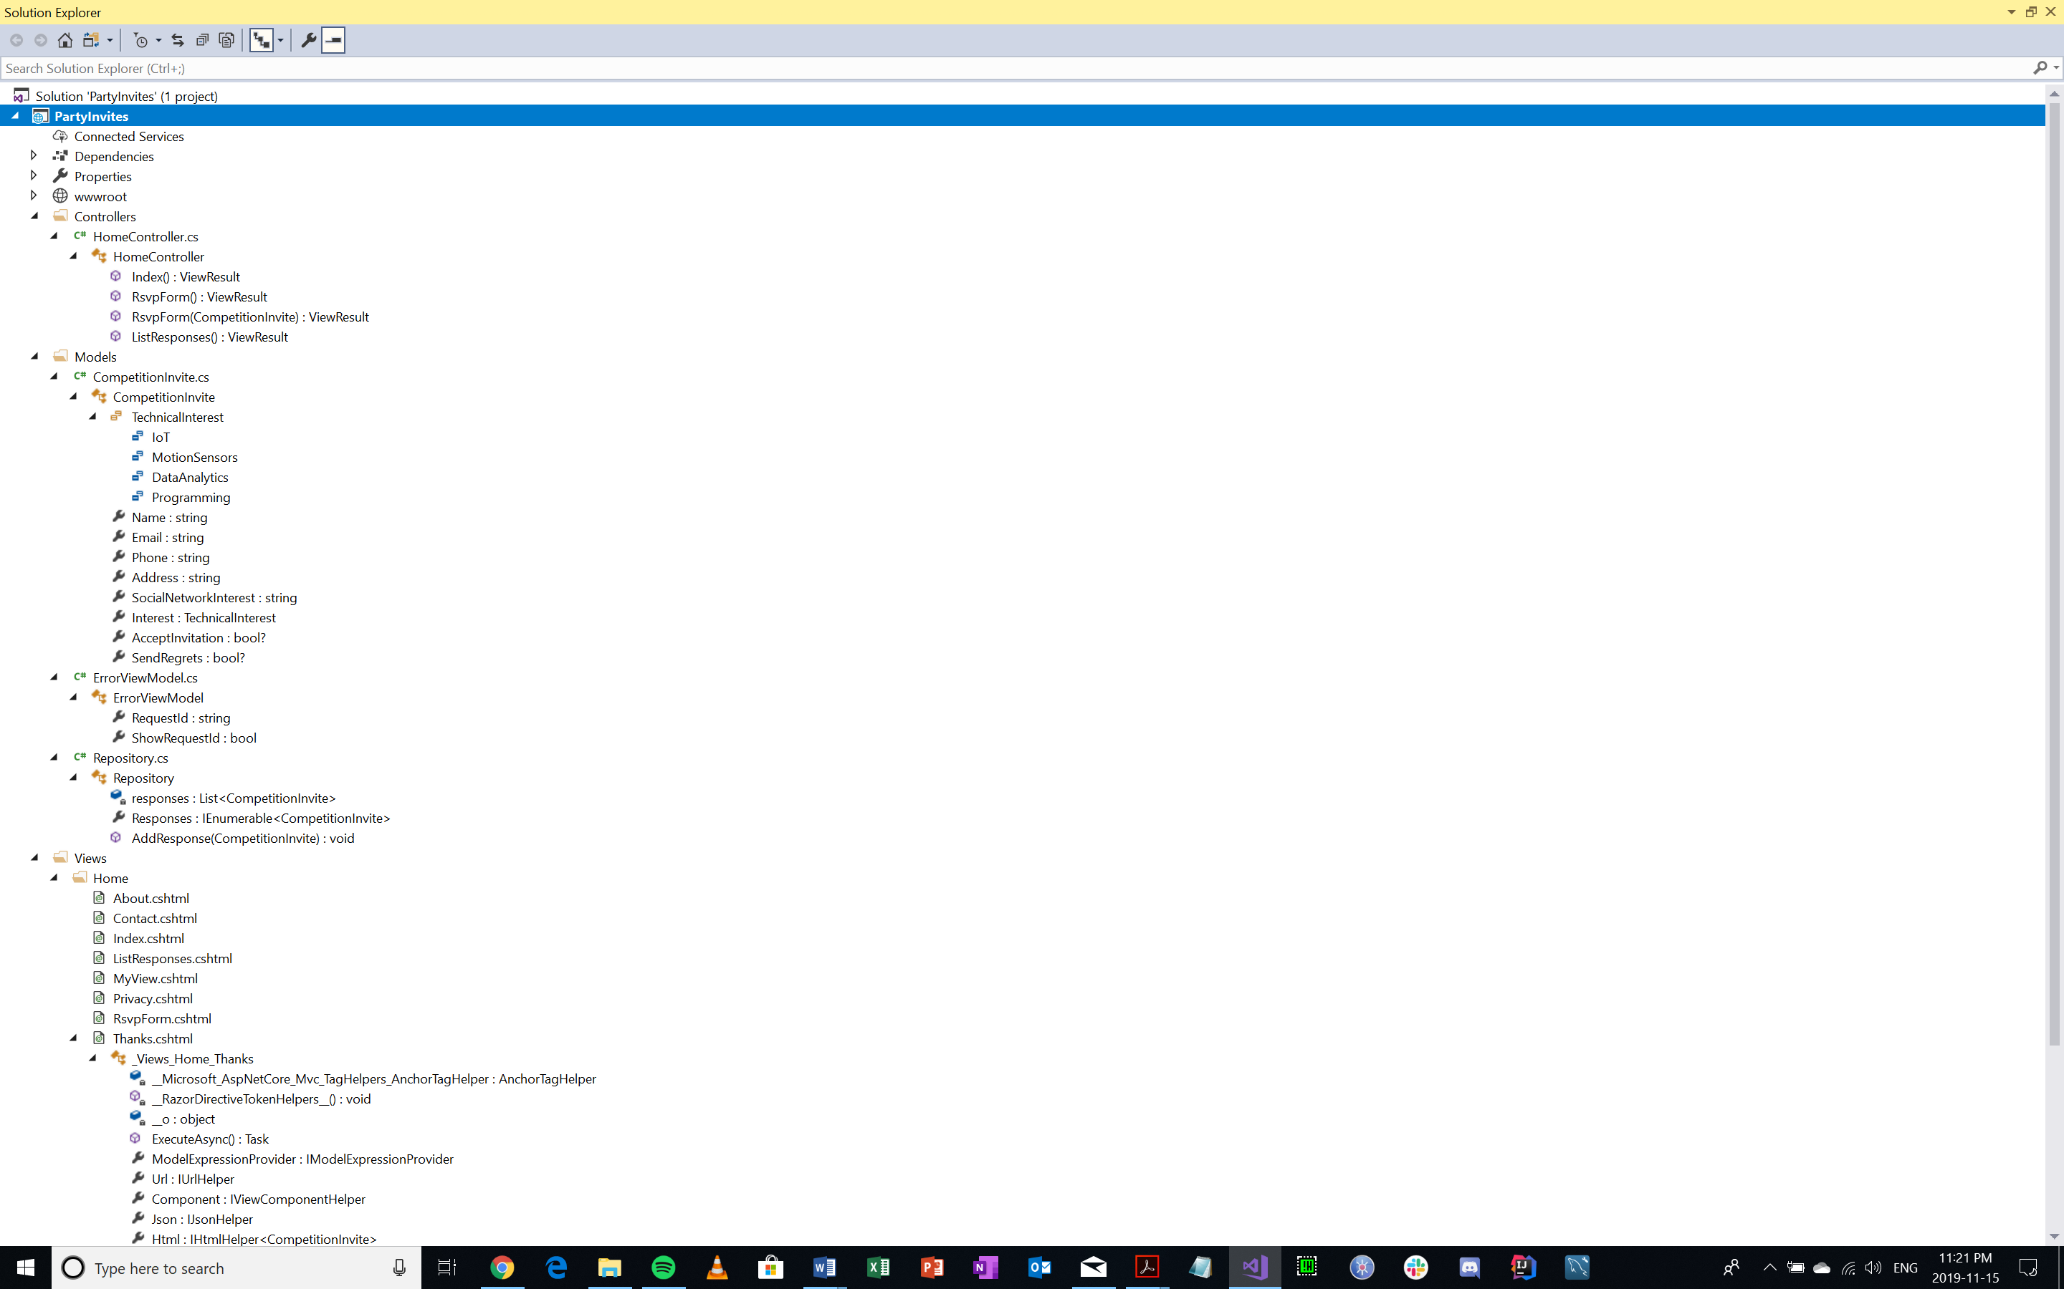

Figure Solution Explorer

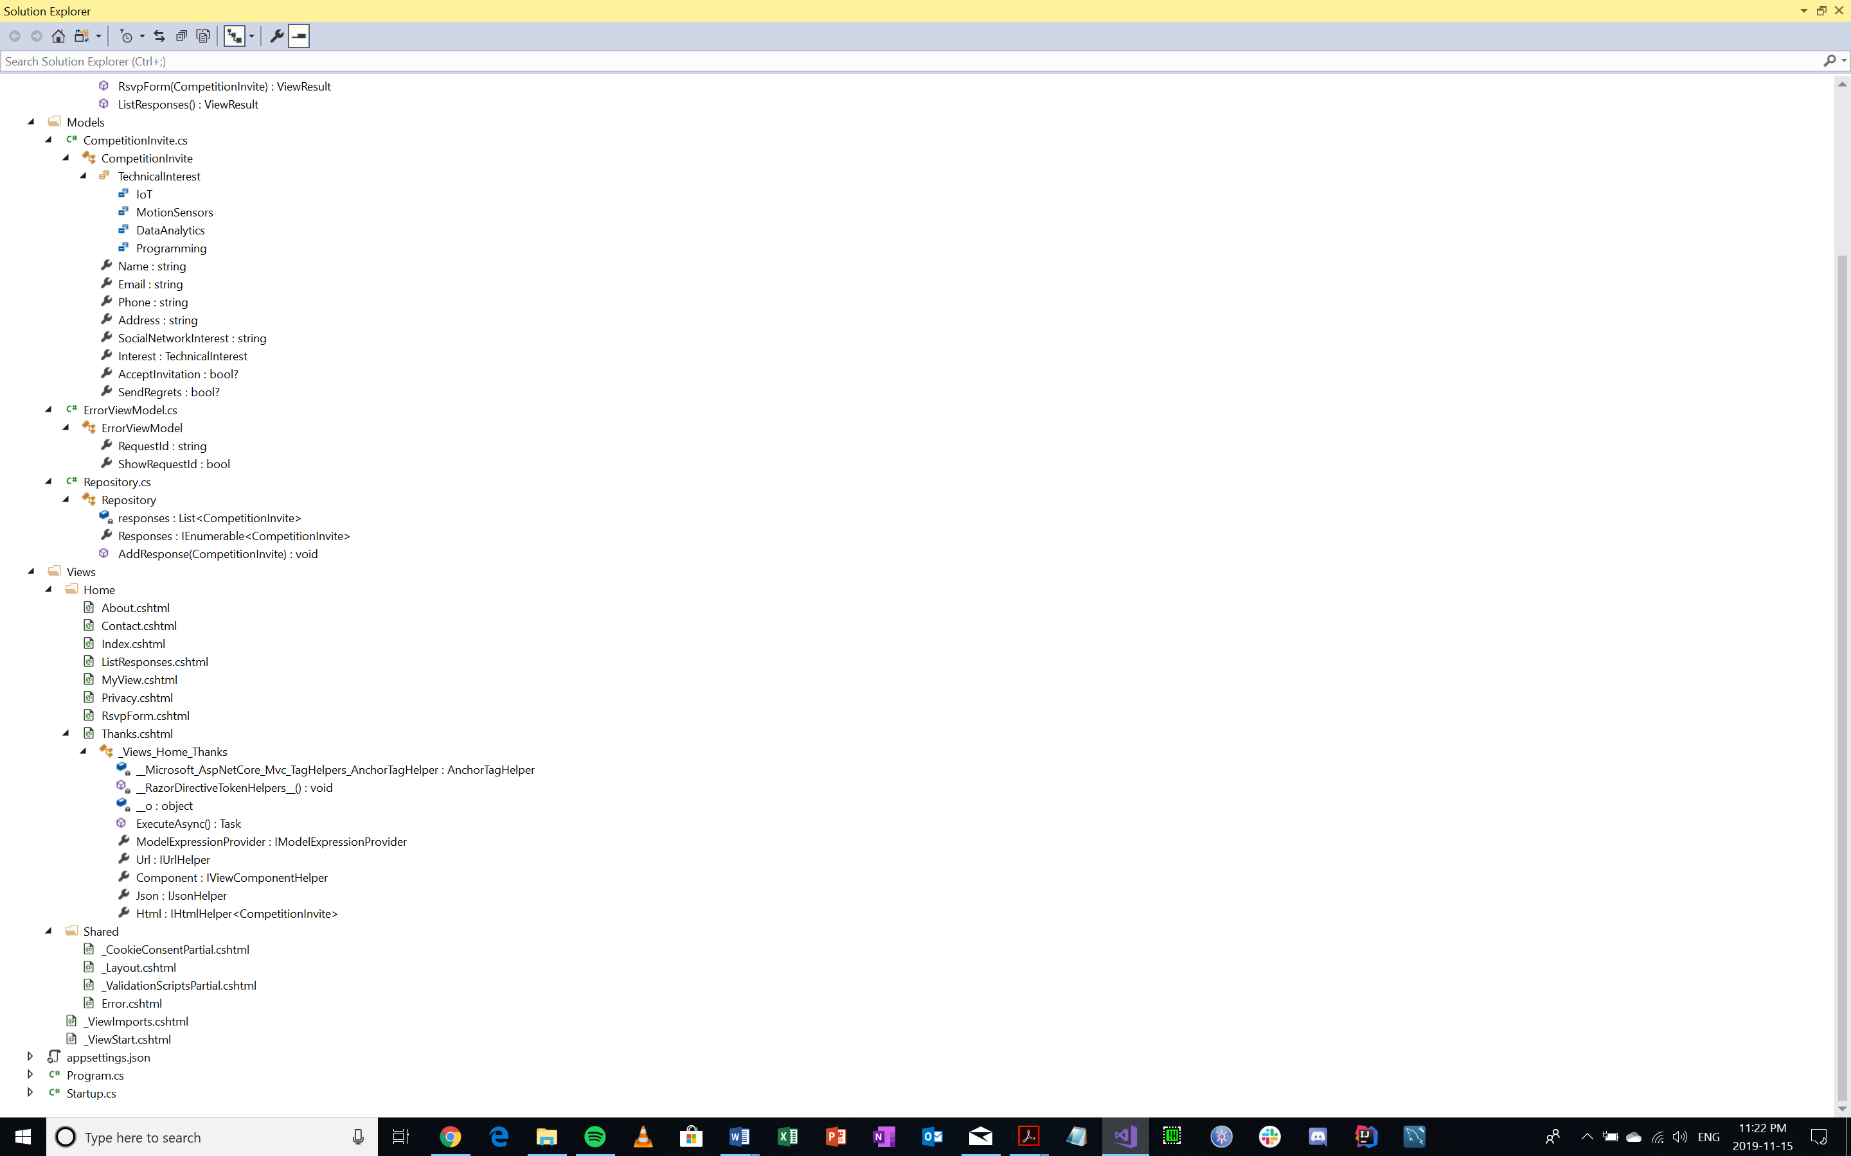

Figure Solution Explorer (Continued)

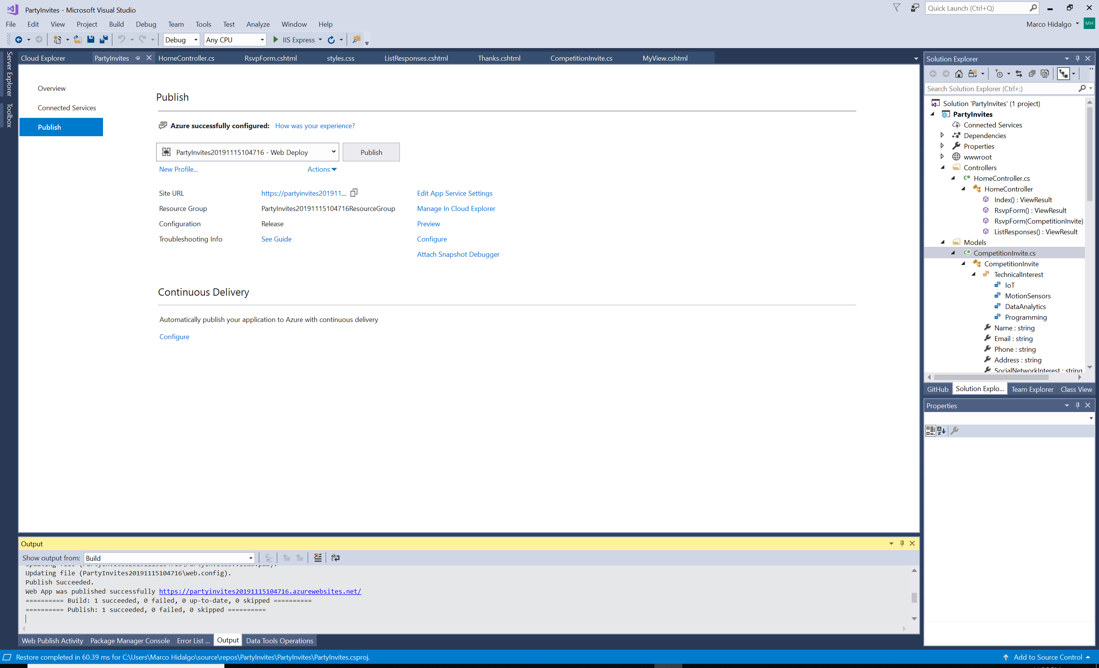

Figure Azure Deployment (Visual Studio Side)



Figure Azure Deployment (Google Chrome Side)