Greenfoot Installation

Greenfoot requires the *Java 6 JDK (or above).*

# Installing Java

The Java download can be found on the following website:

<http://www.oracle.com/technetwork/java/javase/downloads/>

Note that you need the version marked **JDK** not JRE.

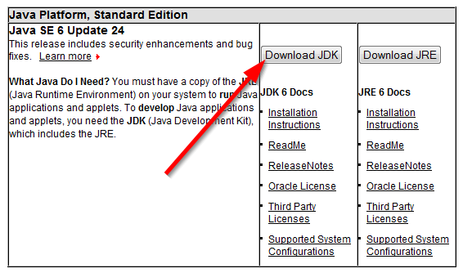

# Installing Greenfoot

The Greenfoot software can be found on the following website:

<http://www.greenfoot.org/download/>

Choose the version for your operating system and install it.